|  |  |
| --- | --- |
|  | **MINISTRY OF EDUCATION AND TRAINING** |

|  |
| --- |
| **FPT UNIVERSITY** |
| Capstone Project Document |
| Photographer Booking System |

|  |  |
| --- | --- |
| **FA20SE21** | |
| **Group Members** | Trần Thiên Thảo – Leader – SE62888  Bồ Công Đạt – Member – SE63154  Đào Sỹ Trung Kiên – Member – SE63208  Trương Ngọc Mỹ - Member – SE62050 |
| **Supervisor** | Lại Đức Hùng |
| **Ext Supervisor** | N/A |
| **Capstone Project code** | PBS |

* HoChiMinh September 2020 -

**Table of Contents**

Acknowledgement 14

Definition and Acronyms 14

I. Project Introduction 15

1. Overview 15

1.1 Project Information 15

1.2 Project Team 15

2. Product Background 15

3. Existing Systems 16

3.1 WeHelp 16

3.2 vLance 16

3.3 Tripo 17

4. Business Opportunity 17

5. Software Product Vision 18

6. Project Scope & Limitations 18

6.1 Major Features 18

6.2 Limitations & Exclusions 20

II. Project Management Plan 21

1. Overview 21

1.1 WBS & Estimation 21

1.2 Project Objectives 26

1.3 Project Risks 26

2. Management Approach 27

2.1 Project Process 27

2.2 Quality Management 28

2.3 Training Plan 28

3. Master Schedule 28

4. Project Organization 30

4.1 Team & Structures 30

4.2 Roles & Responsibilities 30

5. Project Communication 31

5.1 Communication Plan 31

5.2 External Interface 31

6. Configuration Management 32

6.1 Tools & Infrastructures 32

6.2 Document Management 32

6.3 Source Code Management 32

III. Software Requirement Specification 33

1. Overall Description 33

1.1 Product Overview 33

1.2 Business Rules 33

2. User Requirements 34

2.1 Overview 34

2.2 List of use case 37

3. Functional Requirements 130

3.1 System Functional Overview 130

4. Non-Functional Requirements 140

4.1 External Interfaces 140

4.2 Quality Attributes 141

5. Other Requirements 142

5.1 Messages List 142

IV. Software Design Document 144

1. Overall Description 144

1.1 Assumptions 144

1.2 Design Constraints 144

2. System Architecture Design 144

2.1 Overall Architecture 144

2.2 System Architecture 144

2.3 Package Diagram 145

3. System Detailed Design 149

3.1 Overall 149

4. Class Specifications 162

4.1 User 162

4.2 Role 163

4.3 ERole 164

4.4 ServicePackage 164

4.5 Service 165

4.6 Booking 165

4.7 EBookingStatus 166

4.8 Album 167

4.9 Image 168

4.10 Category 168

4.11 DayOfWeek 169

4.12 Location 169

4.13 BookingComment 170

4.14 BookingDetail 170

4.15 BusyDay 171

4.16 Thread 171

4.17 ThreadTopic 172

4.18 ThreadComment 173

4.19 ReturningType 173

4.20 EReturningType 173

4.21 TimeLocationDetail 174

4.22 Variable 174

4.23 CancellationRequest 175

4.24 Report 175

4.25 VerificationToken 176

4.26 Notification 176

4.27 ENotificationType 177

5. Data & Database Design 178

5.1 Database Design 178

5.2 Data File Design 187

6. Algorithm 188

6.1 Multiple-factors weighted sorting 188

6.2 Naive Bayes Classifier 191

V. Software Testing Documentation 195

1. Overall Description 195

1.1 Test Model 195

1.2 Testing Levels 195

1.3 Testing Types 195

2. Test Plan 196

2.1 Test Stages 196

2.2 Resources 196

2.3 Test Milestones sua gio giac 197

2.4 Deliverables 197

3. Test Cases 197

4. Test Reports 197

VI. Release Package & User Guides 198

1. Deliverable Package 198

1.1 Source codes & documents them tên bảng cho ban tieng Nhat 198

1.2 Known Issues, Limitations & Restrictions 199

2. Installation Guides 199

2.1 System Requirements 199

2.2 Setup Files 200

2.3 Installation Instruction 200

2.4 Server-side deployment 204

3. User Manual 208

3.1 Terms and definitions 208

3.2 System requirements 208

3.3 Application Usage 209

3.4 Troubleshooting 243

4. 配達可能なパッケージ 244

4.1 ソースコードと文書 244

4.2 既知の問題、制限および限定 245

5. 設置ガイド 245

5.1 システム要件 245

5.2 設定ファイル 246

5.3 インストール手順 247

5.4 サーバー側の展開 250

6.ユーザーマニュアル 254

6.1 用語と定義 254

6.2システム要件 254

6.3アプリの使用 255

6.4トラブルシューティング 282

VII. Appendix 284

1. Glossary [Optional] 284

2. References [Optional] 284

3. Others [Optional] 284

**List of Figures**

Figure 1 Feature Mind Map 12

Figure 2 Project process 21

Figure 3 Project organization 23

Figure 4 Context Diagram 26

Figure 5 Overview Use Case Diagram 27

Figure 6 <Guest> Overview 30

Figure 7 <Guest> Register 30

Figure 8 <Guest> Login 33

Figure 9 <Guest> Forgot password 35

Figure 10 <Customer> Overview 37

Figure 11 <Customer> Search photographers 38

Figure 12 <Customer> Get photographer's detail 39

Figure 13 <Customer> Book photographer 40

Figure 14 <Customer> Get bookings 43

Figure 15 <Customer> Edit booking 46

Figure 16- <Customer> Make report 48

Figure 17 <Customer> Review photographers 51

Figure 18 <Customer> Submit cancellation 52

Figure 19 <Customer> Post thread 55

Figure 20 <Customer> Edit thread 56

Figure 21 <Customer> Comment thread 58

Figure 22 <Customer> Remove thread 60

Figure 23 <Customer> Chat 61

Figure 24 <Photographer> Overview 63

Figure 25 <Photographer> Accept booking 63

Figure 26 <Photographer> Decline booking 66

Figure 27 <Photographer> Edit working weekdays 68

Figure 28 <Photographer> Add busy day 70

Figure 29 <Photographer> Add package 72

Figure 30 <Photographer> Edit package 74

Figure 31 <Photographer> Remove package 76

Figure 32 <Photographer> Add album 77

Figure 33 <Photographer> Edit album 79

Figure 34 <Photographer> Remove album 82

Figure 35 <Authenticated User> Overview 83

Figure 36 <Authenticated User> Get profile 84

Figure 37 <Authenticated User> Edit profile 85

Figure 38 <Authenticated User> Change password 87

Figure 39 <Authenticated User> Logout 89

Figure 40 <Admin> Overview 90

Figure 41 <Admin> Get cancellation 91

Figure 42 <Admin> Approve cancellation 92

Figure 43 <Admin> Get report 94

Figure 44 <Admin> Get user's detail 95

Figure 45 <Photographer> Get customer's review 97

Figure 46 <Admin> Block user 98

Figure 47 <Admin> Unblock user 100

Figure 48 <Admin> Warn user 102

Figure 49 <Admin> Add category 103

Figure 50 <Admin> Edit category 105

Figure 51 <Admin> Remove category 106

Figure 52 <Admin> Ban thread 108

Figure 53 <Admin> Unban thread 109

Figure 54 <Admin> Update variables 111

Figure 55 <Admin> Add topic 113

Figure 56 <Admin> Edit topic 114

Figure 57 <Admin> Remove topic 116

Figure 58 <<system>> Handler Overview 117

Figure 59 <<system>> Handler make booking notification 118

Figure 60 <<system>> Handler make scheduling notification 119

Figure 61 <<system>> Handler make weather warning 121

Figure 62 <<system>> Handler make time warning 122

Figure 63 Customer's screen flow 124

Figure 64 Photographer's screen flow 125

Figure 65 ER Diagram 132

Figure 66 Overall Architecture 137

Figure 67 Mobile App Architecture 138

Figure 68 Webapi Package Diagram 139

Figure 69 Package Diagram – Mobile app 141

Figure 70 Class Diagram 142

Figure 71 Sequence Diagram - Add Category 143

Figure 72 Sequence Diagram - Edit Category 144

Figure 73 Sequence Diagram - Remove Category 144

Figure 74 Sequence Diagram - Block user 145

Figure 75 Sequence Diagram - Unblock User 145

Figure 76 Sequence Diagram - warn user 146

Figure 77 Sequence Diagram - approve cancellation 147

Figure 78 Sequence Diagram - Update Variables 148

Figure 79 Activity Diagram – Book photographer 149

Figure 80 Activity Diagram – Edit Request 150

Figure 81 Activity Diagram - Cancel booking 151

Figure 82 Activity Diagram - Rating 152

Figure 83 Activity Diagram - Accept booking 153

Figure 84 Activity Diagram - Reject booking 154

Figure 85 State Machine Diagram - Booking 155

Figure 86 Database Design 171

Figure 87 Flowchart - Multiple factors sorting 183

Figure 88 Test Model 188

Figure 89 Setup files - 1 193

Figure 90 Setup files - 2 193

Figure 91 Installation - 1 194

Figure 92 Installation - 2 195

Figure 93 Installation - 3 196

Figure 94 Installation - 4 197

Figure 95 Server-side deployment – 1 198

Figure 96 Server-side deployment – 2 198

Figure 97 Server-side deployment – 3 198

Figure 98 Server-side deployment – 4 199

Figure 99 Server-side deployment -5 200

Figure 100 Server-side deployment - 6 200

Figure 101 Server-side deployment -7 201

Figure 102 Register 203

Figure 103 - Login 204

Figure 104 - Logout 205

Figure 105 Search photographers 206

Figure 106 - Make request for a day 207

Figure 107 - Make request for days 208

Figure 108 - Update booking for a day 208

Figure 109 - Update booking for days 209

Figure 110 - Decline /Accept /Cancel Booking 209

Figure 111 - View Reviews 210

Figure 112 - Write reviews 211

Figure 113 - Change Booking Status 212

Figure 114 - Shooting schedule 213

Figure 115 - Make changes to daily shooting schedule 214

Figure 116 - Add busy days 215

Figure 117 - Follow Album 216

Figure 118 - Add Album 217

Figure 119 - Edit Album 218

Figure 120 - View Services 219

Figure 121 - Add Service 219

Figure 122 - Update Service 220

Figure 123 - Select / View Categories 221

Figure 124 - Chat 222

Figure 125 - View Thread 223

Figure 126 - View Comment 224

Figure 127 - Add Comment 225

Figure 128 - Create Thread 226

Figure 129 - Update Profile 227

Figure 130 - Update Avatar/ Cover 228

Figure 131 - Change Password 229

Figure 132 Web admin - dashboard 230

Figure 133 Web admin - cancellation list 230

Figure 134 Web admin - cancellation detail 231

Figure 135 Web admin - user list 231

Figure 136 Web admin - user detail 232

Figure 137 Web admin - booking list 232

Figure 138 Web admin - booking detail 233

Figure 139 Web admin - booking detail 233

Figure 140 Web admin - report list 234

Figure 141 Web admin - report detail 234

Figure 142 Web admin - category list 235

Figure 143 Web admin - thread list 235

Figure 144 Web admin - thread detail 236

Figure 145 Web admin - topic list 236

図 146 設定ファイル - 1 239

図 147 設定ファイル – 2 239

図 148 インストール - 1 240

図 149 インストール - 2 241

図 150 インストール - 3 242

図 151 インストール - 4 243

図 152 サーバー側の展開 – 1 244

図 153 サーバー側の展開 – 2 244

図 154 サーバー側の展開 – 3 244

図 155 サーバー側の展開 – 4 245

図 156 サーバー側の展開 – 5 246

図 157 サーバー側の展開 – 6 246

図 158 サーバー側の展開 – 7 247

図159－「ＰＢＳ」アカウントを作成する 250

図160 – ログアウト 251

図161-フォトグラファー／サービスの検索 252

図162 –一日の予約 253

図163 –数日の予約 254

図164 - 一日の予約の変更 254

図165 -数日の予約の変更 255

図166 – 予約の断り/受入 /キャンセル 255

図167 – レビューをを観ます 256

図168 – レビューを書きます 257

図169 - 予約の状態を変更します 258

図170 - 撮るスケジュール 259

図171 – 毎日の撮るスケジュールを変更します 260

図172 – 都合がない日を追加します 261

図173 – アルバムをフォローする 262

図174 - アルバムを追加します 263

図175 – アルバムを変更します 264

図176 – サービスを観ます 265

図177 - サービスを追加します 265

図178 – サービスを変更します 266

図179 – カテゴリーを観ます／選択します 267

図180 – チャット 268

図181 – スレッドを観ます 269

図182 – コメントを観ます 270

図183 – コメントをを追加します 271

図184 – スレッドを追加します 272

図185 - 配信方法を選びます 273

図186 – プロファイルを編集します 274

図187 –アバター／コバーを変更します 275

**List of Tables**

Table 1 Definition and Acronyms 7

Table 2 Team Members 8

Table 3 WBS & Estimation 19

Table 4 Project objectives 19

Table 5 Project risks 20

Table 6 Training plan 21

Table 7 Master schedule 22

Table 8 Roles & responsibilities 23

Table 9 Communication Plan 24

Table 10 FU Contacts 25

Table 11 Customer Contacts 25

Table 12 Tools & Infrastructures 25

Table 13 Business Rules 26

Table 14 System Actors 27

Table 15 Use Case List 29

Table 16 <Guest> Register Specification 33

Table 17 <Guest> Register Specification 34

Table 18 <Guest> Forgot password specification 36

Table 19 <Customer> Search Photographers Specification 39

Table 20 <Customer> Get photographer's detail specification 40

Table 21 <Customer> Book photographer specification 42

Table 22 <Customer> Get booking specification 46

Table 23 <Customer> Edit booking specification 48

Table 24 <Admin> Make report specification 51

Table 25 <Customer> Review photographer specification 52

Table 26 <Customer> Submit cancellation specification 54

Table 27 <Customer> Post thread specification 56

Table 28 <Customer> Edit thread specification 58

Table 29 <Customer> Comment thread specification 60

Table 30 <Customer> Remove thread 61

Table 31 <Customer> Chat specification 62

Table 32 <Photographer> Accept booking specification 66

Table 33 <Photographer> Decline booking specification 68

Table 34 <Photographer> Edit working weekdays specification 70

Table 35 <Photographer> Add busy day specification 71

Table 36 <Photographer> Add package specification 73

Table 37 <Photographer> Edit package specification 76

Table 38 <Photographer> Remove package specification 77

Table 39 <Photographer> Add album specification 79

Table 40 <Photographer> Edit album specification 81

Table 41 <Photographer> Remove album specification 83

Table 42 <Authenticated User> Get profile specification 85

Table 43 <Authenticated User> Edit profile specification 87

Table 44 <Authenticated User> Change password specification 88

Table 45 <Authenticated User> Logout specification 90

Table 46 <Admin> Get cancellation specification 92

Table 47 <Admin> Approve cancellation 94

Table 48 <Admin> Get report 95

Table 49 <Admin> Get user's detail 96

Table 50 <Photographer> Get customer's review specification 98

Table 51 <Admin> Block user specification 100

Table 52 <Admin> Unblock user specification 101

Table 53 <Admin> Warn user specification 103

Table 54 <Admin> Add category specification 104

Table 55 <Admin> Edit category specification 106

Table 56 <Admin> Remove category specification 108

Table 57 <Admin> Ban thread specification 109

Table 58 <Admin> Unban thread specification 111

Table 59 <Admin> Change variables specification 112

Table 60 <Admin> Add topic specification 114

Table 61 <Admin> Edit topic 115

Table 62 <Admin> Remove topic 117

Table 63 <System Handler> Make booking notification specification 119

Table 64 <System Handler> Make scheduling notification specification 120

Table 65 <System Handler> Make weather warning specification 122

Table 66 <System Handler> Make time warning specification 123

Table 67 Customer's screen details 127

Table 68 Photographer's screen details 129

Table 69 Non-screen functions 132

Table 70 Entities List 133

Table 71 Messages List 136

Table 72 Package Diagram Description 140

Table 73 Package Diagram Description 142

Table 74 Class Diagram - User 156

Table 75 Class Diagram - Role 157

Table 76 Class Diagram - ERole 157

Table 77 Class Diagram – Service Package 158

Table 78 Class Diagram - Service 158

Table 79 Class Diagram - Booking 159

Table 80 Class Diagram - EBookingStatus 160

Table 81 Class Diagram - Album 160

Table 82 Class Diagram - Image 161

Table 83 Class Diagram - Category 162

Table 84 Class Diagram - DayOfWeek 162

Table 85 Class Diagram - Location 163

Table 86 Class Diagram - BookingComment 163

Table 87 Class Diagram - BookingDetail 164

Table 88 Class Diagram - BusyDay 164

Table 89 Class Diagram - Thread 165

Table 90 Class Diagram - ThreadTopic 165

Table 91 Class Diagram - ThreadComment 166

Table 92 Class Diagram - ReturningType 166

Table 93 Class Diagram - EReturningType 167

Table 94 Class Diagram – TimeLocationDetail 167

Table 95 Class Diagram – Variable 168

Table 96 Class Diagram - Cancellation Request 168

Table 97 Class Diagram - Report 169

Table 98 Class Diagram - Verification Token 169

Table 99 Class Diagram - Notification 170

Table 100 Class Diagram - ENotificationType 171

Table 101 Database - users 172

Table 102 Database - roles 172

Table 103 Database - photographer_packages 173

Table 104 Database - packages_services 173

Table 105 Database - services 173

Table 106 Database - bookings 174

Table 107 Database - albums 175

Table 108 Database - locations 175

Table 109 Database - categories 175

Table 110 Database - album_images 175

Table 111 Database - images 176

Table 112 Database - customer_albums 176

Table 113 Database - working_day_of_week 176

Table 114 Database - busy_days 176

Table 115 Database - returning_types 177

Table 116 Database - booking_details 177

Table 117 Database - time_location_details 177

Table 118 Database - booking_comments 178

Table 119 Database - threads 178

Table 120 Database - thread_comments 178

Table 121 Database - thread_topics 179

Table 122 Database – variables 179

Table 123 Database - notifications 179

Table 124 Database - verification_token 179

Table 125 Database - cancellation_requests 180

Table 126 Database - reports 180

Table 127 Date File Design 181

Table 128 Testing Levels 188

Table 129 Testing Types 189

Table 130 Test Stages 189

Table 131 Human Resources 189

Table 132 Environment 190

Table 133 Test Milestones 190

Table 134 Deliverables 190

Table 135 Test Cases 190

Table 136 Test Reports 190

Table 137 Deliverable Package 191

Table 138 PC Hardware requirements 192

Table 139 Android Hardware requirements 193

Table 140 Software requirements 193

表141 配達可能なパッケージ 238

表142 PCハードウェア要件 238

表 143ソフトウェア要件 239

表 144 ソフトウェア要件 239

Table 145 Glossary 277

# Acknowledgement

# Definition and Acronyms

|  |  |
| --- | --- |
| **Acronym** | **Definition** |
| PBS | Photographer booking system |
| AWS | Amazon Web Services |
| BR | Business Rule |
| ERD | Entity Relationship Diagram |
| SRS | Software Requirement Specification |
| UC | Use Case |
| API | Application Program Interface |

Table Definition and Acronyms

# I. Project Introduction

## 1. Overview

### 1.1 Project Information

* Project name: Photographer Booking System
* Project code: PBS
* Group name: FA20SE21
* Software type: Mobile Application

### 1.2 Project Team

#### a. Supervisor

|  |  |  |  |
| --- | --- | --- | --- |
| **Full Name** | **Email** | **Phone Number** | **Title** |
| Lại Đức Hùng | Hungld5@fe.edu.vn | 0976 710580 | Lecturer |

#### b. Team Members

|  |  |  |  |
| --- | --- | --- | --- |
| **Full Name** | **Email** | **Mobile** | **Role** |
| Trần Thiên Thảo | Thaottse62888@fpt.edu.vn | 0903 917 982 | Leader |
| Bồ Công Đạt | Datbcse63154@fpt.edu.vn | 0915 223 623 | Member |
| Đào Sỹ Trung Kiên | Kiendstse63208@fpt.edu.vn | 0769 606 867 | Member |
| Trương Ngọc Mỹ | Mytnse62050@fpt.edu.vn | 0906 969 071 | Member |

Table Team Members

## 2. Product Background

Despite the ever-increasingly fast-paced development of science and technology, there are still difficulties in the connections between customers and photographers.

As for customers:

* They find it difficult to contact skilful photographers living nearby or near where they want to shoot.
* They cannot view photographers’ working schedule, so they are not able to book the ones they want.
* Without viewing photographers’ albums beforehand, they are not sure if photographers’ style meets their requirements before booking.
* They are unlikely to find the appropriate rates quickly.

As for photographers:

* They are likely to miss potential customers living nearby or near their current shooting sites because customers do not know where they are and how to contact them.
* Applications that allow them to arrange a working schedule and receive bookings from customers are scarce.

## 3. Existing Systems

Currently, there are a myriad of platforms that help connect freelancers from various industries to the customers. However, there are only a few platforms specializing in photography. In addition, there are no systems or applications that provide photographers with time and business management.

Below are some employment and job-search systems that the team takes into consideration while doing research. Learning from their strengths and weaknesses can help better the team’s product/system.

### 3.1 WeHelp

WeHelp is a platform which allows freelancers from a wide range of industries to market their skills and services that companies, organizations and others may need.

Link:

<https://wehelp.vn/>

[https://apps.apple.com/us/app/wehelp-tìm-người-tìm-việc/id1447795502/](https://apps.apple.com/us/app/wehelp-t%C3%ACm-ng%C6%B0%E1%BB%9Di-t%C3%ACm-vi%E1%BB%87c/id1447795502/)

System actors:

* Customer.
* Freelancer.
* Admin.

Features:

* Allow freelancers to market their skills and services.
* Allow customers to state their requirements and book photographers.

Pros

* Good design, user-friendly

Cons

* Covering a wide range of job sectors, hence not well-support any sector.
* No time management for freelancers.
* No payment method.

### 3.2 vLance

A job-search website for freelancers, which helps companies or individuals reach the ones that can fulfil their needs.

Link: <https://www.vlance.vn/>

System actors:

* Customer.
* Freelancer.
* Admin.

Features:

* Allow customers to add job postings and desired commissions.
* E-wallet is supported.

Pros

* Allow freelancers to propose competitive commissions.
* E-wallet helps ensure both sides’ benefits.

Cons

* Complex layouts, not user-friendly.

### 3.3 Tripo

Tripo is a young developed web application for photographer booking. Provide photographer and studio ways to approach potential customers and express their skills.

Link: <https://tripo.vn/>

System actors:

* Customer.
* Photographer.
* Admin.

Features:

* Allows customers to post their request as auction format.
* Photographers can offer the price after viewing customers’ requests.

Pros

* Specialize in the photography domain.
* Easy to use design.

Cons

* Don’t support mobile applications, lack of interactivity.
* Don’t support schedule managing features for photographers.
* Customers can’t book directly from their favoured photographer.

## 4. Business Opportunity

The model that we want to build is not the one emerging in the current market, which freelancers seek websites such as vLance, FreeLancerViet in Vietnam or foreign ones such as Upwork, PeoplePerHour and so on. Despite their long-time existence, they still have limitations, which is a huge opportunity for the research team. Researching comparison websites and users’ feedback, the team realized that most job search websites allow customers to hire photographers, but they cannot arrange shooting time effectively. In addition, photography has various branches such as cosplay photography, portrait photography, product photography, etc. Each of these branches would have its techniques, which means that shooting prices vary. The team would like to improve the drawbacks of those job-seeking websites via this project.

In fact, there is also a need for contact between customers and photographers to help minimize difficulties in finding the most appropriate one. With the team’s product, customers could save a lot of time in searching and thanks to other users’ feedback, they no longer need to ask for advice from friends, family or social networks. Customers would be able to view photographers’ working schedule and then easily arrange desired shooting time. Photographers would not miss potential customers and have the chance to market their abilities via profile and users’ feedback. They could also be more flexible in their working time management.

## 5. Software Product Vision

Intending to help customers easily contact skilful photographers, the researchers came up with the idea of building two mobile applications, which serve as a platform for connecting customers and photographers and vice versa.

All things considered, this project is conducted to provide customers with a faster, more convenient and effective way to contact photographers. They now can view photographers’ working schedules and make their reservations easily without double-booking. Similarly, photographers can also efficiently arrange their schedule and manage their bookings.

Thanks to those applications, customers can reach the most appropriate photographers based on criteria such as shooting time, rates, and feedback from other users. Customers would also be provided with a pricing list and can avoid being overcharged. On the other hand, photographers can easily get booked, upload their album, efficiently manage their working schedule and develop their brand thanks to users’ feedback.

## 6. Project Scope & Limitations

### 6.1 Major Features

FE-01: Customers can search for photographers.

FE-02: Customers can view photographers’ albums, services and profiles.

FE-03: Customers can like photographers’ albums.

FE-04: Customers can book photographers that meet requirements and be able to submit cancellation.

FE-05: Customers and photographers can view booking history.

FE-06: Customers and photographers can view directions to booking history.

FE-07: Customers and photographers can edit and cancel booking.

FE-08: Customers can rate and write reviews for photographers.

FE-09: Photographers can manage their schedule.

FE-10: Photographers can create and edit their albums.

FE-11: Photographers can manage services they provide.

FE-12: Photographers can accept or decline customers’ requests.

FE-13: Photographers and admin can view customers’ reviews.

FE-14: Admin can disable customers’ review.

FE-15: Admin, photographers, and customers can sign up and sign in.

FE-16: Admin, photographers, and customers can add and edit profiles and change passwords.

FE-17: Admin, photographers, and customers can discuss in forums.

FE-18: Admin can create and edit and forum’s topics.

FE-19: Admin, photographers, and customers can create, edit, and remove their threads.

FE-20: Photographers and customers can comment on thread.

FE-21: Admin can remove inappropriate threads.

FE-22: Customers and photographers can send messages to each other.

FE-23: Admin can accept cancellation requests from customers and photographers.

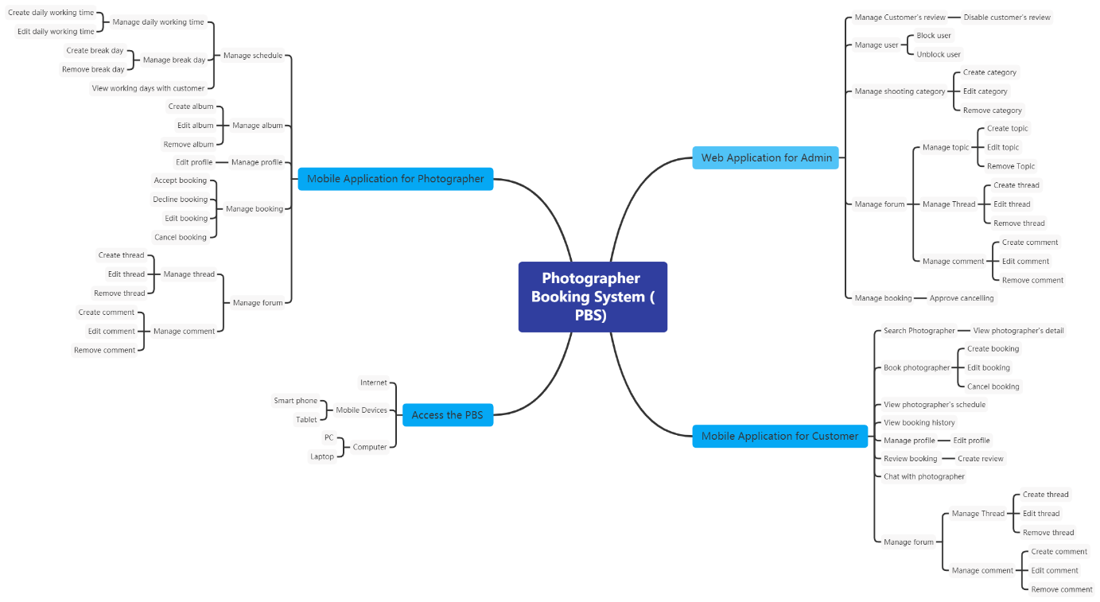

Figure 1 Feature Mind Map

### 6.2 Limitations & Exclusions

LI-01: The application has not supported payment.

LI-02: The system has not had a photo verification feature.

LI-03: The system has not provided a website version to both customers and photographers. Users may find it uncomfortable to use applications.

LI-04: The system only supports Vietnamese language.

# II. Project Management Plan

## 1. Overview

### 1.1 WBS & Estimation

|  |  |  |  |
| --- | --- | --- | --- |
| **#** | **WBS Item** | **Complexity** | **Est. Effort**  **(man-days)** |
| ***1*** | ***Initiating*** |  | ***5*** |
| 1.1 | Kick-off project   * Identify Project Goals & Vision * Get the Right Team Together * Define the Right Key Performance Indicators (KPIs) or Timeline * Project Tools & Methodologies * Project Kick-off Meeting Planning * Project Kick-off Meeting | Medium | 1 |
| 1.2 | Develop business case   * Confirm the opportunity * Analyse and develop shortlisted options * Evaluate the options * Implementation strategy * Recommendation | Medium | 2 |
| 1.3 | Assign Project Manager | Simple | 1 |
| 1.4 | Identify stake-holder   * Identifying * Analysing  1. Stakeholder Type 2. Contribution (value) 3. Legitimacy 4. Willingness to engage 5. Influence 6. Involvement  * Mapping | Medium | 1 |
| ***2*** | ***Planning*** |  | ***14*** |
| 2.1 | Create business plan   * Executive summary * Opportunity * Execution * Company and management summary * Financial plan * Appendix | Medium | 2 |
| 2.2 | Collect requirement | Complex | 7 |
| 2.3 | Define scope   * Identify the project needs * Confirm the objectives and goals of the Project * Project Scope description * Expectations and acceptance * Identify constraints * Identify necessary changes | Medium | 1 |
| 2.4 | Define vision   * Define outcome * Define what unique brings to the above outcome * Apply Add relatable, human, aspects | Medium | 1 |
| 2.5 | Create WBS   * Identify the most important pieces of scope * Break down the project * Identify the known attributes for each activity | Medium | 1 |
| 2.6 | Create Risk Management Plan   * Identify the Risk * Analyse the Risk * Evaluate or Rank the Risk * Treat the Risk * Monitor and Review the Risk | Medium | 1 |
| 2.7 | Create Human Resource Plan   * Analyse the objectives * Make an inventory of current human resources * Forecast your HR demand * Determine the number and extent of skills gaps * Draw up an action plan * Integrate and implement the plan * Monitoring, measurement, and feedback | Simple | 1 |
| ***3*** | ***Executing*** |  | ***22*** |
| **3.1** | **Analysis** |  |  |
| 3.1.1 | Analyse Requirements   * Identify customer's needs. * Evaluate system for feasibility. * Perform economic and technical analysis. * Allocate functions to system elements. * Establish schedule and constraints. * Create system definitions. | Medium | 2 |
| 3.1.2 | Create Use case diagram   * Identify the Actors * For each category of users, identify all roles played by the users relevant to the system * Identify what are the users required the system to be performed to achieve these goals * Create use cases for every goal * Structure the use cases | Medium | 1 |
| 3.1.3 | Create Use case specification   * Create a use case model showing the use cases and actors * Create an overview of the steps (content) of the use case * Write the use case specification | Complex | 1 |
| 3.1.4 | Create SRS   * Create an Outline * Start with a Purpose * Give an Overview * Detail Specific Requirements * Get Approval for the SRS | Medium | 2 |
| **3.2** | **Design** |  |  |
| 3.2.1 | Design System Architecture   * Analyse the requirements * Define use cases for the system * Identify processor/modules to implement the use cases * Select operating system and hardware platform * Define sequence diagrams | Medium | 2 |
| 3.2.2 | Design System Detail (Diagrams) | Medium | 3 |
| 3.2.3 | Design Database   * Determine the purpose * Find and organize the information required * Divide the information into tables * Turn information items into columns * Specify primary keys * Set up the table relationships * Refine your design * Apply the normalization rules | Medium | 3 |
| 3.2.4 | Design User Interface   * Briefing * Analytics * Wireframing * UX prototype * UI creation | Complex | 3 |
| **3.3** | **Prototype** |  |  |
| 3.3.1 | Define storyboard | Medium | 1 |
| 3.3.2 | Create paper prototype | Simple | 1 |
| 3.3.3 | Create digital prototype | Complex | 3 |
| **3.4** | **Implementation** |  |  |
| 3.4.1 | Coding/ implement every module defined in SRS | ***Medium*** | ***30*** |
| **3.5** | **Perform quality assurance** |  | ***7*** |
| 3.5.1 | Perform unit testing | Simple | 1 |
| 3.5.2 | Perform integration testing | Medium | 2 |
| 3.5.3 | Perform system testing | Medium | 2 |
| 3.5.4 | Perform acceptance testing | Medium | 2 |
| **3.6** | **Support** |  | ***7*** |
| 3.6.1 | Training | Medium | 2 |
| 3.6.2 | Documentation | Medium | 2 |
| 3.6.3 | User Support | Simple | 1 |
| 3.6.4 | Enhancement | Medium | 2 |
| ***4*** | ***Monitoring*** |  | ***3*** |
| 4.1 | Validate Scope | Medium | 2 |
| 4.2 | Monitor project work | Medium | 1 |
| ***5*** | ***Controlling*** |  | ***5*** |
| 5.1 | Control scope | *Medium* | *1* |
| 5.2 | Control quality | *Medium* | *1* |
| 5.3 | Control risks | *Medium* | *1* |
| 5.4 | Control schedule | *Medium* | *1* |
| 5.5 | Control communication | *Simple* | *1* |
| ***6*** | ***Closing*** |  | ***1*** |
| 6.1 | Close project | Simple | 1 |
|  | | | FINAL PRESENTATION |
| ***Total Estimated Effort (man-days)*** | | | ***94*** |

Table WBS & Estimation

### 1.2 Project Objectives

|  |  |  |  |  |
| --- | --- | --- | --- | --- |
| **#** | **Quality Stage** | **No. of Defects** | **% of Defect** | **Notes** |
| 1 | Initiating | 2 | 8.7 | Must be completed in the first stage. |
| 2 | Planning | 4 | 17.4 | Plan to complete at least 80% of the project, and time distribution. |
| 3 | Analysis | 4 | 17.4 | Detailed project analysis. |
| 4 | Design | 2 | 8.8 | Design diagram and database. |
| 5 | Prototype | 4 | 17.4 | Make a prototype of a project. |
| 6 | Implementation | 1 | 4.3 | Implementation of the plans. |
| 7 | Perform quality assurance | 2 | 8.8 | Write test cases to check the quality of the project. |
| 8 | Support | 1 | 4.3 | Discuss unclear issues with the instructor. |
| 9 | Monitoring | 1 | 4.3 | Monitoring the steps taken. |
| 10 | Controlling | 1 | 4.3 | Track the progress of the project. |
| 11 | Closing | 1 | 4.3 | Review code and document. |
| ***Total*** | | ***23*** | ***100%*** |  |

Table Project objectives

### 1.3 Project Risks

|  |  |  |  |  |
| --- | --- | --- | --- | --- |
| **#** | **Risk Description** | **Impact** | **Possibility** | **Response Plans** |
| 1 | Most members find it unfamiliar to use flutter or spring framework | High | 30% | Hold training sessions to get familiar with them. |
| 2 | Scrum model is applied for the first time hence there may be difficulties in system development | High | 30% | Hold daily meetings to avoid misunderstandings among members. |
| 3 | Wrong estimation of time needed | Medium | 10% | Regularly track progress and update time estimation. |
| 4 | Unexpected scope change | High | 10% | Be careful in planning to minimize impact of scope change. |
| 5 | Poor code quality | Medium | 20% | Strictly follow code convention, carry out acceptance tests to ensure quality source code. |

Table Project risks

## 2. Management Approach

Scrum model would be implemented in the development of this project because it is appropriate for the process.

### 2.1 Project Process

We choose Scrum model to do this project because of the following reasons:

* The feature can be changed during the developing process to be suitable with the Scrum model we can adapt to change it easily and help reduce risk.
* Scrum allows us to learn new frameworks or technology and develop projects at the same time.
* Because dividing the project allows the team to check partial inspection, identify and fix problems faster.

*Reference:* [*https://www.scrum.org/resources/what-is-scrum*](https://www.scrum.org/resources/what-is-scrum)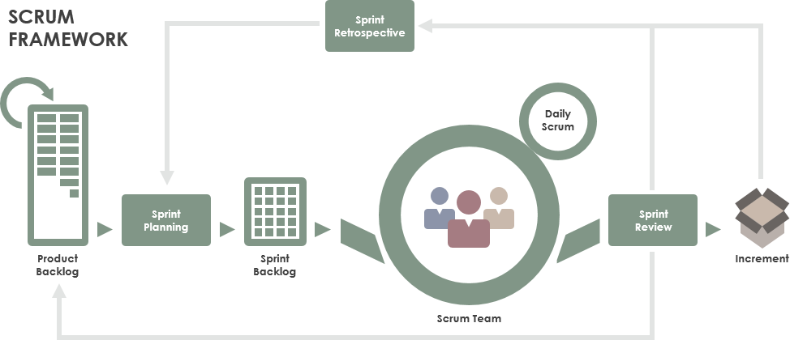

Figure 2 Project process

*Figure SEQ Figure \* ARABIC 1 Project process*

### 2.2 Quality Management

To increase the pace of the project, the team take following measures:

* Observe similar available applications.
* Discuss all requirements together to achieve the best quality.
* Hold daily meetings so that all members are acknowledged of the progress and others’ ability.

### 2.3 Training Plan

|  |  |  |  |
| --- | --- | --- | --- |
| **Training Area** | **Participants** | **When, Duration** | **Waiver Criteria** |
| Java Spring Boot | All team members | 3 days | Mandatory |
| Dart, Flutter | All team members | 4 days | Mandatory |
| StarUML | All team members | 3 days | Mandatory |
| MySQL | All team members | 3 days | Mandatory |
| Git, Github | All team members | 1 day | Mandatory |

Table Training plan

## 3. Master Schedule

|  |  |  |  |
| --- | --- | --- | --- |
| **#** | **Deliverable** | **Due Date** | **Deliverable Scope** |
| 1 | Project Plan | 17/09/2020 | Make a goal plan, list tasks to do, time distribution |
| 2 | Use case diagram | 24/09/2020 | Design use case diagram |
| 3 | Conceptual diagram | 24/09/2020 | Design conceptual diagram |
| 4 | ER diagram | 29/09/2020 | Design ER diagram |
| 5 | Database | 29/09/2020 | Design database |
| 6 | Design | 08/10/2020 | Architecture Design, Detailed Design |
| 7 | Screen prototype | 13/10/2020 | Design screen of application |
| 8 | Report 1 | 20/01/2021 | Project introduction |
| 9 | Report 2 | 20/01/2021 | Project management plan |
| 10 | Report 3 | 20/01/2021 | Software requirement specification |
| 11 | Report 4 | 20/01/2021 | Software design document |
| 12 | Report 5 | 20/01/2021 | Test case document, test documentation |
| 13 | Report 6 | 20/01/2021 | Software user guides |
| 14 | Report 7 | 20/01/2021 | Final project report |
| 15 | Code package 1 | 27/01/2021 | Code & Unit test, System test cases |
| 16 | Code package 2 | 27/01/2021 | Code & Unit test, System test cases |
| 17 | Code package 3 | 27/01/2021 | Code & Unit test, System test cases |
| 18 | Code front-end 1 | 27/01/2021 | Code & design screen |
| 19 | Code front-end 2 | 27/01/2021 | Code & design screen |
| 20 | Code front-end 3 | 27/01/2021 | Code & design screen |
| 21 | Final Package | 27/01/2021 | Final Codes & documents, User manual |

Table Master schedule

## 4. Project Organization

### 4.1 Team & Structures

Figure 3 Project organization

*Figure SEQ Figure \* ARABIC 2 Project organization*

### 4.2 Roles & Responsibilities

|  |  |
| --- | --- |
| **Role** | **Responsibility** |
| Project Manager | Give guidance, check, and help correct mistakes in the project. |
| Analysis Leader | Give guidance and adjust projects’ requirements. |
| Analysis Member | Analyse and update projects’ requirements. |
| Design Leader | Give guidance, design and implement user interface. |
| Design Member | Design and implement user interface. |
| Technical Leader | Introduce new techniques to the team. |
| Test Leader | Write test cases and test plan for the project. |
| Test Member | Write test cases and test plan for the project. |

Table Roles & responsibilities

## 5. Project Communication

### 5.1 Communication Plan

|  |  |  |  |  |
| --- | --- | --- | --- | --- |
| **Communication Item** | **Who/ Target** | **Purpose** | **When, Frequency** | **Type, Tool, Method(s)** |
| Kick off meeting | Project supervisor, project team | Introduce the project | Once | Meeting |
| Project status report | Project supervisor, Project team | Discuss project status, resolve potential issues or delays | Weekly | Meeting |
| Daily stand up meeting | Project team | Review each member's work status or any happening problems | Daily | Meeting |
| Meeting minute reports | Project supervisor | Inform supervisor about meeting content | Weekly | Email |

Table Communication Plan

### 5.2 External Interface

#### a. FU Contacts

|  |  |  |  |
| --- | --- | --- | --- |
| **Function** | **Contact Person**  **(name, position)** | **Contact address**  **(email, telephone)** | **Responsibility** |
| Supervisor | Lại Đức Hùng | Hungld5@fe.edu.vn | - Provide document template - Give instruction to the project team - Review deliverables - Supervise project status  - Answer questions about the project |

Table FU Contacts

#### b. Customer Contacts

|  |  |  |  |
| --- | --- | --- | --- |
| **Function** | **Contact Person**  **(name, position)** | **Contact address**  **(email, telephone)** | **Responsibility** |
| Supervisor | Lại Đức Hùng | Hungld5@fe.edu.vn | - Provide document template - Give instruction to the project team - Review deliverables - Supervise project status  - Answer questions about the project |

Table Customer Contacts

## 6. Configuration Management

### 6.1 Tools & Infrastructures

|  |  |
| --- | --- |
| **Programming languages** | Java, Dart |
| **Framework** | Spring framework, Flutter |
| **API** | Google Map API, ClimaCell API |
| **DBMS** | MySQL |
| **IDEs/Editors** | Visual Studio Code, Android Studio, IntelliJ |
| **UML tools** | StarUML, Draw.io |
| **Version Control** | Github, Git |
| **Deployment server** | Hostinger VPS |
| **Project management tool** | Microsoft Excel |

Table Tools & Infrastructures

### 6.2 Document Management

*https://github.com/thienthao/pbs/tree/master/Documents*

*https://drive.google.com/drive/folders/1A--J0H-8uMiggtnQg93W7fExSaF_4xsl*

### 6.3 Source Code Management

*https://github.com/thienthao/pbs*

# III. Software Requirement Specification

## 1. Overall Description

### 1.1 Product Overview

Photographer Booking System is a new system that helps users find photographers effectively based on their needs. The context diagram below describes the 1.0 version of the system and external entities that interact with it.

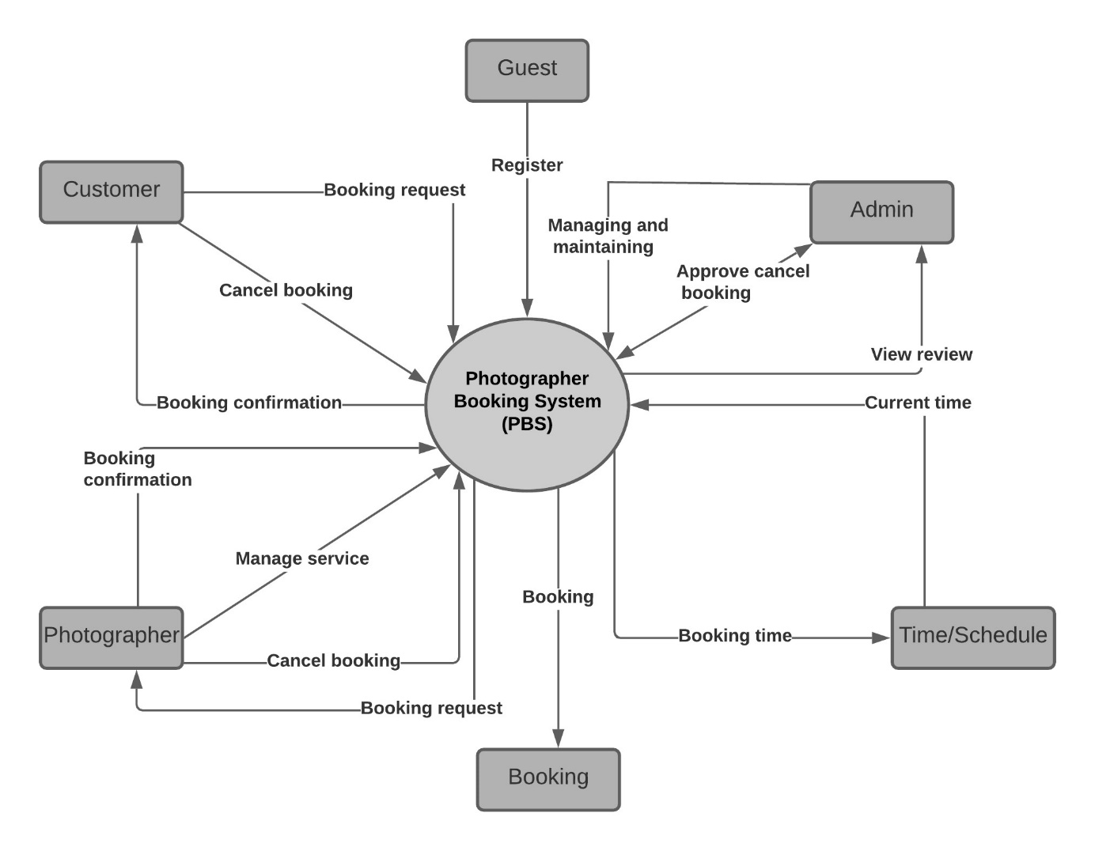

Figure 4 Context Diagram

### 1.2 Business Rules

*Figure SEQ Figure \* ARABIC 1 Context Diagram*

|  |  |
| --- | --- |
| **ID** | **Rule Definition** |
|  |  |

Table Business Rules

## 2. User Requirements

### 2.1 Overview

#### a. Use Case Diagram

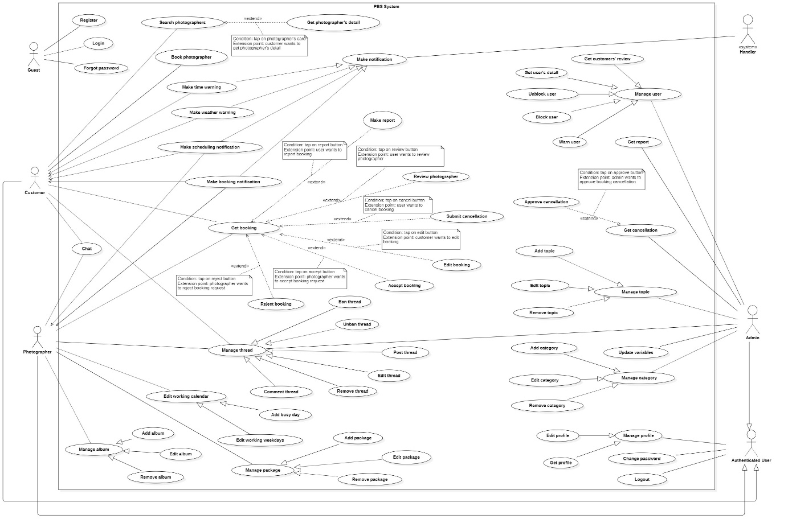

Figure Overview Use Case Diagram

#### b. System Actors

|  |  |  |
| --- | --- | --- |
| **No** | **Actor** | **Description** |
| 1 | Admin | Admin manages the whole system. Admin can view, add, update or remove information related to the system. |
| 2 | Photographer | Photographers offer shooting services and handle customers’ requests |
| 3 | Customer | Customers make bookings to use photographers’ services |
| 4 | Guest | Guests are the ones without accounts |
| 5 | Authenticated User | Authenticated Users are the those who have authenticated accounts (admins, photographers, customers) |
| 6 | <<system>> Handler | <<system>> Handler deals with internal processes. |

Table System Actors

#### c. Use Cases List

|  |  |  |  |
| --- | --- | --- | --- |
| **No** | **Use Case** | **Primary Actors** | **Secondary Actors** |
| 01 | Register | Guest |  |
| 02 | Login | Guest |  |
| 03 | Forgot password | Guest |  |
| 04 | Search photographers | Customer |  |
| 05 | Get photographer’s detail | Customer |  |
| 06 | Book photographer | Customer |  |
| 07 | Get booking | Customer, Photographer |  |
| 08 | Make report | Customer, Photographer |  |
| 09 | Review photographer | Customer |  |
| 10 | Submit cancellation | Customer, Photographer |  |
| 11 | Edit booking | Customer |  |
| 12 | Accept booking | Photographer |  |
| 13 | Reject booking | Photographer |  |
| 14 | Chat | Customer, Photographer |  |
| 15 | Post thread | Customer, Photographer |  |
| 16 | Edit thread | Customer, Photographer |  |
| 17 | Comment thread | Customer, Photographer |  |
| 18 | Remove thread | Customer, Photographer |  |
| 19 | Ban thread | Admin |  |
| 20 | Unban thread | Admin |  |
| 21 | Add busy day | Photographer |  |
| 22 | Edit working weekdays | Photographer |  |
| 23 | Add package | Photographer |  |
| 24 | Edit package | Photographer |  |
| 25 | Remove package | Photographer |  |
| 26 | Add album | Photographer |  |
| 27 | Edit album | Photographer |  |
| 28 | Remove album | Photographer |  |
| 29 | Get profile | Authenticated User |  |
| 30 | Edit profile | Authenticated User |  |
| 31 | Change password | Authenticated User |  |
| 32 | Logout | Authenticated User |  |
| 33 | Update variables | Admin |  |
| 34 | Block user | Admin |  |
| 35 | Unblock user | Admin |  |
| 36 | Warn user | Admin |  |
| 37 | Get user’s detail | Admin |  |
| 38 | Get customers’ review | Admin |  |
| 39 | Get report | Admin |  |
| 40 | Get cancellation | Admin |  |
| 41 | Approve cancellation | Admin |  |
| 42 | Add category | Admin |  |
| 43 | Edit category | Admin |  |
| 44 | Remove category | Admin |  |
| 45 | Add topic | Admin |  |
| 46 | Edit topic | Admin |  |
| 47 | Remove topic | Admin |  |
| 48 | Make booking notification | System Handler |  |
| 49 | Make scheduling notification | System Handler |  |
| 50 | Make weather warning | System Handler |  |
| 51 | Make time warning | System Handler |  |

Table Use Case List

### 2.2 List of use case

#### 2.2.1 <Guest> Overview use case

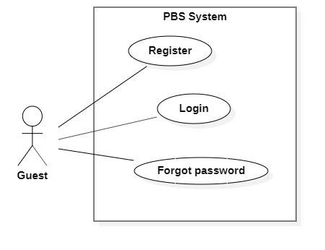

Figure 6 <Guest> Overview

##### a. <Guest> Register

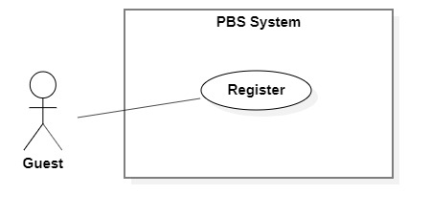

Figure 7 <Guest> Register

|  |  |  |  |  |  |
| --- | --- | --- | --- | --- | --- |
| UC ID and Name: | **UC – 01 Register** | | | | |
| Created By: | Trần Thiên Thảo | | Date Created: | 08/10/2020 | |
| Primary Actor: | Guest | | Secondary Actors: |  | |
| Trigger: | The Guest sends a request to register an account. | | | | |
| Description: | This use case allows Guest to register an account in the system. | | | | |
| Preconditions: | User is not logged in. | | | | |
| Post-conditions: | **Success:** Guest successfully registered an account.  **Fail:** System shows error message. | | | | |
| Normal Flow: | **Step** | **Actor Action** | | | **System Response** |
| 1 | Guest goes to register view | | | System requires information from Guest:  - “Họ & tên”: text input, required.  - “Tên đăng nhập”: text input, required  - “Mật khẩu”: password input, required.  - “Xác nhận mật khẩu”: password input, required.  - “Số điện thoại”: phone number input.  - “Email”: text input, required. |
| 2 | Guest inputs required information | | |  |
| 3 | Guest send request to register in the system | | | The system validates data, outputs message “Đăng ký thành công”  [Exception 1]  [Exception 2]  [Exception 3]  [Exception 4] |
| Alternative Flows: | N/A | | | | |
| Exceptions: | **No** | **Cause** | | | **System Response** |
| 1 | Required fields are empty. | | | System shows error message:  “Thông tin này là bắt buộc” |
| 2 | Password and confirm password are not matched. | | | System shows error message:  “Mật khẩu không khớp”. |
| 3 | Required fields are not valid. | | | System shows error message corresponds to the field:  Username:  “Tên đăng nhập phải từ 8 - 20 kí tự.”  “Không thể có kí tự "_" hoặc "." ở đầu hoặc cuối.”  Email:  “Email phải theo định dạng. Ví dụ: pbs@fpt.edu.vn”  Password:  “Tối thiểu 8 kí tự, 1 chữ cái, 1 số và 1 kí tự đặc biệt.” |
| 4 | Required information exists in the system (username, email). | | | System shows error message corresponds to the field:  “Tên đăng nhập đã có người sử dụng. Vui lòng nhập tên khác.”  “Email đã tồn tại.” |
| Priority: | Medium | | | | |
| Frequency of Use: | Usually | | | | |
| Business Rules: | * Needed information are: username, password, phone number, email, full name. * Username format should be 8-20 characters long, starts with character, underscore or dot can’t be at the end or beginning. Username must not contain special characters. * Password format should be a minimum eight characters, contains at least one number, one letter and one special character. * Password must be encrypted. * Fullname must not contains number, dot, underscore, special characters (except Vietnamese name’s characters). * Email should be in email format. * Phone should be in Vietnamese format. * All information must not be empty when submit. * After registering successfully, navigate back to login view. User account will have status unenable. User will receive verification token through their email, after user clicks on the link the account will be enabled. | | | | |
| Other Information: | N/A | | | | |
| Assumptions: | N/A | | | | |

Table <Guest> Register Specification

##### b. <Guest> Login

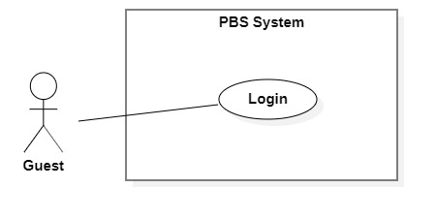

Figure 8 <Guest> Login

|  |  |  |  |  |  |
| --- | --- | --- | --- | --- | --- |
| UC ID and Name: | **UC – 02 Login** | | | | |
| Created By: | Trần Thiên Thảo | | Date Created: | 08/10/2020 | |
| Primary Actor: | Guest | | Secondary Actors: |  | |
| Trigger: | The Guest sends a request to login into the system. | | | | |
| Description: | This use case allows Guest to login into the system. | | | | |
| Preconditions: | User is not logged in. | | | | |
| Post-conditions: | **Success**: Guest successfully logged into the system.  **Fail:** System shows error message. | | | | |
| Normal Flow: | **Step** | **Actor Action** | | | **System Response** |
| 1 | Guest goes to login view | | | System requires information from Guest:  - “Tên đăng nhập”: text input, required  - “Mật khẩu”: password input, required |
| 2 | Guest inputs required information | | |  |
| 3 | Guest sends request to login into the system | | | System validates data, outputs message “Đăng nhập thành công”  [Exception 1]  [Exception 2] |
| Alternative Flows: | N/A | | | | |
| Exceptions: | **No** | **Cause** | | | **System Response** |
| 1 | Required fields are empty | | | System shows error message: “Thông tin này là bắt buộc” |
| 2 | Username or password is incorrect | | | System shows error message: “Thông tin đăng nhập không chính xác” |
| Priority: | Medium | | | | |
| Frequency of Use: | Usually | | | | |
| Business Rules: | * User login using username and password. * Username and password format match with the one they have registered. * Encrypt inputted password and compare to password in database. * New Json web token will be returned to client side. * New user session will be created. * After login successfully, navigate user to Home view. | | | | |
| Other Information: | N/A | | | | |
| Assumptions: | N/A | | | | |

Table <Guest> Register Specification

##### c. <Guest> Forgot password

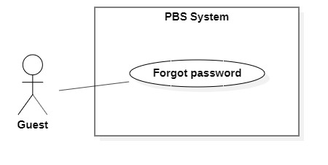

Figure <Guest> Forgot password

|  |  |  |  |  |  |
| --- | --- | --- | --- | --- | --- |
| UC ID and Name: | **UC – 03 Forgot Password** | | | | |
| Created By: | Trương Ngọc Mĩ | | Date Created: | 08/10/2020 | |
| Primary Actor: | Authenticated User | | Secondary Actors: |  | |
| Trigger: | User wants to recover password. | | | | |
| Description: | This use case allows User to recover password. | | | | |
| Preconditions: | User has account in the system. | | | | |
| Post-conditions: | **Success:** User has new password.  **Fail:** System shows error message. | | | | |
| Normal Flow: | **Step** | **Actor Action** | | | **System Response** |
| 1 | User clicks “Forget password” button. | | | System shows “Forget password” detail with following information:  - “Email*”: text  - “Xác nhận”: button |
| 2 | User inputs required information and send password recovery request. | | | System validates information, send password recovery request to the system and outputs message “Gửi yêu cầu thành công. Yêu cầu của sẽ được xử lý và phản hồi thông qua email này”.  [Exception 1]  [Exception 2] |
| Exceptions: | **No** | **Cause** | | | **System Response** |
| 1 | Required fields are empty. | | | System shows error message:  “Thông tin này là bắt buộc” |
| 2 | The process runs into an internal error. | | | System shows error message: “Đã có lỗi xảy ra”. |
| Priority: | Medium | | | | |
| Frequency of Use: | Sometimes | | | | |
| Business Rules: | * Email is required to send a password recovery request. * After sent a request system will verify the email. If it is valid system will send a mail that including new password to that email. * New password is generated following password business rules in register use case. | | | | |
| Other Information: | N/A | | | | |
| Assumptions: | N/A | | | | |

Table <Guest> Forgot password specification

#### 2.2.2 <Customer> Overview Use Case

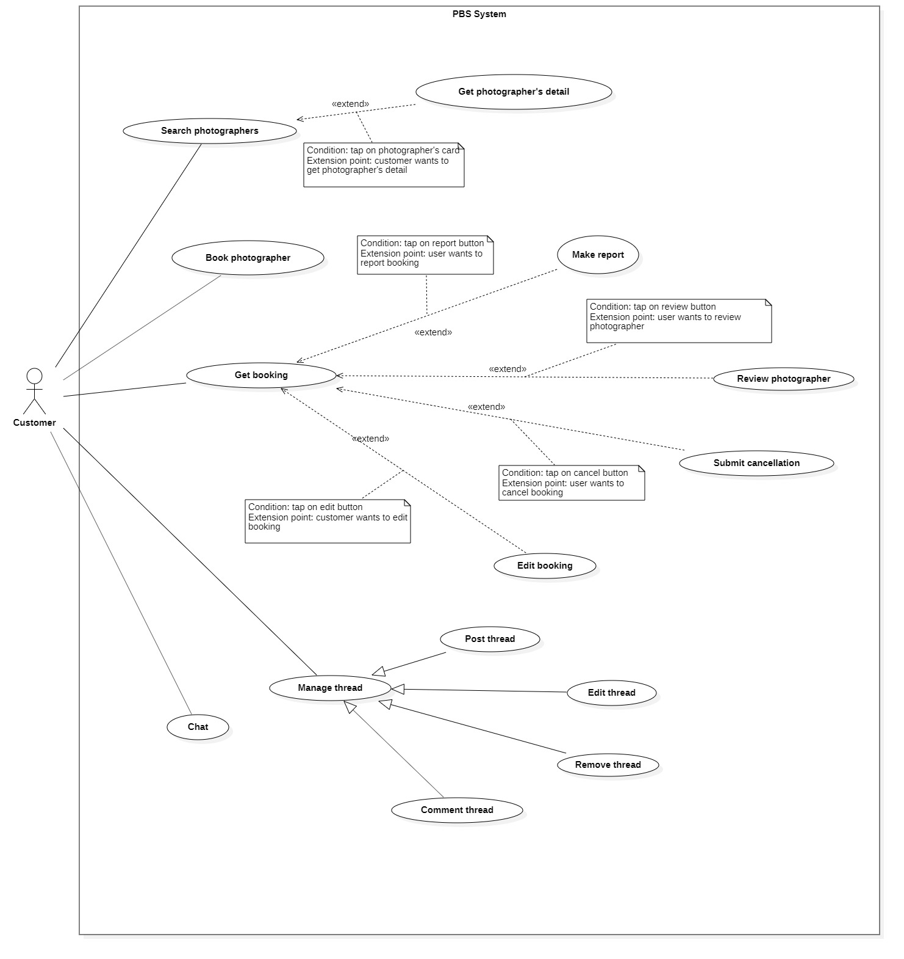

Figure 10 <Customer> Overview

##### <Customer> Search photographer

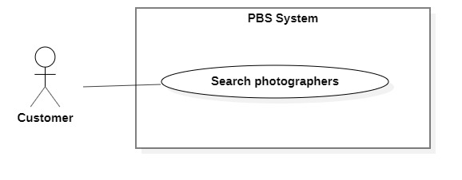

Figure 11 <Customer> Search photographers

|  |  |  |  |  |  |
| --- | --- | --- | --- | --- | --- |
| UC ID and Name: | **UC – 04 Search photographers** | | | | |
| Created By: | Trần Thiên Thảo | | Date Created: | 08/10/2020 | |
| Primary Actor: | Customer | | Secondary Actors: |  | |
| Trigger: | The customer sends a request to find photographers. | | | | |
| Description: | This use case allows customers to find photographers and also packages. | | | | |
| Preconditions: | User must be authenticated as Customer. | | | | |
| Post-conditions: | **Success**: A list of photographers is shown.  **Fail**: System shows error messages. | | | | |
| Normal Flow: | **Step** | **Actor Action** | | | **System Response** |
| 1 | Customer goes to photographers searching view. | | | System requires information from Guest:  - “Tìm kiếm”: text input. |
| 2 | Customer inputs information. | | |  |
| 3 | Customer sends request to search photographers. | | | System displays list of photographers and packages.  [Exception 1] |
| Alternative Flows: | N/A | | | | |
| Exceptions: | **No** | **Cause** | | | **System Response** |
| 1 | The process runs into an internal error. | | | System shows error message: “Đã có lỗi xảy ra”. |
| Priority: | Medium | | | | |
| Frequency of Use: | Sometimes | | | | |
| Business Rules: | * User inputs text in search field, system returns photographers’ name and packages’ name contains the text. * The list of photographers will be ordered by rating count. * List of photographers is shown with following information: name, avatar, rating count. * List of packages is shown with following information: name, price, photographer’s name. * If the list is empty, return empty text to customer. | | | | |
| Other Information: | N/A | | | | |
| Assumptions: | N/A | | | | |

Table <Customer> Search Photographers Specification

##### <Customer> Get photographer’s detail

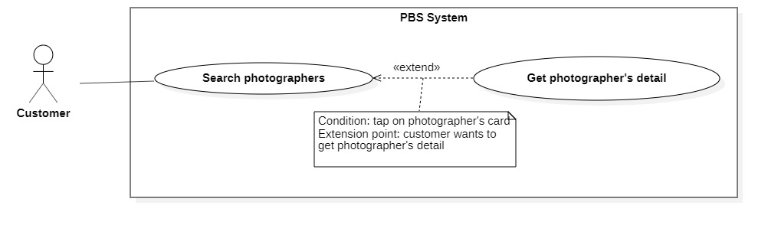

Figure 12 <Customer> Get photographer's detail

|  |  |  |  |  |  |
| --- | --- | --- | --- | --- | --- |
| UC ID and Name: | **UC – 05 Get photographer’s detail** | | | | |
| Created By: | Trần Thiên Thảo | | Date Created: | 08/10/2020 | |
| Primary Actor: | Customer | | Secondary Actors: |  | |
| Trigger: | The customer sends a request to get the photographer's details. | | | | |
| Description: | This use case allows customers to get photographer’s detail. | | | | |
| Preconditions: | User has been authenticated as a Customer. | | | | |
| Post-conditions: | **Success:** The system displays the photographer’s detail.  **Fail:** The system shows error message | | | | |
| Normal Flow: | **Step** | **Actor Action** | | | **System Response** |
| 1 | Customer sends request to get photographer’s detail. | | | System returns photographer’s detail  [Exception 1] |
| Alternative Flows: | N/A | | | | |
| Exceptions: | No | Cause | | | System Response |
| 1 | The process runs into an internal error. | | | System shows error message: “Đã có lỗi xảy ra” |
| Priority: | Medium | | | | |
| Frequency of Use: | Usually | | | | |
| Business Rules: | * The photographer’s detail return contains the following information: photographer’s basic information like rating count, self-description, customers’ reviews, photographer’s working calendar, photographer’s packages. * Photographer working calendar includes the date they have been booked and the date they are busy. * Photographer’s packages contain the following information: multi-days supported package or normal package, package’s name, package’s price, package’s description, package’s services, package’s time anticipation. * If any information is empty, return empty text. | | | | |
| Other Information: | N/A | | | | |
| Assumptions: | N/A | | | | |

Table <Customer> Get photographer's detail specification

##### <Customer> Book photographer

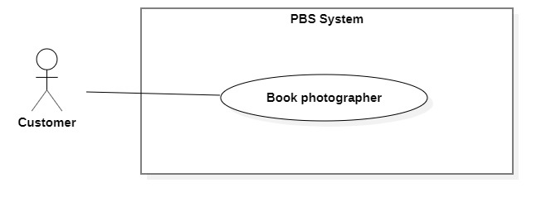

Figure 13 <Customer> Book photographer

|  |  |  |  |  |  |
| --- | --- | --- | --- | --- | --- |
| UC ID and Name: | **UC – 06 Book photographer** | | | | |
| Created By: | Trần Thiên Thảo | | Date Created: | 08/10/2020 | |
| Primary Actor: | Customer | | Secondary Actors: |  | |
| Trigger: | The customer sends a request to make a booking. | | | | |
| Description: | This use case allows customers to make a booking for photographers. | | | | |
| Preconditions: | - Users must login into the system with the role Customer.  - The photographer must exist in the system with status is not blocked and is not deleted. | | | | |
| Post-conditions: | **Success:** A booking will be stored with status is “Pending” **Fail:** System outputs error message and sends to Customer. | | | | |
| Normal Flow: | **Step** | **Actor Action** | | | **System Response** |
| 1 | The customer goes to booking view | | | System returns the available photographer’s detail.  System requires information from customers:  - “Thời gian chụp”: date time picker, required  - “Thời gian nhận ảnh”: date time picker, required  - “Địa điểm”: map picker, required  - “Giao trả”: dropdownlist, required,  - “Gói dịch vụ: drop down list, required  - “Tổng cộng”: text |
| 2 | The customer inputs required information and send request to create new booking | | | - The system validates data  - The system adds new booking to the system, outputs “Đặt hẹn thành công” and send to photographer.  [Exception 1]  [Exception 2] |
| Alternative Flows: | N/A | | | | |
| Exceptions: | **No** | **Cause** | | | **System Response** |
| 1 | The customer inputs invalid data or leaves empty required fields | | | System outputs error message and send request to ask Customer to input correctly |
| 2 | The process run into an internal error | | | Error will be recorded in a log file. System outputs error message to customer. |
| Priority: | Medium | | | | |
| Frequency of Use: | Usually | | | | |
| Business Rules: | - Booking will be managed by the system with following status: PENDING, ONGOING, EDITING, DONE, REJECTED, CANCELLING_PHOTOGRAPHER, CANCELLED_PHOTOGRAPHER, CANCELLING_CUSTOMER, CANCELLED_CUSTOMER, CANCELLED_ADMIN.  - If photographer already have a booking in a time span, customer can’t book photographer in that time span.  - Booking information contains: package’s details, time and location details, editing deadline, photographer’s detail, customer’s detail, returning type.  - Package’s detail contains: package’s name, package’s description, package’s price, package’s services.  - Time and location detail contain: shooting date and time, shooting location.  - All information must not be empty.  - Shooting time and edit deadline must not be in the past. Editing deadline must be after shooting time at least 1 day.  - After booking successfully, a new booking will have PENDING status.  - If booking is failed, return fail message.  - After 24 hours, if photographer doesn’t accept or reject pending booking, status will become REJECTED  - Customers can directly cancel pending bookings. | | | | |
| Other Information: | N/A | | | | |
| Assumptions: | N/A | | | | |

Table <Customer> Book photographer specification

##### <Customer> Get booking

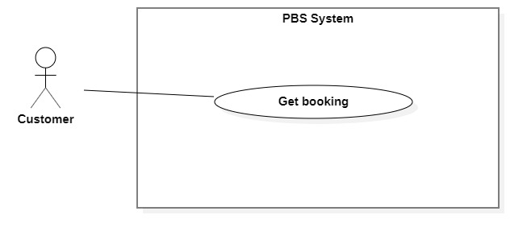

Figure 14 <Customer> Get bookings

|  |  |  |  |  |  |
| --- | --- | --- | --- | --- | --- |
| UC ID and Name: | **UC – 07 Get booking** | | | | |
| Created By: | Trần Thiên Thảo | | Date Created: | 08/10/2020 | |
| Primary Actor: | Customer, Photographer | | Secondary Actors: |  | |
| Trigger: | Customer or Photographer sends a request to get booking detail. | | | | |
| Description: | This use case allows customers or photographers to get their booking detail. | | | | |
| Preconditions: | User has been authenticated as Customer / Photographer | | | | |
| Post-conditions: | **Success:** System displays detail of a booking.  **Fail:** System shows error message. | | | | |
| Normal Flow: | Step | Actor Action | | | System Response |
| 1 | Customer / Photographer sends a request to get detail of a booking. | | | System returns booking detail with following information:  - “Trạng thái”: text  - “Thời gian chụp”: text  - “Thời gian nhận ảnh”: text  - “Thời gian tác nghiệp dự kiến”: text  - “Địa điểm”:   * “Địa chỉ”: text * “Latitude”: double * “Longitude”: double   - “Thông tin photographer”:   * “Tên photographer”: text * “Điểm đánh giá”: number * “Số điện thoại photographer”: number * Avatar: image   - “Thông tin khách hàng”:   * “Tên khách hàng”: text * “Số điện thoại photographer”: number   “Avatar: image  - “Thông tin gói dịch vụ”:   * “Tên gói”: text * “Mô tả”: text * “Tổng cộng”: text * “Bao gồm các dịch vụ”: list of texts   - “Phương thức trả ảnh”: text  [Exception 1] |
| Alternative Flows: | N/A | | | | |
| Exceptions: | No | Cause | | | System Response |
| 1 | System run into internal error | | | System shows error message: “Đã có lỗi xảy ra” |
| Priority: | Medium | | | | |
| Frequency of Use: | Usually | | | | |
| Business Rules: | - The booking detail is displayed with following information: booking status, service’s time anticipation, edit deadline, time and location detail, photographer’s detail, package’s detail, returning type, rating and comment, qrcode scanner, cancelled reason, rejected reason.  - Booking has following status:   * PENDING * ONGOING * EDITING * DONE * REJECTED * CANCELLING_CUSTOMER * CANCELLING_PHOTOGRAPHER * CANCELLED_CUSTOMER * CANCELLED_PHOTOGRAPHER * CANCELLED_ADMIN   - Time and location details have the following information: shooting location, shooting date, shooting time.  - Customer’s information: customer’s avatar, customer’s name, customer’s phone.  - Photographer’s information: photographer’s avatar, photographer’s name, photographer’s rating count photographer’s phone,  - Rating’s information: customer’s avatar, customer’s rating, createdDate, comment. Only display rating section if booking’s status is DONE.  - Package has following information: package’s name, package’s description, package’s price, package’s services.  - Only show qrcode scanner if booking status is ONGOING.  - Only show rejected reason if booking status is REJECTED.  - Only show cancelled reason if booking status is CANCELLING_CUSTOMER, CANCELLING_PHOTOGRAPHER, CANCELLED_CUSTOMER, CANCELLED_PHOTOGRAPHER, CANCELLED_ADMIN.  - Booking status will be changed with following actions:   * Photographer accepts: PENDING will become ONGOING. * Photographer rejects: PENDING will be come REJECTED. * Photographer sends request to change status from ONGOING to EDITING, condition is: all booking date have been checked in, in case photographer forgot to check in, they can send a confirmation request to customer, after customer confirms, status will be changed to EDITING. * Photographer sends request to change status from EDITING to DONE. * Photographer / Customer sends request to cancel booking: if booking status is PENDING, booking status will become CANCELLED_PHOTOGRAPHER / CANCELLED_CUSTOMER. If booking status is ONGOING / EDITING will become CANCELLING_PHOTOGRAPHER / CANCELLING_CUSTOMER. * Admin approves cancellation: CANCELLING_PHOTOGRAPHER / CANCELLING_CUSTOMER will become CANCELLED_PHOTOGRAPHER / CANCELLED_CUSTOMER. * In case admin blocks user or cancel booking after view user’s report: status will become CANCELLED_ADMIN. | | | | |
| Other Information: | N/A | | | | |
| Assumptions: | N/A | | | | |

Table <Customer> Get booking specification

##### <Customer> Edit booking

Figure 15 <Customer> Edit booking

*Figure SEQ Figure \* ARABIC 12 <Customer> Edit booking*

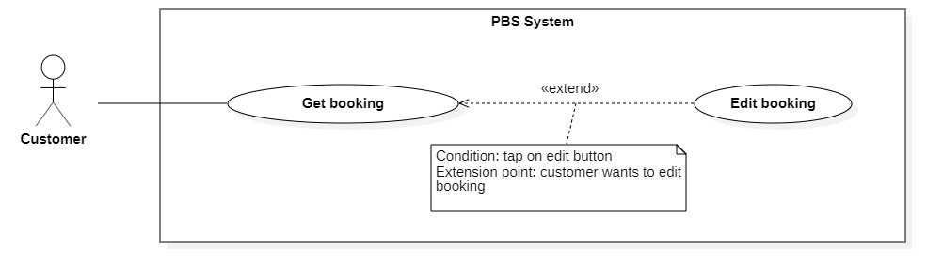

|  |  |  |  |  |  |
| --- | --- | --- | --- | --- | --- |
| UC ID and Name: | **UC – 11 Edit booking** | | | | |
| Created By: | Trần Thiên Thảo | | Date Created: | 08/10/2020 | |
| Primary Actor: | Customer | | Secondary Actors: |  | |
| Trigger: | The Customer sends a request to edit booking. | | | | |
| Description: | This use case allows customers to edit their booking. | | | | |
| Preconditions: | The User has been authenticated as Customer. | | | | |
| Post-conditions: | **Success:** Booking successfully edited and saved to the system.  **Fail:** System shows error message. | | | | |
| Normal Flow: | **Step** | **Actor Action** | | | **System Response** |
| 1 | Customer sends request to receive booking detail | | | System returns booking detail with following information:  - “Trạng thái”: text  - “Thời gian”: text  - “Thời gian chụp”: text  - “Thời gian nhận”: text  - “Giao trả”: dropdown list  - “Địa điểm”: map  - “Tên gói dịch vụ”:   * “Tên gói”: text * “Thời gian chụp: text * “Mô tả”: text * “Giá dịch vụ: text * “Dịch vụ”: list of texts   [Exception 1] |
|  | Customer tap “Cập nhật cuộc hẹn”.  [Alternative 1] | | | - The system validates data  - The system updates the existing booking to the system, outputs “Cập nhật thành công” and send to photographer.  [Exception 2]  [Exception 3] |
| Alternative Flows: | **Step** | **Actor Action** | | | **System Response** |
| 1 | Customer tap back arrow. | | | Back to booking detail view |
| Exceptions: | **No** | **Cause** | | | **System Response** |
| 1 | System can’t get the booking detail | | | System shows error message: “Không tìm thấy cuộc hẹn” |
| 2 | The customer inputs invalid data or leaves empty required fields | | | System outputs error message and send request to ask Customer to input correctly |
| 3 | The process runs into an internal error. | | | System outputs error message to customer. |
| Priority: | Medium | | | | |
| Frequency of Use: | Sometimes | | | | |
| Business Rules: | * Customer can only edit the booking if its status is PENDING. * Customer can edit information like shooting time, shooting location, editing deadline, package, returning type. * All information must not be empty. * Editing deadline must be after shooting time at least 1 day. Shooting time must not be in the past. * After edit, save editing time to the system. * After edit successfully, sends notification to the photographer. | | | | |
| Other Information: | N/A | | | | |
| Assumptions: | N/A | | | | |

Table <Customer> Edit booking specification

##### <Customer > Make report

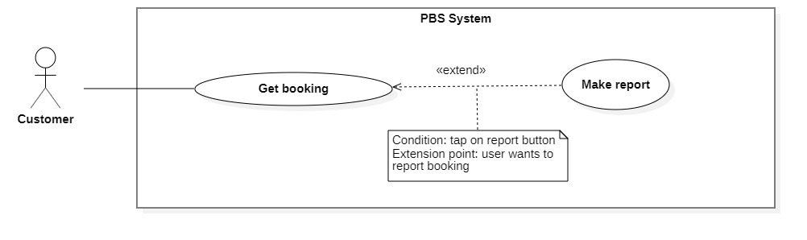

Figure - <Customer> Make report

|  |  |  |  |  |  |  |
| --- | --- | --- | --- | --- | --- | --- |
| UC ID and Name: | **UC – 08 Make report** | | | | | |
| Created By: | Trần Thiên Thảo | | | Date Created: | 01/01/2021 | |
| Primary Actor: | Customer, Photographer | | | Secondary Actors: |  | |
| Trigger: | Customer wants to report booking with Photographer and vice versa. | | | | | |
| Description: | This use case allows Customer and Photographer to report the booking. | | | | | |
| Preconditions: | The User has been authenticated as Customer / Photographer. | | | | | |
| Post-conditions: | **Success:** The customer report photographer via booking successfully.  **Fail:** System shows error message | | | | | |
| Normal Flow: | **Step** | | **Actor Action** | | | **System Response** |
| 1 | | Customer sends request to receive booking detail | | | System returns booking detail with following information:  - “Trạng thái”: text  - “Thời gian chụp”: text  - “Thời gian nhận ảnh”: text  - “Thời gian tác nghiệp dự kiến”: text  - “Địa điểm”:   * “Địa chỉ”: text * “Latitude”: double * “Longitude”: double   - “Thông tin photographer”:   * “Tên photographer”: text * “Điểm đánh giá”: number * “Số điện thoại photographer”: number * Avatar: image   - “Thông tin khách hàng”:   * “Tên khách hàng”: text * “Số điện thoại photographer”: number   “Avatar: image  - “Thông tin gói dịch vụ”:   * “Tên gói”: text * “Mô tả”: text * “Tổng cộng”: text * “Bao gồm các dịch vụ”: list of texts   - “Phương thức trả ảnh”: text  [Exception 1] |
| 2 | | Customer sends request to report photographer | | | System outputs:   * “Lý do”: radio button list * “Chi tiết”: text field |
| 3 | | Customer select an option, input reason and tap “Xác nhận”  [Alternative 1] | | | System outputs message: “Gửi báo cáo thành công”  [Exception 2] |
| Alternative Flows: | **Step** | **Actor Action** | | | | **System Response** |
| 1 | Customer confirm “Hủy” | | | | Back to booking detail view |
| Exceptions: | **No** | | **Cause** | | | **System Response** |
| 1 | | System can’t get the booking detail | | | System shows error message: “Không tìm thấy cuộc hẹn” |
| 2 | | The process run into an internal error | | | System shows error message: “Đã có lỗi xảy ra” |
| Priority: | Medium | | | | | |
| Frequency of Use: | Sometimes | | | | | |
| Business Rules: | * The report information contain: reporter information, booking’s information, report reason, reported time. * Send notification to customer / photographer after admin handle the report. | | | | | |
| Other Information: | N/A | | | | | |
| Assumptions: | N/A | | | | | |

Table <Admin> Make report specification

##### <Customer> Review photographers

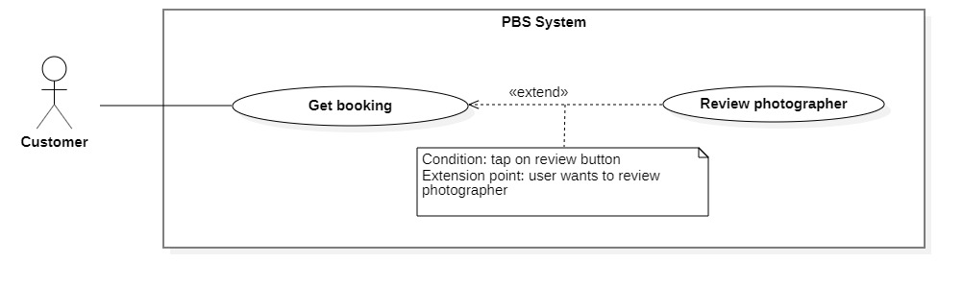

Figure 17 <Customer> Review photographers

|  |  |  |  |  |  |
| --- | --- | --- | --- | --- | --- |
| UC ID and Name: | **UC – 09 Review photographer** | | | | |
| Created By: | Trần Thiên Thảo | | Date Created: | 01/01/2021 | |
| Primary Actor: | Customer | | Secondary Actors: |  | |
| Trigger: | The customer sends a request to review photographer. | | | | |
| Description: | This use case allows customers to review photographer after booking is done. | | | | |
| Preconditions: | - User has been authenticated as Customer.  - Booking status is DONE. | | | | |
| Post-conditions: | **Success:** The review will be stored in the system and response message to Customer.  **Fail:** System shows error message. | | | | |
| Normal Flow: | **Step** | **Actor Action** | | | **System Response** |
| 1 | The customer goes to review view | | | System requires information from Customer:  - “Bình luận của bạn”: text field  - “Đánh giá dịch vụ”: slider, number format. |
| 2 | The customer inputs information and sends requests | | | System creates new review and outputs message: “Đã gửi bình luận”.  [Exception 1] |
| Alternative Flows: | N/A | | | | |
| Exceptions: | **No** | **Cause** | | | **System Response** |
| 1 | The process run into internal error | | | System outputs error message: “Đã có lỗi xảy ra” |
| Priority: | Medium | | | | |
| Frequency of Use: | Sometimes | | | | |
| Business Rules: | - The customer can only review if a booking state is DONE.  - The review contains of comment and rating.  - Rating is double value from 1 to 5. | | | | |
| Other Information: | N/A | | | | |
| Assumptions: | N/A | | | | |

Table <Customer> Review photographer specification

##### <Customer> Submit cancellation

Figure 18 <Customer> Submit cancellation

*Figure SEQ Figure \* ARABIC 13 <Customer> Cancel booking*

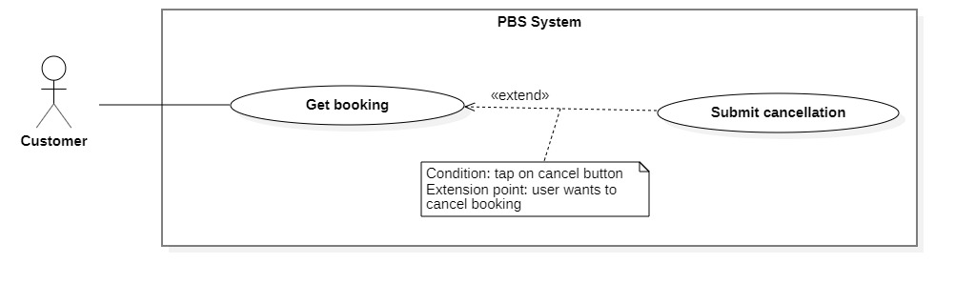

|  |  |  |  |  |  |
| --- | --- | --- | --- | --- | --- |
| UC ID and Name: | **UC – 10 Submit cancellation** | | | | |
| Created By: | Trần Thiên Thảo | | Date Created: | 01/01/2021 | |
| Primary Actor: | Customer, Photographer | | Secondary Actors: |  | |
| Trigger: | Customer or Photographer sends request to cancel booking. | | | | |
| Description: | This use case allows customers or photographers to cancel their booking. | | | | |
| Preconditions: | * The User has been authenticated as Customer / Photographer. * Booking status is ONGOING / EDITING. | | | | |
| Post-conditions: | **Success:** The cancellation request is submitted to the system for admin to handle.  **Fail:** System shows error message | | | | |
| Normal Flow: | **Step** | **Actor Action** | | | **System Response** |
| 1 | Customer sends request to receive booking detail | | | System returns booking detail with following information:  - “Trạng thái”: text  - “Thời gian chụp”: text  - “Thời gian nhận ảnh”: text  - “Thời gian tác nghiệp dự kiến”: text  - “Địa điểm”:   * “Địa chỉ”: text * “Latitude”: double * “Longitude”: double   - “Thông tin photographer”:   * “Tên photographer”: text * “Điểm đánh giá”: number * “Số điện thoại photographer”: number * Avatar: image   - “Thông tin khách hàng”:   * “Tên khách hàng”: text * “Số điện thoại photographer”: number   “Avatar: image  - “Thông tin gói dịch vụ”:   * “Tên gói”: text * “Mô tả”: text * “Tổng cộng”: text * “Bao gồm các dịch vụ”: list of texts   - “Phương thức trả ảnh”: text  [Exception 1] |
| 2 | Customer sends request to cancel booking | | | System outputs: “Bạn muốn hủy cuộc hẹn này?” with textfield to input cancelling reason. |
| 3 | Customer confirm “Có” and inputs cancelling reasons to cancel booking  [Alternative 1] | | | System outputs message: “Đã gửi yêu cầu hủy cuộc hẹn”  [Exception 2] |
| Alternative Flows: | **Step** | **Actor Action** | | | **System Response** |
| 1 | Customer confirm “Không” | | | Back to booking detail view |
| Exceptions: | **No** | **Cause** | | | **System Response** |
| 1 | System can’t get the booking detail | | | System shows error message: “Không tìm thấy cuộc hẹn” |
| 2 | The process run into an internal error | | | System shows error message: “Đã có lỗi xảy ra” |
| Priority: | Medium | | | | |
| Frequency of Use: | Sometimes | | | | |
| Business Rules: | * Customers or Photographers can cancel if status is ONGOING, EDITING. * When cancels, customer send the cancellation request to admin, update status to CANCELLING_CUSTOMER / CANCELLING_PHOTOGRAPHER and notify Photographer / Customer. * The cancellation request information includes: cancelling reason, cancelled user information, booking information, created date. | | | | |
| Other Information: | N/A | | | | |
| Assumptions: | N/A | | | | |

Table <Customer> Submit cancellation specification

##### <Customer> Post thread

Figure 19 <Customer> Post thread

*Figure SEQ Figure \* ARABIC 14 <Customer> Open thread*

|  |  |  |  |  |  |
| --- | --- | --- | --- | --- | --- |
| UC ID and Name: | **UC – 15 Post thread** | | | | |
| Created By: | Trương Ngọc Mỹ | | Date Created: | 11/11/2020 | |
| Primary Actor: | Customer, Photographer | | Secondary Actors: |  | |
| Trigger: | User sends a request to post new thread. | | | | |
| Description: | This use case allows users to post new thread on forum. | | | | |
| Preconditions: | The User has been authenticated. | | | | |
| Post-conditions: | **Success:** A new thread will be stored in the system.  **Fail:** System outputs error message. | | | | |
| Normal Flow: | **Step** | **Actor Action** | | | **System Response** |
| 1 | User goes to a new thread view. | | | Systems requires information from User:  - “Chủ đề”: text, required  - “Tên chủ đề”: text, required  - “Nội dung”: text, required |
| 2 | The User inputs required information and sends a request to open a new thread. | | | System validates information, add new thread to the system, outputs message “Đã đăng bài viết mới”  [Exception 1]  [Exception 2] |
| Alternative Flows: | N/A | | | | |
| Exceptions: | **No** | **Cause** | | | **System Response** |
| 1 | User inputs information incorrectly | | | System outputs error message corresponds to data fields:  “Tên chủ đề không thể để trống”  “Nội dung không thể để trống” |
| 2 | The process runs into an internal error. | | | System outputs error message: “Đã có lỗi xảy ra” |
| Priority: | Medium | | | | |
| Frequency of Use: | Sometimes | | | | |
| Business Rules: | * Needed information are: thread’s name, thread’s content, thread’s topic. * User inputs thread’s name and content as text. * Thread’s topic will be picked from topic option list. | | | | |
| Other Information: | N/A | | | | |
| Assumptions: | N/A | | | | |

Table <Customer> Post thread specification

##### <Customer> Edit thread

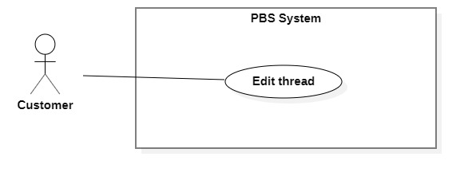

Figure 20 <Customer> Edit thread

|  |  |  |  |  |  |
| --- | --- | --- | --- | --- | --- |
| UC ID and Name: | **UC – 16 Edit thread** | | | | |
| Created By: | Trương Ngọc Mỹ | | Date Created: | 11/11/2020 | |
| Primary Actor: | Customer, Photographer | | Secondary Actors: |  | |
| Trigger: | User sends a request to edit thread. | | | | |
| Description: | This use case allows users to edit their thread. | | | | |
| Preconditions: | The User has been authenticated. | | | | |
| Post-conditions: | **Success:** Thread will be updated in the system with new content.  **Fail:** System shows error message. | | | | |
| Normal Flow: | **Step** | **Actor Action** | | | **System Response** |
| 1 | User sends request to receive thread detail. | | | System returns thread detail with following information:  - “Chủ đề”: text  - “Tên tiêu đề”: text, required  - “Nội dung”: text, required  System requires information from customer:  - “Chủ đề”: combo box, generated  - “Tên tiêu đề”: text, required  - “Nội dung”: text, required  [Exception 1] |
| 2 | User confirms “Có”  [Alternative 1] | | | System validates information, update thread to the system, outputs message “Đã cập nhật bài viết”  [Exception 2]  [Exception 3] |
| Alternative Flows: | **No** | **Actor Action** | | | **System Response** |
| 1 | User confirms “Không” | | | Back to thread detail view |
| Exceptions: | **Step** | **Cause** | | | **System Response** |
| 1 | System can’t get thread detail | | | System outputs “Không tìm được bài viết” |
| 2 | User inputs information incorrectly | | | System outputs error message corresponds to data fields:  “Tiêu đề không thể để trống”  “Nội dung không thể để trống” |
| 3 | The process runs into an internal error. | | | System outputs error message: “Đã có lỗi xảy ra” |
| Priority: | Medium | | | | |
| Frequency of Use: | Sometimes | | | | |
| Business Rules: | * User can edit thread no matter how long they have posted it. * User can edit thread’s name, thread’s content. * After edit successfully, save the datetime of editing. * User can’t change the topic of the thread. | | | | |
| Other Information: | N/A | | | | |
| Assumptions: | N/A | | | | |

Table <Customer> Edit thread specification

##### <Customer> Comment thread

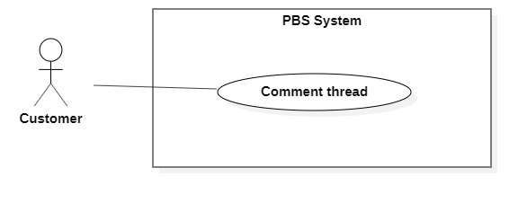

Figure 21 <Customer> Comment thread

|  |  |  |  |  |  |
| --- | --- | --- | --- | --- | --- |
| UC ID and Name: | **UC – 17 Comment thread** | | | | |
| Created By: | Trương Ngọc Mỹ | | Date Created: | 11/11/2020 | |
| Primary Actor: | Customer, Photographer | | Secondary Actors: |  | |
| Trigger: | The user sends a request to the comment on thread. | | | | |
| Description: | This use case allows the user to comment on thread. | | | | |
| Preconditions: | The User has been authenticated. | | | | |
| Post-conditions: | **Success:** A new comment will be stored in the system.  **Fail:** System shows error message. | | | | |
| Normal Flow: | **Step** | **Actor Action** | | | **System Response** |
| 1 | User sends request to receive thread detail. | | | System returns thread detail with following information:  - “Chủ đề”: text, required  - “Tên tiêu đề”: text, required  - “Nội dung”: text, required  [Exception 1] |
| 2 | User sends request to comment thread. | | | System requires information from user:  - “Bình luận của bạn”: text, required |
| 3 | User confirm “Có”  [Alternative 1] | | | System validates information, add new comment to the system, outputs message “Đã bình luận bài viết”  [Exception 2]  [Exception 3] |
| Alternative Flows: | **No** | **Actor Action** | | | **System Response** |
| 1 | User confirm “Không” | | | Back to thread detail view |
| Exceptions: | **No** | **Cause** | | | **System Response** |
| 1 | System can’t get thread detail | | | System outputs “Không tìm được bài viết” |
| 2 | User inputs information incorrectly | | | System outputs error message corresponds to data fields:  ““Bình luận của bạn không thể để trống” |
| 3 | The process runs into an internal error. | | | System outputs error message: “Đã có lỗi xảy ra” |
| Priority: | Medium | | | | |
| Frequency of Use: | Sometimes | | | | |
| Business Rules: | * User inputs comment as text. * Every user can see the comment. * Comment cannot be removed or updated | | | | |
| Other Information: | N/A | | | | |
| Assumptions: | N/A | | | | |

Table <Customer> Comment thread specification

##### <Customer> Remove thread

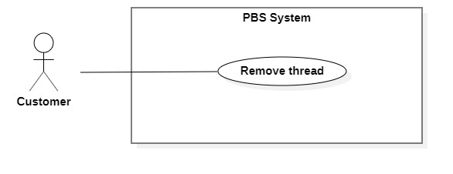

Figure <Customer> Remove thread

|  |  |  |  |  |  |
| --- | --- | --- | --- | --- | --- |
| UC ID and Name: | **UC – 18 Remove thread** | | | | |
| Created By: | Trương Ngọc Mỹ | | Date Created: | 11/11/2020 | |
| Primary Actor: | Customer, Photographer | | Secondary Actors: |  | |
| Trigger: | The user sends a request to the remove thread. | | | | |
| Description: | This use case allows the user to remove thread. | | | | |
| Preconditions: | The User has been authenticated. | | | | |
| Post-conditions: | **Success:** Thread will be removed on forum.  **Fail:** System shows error message. | | | | |
| Normal Flow: | **Step** | **Actor Action** | | | **System Response** |
| 1 | User sends request to receive thread detail. | | | System returns thread detail with following information:  - “Chủ đề”: text,  - “Tên tiêu đề”: text  - “Nội dung”: text  [Exception 1] |
| 2 | User sends request to remove thread. | | | System outputs “Xóa bài viết này?” |
| 3 | User confirm “Có”  [Alternative 1] | | | System remove thread to the system, outputs message “Đã xóa bài viết”  [Exception 2] |
| Alternative Flows: | **No** | **Actor Action** | | | **System Response** |
| 1 | User confirm “Không” | | | Back to thread detail view |
| Exceptions: | **No** | **Cause** | | | **System Response** |
| 1 | System can’t get thread detail | | | System outputs “Không tìm được bài viết” |
| 2 | The process runs into an internal error. | | | System outputs error message: “Đã có lỗi xảy ra” |
| Priority: | Medium | | | | |
| Frequency of Use: | Sometimes | | | | |
| Business Rules: | * Access thread via thread id. * Thread status will be changed to removed. | | | | |
| Other Information: | N/A | | | | |
| Assumptions: | N/A | | | | |

Table <Customer> Remove thread

##### <Customer> Chat

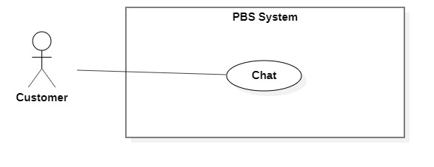

Figure 23 <Customer> Chat

|  |  |  |  |  |  |
| --- | --- | --- | --- | --- | --- |
| UC ID and Name: | **UC – 14 Chat** | | | | |
| Created By: | Trương Ngọc Mỹ | | Date Created: | 08/10/2020 | |
| Primary Actor: | Customer, Photographer | | Secondary Actors: |  | |
| Trigger: | Customer or Photographer sends a request to chat. | | | | |
| Description: | This use case allows the users to chat with each other. | | | | |
| Preconditions: | The User has been authenticated. | | | | |
| Post-conditions: | **Success:** User send message to another user successfully.  **Fail:** System shows error message. | | | | |
| Normal Flow: | **Step** | **Actor Action** | | | **System Response** |
| 1 | User goes to chat view. | | | System return result with following information:   * Photographer’s name / Customer’s name: text * Old messages: text   System receives chat input from customer.  [Exception 1] |
| 2 | User inputs messages and send request to chat with photographer. | | | System sends messages to photographer and output in chat view.  [Exception 2] |
| Alternative Flows: | N/A | | | | |
| Exceptions: | **No** | **Cause** | | | **System Response** |
| 1 | System can’t get chat view with another user. | | | System outputs “Không tìm được photographer/ Khách hàng” |
| 2 | The process runs into an internal error. | | | System outputs error message: “Đã có lỗi xảy ra” |
| Priority: | Medium | | | | |
| Frequency of Use: | Sometimes | | | | |
| Business Rules: | - Chat view contains following information: Full name of two people who joined, previous messages. | | | | |
| Other Information: | N/A | | | | |
| Assumptions: | N/A | | | | |

Table <Customer> Chat specification

#### 2.2.3 <Photographer> Overview Use Case

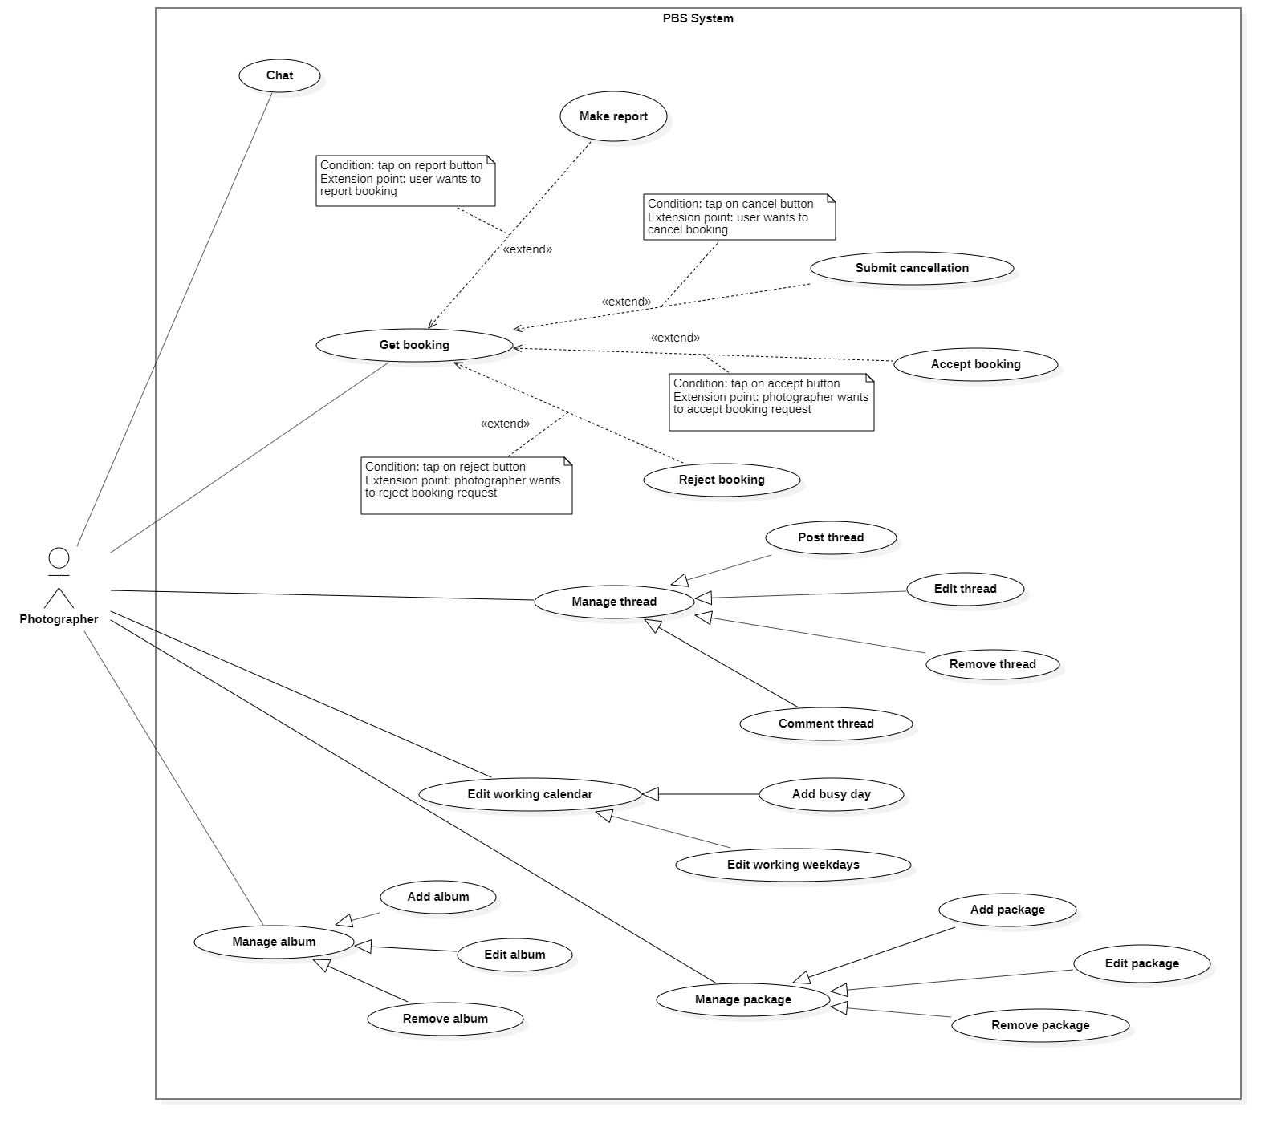

Figure 24 <Photographer> Overview

##### <Photographer> Accept booking

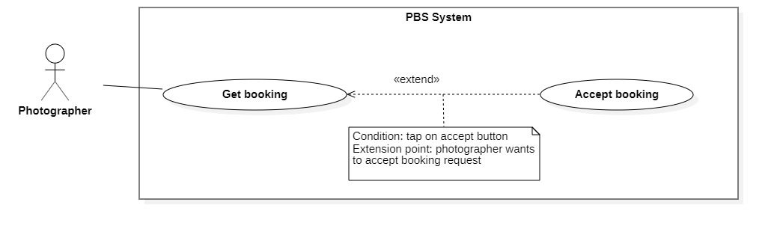

Figure 25 <Photographer> Accept booking

|  |  |  |  |  |  |
| --- | --- | --- | --- | --- | --- |
| UC ID and Name: | **UC – 12 Accept booking** | | | | |
| Created By: | Trần Thiên Thảo | | Date Created: | 08/10/2020 | |
| Primary Actor: | Photographer | | Secondary Actors: |  | |
| Trigger: | The photographer sends a request to accept booking. | | | | |
| Description: | This use case allows photographers to accept booking from customer. | | | | |
| Preconditions: | - User has been authenticated as a Photographer.  - The booking status is PENDING. | | | | |
| Post-conditions: | **Success:** The booking will be updated in the system with status change to ONGOING.  **Fail:** System shows error message | | | | |
| Normal Flow: | **Step** | **Actor Action** | | | **System Response** |
| 1 | Photographer sends request to receive booking details. | | | System returns booking detail with following information:  - “Trạng thái”: text  - “Thời gian chụp”: text  - “Thời gian nhận ảnh”: text  - “Thời gian tác nghiệp dự kiến”: text  - “Địa điểm”:   * “Địa chỉ”: text * “Latitude”: double * “Longitude”: double   - “Thông tin photographer”:   * “Tên photographer”: text * “Điểm đánh giá”: number * “Số điện thoại photographer”: number * Avatar: image   - “Thông tin khách hàng”:   * “Tên khách hàng”: text * “Số điện thoại photographer”: number   “Avatar: image  - “Thông tin gói dịch vụ”:   * “Tên gói”: text * “Mô tả”: text * “Tổng cộng”: text * “Bao gồm các dịch vụ”: list of texts   - “Phương thức trả ảnh”: text  [Exception 1] |
| 2 | Photographer tap “Đồng ý”  [Alternative 1] | | | System changes booking status to ONGOING.  [Exception 2] |
|  |  | | |  |
| Alternative Flows: | **Step** | **Actor Action** | | | **System Response** |
| 1 | Photographer confirm “Không” | | | Back to booking detail view |
| Exceptions: | **No** | **Cause** | | | **System Response** |
| 1 | System can’t get the booking detail | | | System shows error message: “Không tìm thấy cuộc hẹn” |
| 2 | The process run into an internal error | | | System shows error message: “Đã có lỗi xảy ra” |
| Priority: | Medium | | | | |
| Frequency of Use: | Usually | | | | |
| Business Rules: | * After accepting, change status of booking to ONGOING. * After photographer accepts, notification will be sent to customer. | | | | |
| Other Information: | N/A | | | | |
| Assumptions: | N/A | | | | |

Table <Photographer> Accept booking specification

##### <Photographer> Reject booking

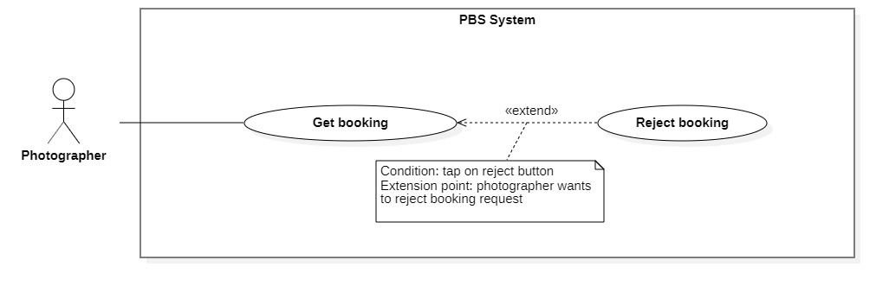

Figure 26 <Photographer> Decline booking

|  |  |  |  |  |  |
| --- | --- | --- | --- | --- | --- |
| UC ID and Name: | **UC – 13 Reject booking** | | | | |
| Created By: | Trương Ngọc Mỹ | | Date Created: | 08/10/2020 | |
| Primary Actor: | Photographer | | Secondary Actors: |  | |
| Trigger: | The photographer sends a request to reject booking. | | | | |
| Description: | This use case allows photographer to reject booking from customer | | | | |
| Preconditions: | - The User has been authenticated as a Photographer.  - The booking status is PENDING. | | | | |
| Post-conditions: | **Success:** The booking will be updated in the system and status change to REJECTED  **Fail:** System shows error message | | | | |
| Normal Flow: | **Step** | **Actor Action** | | | **System Response** |
| 1 | Photographer sends request to receive booking details. | | | System returns booking detail with following information:  - “Trạng thái”: text  - “Thời gian chụp”: text  - “Thời gian nhận ảnh”: text  - “Thời gian tác nghiệp dự kiến”: text  - “Địa điểm”:   * “Địa chỉ”: text * “Latitude”: double * “Longitude”: double   - “Thông tin photographer”:   * “Tên photographer”: text * “Điểm đánh giá”: number * “Số điện thoại photographer”: number * Avatar: image   - “Thông tin khách hàng”:   * “Tên khách hàng”: text * “Số điện thoại photographer”: number   “Avatar: image  - “Thông tin gói dịch vụ”:   * “Tên gói”: text * “Mô tả”: text * “Tổng cộng”: text * “Bao gồm các dịch vụ”: list of texts   - “Phương thức trả ảnh”: text  [Exception 1] |
| 2 | Photographer sends request to reject booking | | | System outputs: “Từ chối cuộc hẹn này?” |
| 3 | Photographer confirms “Có”  [Alternative 1] | | | System outputs: “Đã từ chối cuộc hẹn”  [Exception 2] |
| Alternative Flows: | **Step** | **Actor Action** | | | **System Response** |
| 1 | Photographer confirm “Không” | | | Back to booking detail view |
| Exceptions: | **No** | **Cause** | | | **System Response** |
| 1 | System can’t get the booking detail | | | System shows error message: “Không tìm thấy cuộc hẹn” |
| 2 | The process run into an internal error | | | System shows error message: “Đã có lỗi xảy ra” |
| Priority: | Usually | | | | |
| Frequency of Use: | Sometimes | | | | |
| Business Rules: | * After rejected, change booking status to REJECTED. * When photographer sends request to reject booking, get the rejection reason and save to system. * After photographer reject a booking, notification will be sent to customer. | | | | |
| Other Information: | N/A | | | | |
| Assumptions: | N/A | | | | |

Table <Photographer> Decline booking specification

##### <Photographer> Edit working weekdays

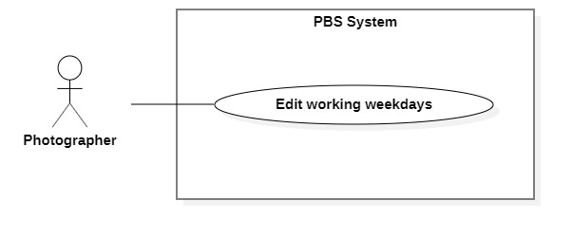

Figure <Photographer> Edit working weekdays

|  |  |  |  |  |  |
| --- | --- | --- | --- | --- | --- |
| UC ID and Name: | **UC – 22 Edit working weekdays** | | | | |
| Created By: | Trương Ngọc Mỹ | | Date Created: | 08/10/2020 | |
| Primary Actor: | Photographer | | Secondary Actors: |  | |
| Trigger: | The photographer sends requests to edit working weekdays. | | | | |
| Description: | This use case allows photographers to edit their working weekday. | | | | |
| Preconditions: | The User has been authenticated as a Photographer. | | | | |
| Post-conditions: | **Success:** Photographer’s working weekday will be updated in the system.  **Fail:** System outputs error message. | | | | |
| Normal Flow: | **Step** | **Actor Action** | | | **System Response** |
| 1 | Photographer goes to work weekday editing view. | | | System returns information:   * “Giờ làm việc”: timepicker, start time and end time. * “Ngày làm việc”: checkbox, weekday from Monday to Sunday   System requires information from photographer:   * “Chọn giờ làm việc”: checkbox * “Chọn ngày làm việc”: checkbox |
| 2 | Photographer inputs required information and sends requests to add busy days. | | | System outputs “Xác nhận” |
| 3 | Photographer confirm “Có”  [Alternative 1] | | | System updates working weekdays to system and outputs message “Đã điều chỉnh thời gian làm việc”  [Exception 1] |
| Alternative Flows: | **Step** | **Actor Action** | | | **System Response** |
| 1 | Photographer confirms “Không”. | | | Back to working weekday editing view. |
| Exceptions: | **No** | **Cause** | | | **System Response** |
| 1 | The process runs into an internal error | | | System outputs “Đã có lỗi xảy ra” |
| Priority: | Medium | | | | |
| Frequency of Use: | Sometimes | | | | |
| Business Rules: | * Weekday is: Monday, Tuesday, Wednesday, Thursday, Friday, Saturday, Sunday. * Photographer can decide whether or not they want to work on a weekday. A boolean isWorking will be used to keep track photographer’s working weekday. * Photographer can set starting time and ending time of a weekday. * All booking date will not be affected if they are accepted before photographer change the working weekday. | | | | |
| Other Information: | N/A | | | | |
| Assumptions: | N/A | | | | |

Table <Photographer> Edit working weekdays specification

##### <Photographer> Add busy day

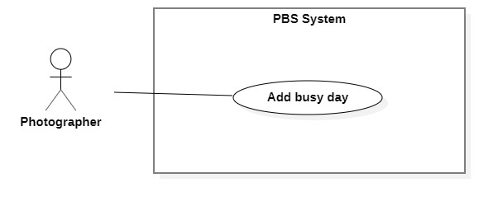

Figure 28 <Photographer> Add busy day

|  |  |  |  |  |  |
| --- | --- | --- | --- | --- | --- |
| UC ID and Name: | **UC – 21 Add busy day** | | | | |
| Created By: | Trương Ngọc Mỹ | | Date Created: | 08/10/2020 | |
| Primary Actor: | Photographer | | Secondary Actors: |  | |
| Trigger: | The photographer sends a request to add a busy day. | | | | |
| Description: | This use case allows photographers to add their busy day. | | | | |
| Preconditions: | The User has been authenticated as a Photographer. | | | | |
| Post-conditions: | **Success:** New busy days will be stored in the system.  **Fail:** System outputs error message. | | | | |
| Normal Flow: | **Step** | **Actor Action** | | | **System Response** |
| 1 | Photographer goes on a busy day adding view. | | | System requires information from photographer:   * “Tiêu đề”: text, required * “Mô tả”: text, required * “Ngày nghỉ”: datepicker, required |
| 2 | Photographer inputs required information and sends requests to add busy days. | | | System outputs “Bạn muốn thêm ngày nghỉ?” |
| 3 | Photographer confirm “Có”  [Alternative 1] | | | System adds busy day to system and outputs message “Đã thêm ngày nghỉ”  [Exception 1]  [Exception 2] |
| Alternative Flows: | **Step** | **Actor Action** | | | **System Response** |
| 1 | Photographer confirms “Không”. | | | Back to a busy day adding views. |
| Exceptions: | **No** | **Cause** | | | **System Response** |
| 1 | Photographer inputs data incorrectly or leave them empty | | | System outputs error message to notify photographer re-input. |
| 2 | The process runs into an internal error | | | System outputs “Đã có lỗi xảy ra” |
| Priority: | Medium | | | | |
| Frequency of Use: | Sometimes | | | | |
| Business Rules: | * Busy day information contains: busy day title, busy datetime, description on busy day. * Busy date must not be in the past. | | | | |
| Other Information: | N/A | | | | |
| Assumptions: | N/A | | | | |

Table <Photographer> Add busy day specification

##### <Photographer> Add package

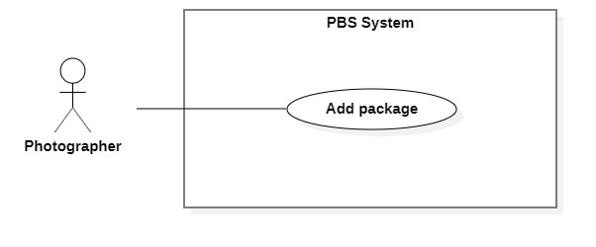

Figure 29 <Photographer> Add package

|  |  |  |  |  |  |
| --- | --- | --- | --- | --- | --- |
| UC ID and Name: | **UC – 23 Add package** | | | | |
| Created By: | Đào Sỹ Trung Kiên | | Date Created: | 08/10/2020 | |
| Primary Actor: | Photographer | | Secondary Actors: |  | |
| Trigger: | Photographer sends a request to add a new package. | | | | |
| Description: | This use case allows photographers to add new packages. | | | | |
| Preconditions: | The User has been authenticated as Photographer | | | | |
| Post-conditions: | **Success**: Package will be stored with status active.  **Fail**: System outputs error message and sends to Photographer. | | | | |
| Normal Flow: | **Step** | **Actor Action** | | | **System Response** |
| 1 | Photographer goes to New Package View. | | | System requires information from photographer:  - “Kiểu dịch vụ”: radio button, required.  - “Tên dịch vụ”: text, required.  - “Thể loại”: combobox, required.  - “Mô tả”: text, required.  - “Giá thành dịch vụ”: text, required  - “Thời gian tác nghiệp”: text, required  - “Chi tiết dịch vụ”: list of text, required. |
| 2 | Photographers input required information and send requests to create new packages. | | | System validates information, adds new package to system, output message “Tạo gói dịch vụ thành công” and send to Photographer  [Exception 1]  [Exception 2] |
| Alternative Flows: | N/A | | | | |
| Exceptions: | **No** | **Actor Action** | | | **System Response** |
| 1 | Photographer inputs invalid format text inputs or leaves empty required fields | | | System outputs error message and sends it to ask the photographer to input correct required fields. |
| 2 | The create process encountered an internal error. | | | System outputs error message and sends to photographer and notify that create new package fails. |
| Priority: | Medium | | | | |
| Frequency of Use: | Sometimes | | | | |
| Business Rules: | * Package will be managed by the system with status available and inavailable. * Package information contains: Id, package category, package name, description, price, time anticipation, services, isSupportMultiDay. * Package id will be generated by the system. * Category option dropdown list is returned by system. * IsSupportMultiDay is a boolean. * After creating a new package successfully, the new package will have status available and customers can choose it. | | | | |
| Other Information: | N/A | | | | |
| Assumptions: | N/A | | | | |

Table <Photographer> Add package specification

##### <Photographer> Edit package

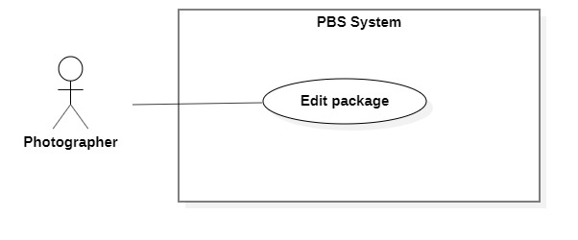

Figure 30 <Photographer> Edit package

|  |  |  |  |
| --- | --- | --- | --- |
| UC ID and Name: | **UC – 24 Edit package** | | |
| Created By: | Đào Sỹ Trung Kiên | Date Created: | 08/10/2020 |
| Primary Actor: | Photographer | Secondary Actors: |  |
| Trigger: | Photographer sends request to edit package. | | |
| Description: | This use case allows photographers to edit packages. | | |
| Preconditions: | The User has been authenticated as Photographer | | |
| Post-conditions: | **Success**: Package is edited.  **Fail**: System outputs error message and sends to Photographer. | | |
| Normal Flow: | **No** | **Actor Action** | **System Response** |
| 1 | Photographers send requests to receive a list of packages. | System displays list of packages.  [Exception 1] |
| 2 | Photographer sends request to receive package details | System requires information from photographer:  - “Kiểu dịch vụ”: combobox, required.  - “Tên dịch vụ”: text, required.  - “Mô tả”: text, required.  - “Giá thành dịch vụ”: text, required  - “Thời gian tác nghiệp”: text, required  - “Chi tiết dịch vụ”: text, required.  [Exception 2] |
|  | 3 | Photographer inputs package required information and send request to update package | System validates information, updates package, sends output message: “Chỉnh sửa thành công” to photographer.  [Exception 3] |
| Alternative Flows: | N/A | | |
| Exceptions: | **No** | **Actor Action** | **System Response** |
| 1 | System retrieves an empty list of available packages. | System outputs the error message “Không tìm thấy package” and sends it to the photographer. |
| 2 | Photographer inputs invalid format text inputs or leaves empty required fields. | System outputs error message and sends it to photographer to ask photographer to input correct required fields. |
| 3 | Update package process encountered a system internal error. | System outputs error message to notify photographer that update package failed. |
| Priority: | Medium | | |
| Frequency of Use: | Sometimes | | |
| Business Rules: | * Photographers access packages via package id. * Package will be updated in the system with inputted information. * Package id cannot be updated. * Package will be managed by the system with status available and inavailable. * Package information contains: Id, package category, package name, description, price, time anticipation, services, isSupportMultiDay. * IsSupportMultiDay is a boolean. * Category option list returned by system. * After updating the package successfully, the package will have new value and available for customers to choose. | | |
| Other Information: | N/A | | |
| Assumptions: | N/A | | |

Table <Photographer> Edit package specification

##### <Photographer> Remove package

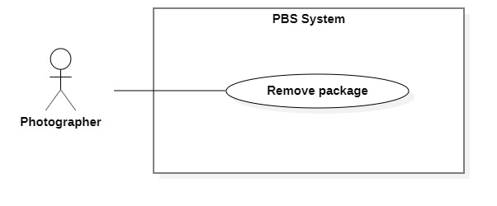

Figure 31 <Photographer> Remove package

|  |  |  |  |  |  |
| --- | --- | --- | --- | --- | --- |
| UC ID and Name: | **UC – 25 Remove package** | | | | |
| Created By: | Đào Sỹ Trung Kiên | | Date Created: | 08/10/2020 | |
| Primary Actor: | Photographer | | Secondary Actors: |  | |
| Trigger: | Photographer sends request to remove package. | | | | |
| Description: | This use case allows photographers to remove packages. | | | | |
| Preconditions: | The User has been authenticated as Photographer | | | | |
| Post-conditions: | **Success**: Package is set to inavailable.  **Fail**: System outputs error message and sends to Photographer. | | | | |
| Normal Flow: | **Step** | **Actor Action** | | | **System Response** |
| 1 | Photographer sends a request to get a list package. | | | System returns and displays list package.  [Exception 1] |
| 2 | Photographer sends request to remove package. | | | System outputs confirm messages: “Bạn có muốn xóa gói dịch vụ này không?” and requires Photographer to confirm. |
| 2 | Photographer confirms “Xác nhận” to remove the package. | | | System outputs and sends message: “Xóa gói dịch vụ thành công” to photographer and updates list package.  [Exception 2] |
| Alternative Flows: | N/A | | | | |
| Exceptions: | **No** | **Actor Action** | | | **System Response** |
| 1 | System retrieves an empty list package. | | | System outputs error message “Không có gói dịch vụ nào” and sends to photographer. |
| 2 | The remove action process encountered an internal error. | | | System outputs error message and sends it to photographer to notify that the remove package failed. |
| Priority: | Medium | | | | |
| Frequency of Use: | Sometimes | | | | |
| Business Rules: | * Photographers only access packages via package id. * Update status to inavailable. * Package which currently has been booking can’t not be removed. | | | | |
| Other Information: | N/A | | | | |
| Assumptions: | N/A | | | | |

Table <Photographer> Remove package specification

##### <Photographer> Add album

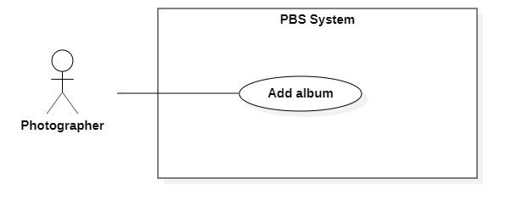

Figure 32 <Photographer> Add album

|  |  |  |  |  |  |
| --- | --- | --- | --- | --- | --- |
| UC ID and Name: | **UC – 26 Add album** | | | | |
| Created By: | Đào Sỹ Trung Kiên | | Date Created: | 08/10/2020 | |
| Primary Actor: | Photographer | | Secondary Actors: |  | |
| Trigger: | The photographer sends request to add new album | | | | |
| Description: | This use case allows Photographer to add new album | | | | |
| Preconditions: | The User has been authenticated as Photographer | | | | |
| Post-conditions: | **Success:** Album will be added successfully  **Fail:** Systems outputs error message and sends to Photographer | | | | |
| Normal Flow: | **Step** | **Actor Action** | | | **System Response** |
| 1 | The Photographer goes to new Album View | | | System returns “category” for execution steps.  System requires information from photographer:  - “Thời gian”: datetime, required.  - “Mô tả”: text, required.  - “Tên album”: text, required.  - “Hình ảnh”: image.  - “Category”: combobox, required |
| 2 | Photographer inputs required information and send request to create new album | | | System validates information, adds new album to the system, outputs message “Tạo mới album thành công” and sends to the Photographer  [Exception 1]  [Exception 2] |
| Alternative Flows: | N/A | | | | |
| Exceptions: | **No** | **Actor Action** | | | **System Response** |
| 1 | Photographer inputs invalid format text inputs or leaves empty require fields. | | | System outputs error message and send to ask Photographer to input correct required fields. |
| 2 | The create process encountered an internal error. | | | System outputs error message and sends photographer to notify that create new album failed. |
| Priority: | Medium | | | | |
| Frequency of Use: | Sometimes | | | | |
| Business Rules: | * Album will be managed by the system with status active and deactivated. * Album information contains: id, created date, description, album’s name, images, category. * Album id will be generated by the system. * Category option list returned by system. * After creating new album successfully, new album will have status active and available for customers. * Save image file to S3 service and image url into database. * After album created, customers can view and press like album. | | | | |
| Other Information: | N/A | | | | |
| Assumptions: | N/A | | | | |

Table <Photographer> Add album specification

##### <Photographer> Edit album

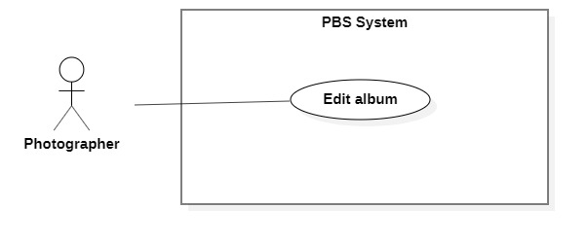

Figure 33 <Photographer> Edit album

|  |  |  |  |  |  |
| --- | --- | --- | --- | --- | --- |
| UC ID and Name: | **UC – 27 Edit album** | | | | |
| Created By: | Đào Sỹ Trung Kiên | | Date Created: | 08/10/2020 | |
| Primary Actor: | Photographer | | Secondary Actors: |  | |
| Trigger: | The photographer sends request to edit album | | | | |
| Description: | This use case allows Photographer to edit album | | | | |
| Preconditions: | The User has been authenticated as Photographer | | | | |
| Post-conditions: | **Success:** Album will be updated  **Fail:** Systems outputs error message and sends to Photographer | | | | |
| Normal Flow: | **No** | **Actor Action** | | | **System Response** |
| 1 | Photographers send requests to receive a list of albums. | | | System displays list of albums.  [Exception 1] |
| 2 | Photographer sends request to receive album details | | | System returns album information for execution steps.  System requires information from photographer:  - “Thời gian”: datetime, required.  - “Mô tả”: text, required.  - “Tên album”: text, required.  - “Hình ảnh”: image.  - “Category”: combobox, required  [Exception 2] |
| 3 | Photographer inputs album required information and send request to update album | | | System validates information, updates package, sends output message: “Chỉnh sửa thành công” to photographer.  [Exception 3]  [Exception 4] |
| Alternative Flows: | N/A | | | | |
| Exceptions: | **No** | **Actor Action** | | | **System Response** |
| 1 | System retrieves an empty list of available albums. | | | System outputs the error message “Không tìm thấy album” and sends it to the photographer. |
| 2 | System retrieves an empty list of “category”. | | | System outputs the error message “Không tìm thấy category” and sends it to the photographer. |
| 3 | Photographer inputs invalid format text inputs or leaves empty required fields. | | | System outputs error message and sends it to photographer to ask photographer to input correct required fields. |
|  | 4 | Update album process encountered a system internal error. | | | System outputs error message to notify photographer that update album failed. |
| Priority: | Medium | | | | |
| Frequency of Use: | Sometimes | | | | |
| Business Rules: | * Photographers access albums by album id. * Albums will be updated in the system with inputted information. * Album id cannot be updated. * Albums will be managed by the system with status active and deactivated. * Album information contains: id, created date, description, album’s name, images, category. * Category option list returned by system. * After updating the album successfully, the album will have new value and be available for customers. * Update image file to S3 service. | | | | |
| Other Information: | N/A | | | | |
| Assumptions: | N/A | | | | |

Table <Photographer> Edit album specification

##### <Photographer> Remove album

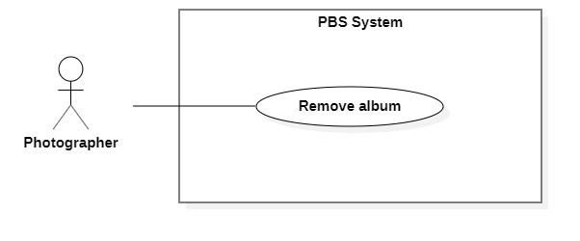

Figure 34 <Photographer> Remove album

|  |  |  |  |  |  |
| --- | --- | --- | --- | --- | --- |
| UC ID and Name: | **UC – 28 Remove album** | | | | |
| Created By: | Đào Sỹ Trung Kiên | | Date Created: | 08/10/2020 | |
| Primary Actor: | Photographer | | Secondary Actors: |  | |
| Trigger: | Photographer sends request to remove album | | | | |
| Description: | This use case allows photographers to remove albums. | | | | |
| Preconditions: | The User has been authenticated as Photographer | | | | |
| Post-conditions: | **Success**: Album is set to deactivated.  **Fail**: System outputs error message and sends to Photographer. | | | | |
| Normal Flow: | **Step** | **Actor Action** | | | **System Response** |
| 1 | Photographer sends request to get album detail. | | | System returns and displays the album detail.  [Exception 1] |
| 2 | Photographer sends request to remove album. | | | System outputs confirm messages: “Bạn có muốn xóa album này không?” and requires Photographer to confirm. |
| 3 | Photographer confirms “Đồng ý” to remove album. | | | System outputs and sends a message: “Xóa album thành công” to photographer and updates list album.  [Exception 2] |
| Alternative Flows: | N/A | | | | |
| Exceptions: | **No** | **Actor Action** | | | **System Response** |
| 1 | System retrieves an empty list album. | | | System outputs the error message “Không có album nào” and sends it to the photographer. |
| 2 | The remove action process encountered an internal error. | | | System outputs error message and sends it to photographer to notify that the remove album failed. |
| Priority: | Medium | | | | |
| Frequency of Use: | Sometimes | | | | |
| Business Rules: | * Photographers only access albums via album id. * If album status is active: Update status to deactivate. * Customer no longer see removed album. | | | | |
| Other Information: | N/A | | | | |
| Assumptions: | N/A | | | | |

Table <Photographer> Remove album specification

#### 2.2.4 <Authenticated User> Overview Use Case

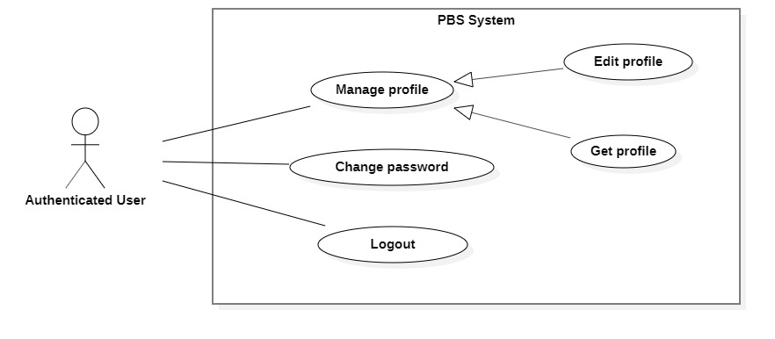

Figure 35 <Authenticated User> Overview

##### <Authenticated User> Get profile

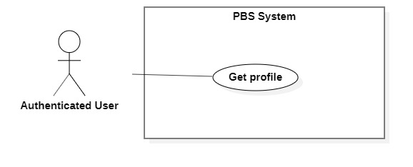

Figure 36 <Authenticated User> Get profile

|  |  |  |  |  |  |
| --- | --- | --- | --- | --- | --- |
| UC ID and Name: | **UC – 29 Get profile** | | | | |
| Created By: | Trương Ngọc Mỹ | | Date Created: | 08/10/2020 | |
| Primary Actor: | Authenticated User | | Secondary Actors: |  | |
| Trigger: | The Authenticated User sends request to get profile. | | | | |
| Description: | This use case allows authenticated user to get their profile. | | | | |
| Preconditions: | User has been authenticated. | | | | |
| Post-conditions: | **Success:** System returns authenticated user’s profile.  **Fail:** System shows error message. | | | | |
| Normal Flow: | **Step** | **Actor Action** | | | **System Response** |
| 1 | Authenticated users send requests to get their profile. | | | System outputs the result to the authenticated user.  [Exception 1]  [Exception 2] |
| Alternative Flows: | N/A | | | | |
| Exceptions: | **No** | **Cause** | | | **System Response** |
| 1 | System can’t get the profile. | | | System outputs error message “Không thể tìm thấy thông tin”. |
| 2 | The process runs into an internal error. | | | System outputs error message “Đã có lỗi xảy ra” |
| Priority: | Medium | | | | |
| Frequency of Use: | Sometimes | | | | |
| Business Rules: | * The results contain following information: avatar, full name, phone, email, description, working locations, rating count, booked number, cover. * Only Photographer has rating count, booked number, cover, description, working locations. | | | | |
| Other Information: | N/A | | | | |
| Assumptions: | N/A | | | | |

Table <Authenticated User> Get profile specification

##### <Authenticated User> Edit profile

Figure 37 <Authenticated User> Edit profile

*Figure SEQ Figure \* ARABIC 32 <Authenticated User> Edit profile*

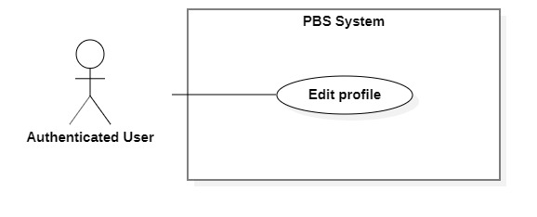

|  |  |  |  |  |  |
| --- | --- | --- | --- | --- | --- |
| UC ID and Name: | **UC – 30 Edit profile** | | | | |
| Created By: | Trương Ngọc Mỹ | | Date Created: | 08/10/2020 | |
| Primary Actor: | Authenticated User | | Secondary Actors: |  | |
| Trigger: | The Authenticated User sends a request to edit the profile. | | | | |
| Description: | This use case allows authenticated users to edit their profile. | | | | |
| Preconditions: | User has been authenticated. | | | | |
| Post-conditions: | **Success:** The profile will be updated into the system.  **Fail:** System outputs error message. | | | | |
| Normal Flow: | **Step** | **Actor Action** | | | **System Response** |
| 1 | Authenticated users send requests to receive their profile. | | | System return results and requires information from user:  - “Họ tên”: text, required  - “Email”: text, required  - “Số điện thoại”: number, required  - “Ảnh bìa”: image  - “Mô tả”: text  - “Ảnh đại diện”: image  - “Địa điểm làm việc”: list of locations  [Exception 1] |
| 2 | Authenticated tap confirm button.  [Alternative 1] | | | System update data and outputs “Cập nhật thông tin thành công!”.  [Exception 2]  [Exception 3] |
| Alternative Flows: | **Step** | **Actor Action** | | | **System Response** |
| 1 | Authenticated tap close button. | | | Back to profile view. |
| Exceptions: | **No** | **Cause** | | | **System Response** |
| 1 | System can’t get user’s profile | | | System outputs “Không thể tìm thấy hồ sơ” |
| 2 | User inputs information incorrectly or leaves it empty in the required field. | | | System outputs error messages to get user input correctly. |
| 3 | System runs into an internal error. | | | System outputs error message “Đã có lỗi xảy ra” |
| Priority: | Medium | | | | |
| Frequency of Use: | Sometimes | | | | |
| Business Rules: | * The return view contains following information: avatar, full name, phone, email, description, cover, locations. * Only Photographer can edit description, cover, working locations. * Avatar and Cover will be uploaded to S3 service and save url in database. * Fullname must not contains number, dot, underscore, special characters (except Vietnamese name’s characters). * Email should be in email format. * Phone should be in Vietnamese format. * Fullname, email, phone should not be empty. | | | | |
| Other Information: | N/A | | | | |
| Assumptions: | N/A | | | | |

Table <Authenticated User> Edit profile specification

##### <Authenticated User> Change password

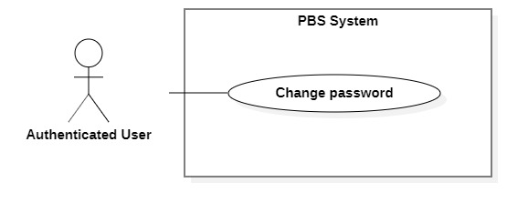

Figure 38 <Authenticated User> Change password

|  |  |  |  |  |  |
| --- | --- | --- | --- | --- | --- |
| UC ID and Name: | **UC – 31 Change password** | | | | |
| Created By: | Bồ Công Đạt | | Date Created: | 08/10/2020 | |
| Primary Actor: | Authenticated User | | Secondary Actors: |  | |
| Trigger: | The Authenticated User sends a request to change password. | | | | |
| Description: | This use case allows authenticated users to change their password. | | | | |
| Preconditions: | User has been authenticated. | | | | |
| Post-conditions: | **Success:** User’s password updated successfully in the system.  **Fail:** System outputs error message. | | | | |
| Normal Flow: | **Step** | **Actor Action** | | | **System Response** |
| 1 | Authenticated user sends request to get their password | | | System returns result and requires following information from user:  - “Mật khẩu cũ của bạn”: password, required  - “Mật khẩu mới”: password, required  - “Nhập lại mật khẩu mới”: password, required  [Exception 1] |
| 2 | Authenticated user inputs required information and sends request to change password | | | System outputs “Bạn muốn cập nhật mật khẩu?” |
| 3 | Authenticated user confirms “Có”  [Alternative 1] | | | System update data and output “Cập nhật mật khẩu thành công”  [Exception 2]  [Exception 3] |
| Alternative Flows: | **Step** | **Actor Action** | | | **System Response** |
| 1 | Authenticated user confirms “Không” | | | Back to password changing view |
| Exceptions: | **No** | **Cause** | | | **System Response** |
| 1 | System can’t get user’s password | | | System outputs “Không thể tìm thấy thông tin” |
| 2 | User inputs information incorrectly or leave required fields empty | | | System outputs error message to get user input information correctly |
| 3 | The process runs into an internal error | | | System outputs “Đã có lỗi xảy ra” |
| Priority: | Medium | | | | |
| Frequency of Use: | Sometimes | | | | |
| Business Rules: | * User must input the current password before changing new password. * Current password must match password stored in the system. * Password must follow password business rules in Register use case. | | | | |
| Other Information: | N/A | | | | |
| Assumptions: | N/A | | | | |

Table <Authenticated User> Change password specification

##### <Authenticated User> Logout

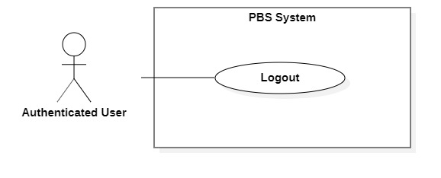

Figure 39 <Authenticated User> Logout

|  |  |  |  |  |  |
| --- | --- | --- | --- | --- | --- |
| UC ID and Name: | **UC – 32 Logout** | | | | |
| Created By: | Bồ Công Đạt | | Date Created: | 08/10/2020 | |
| Primary Actor: | Authenticated User | | Secondary Actors: |  | |
| Trigger: | The Authenticated User sends a request to log out from the system. | | | | |
| Description: | This use case allows users to log out from the system. | | | | |
| Preconditions: | User has been authenticated. | | | | |
| Post-conditions: | **Success:** User logged out from the system.  **Fail:** System outputs error message | | | | |
| Normal Flow: | **Step** | **Actor Action** | | | **System Response** |
| 1 | User tap “Đăng xuất”  [Alternative 1] | | | System logs the user out.  Navigate user back to login view.  [Exception 1] |
| Alternative Flows: | N/A | | | | |
| Exceptions: | **No** | **Cause** | | | **System Response** |
| 1 | The process runs into an internal error | | | System outputs “Đã có lỗi xảy ra” |
| Priority: | Medium | | | | |
| Frequency of Use: | Usually | | | | |
| Business Rules: | * User’s Json web token will be removed on client side. * User’s session will be destroyed on client side. | | | | |
| Other Information: | N/A | | | | |
| Assumptions: | N/A | | | | |

Table <Authenticated User> Logout specification

#### 2.2.5 <Admin> Overview Use Case

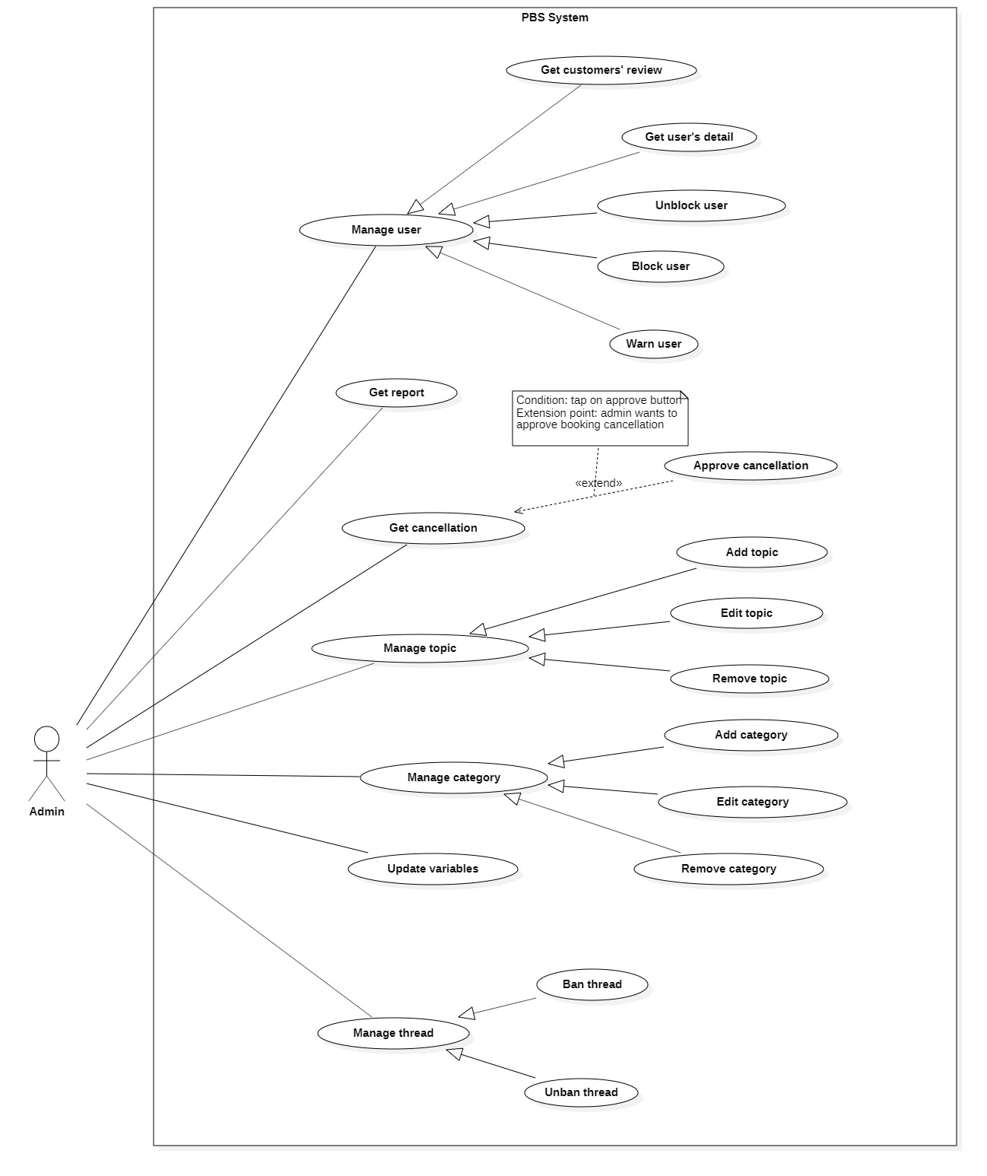

Figure 40 <Admin> Overview

##### <Admin> Get cancellation

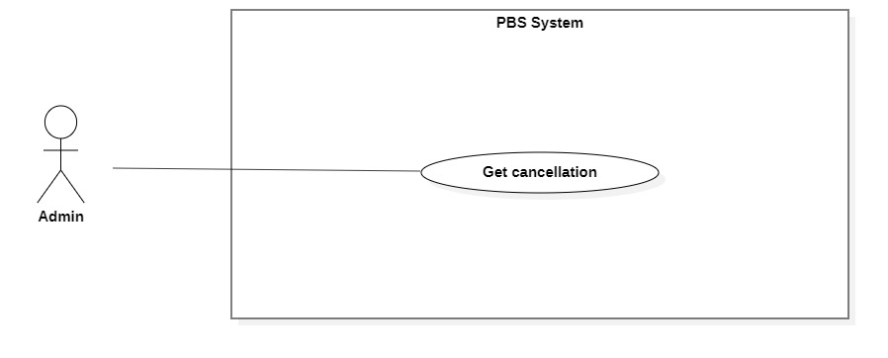

Figure <Admin> Get cancellation

|  |  |  |  |  |  |
| --- | --- | --- | --- | --- | --- |
| UC ID and Name: | **UC – 40 Get cancellation** | | | | |
| Created By: | Trần Thiên Thảo | | Date Created: | 01/01/2021 | |
| Primary Actor: | Admin | | Secondary Actors: |  | |
| Trigger: | Admin sends a request to get cancellation. | | | | |
| Description: | This use case allows admin to get cancellation. | | | | |
| Preconditions: | User has been authenticated as Admin. | | | | |
| Post-conditions: | **Success:** System displays detail of a cancellation.  **Fail:** System shows error message. | | | | |
| Normal Flow: | Step | Actor Action | | | System Response |
| 1 | Admin sends a request to get detail of a cancellation. | | | System returns cancellation detail with following information:  - “Người hủy”: text  - “Lý do hủy”: text  - “Thời gian hủy”: datetime  - “Lý do hủy”: text  - Booking information:   * “Khách hàng”: text * “Thợ ảnh”: text * “Trạng thái”: text   [Exception 1] |
| Alternative Flows: | N/A | | | | |
| Exceptions: | No | Cause | | | System Response |
| 1 | System run into internal error | | | System shows error message: “Đã có lỗi xảy ra” |
| Priority: | Medium | | | | |
| Frequency of Use: | Usually | | | | |
| Business Rules: | * In cancellation view, admin can approve cancellation, warn user or navigate to user detail and block them there. * Admin can navigate to booking detail view to check information. | | | | |
| Other Information: | N/A | | | | |
| Assumptions: | N/A | | | | |

Table <Admin> Get cancellation specification

##### <Admin> Approve cancellation

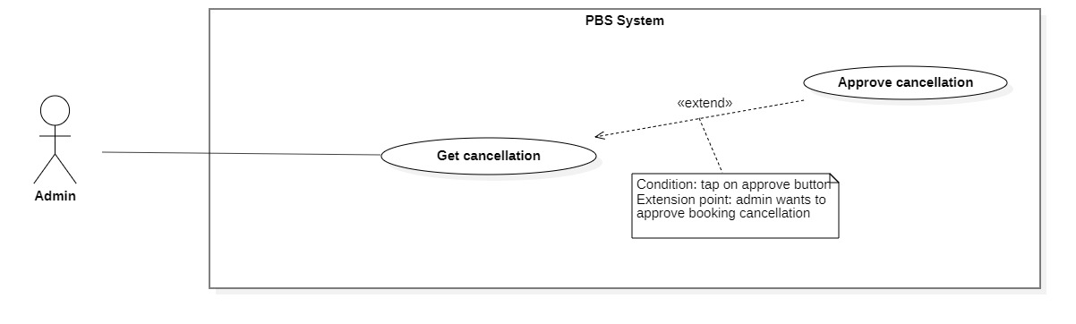

Figure <Admin> Approve cancellation

|  |  |  |  |  |
| --- | --- | --- | --- | --- |
| UC ID and Name: | **UC – 41 Approve cancellation** | | | |
| Created By: | Đào Sỹ Trung Kiên | Date Created: | | 01/01/2021 |
| Primary Actor: | Admin | Secondary Actors: | |  |
| Trigger: | The Admin sends request to approve cancellation | | | |
| Description: | This use case allows Admin to approve cancellation | | | |
| Preconditions: | The User has been authenticated as Admin | | | |
| Post-conditions: | **Success:** User's cancellation request is approved.  **Fail:** Systems outputs error message and sends to Admin | | | |
| Normal Flow: | **Step** | **Actor Action** | **System Response** | |
| 1 | Admin send requests to receive cancellation view. | System returns cancellation view with following information:  - “Người hủy”: text  - “Lý do hủy”: text  - “Khách hàng”: text  - “Thợ ảnh”: text  - “Thời gian hẹn”: text  - “Thời gian hủy”: text  - “Trạng thái đơn hẹn”: text  [Exception 1] | |
| 2 | Admin send request to approve cancellation. | System outputs “Bạn muốn hủy đơn này ?”. | |
|  | 3 | Admin confirms “Có”.  [Alternative 1] | System update data and outputs “Đã hủy đơn”.  [Exception 2] | |
| Alternative Flows: | **Step** | **Actor Action** | **System Response** | |
| 1 | Admin confirms “Không”. | Back to cancellation view. | |
| Exceptions: | **No** | **Actor Action** | **System Response** | |
| 1 | System can’t get cancellation view. | System shows error message: “Không tìm thấy yêu cầu hủy” | |
|  | 2 | The process run into an internal error | System shows error message: “Đã có lỗi xảy ra” | |
| Priority: | Medium | | | |
| Frequency of Use: | Sometimes | | | |
| Business Rules: | * After approval, change status of booking to CANCELLED_PHOTOGRAPHER / CANCELLED_CUSTOMER. * After admin approval, notification will be sent to customer or photographer. | | | |
| Other Information: | N/A | | | |
| Assumptions: | N/A | | | |

Table <Admin> Approve cancellation

##### <Admin> Get report

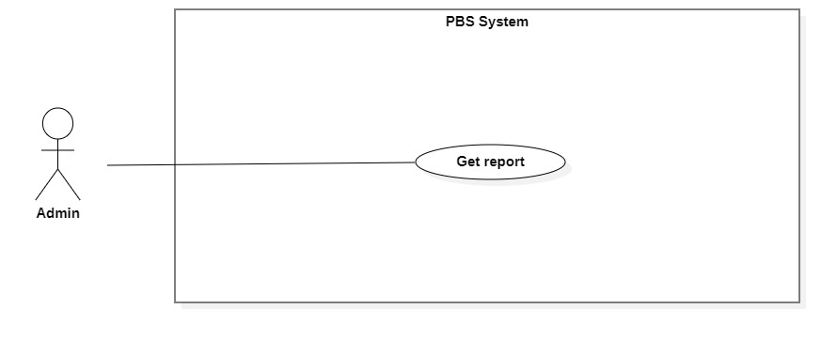

Figure <Admin> Get report

|  |  |  |  |  |  |
| --- | --- | --- | --- | --- | --- |
| UC ID and Name: | **UC – 39 Get report** | | | | |
| Created By: | Đào Sỹ Trung Kiên | | Date Created: | 08/10/2020 | |
| Primary Actor: | Admin | | Secondary Actors: |  | |
| Trigger: | The admin sends a request to get user’s report. | | | | |
| Description: | This use case allows admins to get get user’s report. | | | | |
| Preconditions: | The User has been authenticated as admin | | | | |
| Post-conditions: | **Success:** The system returns get user’s report  **Fail:** System shows error message | | | | |
| Normal Flow: | **Step** | **Actor Action** | | | **System Response** |
| 1 | Admin send requests to get user’s report. | | | System displays following information:   * “Người báo cáo”: text. * “Lý do”: text. * “Khách hàng”: text. * “Thợ ảnh”: text. * “Thời gian”: text.   [Exception 1] |
| Alternative Flows: | N/A | | | | |
| Exceptions: | **No** | **Cause** | | | **System Response** |
| 1 | The process runs into an internal error. | | | System outputs error message: “Đã có lỗi xảy ra” |
| Priority: | Medium | | | | |
| Frequency of Use: | Sometimes | | | | |
| Business Rules: | * Admin can check seen the report. * Admin can warn user via notification and email. * Admin can navigate to user’s detail and block them there. | | | | |
| Other Information: | N/A | | | | |
| Assumptions: | N/A | | | | |

Table <Admin> Get report

##### <Admin> Get user’s detail

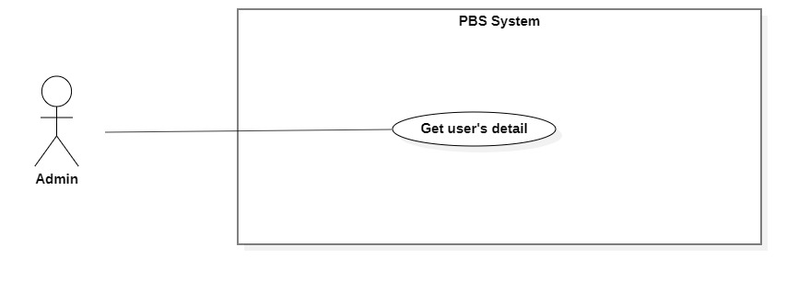

Figure <Admin> Get user's detail

|  |  |  |  |  |  |
| --- | --- | --- | --- | --- | --- |
| UC ID and Name: | **UC – 37 Get user’s detail** | | | | |
| Created By: | Trương Ngọc Mỹ | | Date Created: | 08/10/2020 | |
| Primary Actor: | Admin | | Secondary Actors: |  | |
| Trigger: | The Admin sends request to get user’s detail. | | | | |
| Description: | This use case allows admin to get user’s detail. | | | | |
| Preconditions: | User has been authenticated as admin. | | | | |
| Post-conditions: | **Success:** System returns user’s detail for admin.  **Fail:** System shows error message. | | | | |
| Normal Flow: | **Step** | **Actor Action** | | | **System Response** |
| 1 | Admin send requests to get a user’s detail. | | | System returns user information include:  - Avatar: image  - Role: text  - All booking number: number  - Number of cancelled booking: number  - Cancellation rate: number  - Number of done booking: number  - Emai: text  - Phone: text  - Account status: text  [Exception 1]  [Exception 2] |
| Alternative Flows: | N/A | | | | |
| Exceptions: | **No** | **Cause** | | | **System Response** |
| 1 | System can’t get the user’s detail. | | | System outputs error message “Không thể tìm thấy thông tin”. |
| 2 | The process runs into an internal error. | | | System outputs error message “Đã có lỗi xảy ra” |
| Priority: | Medium | | | | |
| Frequency of Use: | Sometimes | | | | |
| Business Rules: | * The results contain following information: avatar, full name, phone, email, number of bookings, number of done bookings, number of cancelled bookings, cancellation rate. | | | | |
| Other Information: | N/A | | | | |
| Assumptions: | N/A | | | | |

Table <Admin> Get user's detail

##### <Admin> Get customers’ review

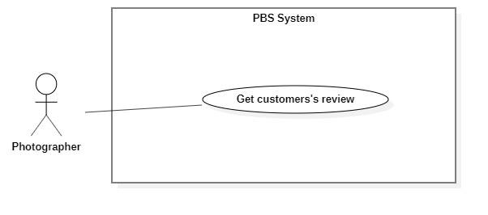

Figure 45 <Photographer> Get customer's review

|  |  |  |  |  |  |
| --- | --- | --- | --- | --- | --- |
| UC ID and Name: | **UC – 38 Get customers’ review** | | | | |
| Created By: | Trương Ngọc Mỹ | | Date Created: | 08/10/2020 | |
| Primary Actor: | Admin | | Secondary Actors: |  | |
| Trigger: | The photographer or admin sends a request to get a customer's review. | | | | |
| Description: | This use case allows photographers or admins to get customers’ reviews. | | | | |
| Preconditions: | The User has been authenticated as Photographer or Admin | | | | |
| Post-conditions: | **Success:** The system returns customers’ review of photographer  **Fail:** System shows error message | | | | |
| Normal Flow: | **Step** | **Actor Action** | | | **System Response** |
| 1 | Photographer or Admin send requests to get their reviews from customers. | | | System displays list of reviews.  [Exception 1] |
| Alternative Flows: | N/A | | | | |
| Exceptions: | **No** | **Cause** | | | **System Response** |
| 1 | The process runs into an internal error. | | | System outputs error message: “Đã có lỗi xảy ra” |
| Priority: | Medium | | | | |
| Frequency of Use: | Sometimes | | | | |
| Business Rules: | * The results contain: customers’ comments, customers’ ratings, commented dates. * If the result is empty, returns empty text. * Admin can’t remove customers’ reviews | | | | |
| Other Information: | N/A | | | | |
| Assumptions: | N/A | | | | |

Table <Photographer> Get customer's review specification

##### <Admin> Block user

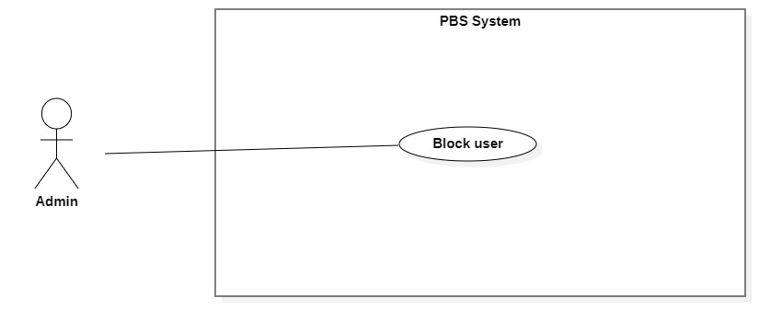

Figure 46 <Admin> Block user

|  |  |  |  |  |  |
| --- | --- | --- | --- | --- | --- |
| UC ID and Name: | **UC – 34 Block user** | | | | |
| Created By: | Đào Sỹ Trung Kiên | | Date Created: | 11/11/2020 | |
| Primary Actor: | Admin | | Secondary Actors: |  | |
| Trigger: | The Admin sends request to block user. | | | | |
| Description: | This use case allows Admin to block user. | | | | |
| Preconditions: | The User has been authenticated as Admin. | | | | |
| Post-conditions: | **Success:** User will be blocked and unable to access the system.  **Fail:** Systems outputs error message and sends to Admin. | | | | |
| Normal Flow: | **Step** | **Actor Action** | | | **System Response** |
| 1 | The Admin goes to user view. | | | System returns user information include:  - Avatar: image  - Role: text  - All booking number: number  - Number of cancelled booking: number  - Cancellation rate: number  - Number of done booking: number  - Emai: text  - Phone: text  - Account status: text |
| 2 | Admin send request to block user. | | | System shows confirmation message: “Bạn có muốn chặn người dung này?” |
| 3 | Admin confim “Có”  [Alternative 1] | | | System block user and outputs message “Chặn người dùng thành công” and sends to the admin.  [Exception 1] |
| Alternative Flows: | **Step** | **Actor Action** | | | **System Response** |
| 1 | Admin confim “Không”. | | | Back to user view. |
| Exceptions: | **No** | **Actor Action** | | | **System Response** |
| 1 | The create process encountered an internal error. | | | System outputs error message and sends admin to notify that block user failed. |
| Priority: | Medium | | | | |
| Frequency of Use: | Sometimes | | | | |
| Business Rules: | * User’s status will be changed to blocked. * System will log the user out of the system. * If the user login after being blocked, system shows “Tài khoản của bạn đã bị vô hiệu”. * If user has booking, the system will notice admin that this user has bookings and show confirmation alert. If the admin confirms yes the system will block the user and set all bookings’ status to CANCELLED_ADMIN then notify the opposite Customer / Photographer. * Mail to blocked user. | | | | |
| Other Information: | N/A | | | | |
| Assumptions: | N/A | | | | |

Table <Admin> Block user specification

##### <Admin> Unblock user



Figure 47 <Admin> Unblock user

|  |  |  |  |  |  |
| --- | --- | --- | --- | --- | --- |
| UC ID and Name: | **UC – 35 Unblock user** | | | | |
| Created By: | Đào Sỹ Trung Kiên | | Date Created: | 11/11/2020 | |
| Primary Actor: | Admin | | Secondary Actors: |  | |
| Trigger: | The Admin sends request to unblock user. | | | | |
| Description: | This use case allows Admin to unblock user. | | | | |
| Preconditions: | The User has been authenticated as Admin. | | | | |
| Post-conditions: | **Success:** User will be unblocked and enabled to access the system.  **Fail:** Systems outputs error message and sends to Admin. | | | | |
| Normal Flow: | **Step** | **Actor Action** | | | **System Response** |
| 1 | The Admin goes to user view. | | | System returns user information include:  - Avatar: image  - Role: text  - All booking number: number  - Number of cancelled booking: number  - Cancellation rate: number  - Number of done booking: number  - Emai: text  - Phone: text  - Account status: text |
| 2 | Admin send request to unblock user. | | | System shows confirmation message: “Bạn có muốn gỡ chặn người dung này?” |
|  | 3 | Admin confim “Có”  [Alternative 1] | | | System unblock user and outputs message “Gỡ chặn người dùng thành công” and sends to the admin.  [Exception 1] |
| Alternative Flows: | **Step** | **Actor Action** | | | **System Response** |
| 1 | Admin confim “Không”. | | | Back to user view. |
| Exceptions: | **No** | **Actor Action** | | | **System Response** |
| 1 | The create process encountered an internal error. | | | System outputs error message and sends admin to notify that unblock user failed. |
| Priority: | Medium | | | | |
| Frequency of Use: | Sometimes | | | | |
| Business Rules: | * User’s status will be changed to unblocked. * Mail to inform user. | | | | |
| Other Information: | N/A | | | | |
| Assumptions: | N/A | | | | |

Table <Admin> Unblock user specification

##### <Admin> Warn User

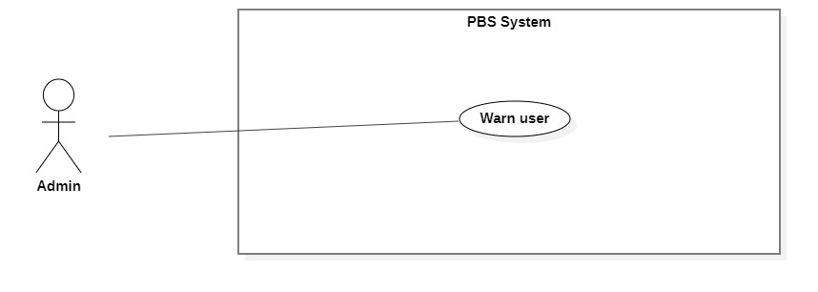

Figure <Admin> Warn user

|  |  |  |  |  |  |
| --- | --- | --- | --- | --- | --- |
| UC ID and Name: | **UC – 36 Warn user** | | | | |
| Created By: | Đào Sỹ Trung Kiên | | Date Created: | 01/01/2021 | |
| Primary Actor: | Admin | | Secondary Actors: |  | |
| Trigger: | The Admin sends request to warn user. | | | | |
| Description: | This use case allows Admin to warn user. | | | | |
| Preconditions: | The User has been authenticated as Admin. | | | | |
| Post-conditions: | **Success:** User will be warned because of inproper activity.  **Fail:** Systems outputs error message and sends to admin. | | | | |
| Normal Flow: | **Step** | **Actor Action** | | | **System Response** |
| 1 | The Admin sends request to warn | | | System requires information from admin:  - “User Id”: text, required. |
| 2 | Admin inputs required information and send request to warn user | | | System validates information, warn user and outputs message “Cảnh báo người dùng thành công” and sends to the admin.  [Exception 1]  [Exception 2] |
| Alternative Flows: | N/A | | | | |
| Exceptions: | **No** | **Actor Action** | | | **System Response** |
| 1 | Admin inputs invalid format text inputs or leaves empty required fields. | | | System outputs error message and sends it to ask admin to input correct required fields. |
| 2 | The create process encountered an internal error. | | | System outputs error message and sends admin to notify that warn user failed. |
| Priority: | Medium | | | | |
| Frequency of Use: | Sometimes | | | | |
| Business Rules: | * This use case related to cancellation management. * After warn user, set warned user’s booking to CANCELLED_PHOTOGRAPHER or CANCELLED_CUSTOMER depends on the role of warned user. * Send warning notification to warned user. Warning notification includes admin’s warning message, cancelled booking information. | | | | |
| Other Information: | N/A | | | | |
| Assumptions: | N/A | | | | |

Table <Admin> Warn user specification

##### <Admin> Add Category

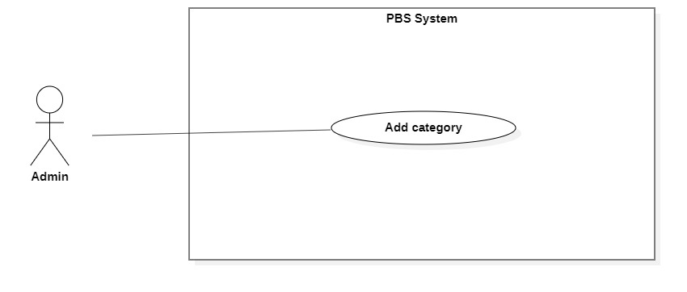

Figure 49 <Admin> Add category

|  |  |  |  |  |  |
| --- | --- | --- | --- | --- | --- |
| UC ID and Name: | **UC – 42 Add category** | | | | |
| Created By: | Đào Sỹ Trung Kiên | | Date Created: | 08/10/2020 | |
| Primary Actor: | Admin | | Secondary Actors: |  | |
| Trigger: | The admin sends request to add new category. | | | | |
| Description: | This use case allows Admin to add new category. | | | | |
| Preconditions: | The User has been authenticated as Admin. | | | | |
| Post-conditions: | **Success:** Category will be added successfully.  **Fail:** Systems outputs error message and sends to Admin. | | | | |
| Normal Flow: | **Step** | **Actor Action** | | | **System Response** |
| 1 | The Admin goes to new Category View. | | | System requires information from admin:  - “Thể loại”: text, required  - “Icon”: image, required |
| 2 | Admin inputs required information and send request to create category. | | | System validates information, adds new category to the system, outputs message “Tạo mới category thành công” and sends to the Admin.  [Exception 1]  [Exception 2] |
| Alternative Flows: | N/A | | | | |
| Exceptions: | **No** | **Actor Action** | | | **System Response** |
| 1 | Admin inputs invalid format text inputs or leaves empty required fields. | | | System outputs error message and sends it to ask admin to input correct required fields. |
| 2 | The create process encountered an internal error. | | | System outputs error message and sends admin to notify that create new category. |
| Priority: | Medium | | | | |
| Frequency of Use: | Sometimes | | | | |
| Business Rules: | * Category information contains: id, category name, icon link. * After category created, photographer can add album or package to that category. * Icon will be stored to S3 service and save url to database. | | | | |
| Other Information: | N/A | | | | |
| Assumptions: | N/A | | | | |

Table <Admin> Add category specification

##### <Admin> Edit category

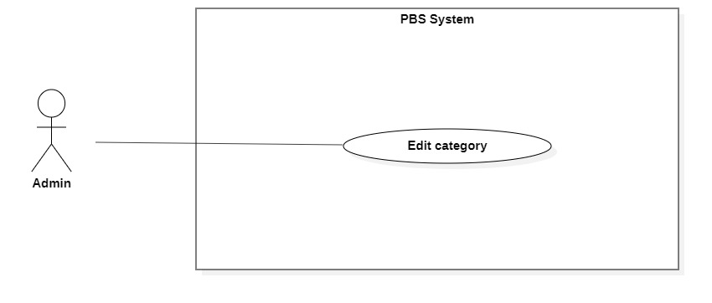

Figure 50 <Admin> Edit category

|  |  |  |  |  |  |
| --- | --- | --- | --- | --- | --- |
| UC ID and Name: | **UC – 43 Edit category** | | | | |
| Created By: | Đào Sỹ Trung Kiên | | Date Created: | 08/10/2020 | |
| Primary Actor: | Admin | | Secondary Actors: |  | |
| Trigger: | The admin sends request to edit category. | | | | |
| Description: | This use case allows Admin to edit category. | | | | |
| Preconditions: | The User has been authenticated as Admin. | | | | |
| Post-conditions: | **Success:** Category will be updated.  **Fail:** Systems outputs error message and sends to Admin. | | | | |
| Normal Flow: | **No** | **Actor Action** | | | **System Response** |
| 1 | Admin sends a request to receive a list of categories. | | | System displays list of categories.  [Exception 1] |
| 2 | Admin sends request to receive category details. | | | System requires information from admin:  - “Tên category”: text, required.  - “Icon”: image. |
| 3 | Admin inputs category required information and send request to update category. | | | System validates information, updates category, sends output message: “Chỉnh sửa thành công” to admin.  [Exception 2]  [Exception 3] |
| Alternative Flows: | N/A | | | | |
| Exceptions: | **No** | **Actor Action** | | | **System Response** |
| 1 | System retrieves an empty list of available categories. | | | System outputs the error message “Không tìm thấy category” and sends it to the admin. |
| 2 | Admin inputs invalid format text inputs or leaves empty required fields. | | | System outputs error message and send to ask admin to input correct required fields |
|  | 3 | Update category process encountered a system internal error. | | | System outputs error message to notify admin that update category failed. |
| Priority: | Medium | | | | |
| Frequency of Use: | Sometimes | | | | |
| Business Rules: | * Category “Tất cả” cannot be edited. * Category information contains: id, category name, icon link. | | | | |
| Other Information: | N/A | | | | |
| Assumptions: | N/A | | | | |

Table <Admin> Edit category specification

##### <Admin> Remove category

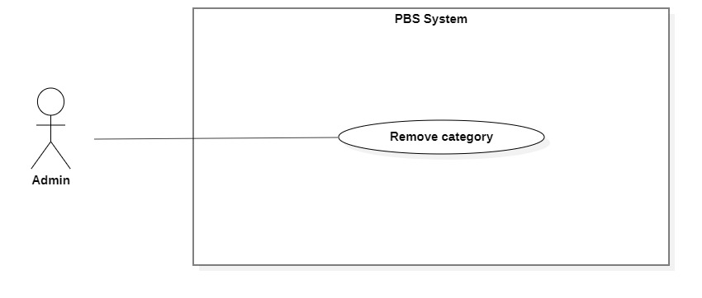

Figure 51 <Admin> Remove category

|  |  |  |  |  |  |
| --- | --- | --- | --- | --- | --- |
| UC ID and Name: | **UC – 44 Remove category** | | | | |
| Created By: | Đào Sỹ Trung Kiên | | Date Created: | 08/10/2020 | |
| Primary Actor: | Admin | | Secondary Actors: |  | |
| Trigger: | Admin sends a request to remove the category. | | | | |
| Description: | This use case allows the admin to remove category. | | | | |
| Preconditions: | The User has been authenticated as Admin. | | | | |
| Post-conditions: | **Success**: Category is removed out of the system.  **Fail**: System outputs error message and sends to Admin. | | | | |
| Normal Flow: | **Step** | **Actor Action** | | | **System Response** |
| 1 | Admin sends a request to get a list category. | | | System returns and displays list category.  [Exception 1] |
| 2 | Admin sends a request to remove category. | | | System outputs confirm messages: “Bạn có muốn xóa thể loại này không?” and requires Admin to confirm. |
| 3 | Admin confirms “Đồng ý” to remove the category. | | | System outputs and sends a message: “Xóa thể loại thành công” to the admin and updates list category.  [Exception 2] |
| Alternative Flows: | N/A | | | | |
| Exceptions: | **No** | **Actor Action** | | | **System Response** |
| 1 | System retrieves an empty list of categories. | | | System outputs the error message “Không có thể loại nào” and sends it to the admin. |
| 2 | The remove action process encountered an internal error. | | | System outputs error message and sends it to admin to notify that remove category failed. |
| Priority: | Medium | | | | |
| Frequency of Use: | Sometimes | | | | |
| Business Rules: | * Set category’s status to unavailable. * Admin can undo remove action by set category to available. * Customer will no longer can find packages or albums belongs to that category on home screen, but can still access albums or packages in photographer’s detail. | | | | |
| Other Information: | N/A | | | | |
| Assumptions: | N/A | | | | |

Table <Admin> Remove category specification

##### <Admin> Ban thread

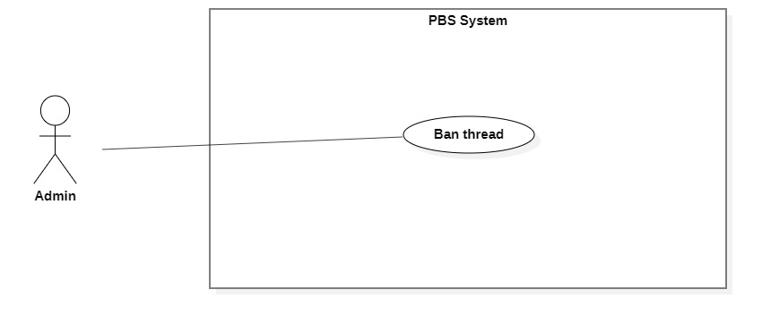

Figure 52 <Admin> Ban thread

|  |  |  |  |  |  |
| --- | --- | --- | --- | --- | --- |
| UC ID and Name: | **UC – 19 Ban thread** | | | | |
| Created By: | Bồ Công Đạt | | Date Created: | 11/11/2020 | |
| Primary Actor: | Admin | | Secondary Actors: |  | |
| Trigger: | The Admin sends request to ban thread. | | | | |
| Description: | This use case allows Admin to ban thread. | | | | |
| Preconditions: | The User has been authenticated as Admin. | | | | |
| Post-conditions: | **Success:** Thread will be banned successfully.  **Fail:** Systems outputs error message and sends to Admin. | | | | |
| Normal Flow: | **Step** | **Actor Action** | | | **System Response** |
| 1 | The Admin goes to thread view. | | | System returns information:   * Thread title: text * Thread owner’s name: text * Thread owner’s avatar: image * Thread created_date: text * Thread’s comments included: owner’s fullname, owner’s comment, commented’s date. |
| 2 | Admin sends request to ban thread | | | System ban thread and outputs message “Chặn bài đăng thành công” and sends to the admin.  [Exception 1] |
| Alternative Flows: | N/A | | | | |
| Exceptions: | **No** | **Actor Action** | | | **System Response** |
| 1 | The create process encountered an internal error. | | | System outputs error message and sends admin to notify that ban thread failed. |
| Priority: | Medium | | | | |
| Frequency of Use: | Sometimes | | | | |
| Business Rules: | * After ban thread, thread’s status will be changed to banned. * Thread will no longer exist in forum. | | | | |
| Other Information: | N/A | | | | |
| Assumptions: | N/A | | | | |

Table <Admin> Ban thread specification

##### <Admin> Unban thread

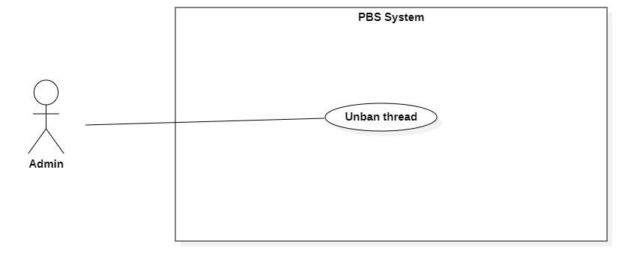

Figure <Admin> Unban thread

|  |  |  |  |  |  |
| --- | --- | --- | --- | --- | --- |
| UC ID and Name: | **UC – 20 Unban thread** | | | | |
| Created By: | Bồ Công Đạt | | Date Created: | 11/11/2020 | |
| Primary Actor: | Admin | | Secondary Actors: |  | |
| Trigger: | The Admin sends request to unban thread | | | | |
| Description: | This use case allows Admin to unban thread | | | | |
| Preconditions: | The User has been authenticated as Admin | | | | |
| Post-conditions: | **Success:** Thread will be unbanned successfully.  **Fail:** Systems outputs error message and sends to Admin | | | | |
| Normal Flow: | **Step** | **Normal Flow:** | | | **System Response** |
| 1 | Admin sends request to receive thread details. | | | System returns information:   * Thread title: text * Thread owner’s name: text * Thread owner’s avatar: image * Thread created_date: text   Thread’s comments included: owner’s fullname, owner’s comment, commented’s date. |
| 2 | Admin inputs required information and send request to unban thread | | | System validates information, ban thread and outputs message “Chặn bài đăng thành công” and sends to the admin.  [Exception 1] |
| Alternative Flows: | N/A | | | | |
| Exceptions: | **No** | **Exceptions:** | | | **System Response** |
| 1 | The create process encountered an internal error. | | | System outputs error message and sends admin to notify that unban thread failed. |
| Priority: | Medium | | | | |
| Frequency of Use: | Sometimes | | | | |
| Business Rules: | * Thread status will be changed to not banned. | | | | |
| Other Information: | N/A | | | | |
| Assumptions: | N/A | | | | |

Table <Admin> Unban thread specification

##### <Admin> Update variables

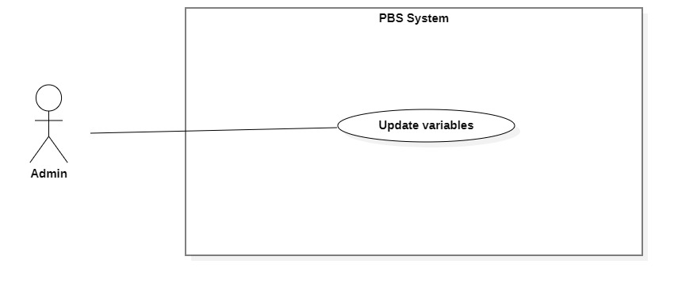

Figure 54 <Admin> Update variables

|  |  |  |  |  |  |
| --- | --- | --- | --- | --- | --- |
| UC ID and Name: | **UC – 33 Update variables** | | | | |
| Created By: | Đào Sỹ Trung Kiên | | Date Created: | 11/11/2020 | |
| Primary Actor: | Admin | | Secondary Actors: |  | |
| Trigger: | The admin sends request to update variables. | | | | |
| Description: | This use case allows Admin to update variables. | | | | |
| Preconditions: | The User has been authenticated as Admin. | | | | |
| Post-conditions: | **Success:** Variables will be updated.  **Fail:** Systems outputs error message and sends to Admin. | | | | |
| Normal Flow: | **No** | **Actor Action** | | | **System Response** |
| 1 | Admin sends request to receive variables details | | | System requires information from admin:  - “Khoảng cách”: number, required.  - “Trung bình giá dịch vụ”: number, required.  - “Đánh giá từ người dùng”: number, required.  [Exception 1] |
| 2 | Admin inputs variables required information and send request to update variables | | | System validates information, change variables, sends output message: “Chỉnh sửa thành công” to admin.  [Exception 2]  [Exception 3] |
| Alternative Flows: | N/A | | | | |
| Exceptions: | **No** | **Actor Action** | | | **System Response** |
| 1 | System retrieves an empty variable. | | | System outputs error message “Không tìm thấy trọng số nào” and sends to admin. |
| 2 | Admin inputs invalid format text inputs or leaves empty required fields. | | | System outputs error message and send to ask admin to input correct required fields |
|  | 3 | Update variables process encountered a system internal error. | | | System outputs error message to notify admin that change variables failed. |
| Priority: | Medium | | | | |
| Frequency of Use: | Sometimes | | | | |
| Business Rules: | * The sum of the variables must equal to 1. | | | | |
| Other Information: | N/A | | | | |
| Assumptions: | N/A | | | | |

Table <Admin> Change variables specification

##### <Admin> Add topic

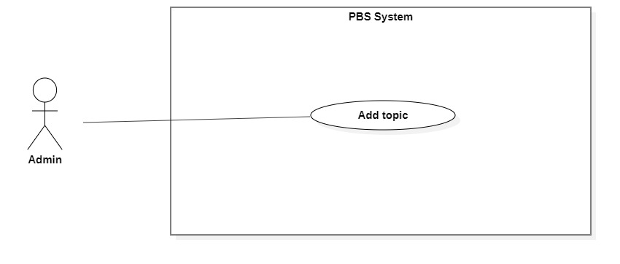

Figure <Admin> Add topic

|  |  |  |  |  |  |
| --- | --- | --- | --- | --- | --- |
| UC ID and Name: | **UC – 45 Add topic** | | | | |
| Created By: | Trương Ngọc Mỹ | | Date Created: | 01/01/2021 | |
| Primary Actor: | Admin | | Secondary Actors: |  | |
| Trigger: | The admin sends request to add topic. | | | | |
| Description: | This use case allows Admin to add new topic on forum. | | | | |
| Preconditions: | The User has been authenticated as Admin. | | | | |
| Post-conditions: | **Success:** New topic will be created on forum.  **Fail:** Systems outputs error message and sends to Admin. | | | | |
| Normal Flow: | **No** | **Actor Action** | | | **System Response** |
| 1 | Admin goes to new topic view. | | | Systems requires information from Admin:  - “Tên chủ đề”: text, required |
| 2 | Admin inputs variables required information and send request to add topic. | | | System validates information, add new topic to the system, outputs message “Đã tạo chủ đề mới”  [Exception 1]  [Exception 2] |
| Alternative Flows: | N/A | | | | |
| Exceptions: | **No** | **Actor Action** | | | **System Response** |
| 1 | Admin leaves field empty. | | | System outputs error message “Thông tin này không thể để trống” and sends to admin. |
|  | 2 | System runs into an internal server error. | | | System outputs error message to notify admin that add topic failed. |
| Priority: | Medium | | | | |
| Frequency of Use: | Sometimes | | | | |
| Business Rules: | * After topic created, user can view topic on forum, and post threads to that topic. * Topic status is available after created. | | | | |
| Other Information: | N/A | | | | |
| Assumptions: | N/A | | | | |

Table <Admin> Add topic specification

##### <Admin> Edit topic

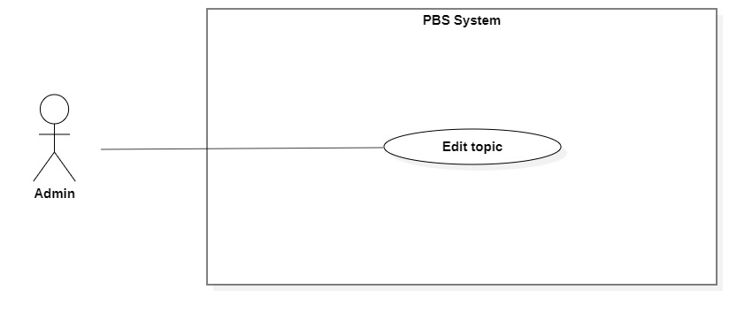

Figure <Admin> Edit topic

|  |  |  |  |  |  |
| --- | --- | --- | --- | --- | --- |
| UC ID and Name: | **UC – 46 Edit topic** | | | | |
| Created By: | Trương Ngọc Mỹ | | Date Created: | 01/01/2021 | |
| Primary Actor: | Admin | | Secondary Actors: |  | |
| Trigger: | The admin sends request to edit topic. | | | | |
| Description: | This use case allows Admin to edit topic on forum. | | | | |
| Preconditions: | The User has been authenticated as Admin. | | | | |
| Post-conditions: | **Success:** New topic will be edited on forum.  **Fail:** Systems outputs error message and sends to Admin. | | | | |
| Normal Flow: | **No** | **Actor Action** | | | **System Response** |
| 1 | Admin sends request to get topic detail. | | | System returns topic detail with following information:  - “Tên tiêu đề”: text |
| 2 | Admin inputs topic and sends request to edit topic. | | | System validates information, edit topic to the system, outputs message “Đã chỉnh sửa thành công”  [Exception 1]  [Exception 2] |
| Alternative Flows: | N/A | | | | |
| Exceptions: | **No** | **Actor Action** | | | **System Response** |
| 1 | Admin leaves field empty. | | | System outputs error message “Thông tin này không thể để trống” and sends to admin. |
|  | 2 | System runs into an internal server error. | | | System outputs error message to notify admin that add topic failed. |
| Priority: | Medium | | | | |
| Frequency of Use: | Sometimes | | | | |
| Business Rules: | * Admin can edit topic’s name. * Threads in that topic will be remained same. | | | | |
| Other Information: | N/A | | | | |
| Assumptions: | N/A | | | | |

Table <Admin> Edit topic

##### <Admin> Remove topic

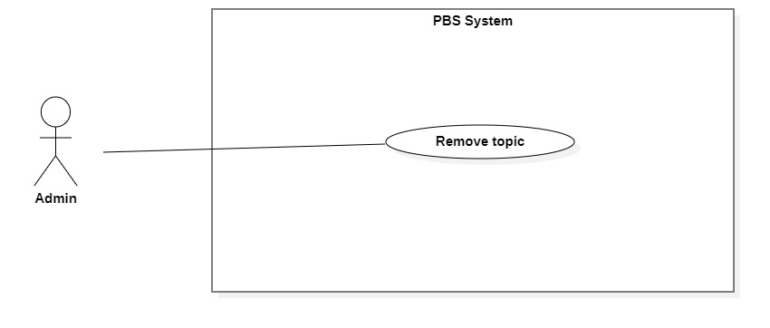

Figure <Admin> Remove topic

|  |  |  |  |  |  |
| --- | --- | --- | --- | --- | --- |
| UC ID and Name: | **UC – 47 Remove topic** | | | | |
| Created By: | Trương Ngọc Mỹ | | Date Created: | 01/01/2021 | |
| Primary Actor: | Admin | | Secondary Actors: |  | |
| Trigger: | The Admin sends request to remove topic. | | | | |
| Description: | This use case allows Admin to remove topic. | | | | |
| Preconditions: | The User has been authenticated as Admin. | | | | |
| Post-conditions: | **Success:** Topic will be set to Unavailable.  **Fail:** Systems outputs error message and sends to Admin. | | | | |
| Normal Flow: | **Step** | **Actor Action** | | | **System Response** |
| 1 | The Admin goes to topic detail. | | | System returns topic detail with following information:  - “Tên tiêu đề”: text |
| 2 | Admin send request to remove topic. | | | System shows confirmation message: “Xóa chủ đề này?” |
|  | 3 | Admin confim “Có”  [Alternative 1] | | | System removes topic and outputs message “Xóa chủ đề thành công” and sends to the admin.  [Exception 1] |
| Alternative Flows: | **Step** | **Actor Action** | | | **System Response** |
| 1 | Admin confim “Không”. | | | Back to topic view. |
| Exceptions: | **No** | **Actor Action** | | | **System Response** |
| 1 | The create process encountered an internal error. | | | System outputs error message and sends admin to notify that remove topic failed. |
| Priority: | Medium | | | | |
| Frequency of Use: | Sometimes | | | | |
| Business Rules: | * Set topic status to unavailable. * Admin can undo remove action by set topic status to available. * User can’t add posts into that topic anymore. | | | | |
| Other Information: | N/A | | | | |
| Assumptions: | N/A | | | | |

Table <Admin> Remove topic

#### 2.2.6 <<system>>Handler Overview use case

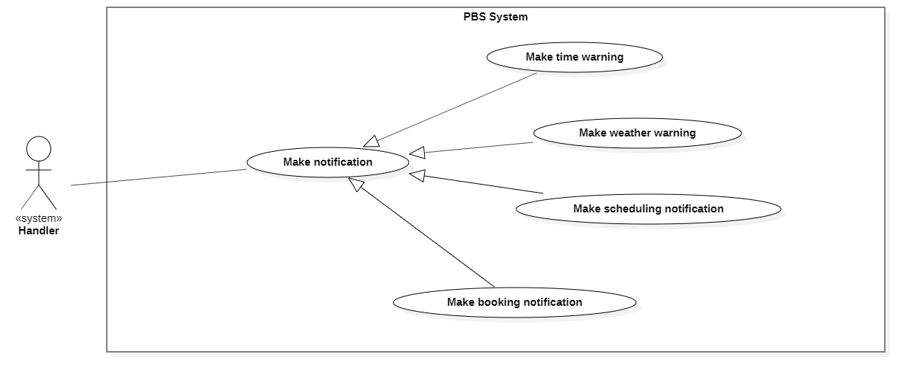

Figure 58 <<system>> Handler Overview

##### <<system>>Handler Make booking notification

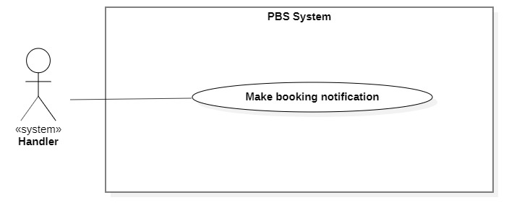

Figure 59 <<system>> Handler make booking notification

|  |  |  |  |  |  |
| --- | --- | --- | --- | --- | --- |
| UC ID and Name: | **UC – 48 Make booking notification** | | | | |
| Created By: | Bồ Công Đạt | | Date Created: | 08/10/2020 | |
| Primary Actor: | System Handler | | Secondary Actors: |  | |
| Trigger: | System handler sends request to notify photographer or customer whenever booking status is changed | | | | |
| Description: | This use case allows system handler to make booking notification | | | | |
| Preconditions: | N/A | | | | |
| Post-conditions: | **Success:** System make booking notification and sends to photographer or customer  **Fail:** System outputs error and sends to photographer or customer | | | | |
| Normal Flow: | **Step** | **Actor Action** | | | **System Response** |
| 1 | System handler retrieves booking request | | | System stores booking information and return notification to system handler |
| 2 | System handler retrieves notification information and sends to photographer or customer  [Exception 1] | | |  |
| Alternative Flows: | N/A | | | | |
| Exceptions: | **No** | **Cause** | | | **System Response** |
| 1 | The process runs into an internal error | | | System outputs error and sends to photographer or customer |
| Priority: | Medium | | | | |
| Frequency of Use: | Usually | | | | |
| Business Rules: | This use case will be triggered in following situations:   * When customer makes a new booking request. Notification will be sent to photographer. * When photographer accepts an incoming request. Notification will be sent to customer. * When photographer reject an incoming request. Notification will be sent to customer. * When customer submit to cancel a booking. Notification will be sent to photographer. * When photographer submit to cancel a booking. Notification will be sent to customer. * When admin approves cancellation. Notification will be sent to customer / photographer. * When photographer changes status of a booking from ONGOING to EDITING. Notification will be sent to customer. * When photographer changes status of a booking from EDITING to DONE. Notification will be sent to customer. | | | | |
| Other Information: | N/A | | | | |
| Assumptions: | N/A | | | | |

Table <System Handler> Make booking notification specification

##### <<system>>Handler Make scheduling notification

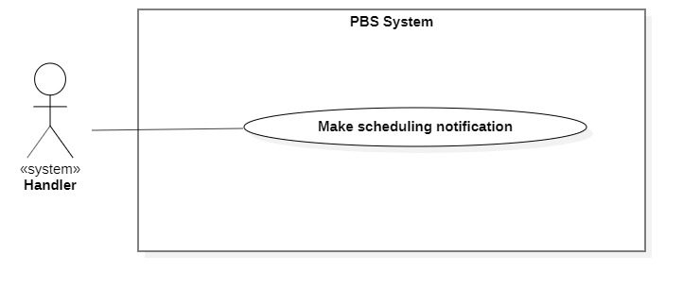

Figure 60 <<system>> Handler make scheduling notification

|  |  |  |  |  |  |
| --- | --- | --- | --- | --- | --- |
| UC ID and Name: | **UC – 49 Make scheduling notification** | | | | |
| Created By: | Bồ Công Đạt | | Date Created: | 08/10/2020 | |
| Primary Actor: | System Handler | | Secondary Actors: |  | |
| Trigger: | System handler sends a request to notify photographer or customer on scheduling. | | | | |
| Description: | This use case allows system handler to make scheduling notification | | | | |
| Preconditions: | N/A | | | | |
| Post-conditions: | **Success:** System make scheduling notification and sends to photographer or customer  **Fail:** System outputs error and sends to photographer or customer | | | | |
| Normal Flow: | **Step** | **Actor Action** | | | **System Response** |
| 1 | System handler retrieves scheduling changing request | | | System stores scheduling information and return notification to system handler |
| 2 | System handler retrieves notification information and sends to photographer or customer  [Exception 1] | | |  |
| Alternative Flows: |  | | | | |
| Exceptions: | **No** | **Cause** | | | **System Response** |
| 1 | The process runs into an internal error | | | System outputs error and sends to photographer or customer |
| Priority: | Medium | | | | |
| Frequency of Use: | Usually | | | | |
| Business Rules: | This use case will be triggered in following situations:   * For ONGOING or EDITING booking, scheduling notification will be sent in following situation: * If booking has start time or editing deadline in between 00:00 – 12:00, system will notice user at 21:00 of the day before. * If booking has start time or editing deadline in between 12:00 – 24:00, system will notice user at 07:00 of that day. | | | | |
| Other Information: | N/A | | | | |
| Assumptions: | N/A | | | | |

Table <System Handler> Make scheduling notification specification

##### <<system>>Handler Make weather warning

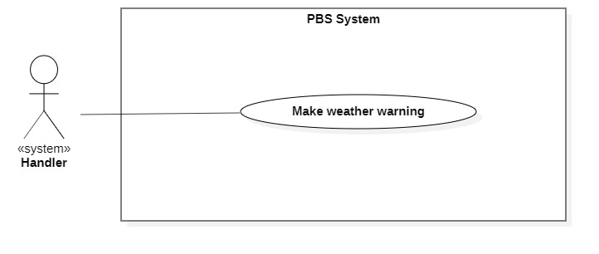

Figure 61 <<system>> Handler make weather warning

|  |  |  |  |  |  |
| --- | --- | --- | --- | --- | --- |
| UC ID and Name: | **UC – 50 Make weather warning** | | | | |
| Created By: | Bồ Công Đạt | | Date Created: | 08/10/2020 | |
| Primary Actor: | System Handler | | Secondary Actors: |  | |
| Trigger: | System handler sends requests to notify customers of bad weather. | | | | |
| Description: | This use case allows the system handler to make weather warnings. | | | | |
| Preconditions: | N/A | | | | |
| Post-conditions: | **Success:** System makes weather warning and sends to customer.  **Fail:** System outputs error and sends to photographer or customer | | | | |
| Normal Flow: | **Step** | **Actor Action** | | | **System Response** |
| 1 | System handler retrieves bad weather request | | | System stores bad weather information and return notification to system handler |
| 2 | System handler retrieves notification information and sends to photographer or customer  [Exception 1] | | |  |
| Alternative Flows: |  | | | | |
| Exceptions: | **No** | **Cause** | | | **System Response** |
| 1 | The process runs into an internal error | | | System outputs error and sends to photographer or customer |
| Priority: | Medium | | | | |
| Frequency of Use: | Usually | | | | |
| Business Rules: | This use case will be triggered in following situations:   * Customer make a new booking, system checks whether if that day’s weather is suitable for shooting and send the warning notification back to her/his. * The return information will include: datetime, location, weather information. | | | | |
| Other Information: | N/A | | | | |
| Assumptions: | N/A | | | | |

Table <System Handler> Make weather warning specification

##### <<system>>Handler Make time warning

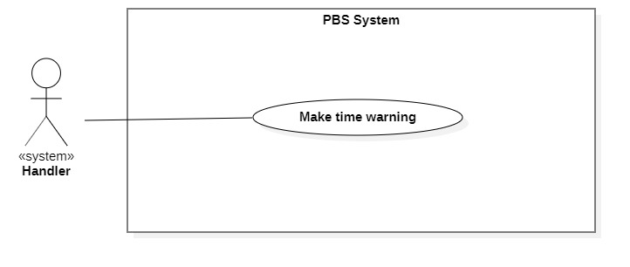

Figure 62 <<system>> Handler make time warning

|  |  |  |  |  |  |
| --- | --- | --- | --- | --- | --- |
| UC ID and Name: | **UC – 51 Make time warning** | | | | |
| Created By: | Bồ Công Đạt | | Date Created: | 08/10/2020 | |
| Primary Actor: | System Handler | | Secondary Actors: |  | |
| Trigger: | System handler sends requests to notify customers of bad time selection. | | | | |
| Description: | This use case allows the system handler to make time warnings. | | | | |
| Preconditions: | N/A | | | | |
| Post-conditions: | **Success:** System makes time warning and sends to customer.  **Fail:** System outputs error and sends to customer | | | | |
| Normal Flow: | **Step** | **Actor Action** | | | **System Response** |
| 1 | System handler retrieves bad time selection request | | | System stores bad time information and return notification to system handler |
| 2 | System handler retrieves notification information and sends to customer  [Exception 1] | | |  |
| Alternative Flows: |  | | | | |
| Exceptions: | **No** | **Cause** | | | **System Response** |
| 1 | The process runs into an internal error | | | System outputs error and sends to customer |
| Priority: | Medium | | | | |
| Frequency of Use: | Usually | | | | |
| Business Rules: | This use case will be triggered in following situations:   * Customer make a new booking, system checks whether if the selected time is too tight for photographer. * For example, photographer have a booking between 9am – 12pm 10/10/2020, if customer book at 13pm 10/10/2020, the system will suggest the customer that photographer may not be able to accept this. | | | | |
| Other Information: | N/A | | | | |
| Assumptions: | N/A | | | | |

Table <System Handler> Make time warning specification

## 3. Functional Requirements

### 3.1 System Functional Overview

#### a. Screen Flow

1. **Customer’s screen flow**

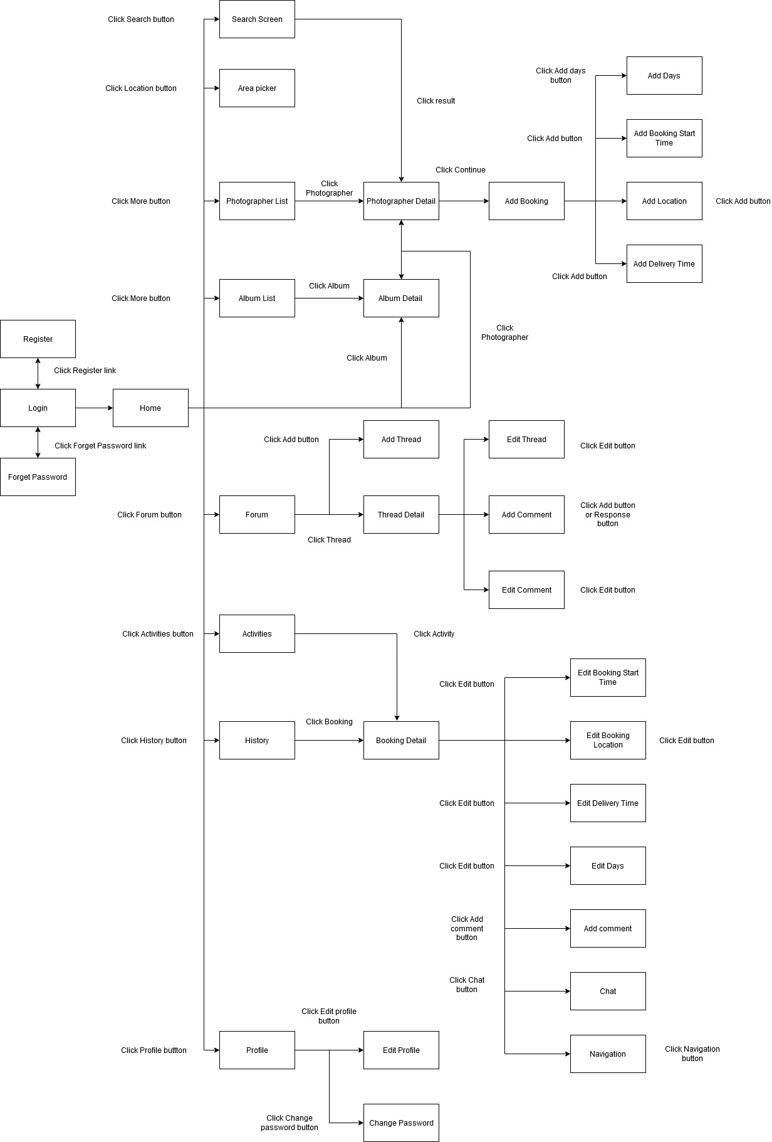

Figure 63 Customer's screen flow

1. **Photographer’s screen flow**

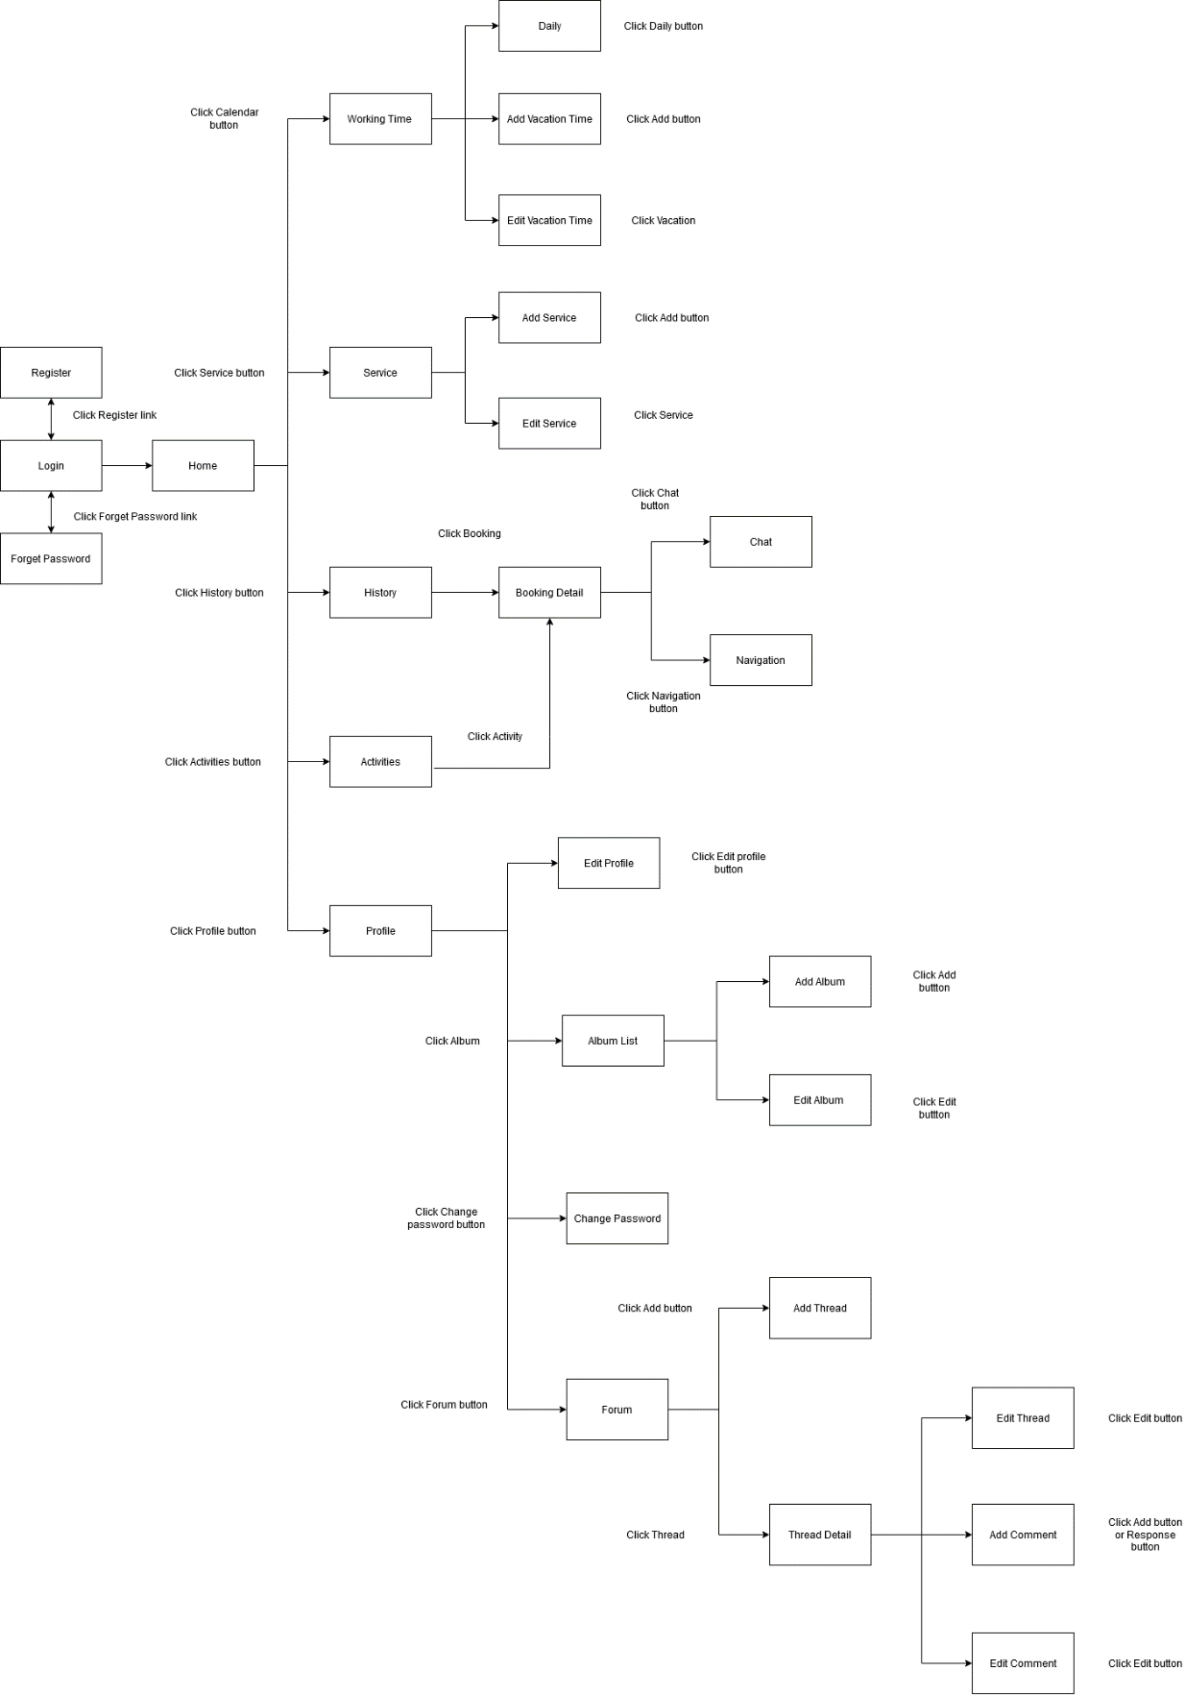

Figure 64 Photographer's screen flow

#### b. Screen Details

1. ***Customer’s screen details***

|  |  |  |  |
| --- | --- | --- | --- |
| **#** | **Feature** | **Screen** | **Description** |
| 1 | Register | Register | Register screen included: username textfield, password textfield, re-password textfield |
| 2 | Login | Login | Login screen included: username textfield, password textfield |
| 3 | Forgot password | Forgot password | Forgot password screen included: email textfield |
| 4 | View application | Home | Main screen included: Search icon, category list, photographer list, album list |
| 5 | View profile | Profile | Profile screen included: fullname, username, phone number, email. |
| 6 | Update profile | Edit profile | Edit profile screen included: fullname textfield, phone number textfield, email textfield. |
| 7 | View photographer | Photographer List | Photographer list screen included: photographer name, price, working location, rate. |
| Photographer Detail | Detail request screen included: photographer name, describe, album, review, schedule, package. |
| 9 | Booking | Add Booking | Add booking screen included: photographer name, start time button, delivery time button, location button, package drop list, delivery method drop list. |
| Add Days | Add days screen included: photographer name, days button, delivery time button, location button, package drop list, delivery method drop list. |
| Add Booking Start Time | Add booking start time screen included: calendar picker, time picker. |
| Add Location | Add location include: map picker |
| Add Delivery Time | Add delivery time screen included: calendar picker, time picker. |
| 14 | View album | Album List | Album list screen included: name, rating. |
| Album Detail | Album detail screens include: name, rating, describe, date, location. |
| 16 | View forum | Forum | Forum screen included: list thread |
| 17 | Add thread | Add Thread | Add thread screen included: name textfield , topic button, detail textfield |
| 18 | View thread | Thread Detail | Thread detail screen included: thread, comment |
| 19 | Edit thread | Edit Thread | Edit thread screen included: name textfield, detail textfield |
| 20 | Add comment in forum | Add Comment | Add comment screen included: comment textfield |
| 21 | Edit comment in forum | Edit Comment | Edit comment screen included: comment textfield |
| 22 | View booking | History | History screen included: booking list |
| Booking Detail | Booking detail screen included: photographer name, chat, location, start time, delivery time, delivery method, package |
| 24 | Edit booking | Edit Booking Start Time | Edit booking start time screen included: time picker, calendar picker |
| Edit Booking Location | Edit booking location screen included: map picker |
| Edit Delivery Time | Edit delivery screen included: time picker, calendar picker |
| Edit Days | Edit days screen included: days button |
| 27 | Add comment | Add Comment | Add comment screen included: rating slider, comment textfield |
| 28 | Chat | Chat | Chat screen included: chat bubble, chat textfield |
| 29 | Pick shooting area | Area Picker | Area picker screen included: map picker |
| 30 | Search photographer and package | Search | Search screen included: search area, result area |
| 31 | Change password | Change Password | Change password screen included: old password, new password, re-enter password |
| 32 | Keep track of system notifications | Activities | Activities screen included: Activities list |
| 33 | Navigation | Navigation | Navigation screen included: map |

Table Customer's screen details

1. ***Photographer’s screen details***

|  |  |  |  |
| --- | --- | --- | --- |
| **#** | **Feature** | **Screen** | **Description** |
| 1 | Register | Register | Register screen included: username textfield, password textfield, re-password textfield |
| 2 | Login | Login | Login screen included: username textfield, password textfield |
| 3 | Forgot password | Forgot password | Forgot password screen included: email textfield |
| 4 | View application | Home | Main screen included: calendar icon, pending task list, to do task list |
| 5 | View profile | Profile | Profile screen included: fullname, username, phone number, working location, email. |
| 6 | Update profile | Edit profile | Edit profile screen included: fullname textfield, phone number textfield, working location picker, email textfield. |
| 7 | View album | Album List | Album list screen included: album picture |
| 8 | Add album | Add Album | Add album screen included: album name textfield, date picker, location picker, describe textfield, category picker, photo picker |
| 9 | Edit album | Edit Album | Edit album screen included: album name textfield, date picker, location picker, describe textfield, category picker, photo picker |
| 10 | View forum | Forum | Forum screen included: list thread |
| 11 | Add thread | Add Thread | Add thread screen included: name textfield, topic button, detail textfield |
| 12 | View thread | Thread Detail | Thread detail screen included: thread, comment |
| 13 | Edit thread | Edit Thread | Edit thread screen included: name textfield, detail textfield |
| 14 | Add comment in forum | Add Comment | Add comment screen included: comment textfield |
| 15 | Edit comment in forum | Edit Comment | Edit comment screen included: comment textfield |
| 16 | Booking | History | History screen included: booking list |
| Booking Detail | Booking detail screen included: customer name, chat, location, start time, delivery time, delivery method, package |
| 17 | Chat | Chat | Chat screen included: chat bubble, chat textfield |
| 18 | View working time | Working time | Working time screen included: daily button, add vacation button, vacation day list |
| 19 | Manage daily working time | Daily | Daily screen included: day of the week picker, begin time picker, end time picker |
| 20 | Add vacation time | Add Vacation time | Add vacation time included: calendar picker, name textfield |
| 21 | Edit vacation time | Edit Vacation time | Edit vacation time included: calendar picker, name textfield |
| 22 | View Service | Service | Service screen included: service list |
| 23 | Add Service | Add Service | Add service included: service type radio button, service name textfield, category drop list, describe textfield, duration textfield, price textfield, delivery type picker, detail list |
| 24 | Edit Service | Edit Service | Edit service included: service type radio button, service name textfield, category drop list, describe textfield, duration textfield, price textfield, delivery type picker, detail list |
| 25 | Change password | Change Password | Change password screen included: old password, new password, re-enter password |
| 26 | Keep track of system notifications | Activities | Activities screen included: Activities list |
| 27 | Navigation | Navigation | Navigation screen included: map |

Table Photographer's screen details

#### c. Screen Authorization

|  |  |  |  |  |  |
| --- | --- | --- | --- | --- | --- |
| **Screen** | **Guest** | **Customer** | **Photographer** | **Admin** | **Authenticated User** |
| Register | X |  |  |  |  |
| Login |  | X | X | X | X |
| Forgot password |  | X | X | X | X |
| Home |  | X | X | X | X |
| Profile |  | X | X | X | X |
| Edit profile |  | X | X | X | X |
| Photographer List |  | X |  |  | X |
| Photographer Detail |  | X |  |  | X |
| Add Booking |  | X |  |  | X |
| Add Days |  | X |  |  | X |
| Add Booking Start Time |  | X |  |  | X |
| Add Location |  | X |  |  | X |
| Add Delivery Time |  | X |  |  | X |
| Album List |  | X | X |  | X |
| Album Detail |  | X | X |  | X |
| Add Album |  |  | X |  | X |
| Edit Album |  |  | X |  | X |
| Forum |  | X | X | X | X |
| Add Thread |  | X | X | X | X |
| Thread Detail |  | X | X | X | X |
| Edit Thread |  | X | X | X | X |
| Add Comment in Forum |  | X | X | X | X |
| Edit Comment in Forum |  | X | X | X | X |
| History |  | X | X |  | X |
| Booking Detail |  | X | X |  | X |
| Edit Booking Start Time |  | X |  |  | X |
| Edit Booking Location |  | X |  |  | X |
| Edit Delivery Time |  | X |  |  | X |
| Edit Days |  | X |  |  | X |
| Add Comment |  | X |  |  | X |
| Chat |  | X | X |  | X |
| Area Picker |  | X |  |  | X |
| Working time |  |  | X |  | X |
| Daily |  |  | X |  | X |
| Add Vacation time |  |  | X |  | X |
| Edit Vacation time |  |  | X |  | X |
| Service |  |  | X |  | X |
| Add Service |  |  | X |  | X |
| Edit Service |  |  | X |  | X |
| Change Password |  | X | X | X | X |
| Activities |  | X | X | X | X |
| Navigation |  | X | X |  | X |

*Figure 53 Screen authorization*

In which:

* Guest: The user has not registered for an account.
* Customer: The user who used this app for booking photographer services.
* Photographer: The user who used this app for providing services.
* Admin: The user who manages the whole system.
* Authenticated user: The user who has logged in to the system successfully.

#### d. Non-Screen Functions

|  |  |  |  |
| --- | --- | --- | --- |
| **No** | **Feature** | **System Function** | **Description** |
| 1 | Authentication | Register | Function allows user to register into the system to be either photographer or customer. |
| Login | Function allows user to log into the system if they have account. |
| 2 | Booking | Book photographer | Function allows customer to book a photographer. |
| Accept booking | Function allows photographer to accept incoming request. |
| Reject booking | Function allows photographer to reject incoming request. |
| Cancel booking | Function allows photographer or customer to submit cancellation to admin. And then admin will approve or warn them about the cancellation. |
| Edit booking | Function allows customer to edit their request, they can edit information like time, location or package. |
| Review booking | Function allows customer to review booking after it done. |
| 3 | Photographer | Manage package | Function allows photographer to manage their package service. |
| Manage album | Function allows photographer to manage their album. |
| Manage working calendar | Function allows photographer to manage their working schedule including add busy day, edit working weekday. |
| 4 | Forum | Open thread | Function allows user to open new thread. |
| Edit thread | Function allows user to edit their posted thread. |
| Comment thread | Function allows user to comment on a thread. |
| Ban thread | Function allows admin to ban a thread. |
| 5 | Profile | Edit profile | Function allows user to change their basic information like full name, avatar, etc. |
| Change password | Function allows user to change their password. |
| 6 | Notification | Make weather warning | Function allows system to warn customer about bad weather. |
| Make scheduling notification | Function allows system to notify customer or photographer on their schedule. |
| Make booking notification | Function allows system to notify customer or photographer about booking. |

Table Non-screen functions

#### e. Entity Relationship Diagram

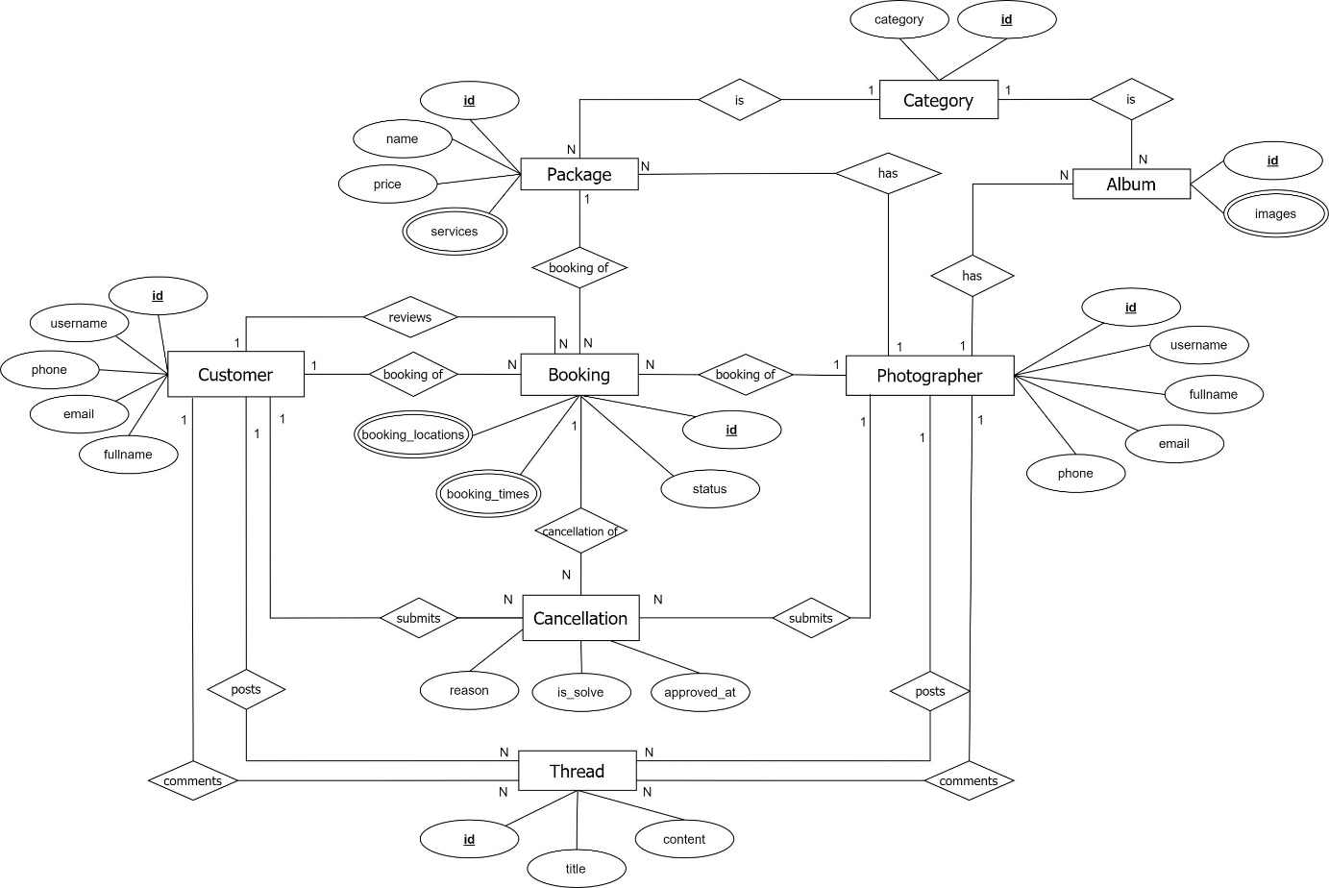

Figure 65 ER Diagram

**Entities List**

|  |  |  |
| --- | --- | --- |
| **#** | **Entity** | **Description** |
| 1 | Customer | Customer is an entity representing the person who purchases bookings from photographers: id, username, fullname, phone, email. |
| 2 | Booking | Booking is an entity represents the photography deal between photographer and customer: id, status, booking_times, booking_locations. |
| 3 | Photographer | Photographer is an entity that represents the person who provides the photography services and takes customers’ deals. |
| 4 | Category | Category is an entity represents the type of albums or package (is it wedding or look book or anything else): id, category. |
| 5 | Album | Album is an entity represents the images which photographer wants to show the customers to attract them: id, images. |
| 6 | Package | Package is an entity represents the photography services which photographer provided: id, name, price, services. |
| 7 | Thread | Thread is an entity represents a post of photographer or customer or admin on forum: id, title, content, comments. |
| 8 | Cancellation | Cancellation is an entity represents a cancellation of a booking, submitted by customer or photographer and will be handled by admin. |

Table Entities List

## 4. Non-Functional Requirements

### 4.1 External Interfaces

#### a. User Interfaces

For web application:

UI-1: GUI has to be simple and easy to use.

UI-2: The language used in the web application is Vietnamese.

UI-3: The web application has to be responsive on multiple devices: laptop, tablet and mobile.

For mobile application:

UI-1: User interface is pleasant to look at and easy to use.

UI-2: The language is Vietnamese.

UI-3: The user interface can be responsive on multiple screen sizes.

UI-4: The functionalities are arranged clearly.

#### b. Software Interfaces

This system will have required software MySQL to program and create and manage the database for the system. Use for source control is Git and GitHub. Test browsers use Chrome 96 or above. Specification for developing the web application is Java EE 11.0.8. Program tools are Visual Studio Code, Android Studio, IntelliJ.

The system will require software window 7 and window 10 to program and manage photographer booking systems. Booking process of the system that organizes the distribution of users in the mobile app and able to do this manage review.

#### c. Hardware Interfaces

Just like any other system, this system requires a basic computer that consists of CPU, monitor, keyboard and mouse or laptop and smartphone for input and output. Smartphones could be used to do booking and use the system. Besides, for direction the system connected with a GPS device in every smartphone to get the location detail.

#### d. Communications Interfaces

The system communication interface is completely dependent on correctly sending and retrieving data from the database. Other than that is an online protocol to connect between GPS and the mobile.

### 4.2 Quality Attributes

#### a. Usability

* The system does not require its users to have any technical knowledge before using its functionalities.
* Layout and navigation are clear and easy to use.
* Customers can use PSB easily even if they have never used it before. They can find a photographer and make a request within 5 minutes.
* Photographers can use PSB easily even if they have never used it before. They can view and confirm requests received from the customers within 5 minutes. They can also use other functionalities quickly and effectively with easy-to-understand instructions and simple operation.

#### b. Reliability

* The availability of the system is 80%. The system can be used within 60 minutes and will automatically log the user out if there is no operation within 5 minutes.

#### c. Performance

All requests will be processed within 10 seconds on an Internet connection above 25Mbps.

#### d. Dependability

##### d1. Security

* All user’s passwords will be encrypted before being saved into the database.
* Accounts will be verified by email.
* Username must be unique.
* Photographers’ email and phone number will be secured.

##### d2. Safety

* A service price a photographer has posted cannot be changed when a customer chooses that service. If there is a surcharge, it must be negotiated with the customer.
* When the photos return day has come, if the photographer does not return the photos, the request will be cancelled automatically.

#### e. Supportability

* Online bookings in real time: The customer will be able to see all the available dates directly, and make a booking. If there is no further availability on one date, this will be blocked in real time to prevent further bookings.
* Intelligent calendar: An intelligent and easy-to-understand booking or occupancy calendar provides the user with a summary of all bookings, capacity and turnover for the required periods at a glance.
* Online and chat support for booking systems.
* Booking management via smartphone.

#### f. Design Constraints

* The software language is Vietnamese.
* The software process is Scrum.

#### g. Support Documents

The system does not use any references to support document writing.

#### h. Purchased Components

To support the system operation, we have used some third-party services such as:

* Google Map API.
* AWS S3.
* ClimaCell weather api.

## 5. Other Requirements

### 5.1 Messages List

|  |  |  |  |  |
| --- | --- | --- | --- | --- |
| # | Message code | Message Type | Context | Content |
| 1 | MSG01 | In line | There is not any search result | Không có kết quả. |
| 2 | MSG02 | In red, under the text box | Input-required fields are empty | Thông tin này là bắt buộc. |
| 3 | MSG03 | Toast message | Updating asset(s) information successfully | Cập nhật thành công. |
| 4 | MSG04 | Toast message | Adding new asset successfully | Thêm * thành công. |
| 5 | MSG05 | Toast message | Confirming email of asset hand-over is sent successfully | A confirmation email has been sent to {email_address}. |
| 6 | MSG06 | Toast message | Resetting asset information successfully | Thay đổi * thành công |
| 7 | MSG07 | Toast message | Deleting asset information successfully | Xóa * thành công. |
| 8 | MSG08 | In red, under the text box | Input value length > max length | Bạn vui lòng nhập đủ{max_length} ký tự. |
| 9 | MSG09 | In line | Username or password is not correct when clicking sign-in | Thông tin đăng nhập không chính xác. |
| 10 | MSG10 | In line | Password and Confirm password are not matched. | Mật khẩu nhập lại không khớp. |
| 11 | MSG11 | Toast message | Register successfully | Đăng ký thành công |
| 12 | MSG12 | In red, under the text box | Email is invalid | Email mail này không hợp lệ. Vui lòng nhập email khác |
| 13 | MSG13 | In red, under the text box | Username is existing | Tên đăng nhập của bạn đã có người sử dụng. Vui lòng nhập tên khác |
| 14 | MSG14 | Toast message | The customer book photographer successfully. | Gửi yêu cầu thành công. |
| 15 | MSG15 | In red, under the text box | The customer does not choose a calendar and address. | Bạn chưa chọn thông tin. |
| 16 | MSG16 | Notifications | The system sends notifications to the customer when photographers accept requests. | Yêu cầu của bạn đã được xác nhận |
| 17 | MSG17 | Notifications | The system sends notification to the customer when a photographer declines a request. | Yêu cầu của bạn đã bị từ chối. |
| 18 | MSG18 | In red, under the text box | Current password is invalid | Mật khẩu nhập lại chưa chính xác |
| 19 | MSG19 | Toast message | The system shows notifications to the admin when blocking users. | Bạn có muốn khóa người dùng này? |
| 20 | MSG20 | Toast message | The admin block user successfully. | Người dùng đã được khóa thành công. |
| 21 | MSG21 | Toast message | The system sends notifications to the user when the account has been blocked. | Tài khoản của bạn đã bị vi phạm. Vui lòng liên hệ với quản trị viên |
| 22 | MSG22 | Toast message | The system shows notifications to the admin when unblocking the user. | Bạn có muốn mở khóa người dùng này? |
| 23 | MSG23 | Toast message | The system sends notifications to the user when the account has unblocked. | Người dùng đã được mở khóa thành công |
| 24 | MSG24 | In red, under the text box | Information is duplicated | * đã tồn tại. |

Table Messages List

# IV. Software Design Document

## 1. Overall Description

### 1.1 Assumptions

Assuming all the users for this system have basic mobile knowledge and knows how to operate the system smoothly.

### 1.2 Design Constraints

Hard drive space: The system will need at least 8GB storage space and minimum 1GB Storage space in order to run the booking system.

## 2. System Architecture Design

### 2.1 Overall Architecture

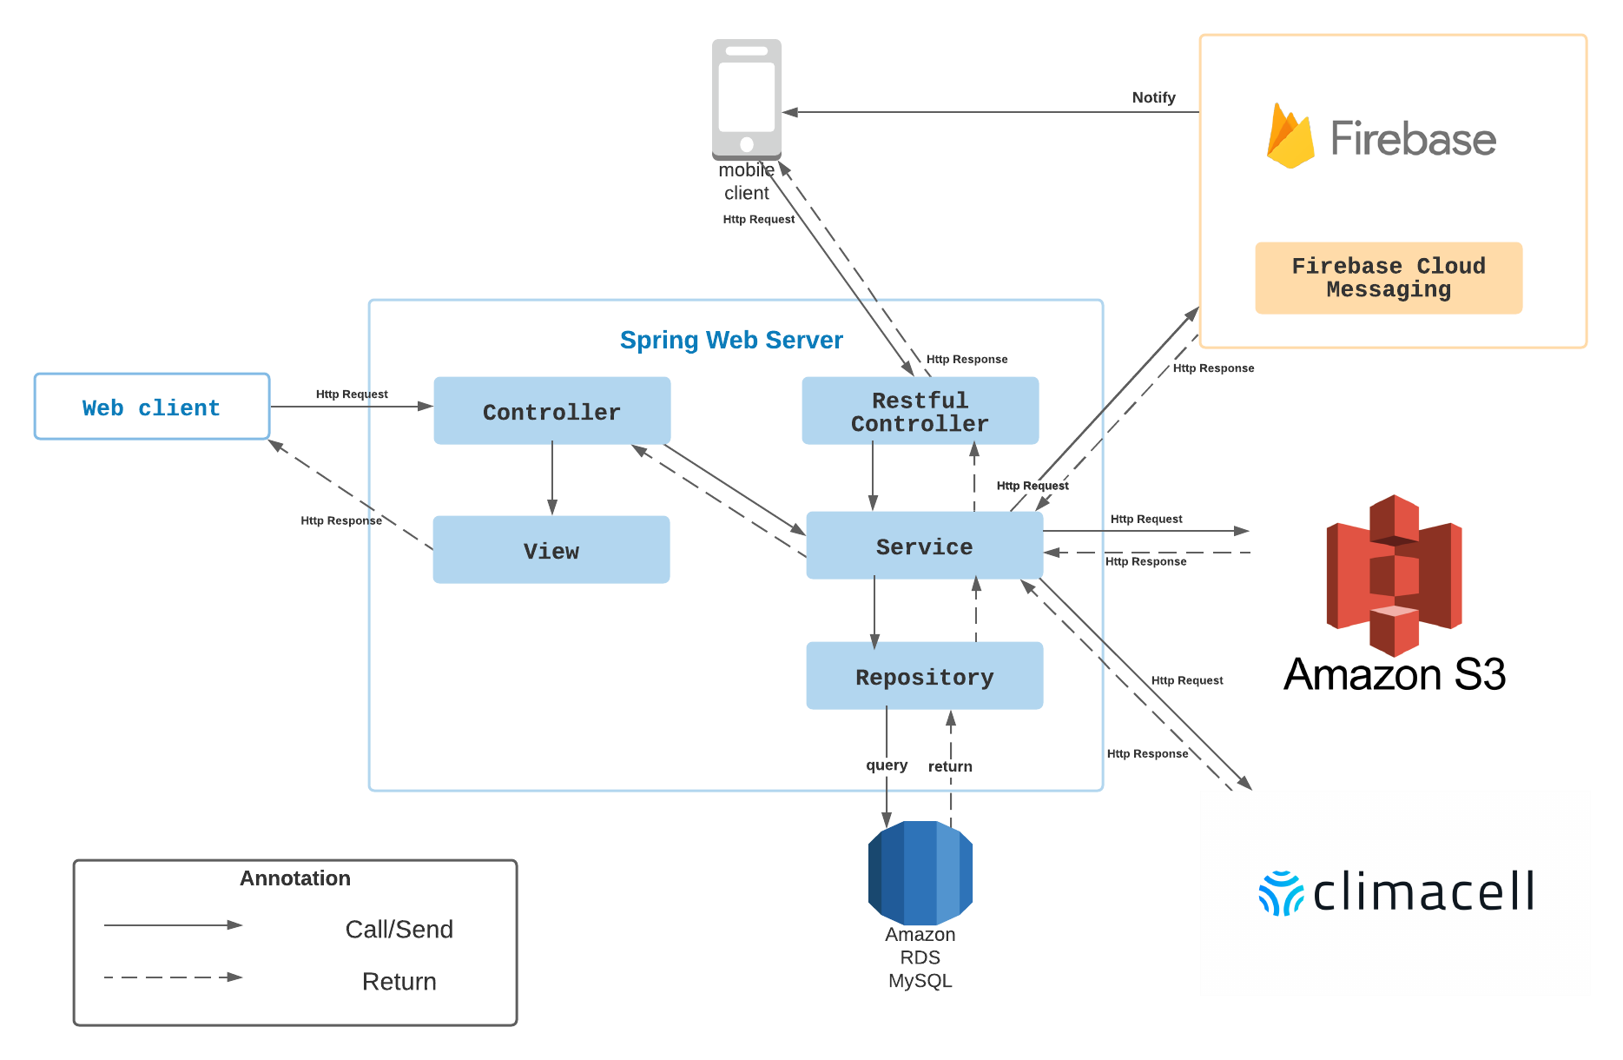

Figure 66 Overall Architecture

PBS system consists of three components, the spring boot web server provides APIs, two mobile applications for customers and photographers, and the web application for admin roles.

We also use several third-party services such as Aws S3 for image storage, Firebase cloud messaging for push notification functions and Amazon RDS for MySQL instances.

### 2.2 System Architecture

**2.2.1 Web server architecture**

We build our web server following n-tier architecture. We decided to use this pattern for several reasons:

* It has been proven to be a scalable architecture model.
* Provide reusability, maintainability and fault tolerance.
* Helps our members to create reusable and flexible functionality.

**2.2.2 Mobile app architecture**

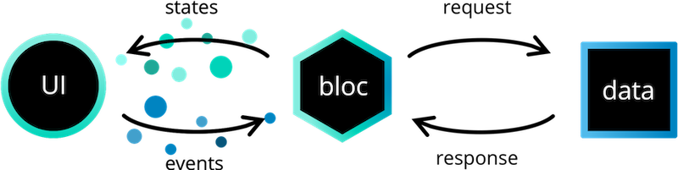

Figure 67 Mobile App Architecture

*Reference:* [*https://bloclibrary.dev/#/architecture*](https://bloclibrary.dev/#/architecture)

Bloc pattern allow us to separate our mobile app into 3 layers:

* Presentation: UI
* Business Logic Component: bloc (where we can manage events – click, tap, etc. - send a request to data layer, then retrieve data from data layer and response to input from UI through states).
* Data Layer: Repository (where we can retrieve data from sources).

### 2.3 Package Diagram

**2.3.1 Webapi**

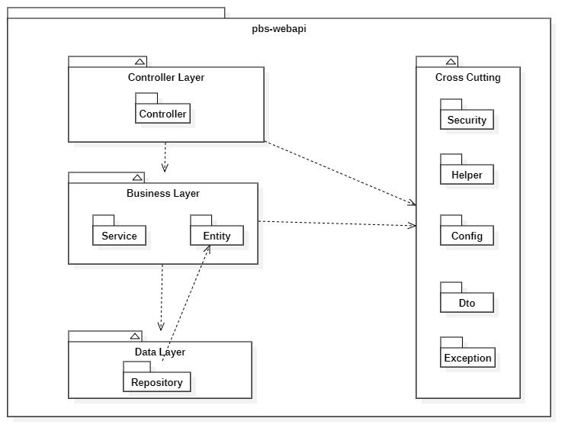

Figure 68 Webapi Package Diagram

|  |  |  |
| --- | --- | --- |
| **No** | **Package** | **Description** |
| 01 | Controller | Package contains classes responsible for handling Http request and return responses with values |
| 02 | Service | Package contains classes responsible for handling business logic, validation and communicate with repository |
| 03 | Entity | Package contains classes represents the business logic entities, also responsible for code first approach with hibernate |
| 04 | Repository | Package contains classes responsible for executing query and communicate with database |
| 05 | Security | Package contains classes responsible for performing security includes jwt handling, authentication and authorization |
| 06 | Helper | Package contains classes responsible for utilizing like map helper, datetime helper, String helper |
| 07 | Config | Package contains classes responsible for configuring spring boot app, from security, application properties to firebase notification |
| 08 | Exception | Package contains classes responsible for handling exception, including status code mapping or error messages returning |
| 09 | Dto | Package contains classes responsible for sharping the data to return to clients |

Table Package Diagram Description

**2.3.2 Mobile App**

Both mobile apps share a same project structuring, so we use one diagram to represents both of them here:

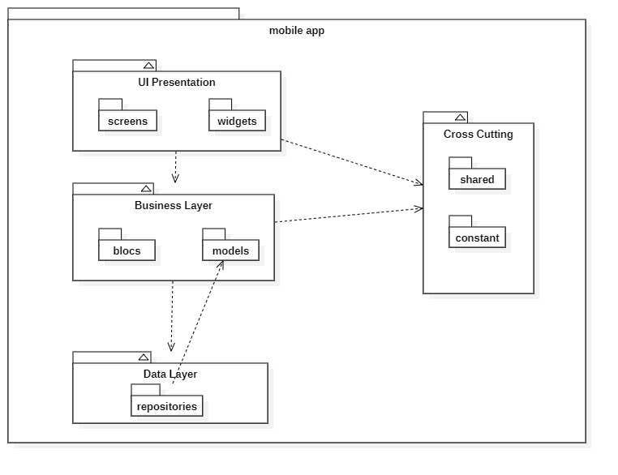

Figure 69 Package Diagram – Mobile app

|  |  |  |
| --- | --- | --- |
| **No** | **Package** | **Description** |
| 01 | screens | Package contains classes for UI representation |
| 02 | widgets | Package contains classes to form the widgets used by screens |
| 03 | blocs | Package contains classes to implement the bloc architecture including bloc’s state, bloc’s event |
| 04 | models | Package contains classes to form an object extracted from api |
| 05 | repositories | Package contains classes responsible for communicating with api server |
| 06 | shared | Package contains classes responsible for utilizing and environment variables |
| 07 | constant | Package contains classes represents the constants used by application |

Table Package Diagram Description

## 3. System Detailed Design

### 3.1 Overall

#### a. Class Diagram

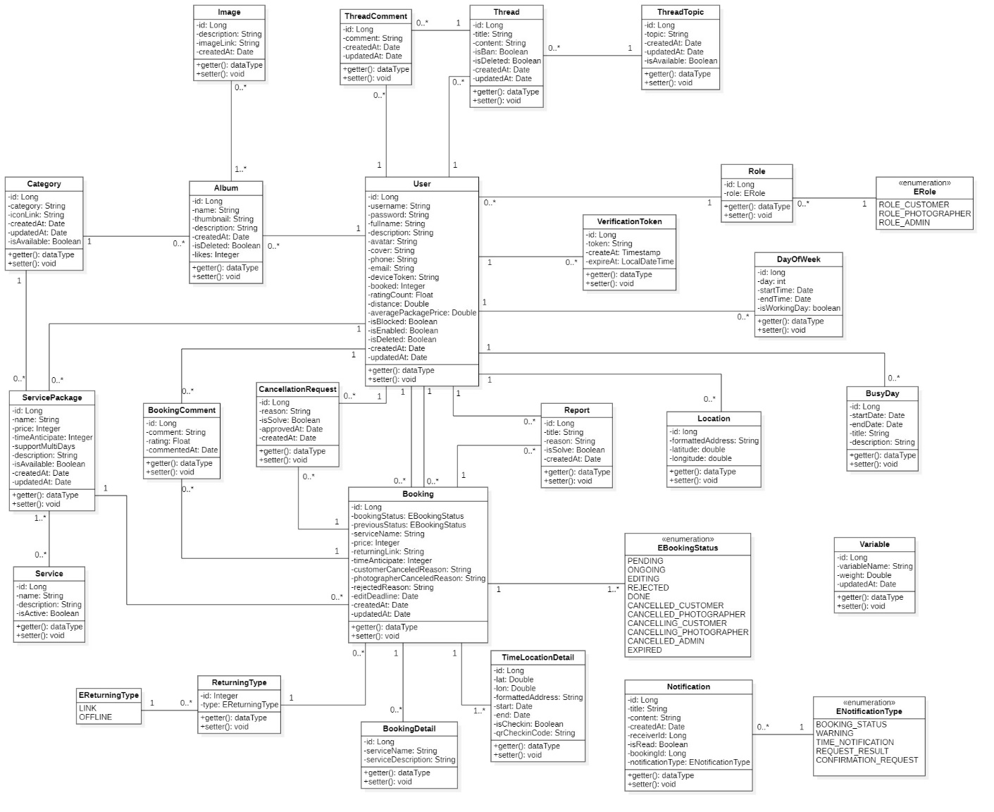

Figure 70 Class Diagram

#### b. Sequence Diagram(s)

1. Add Category

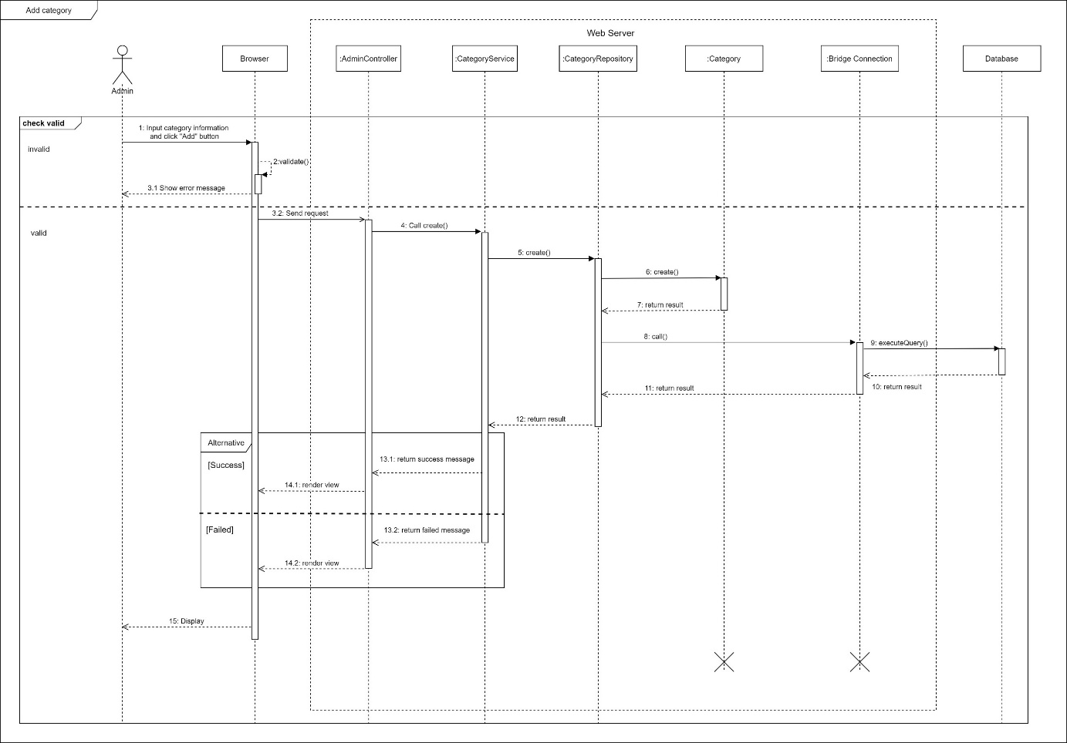

Figure 71 Sequence Diagram - Add Category

1. Edit Category

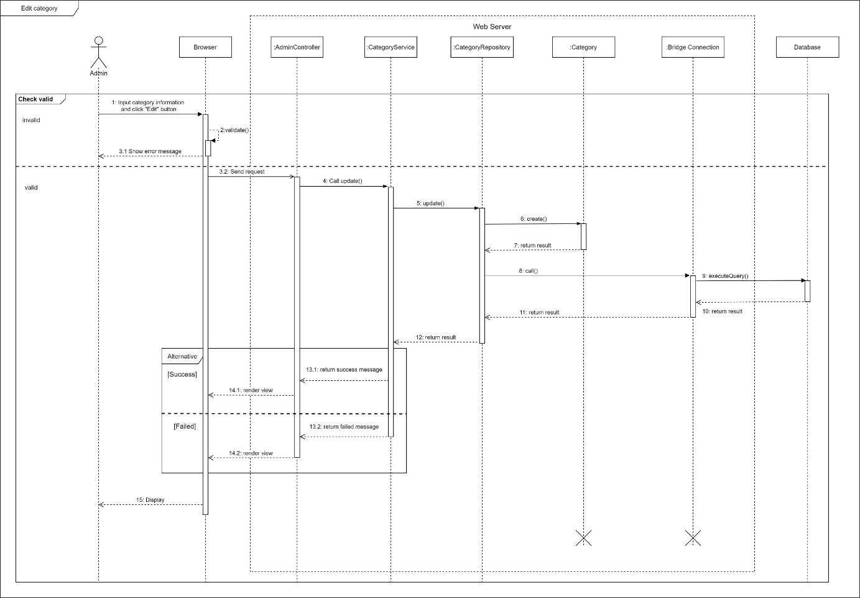

Figure 72 Sequence Diagram - Edit Category

1. Remove category

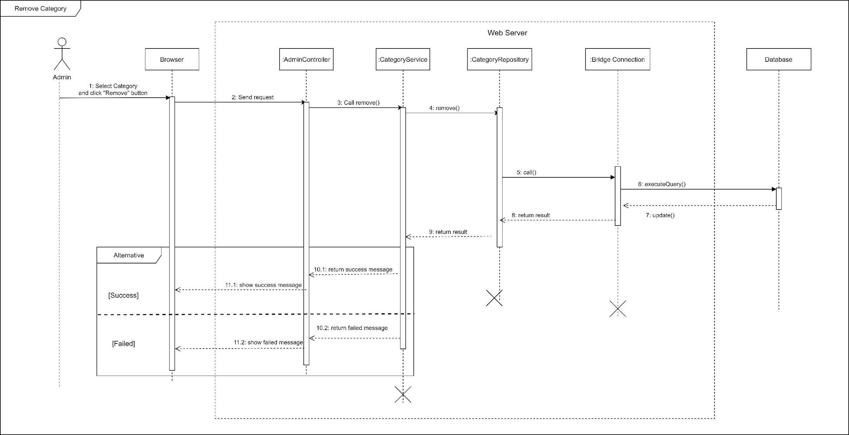

Figure 73 Sequence Diagram - Remove Category

1. Block user

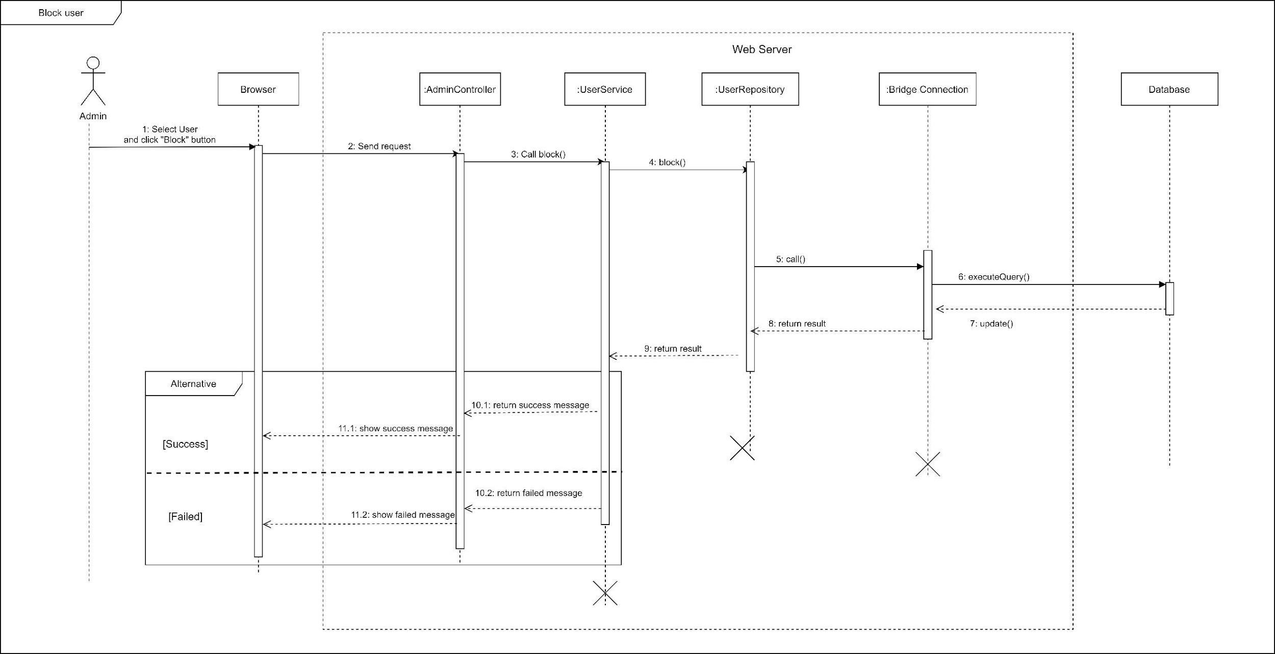

Figure Sequence Diagram - Block user

1. Unblock user

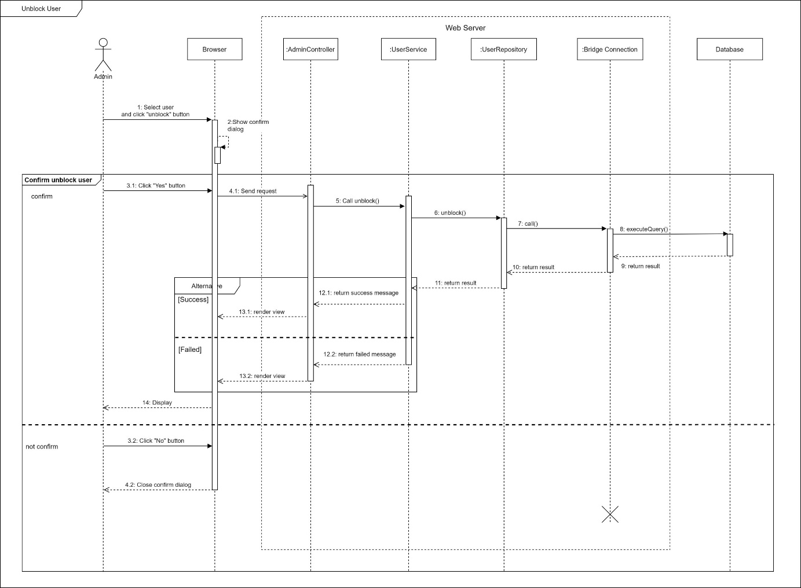

Figure 75 Sequence Diagram - Unblock User

1. Warn user

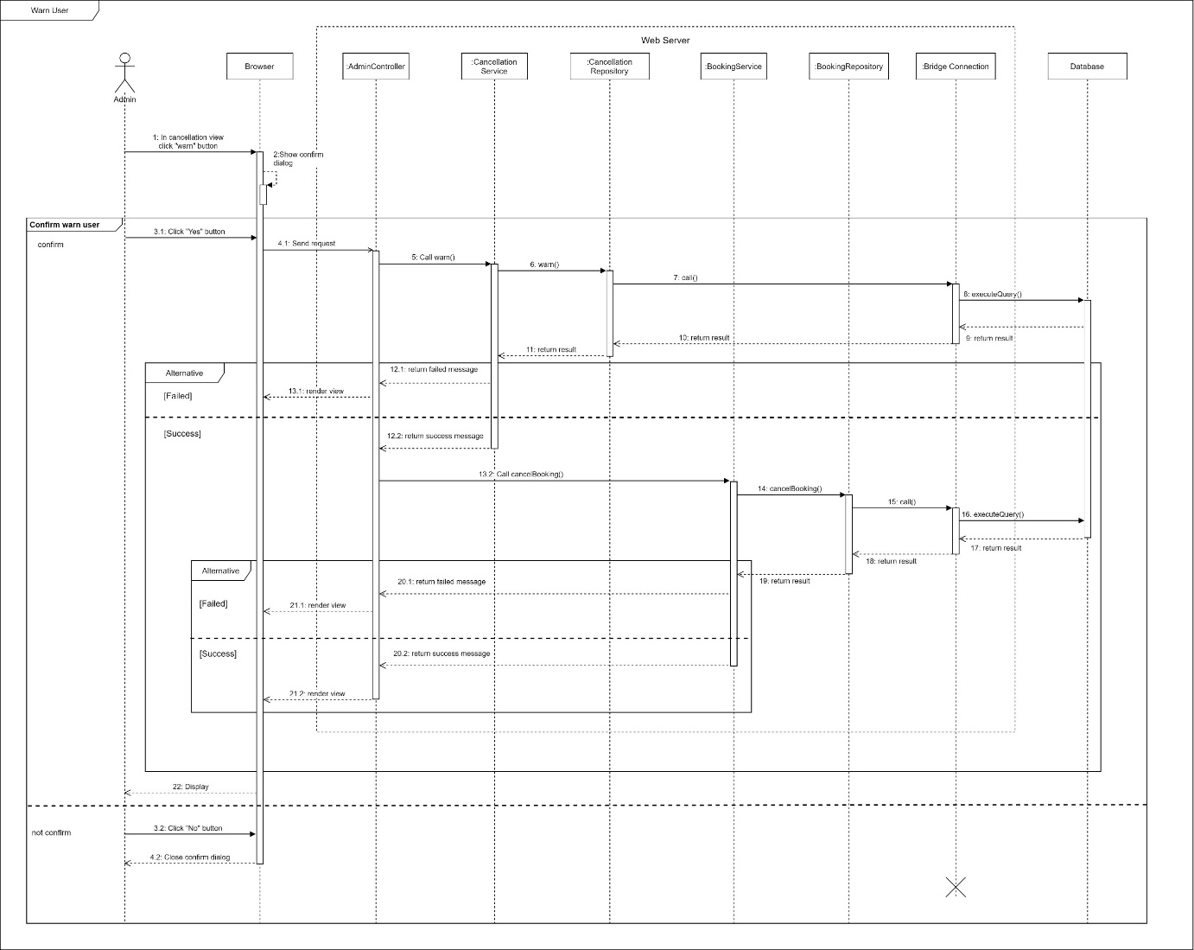

Figure Sequence Diagram - warn user

1. Approve cancellation

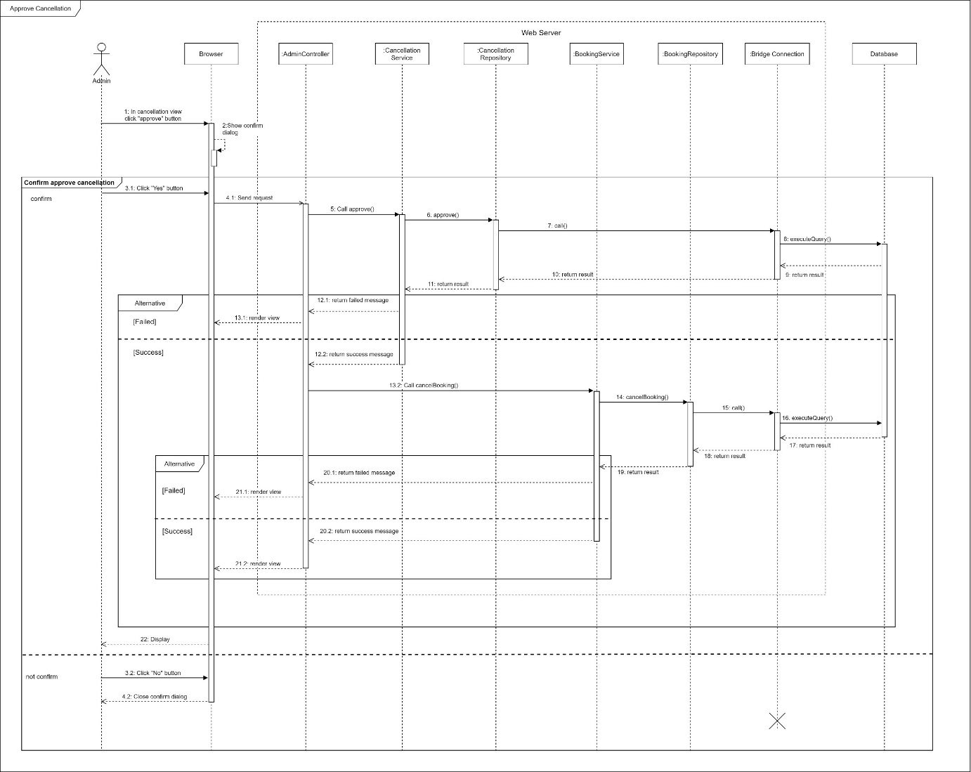

Figure Sequence Diagram - approve cancellation

1. Update variables

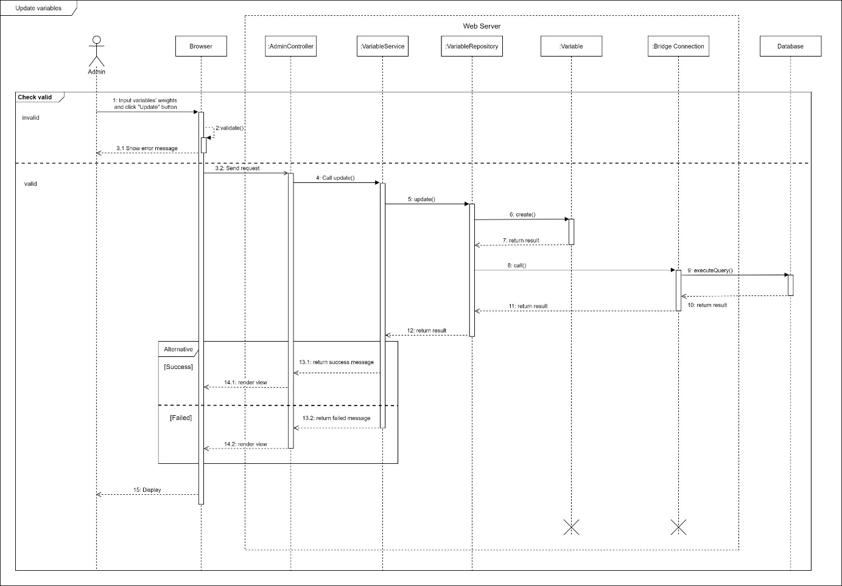

Figure 78 Sequence Diagram - Update Variables

#### c. Activity Diagram(s)

1. **<Customer>** **Book photographer**

Summary: This diagram shows the process when customer books a photographer.

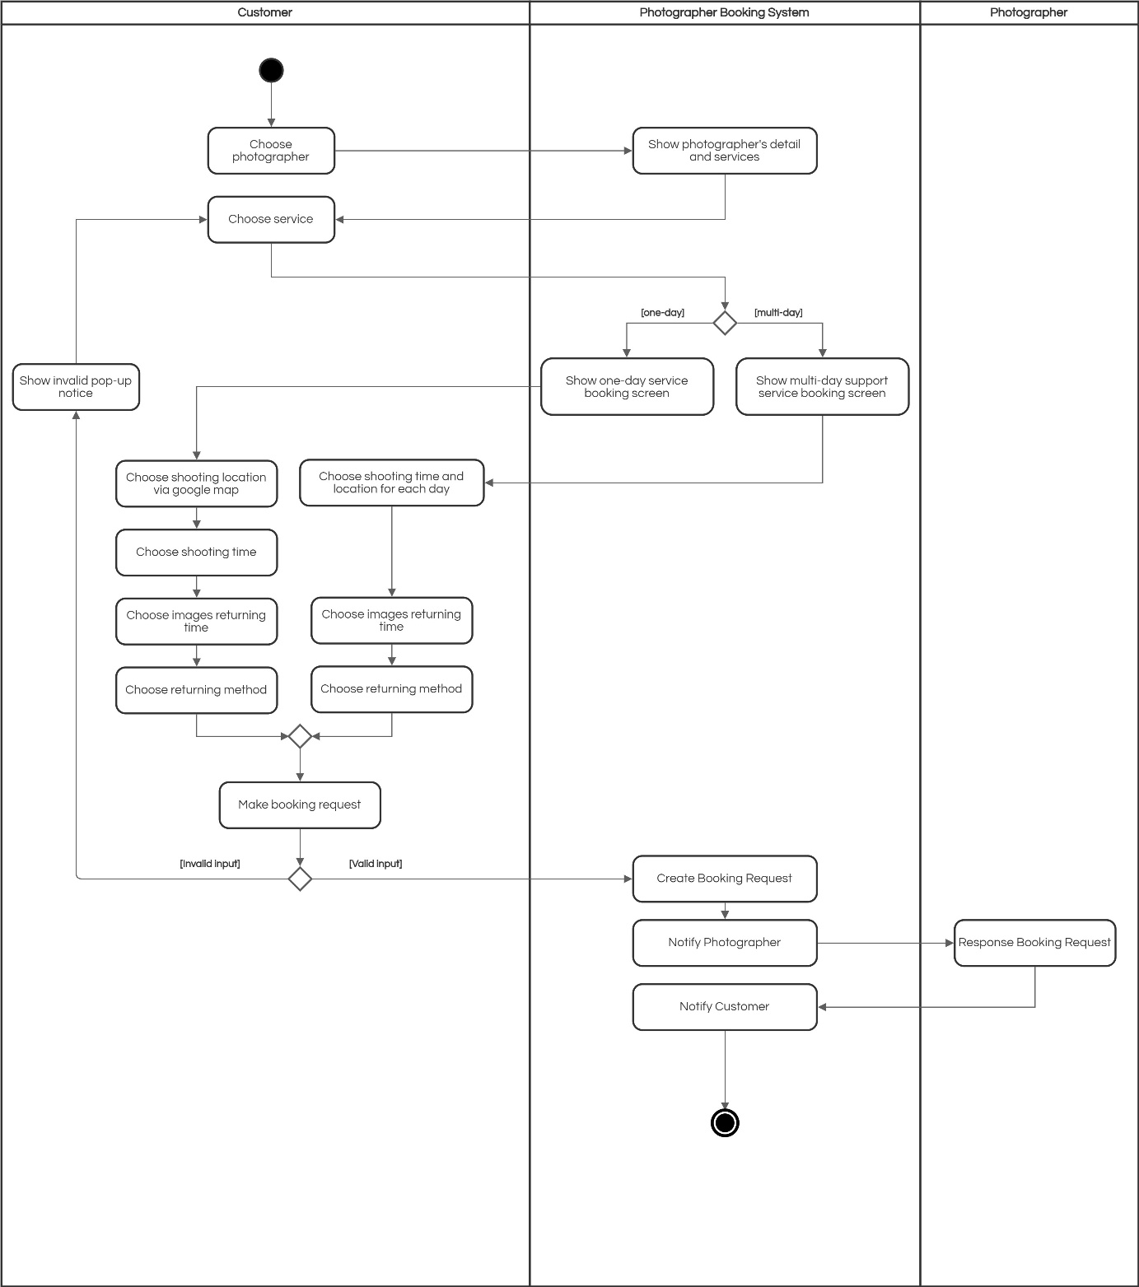

Figure 79 Activity Diagram – Book photographer

*Figure SEQ Figure \* ARABIC 12 Activity Diagram - Make Request*

1. **<Customer> Edit booking**

Summary: This diagram shows the process when a customer edits a booking.

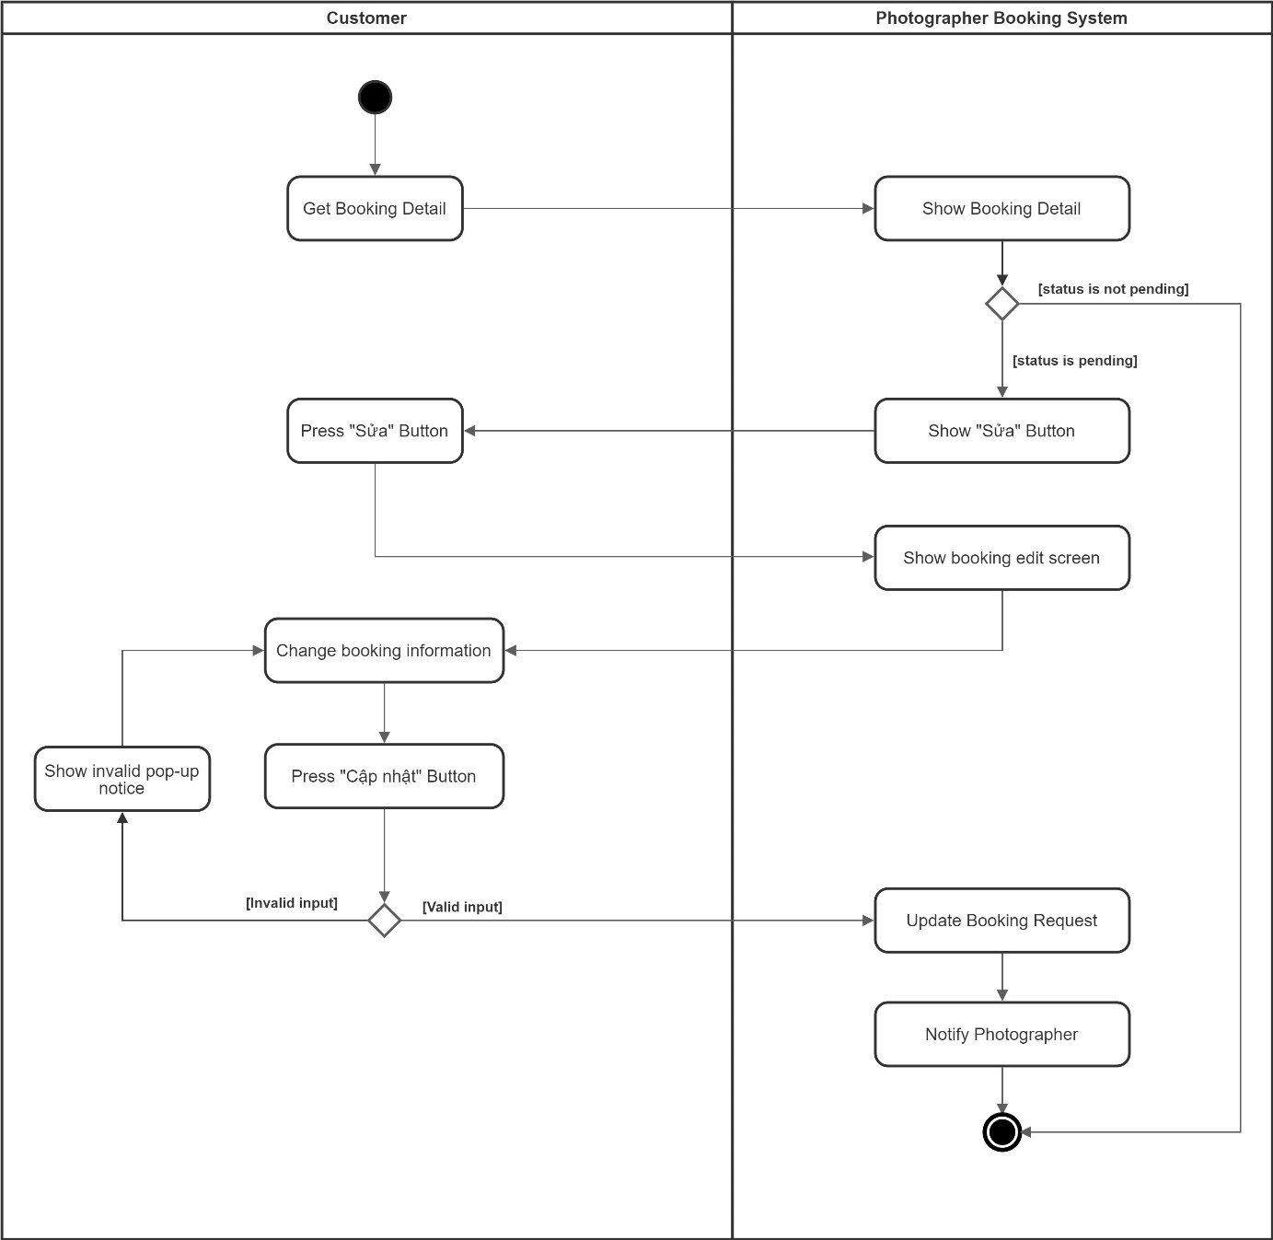

Figure 80 Activity Diagram – Edit Request

1. **<Customer> Cancel booking**

Summary: This diagram shows the process when a customer cancels a booking.

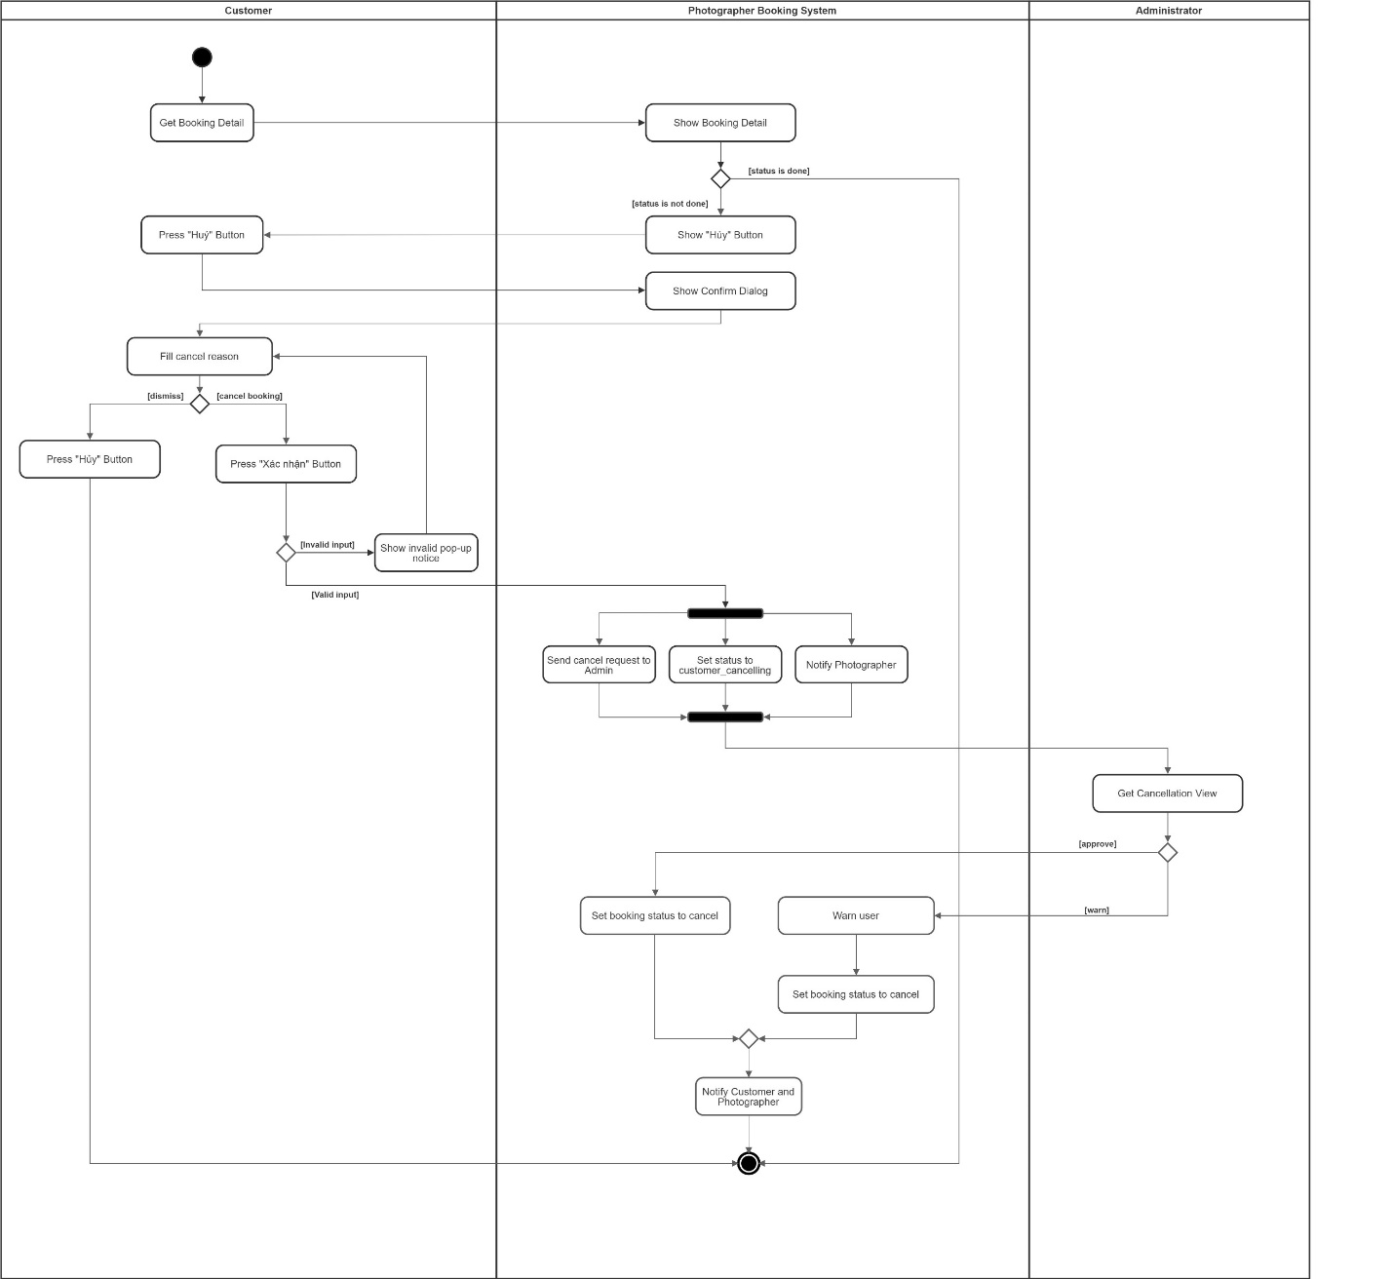

Figure 81 Activity Diagram - Cancel booking

1. **<Customer> Rating**

Summary: This diagram shows the process when a customer rates a photographer after booking finishes.

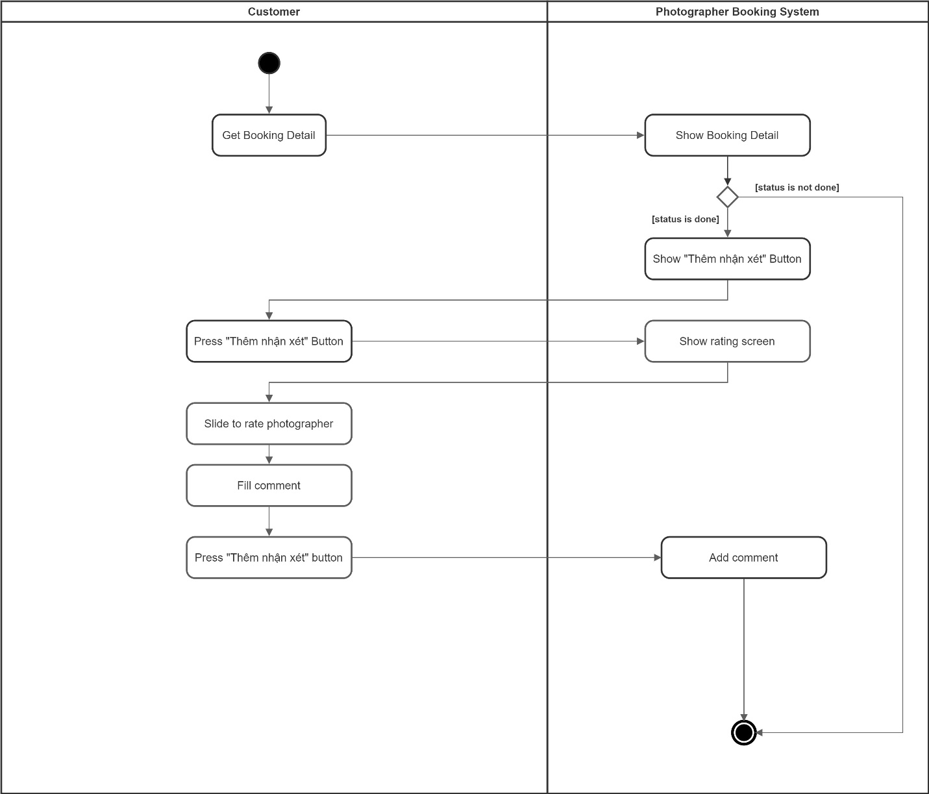

Figure 82 Activity Diagram - Rating

*Figure Activity Diagram - Rating*

1. **<Photographer> Accept booking**

Summary: This diagram shows the process when a photographer accepts a request.

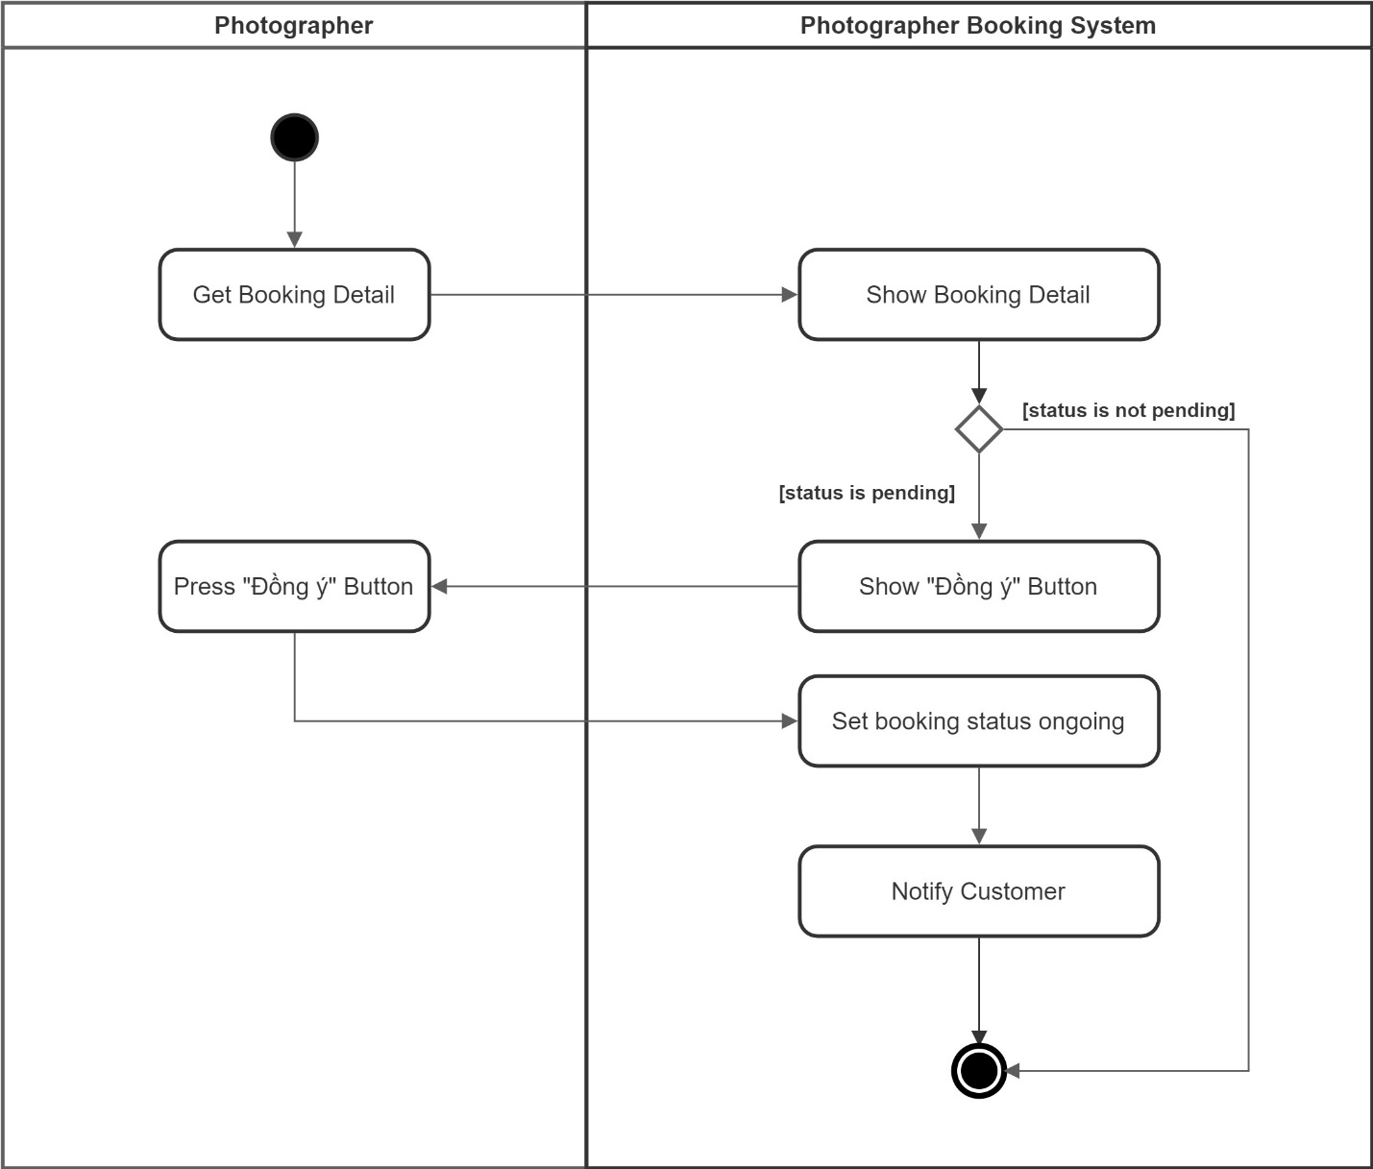

Figure 83 Activity Diagram - Accept booking

1. **<Photographer> Reject booking**

Summary: This diagram shows the process when a photographer rejects a request.

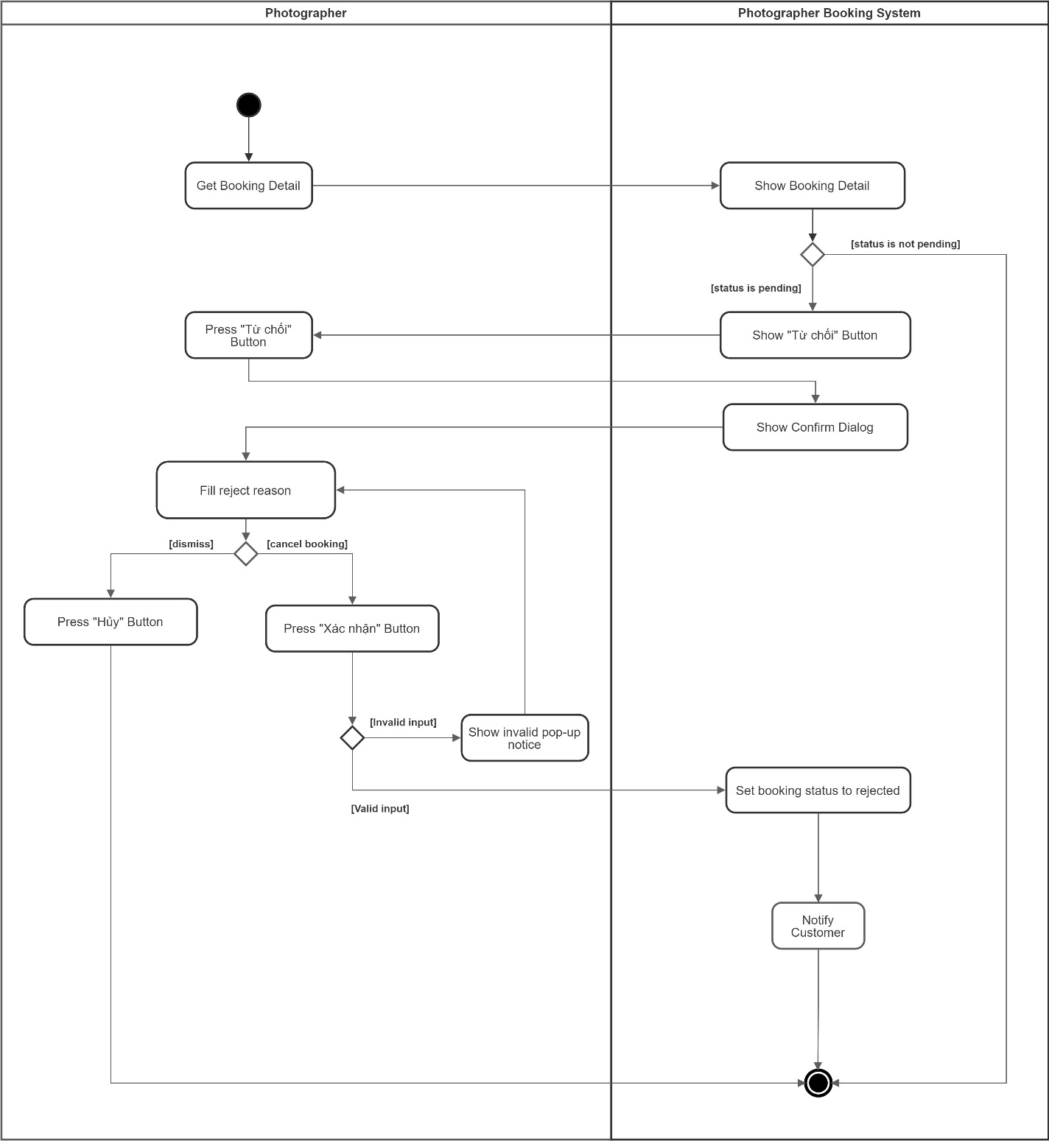

Figure 84 Activity Diagram - Reject booking

#### d. State Machine Diagram(s)

This state machine diagram describes states of a booking from start to done.

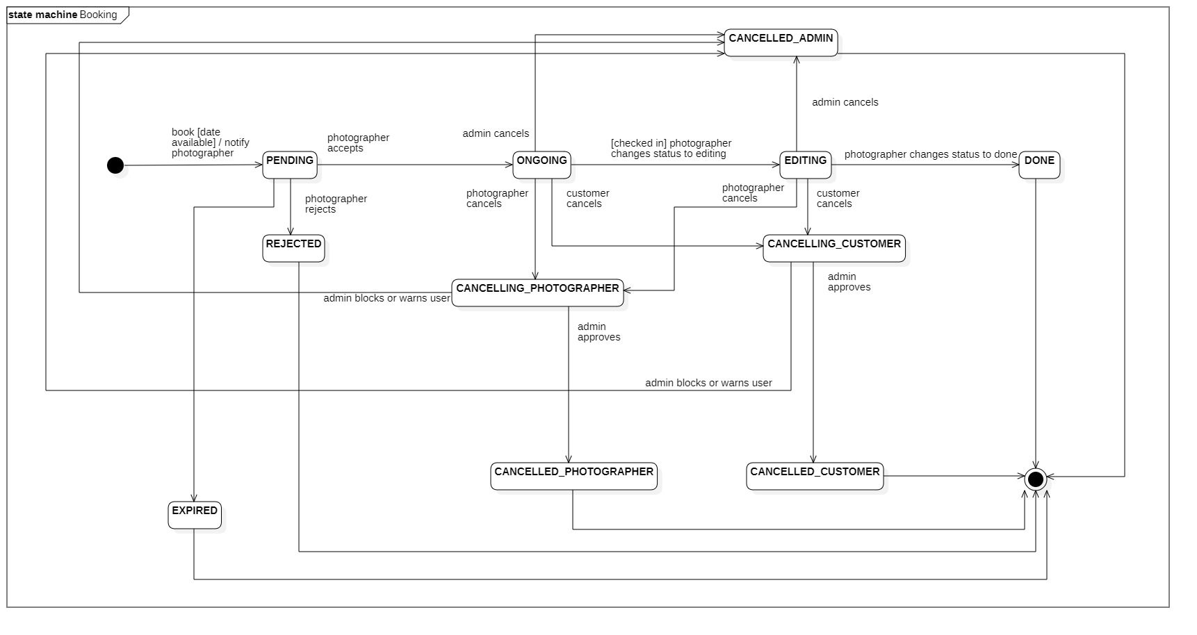

Figure 85 State Machine Diagram - Booking

## 4. Class Specifications

### 4.1 User

|  |  |  |  |
| --- | --- | --- | --- |
| **Attribute** | **Type** | **Visibility** | **Description** |
| id | Long | private | Unique identifier of a user |
| username | String | private | The attribute represents username of a user |
| password | String | private | The attribute represents password of a user |
| fullname | String | private | The attribute represents full name of a user |
| description | String | private | The attribute represents user self-description |
| avatar | String | private | The attribute represents avatar image link of a user |
| cover | String | private | The attribute represents cover image link of a user |
| phone | String | private | The attribute represents phone of a user |
| email | String | private | The attribute represents email of a user |
| deviceToken | String | private | The attribute represents user’s firebase device token |
| ratingCount | Float | private | (photographer role only) The attribute represents the rating count of a user whose role is photographer |
| distance | Double | private | (photographer role only) The attribute represents the distance between photographer to customer’s location |
| averagePackagePrice | Double | private | (photographer role only) The attribute represents the average service price of a photographer |
| isBlocked | Boolean | private | The attribute represents if user has been blocked |
| isEnabled | Boolean | private | The attribute represents if user account has been enabled or not |
| isDeleted | Boolean | private | The attribute represents if user account has been deleted |
| createdAt | Date | private | The attribute represents joined date of a user |
| updatedAt | Date | private | The attribute represents updated date of a user object |

|  |  |  |  |  |
| --- | --- | --- | --- | --- |
| **No** | **Method** | **Visibility** | **Return Type** | **Description** |
| 1 | getter | public | Attribute Type | get attribute value |
| 2 | setter | public | void | set attribute value |

Table Class Diagram - User

### 4.2 Role

|  |  |  |  |
| --- | --- | --- | --- |
| **Attribute** | **Type** | **Visibility** | **Description** |
| id | Long | private | Unique identifier of a role |
| role | ERole | private | The attribute represents role name |

|  |  |  |  |  |
| --- | --- | --- | --- | --- |
| **No** | **Method** | **Visibility** | **Return Type** | **Description** |
| 1 | getter | public | Attribute Type | get attribute value |
| 2 | setter | public | void | set attribute value |

Table Class Diagram - Role

### 4.3 ERole

|  |  |  |  |
| --- | --- | --- | --- |
| **Attribute** | **Type** | **Visibility** | **Description** |
| ROLE_CUSTOMER |  |  | Enum attribute |
| ROLE_PHOTOGRAPHER |  |  | Enum attribute |
| ROLE_ADMIN |  |  | Enum attribute |

Table Class Diagram - ERole

### 4.4 ServicePackage

|  |  |  |  |
| --- | --- | --- | --- |
| **Attribute** | **Type** | **Visibility** | **Description** |
| id | Integer | private | Unique identifier of a package |
| name | String | private | The attribute represents the package name |
| price | Integer | private | The attribute represents the package price |
| supportMultiDays | Boolean | private | The attribute represents if this package support multi days deal |
| description | String | private | The attribute represents the package description |
| isAvailable | Boolean | private | The attribute represents if the package has been deleted or not |
| createdAt | Date | private | The attribute represents created date of a package object |
| updatedAt | Date | private | The attribute represents updated date of a package object |

|  |  |  |  |  |
| --- | --- | --- | --- | --- |
| **No** | **Method** | **Visibility** | **Return Type** | **Description** |
| 1 | getter | public | Attribute Type | get attribute value |
| 2 | setter | public | void | set attribute value |

Table Class Diagram – Service Package

### 4.5 Service

|  |  |  |  |
| --- | --- | --- | --- |
| **Attribute** | **Type** | **Visibility** | **Description** |
| id | Long | private | Unique identifier of a package |
| name | String | private | The attribute represents the name of a service |
| description | String | private | The attribute represents the service’s description |
| isActive | Boolean | private | The attribute represents if the service is still available |

|  |  |  |  |  |
| --- | --- | --- | --- | --- |
| **No** | **Method** | **Visibility** | **Return Type** | **Description** |
| 1 | getter | public | Attribute Type | get attribute value |
| 2 | setter | public | void | set attribute value |

Table Class Diagram - Service

### 4.6 Booking

|  |  |  |  |
| --- | --- | --- | --- |
| **Attribute** | **Type** | **Visibility** | **Description** |
| id | Long | private | Unique identifier of a booking |
| bookingStatus | EBookingStatus | private | The attribute represents the status of a booking |
| previousStatus | EBookingStatus | private | The attribute represents the previous status each time booking status changes |
| serviceName | String | private | The attribute represents the name of the booked package |
| price | Integer | private | The attribute represents the service price of the booked package |
| returningLink | String | private | The attribute represents the image link after photographer finishes editing phase |
| timeAnticipate | Integer | private | The attribute represents the shooting time of the booked package |
| customerCanceledReason | String | private | The attribute represents the reason if customer decided to cancel a booking |
| photographerCanceledReason | String | private | The attribute represents the reason if photographer decided to cancel a booking |
| rejectedReason | String | private | The attribute represents the reason if photographer decided to reject a booking |
| editDeadline | Date | private | The attribute represents the edit deadline of a booking |
| createdAt | Date | private | The attribute represents the created date of a booking |
| updatedAt | Date | private | The attribute represents the updated date of a booking |

|  |  |  |  |  |
| --- | --- | --- | --- | --- |
| **No** | **Method** | **Visibility** | **Return Type** | **Description** |
| 1 | getter | public | Attribute Type | get attribute value |
| 2 | setter | public | void | set attribute value |

Table Class Diagram - Booking

### 4.7 EBookingStatus

|  |  |  |  |
| --- | --- | --- | --- |
| **Attribute** | **Type** | **Visibility** | **Description** |
| PENDING |  |  | Status after customer sends request to book photographer |
| ONGOING |  |  | Status after photographer accepts booking |
| EDITING |  |  | Status after ONGOING, photographer changes status to Editing phase |
| REJECTED |  |  | Status after photographer rejects booking |
| DONE |  |  | Status after booking is done |
| CANCELLED_CUSTOMER |  |  | Status after admin approves customer’s cancellation request |
| CANCELLED_PHOTOGRAPHER |  |  | Status after admin approves photographer’s cancellation request |
| CANCELLING_CUSTOMER |  |  | Status after customer sends request to cancel booking |
| CANCELLING_PHOTOGRAPHER |  |  | Status after photographer sends request to cancel booking |
| CANCELLED_ADMIN |  |  | Status after admin block user, warn user, booking of that user will be changed to this status |
| EXPIRED |  |  | Booking will be changed to this status if photographer doesn’t accept or reject booking after 24 hours |

Table Class Diagram - EBookingStatus

### 4.8 Album

|  |  |  |  |
| --- | --- | --- | --- |
| **Attribute** | **Type** | **Visibility** | **Description** |
| id | Long | private | Unique identifier of album |
| name | String | private | The attribute represents the name album |
| thumbnail | String | private | The attribute represents the album’s thumbnail link |
| description | String | private | The attribute represents the album’s description |
| createdAt | Date | private | The attribute represents the created date of album object |
| isDeleted | Boolean | private | The attribute represents if album has been deleted |
| likes | Integer | private | The attribute represents the album like count |

|  |  |  |  |  |
| --- | --- | --- | --- | --- |
| **No** | **Method** | **Visibility** | **Return Type** | **Description** |
| 1 | getter | public | Attribute Type | get attribute value |
| 2 | setter | public | void | set attribute value |

Table Class Diagram - Album

### 4.9 Image

|  |  |  |  |
| --- | --- | --- | --- |
| **Attribute** | **Type** | **Visibility** | **Description** |
| id | Long | private | Unique identifier of image |
| description | String | private | The attribute represents the description of album |
| imageLink | String | private | The attribute represents the album’s image link |
| createdAt | Date | private | The attribute represents the created date of image object |

|  |  |  |  |  |
| --- | --- | --- | --- | --- |
| **No** | **Method** | **Visibility** | **Return Type** | **Description** |
| 1 | getter | public | Attribute Type | get attribute value |
| 2 | setter | public | void | set attribute value |

Table Class Diagram - Image

### 4.10 Category

|  |  |  |  |
| --- | --- | --- | --- |
| **Attribute** | **Type** | **Visibility** | **Description** |
| id | Long | private | Unique identifier of category |
| category | String | private | The attribute represents the category name |
| iconLink | String | private | The attribute represents the category icon link |
| createdAt | Date | private | The attribute represents the created date of category object |
| updatedAt | Date | private | The attribute represents the updated date of category object |
| isAvailable | Boolean | private | The attribute represents if the admin turns category on or off |

|  |  |  |  |  |
| --- | --- | --- | --- | --- |
| **No** | **Method** | **Visibility** | **Return Type** | **Description** |
| 1 | getter | public | Attribute Type | get attribute value |
| 2 | setter | public | void | set attribute value |

Table Class Diagram - Category

### 4.11 DayOfWeek

|  |  |  |  |
| --- | --- | --- | --- |
| **Attribute** | **Type** | **Visibility** | **Description** |
| id | Long | private | Unique identifier of day of week |
| day | Int | private | The attribute represents the day of the week |
| startTime | Date | private | The attribute represents the start time of photographer’s working time |
| endTime | Date | private | The attribute represents the end time of photographer’s working time |
| isWorkingDay | Boolean | private | The attribute represents if this day of week is working day |

|  |  |  |  |  |
| --- | --- | --- | --- | --- |
| **No** | **Method** | **Visibility** | **Return Type** | **Description** |
| 1 | getter | public | Attribute Type | get attribute value |
| 2 | setter | public | void | set attribute value |

Table Class Diagram - DayOfWeek

### 4.12 Location

|  |  |  |  |
| --- | --- | --- | --- |
| **Attribute** | **Type** | **Visibility** | **Description** |
| id | Long | private | Unique identifier of location |
| formattedAddress | String | private | The attribute represents the location full address |
| longitude | String | private | The attribute represents the longitude of a location |
| latitude | Double | private | The attribute represents the latitude of a location |

|  |  |  |  |  |
| --- | --- | --- | --- | --- |
| **No** | **Method** | **Visibility** | **Return Type** | **Description** |
| 1 | getter | public | Attribute Type | get attribute value |
| 2 | setter | public | void | set attribute value |

Table Class Diagram - Location

### 4.13 BookingComment

|  |  |  |  |
| --- | --- | --- | --- |
| **Attribute** | **Type** | **Visibility** | **Description** |
| id | Long | private | Unique identifier of booking comment |
| comment | String | private | The attribute represents the comment of user |
| rating | Float | private | The attribute represents the rating of user |
| commentedAt | Date | private | The attribute represents the commented date of a booking |

|  |  |  |  |  |
| --- | --- | --- | --- | --- |
| **No** | **Method** | **Visibility** | **Return Type** | **Description** |
| 1 | getter | public | Attribute Type | get attribute value |
| 2 | setter | public | void | set attribute value |

Table Class Diagram - BookingComment

### 4.14 BookingDetail

|  |  |  |  |
| --- | --- | --- | --- |
| **Attribute** | **Type** | **Visibility** | **Description** |
| id | Long | private | Unique identifier of booking detail |
| serviceName | String | private | The attribute represents the booked service’s name |
| serviceDescription | String | private | The attribute represents the booked service’s description |

|  |  |  |  |  |
| --- | --- | --- | --- | --- |
| **No** | **Method** | **Visibility** | **Return Type** | **Description** |
| 1 | getter | public | Attribute Type | get attribute value |
| 2 | setter | public | void | set attribute value |

Table Class Diagram - BookingDetail

### 4.15 BusyDay

|  |  |  |  |
| --- | --- | --- | --- |
| **Attribute** | **Type** | **Visibility** | **Description** |
| id | Long | private | Unique identifier of busy day |
| startDate | Date | private | The attribute represents the start date of photographer’s busy event |
| endDate | Date | private | The attribute represents the end date of photographer’s busy event |
| title | String | private | The attribute represents the title of photographer’s busy event |
| description | String | private | The attribute represents the description of this busy event |

|  |  |  |  |  |
| --- | --- | --- | --- | --- |
| **No** | **Method** | **Visibility** | **Return Type** | **Description** |
| 1 | getter | public | Attribute Type | get attribute value |
| 2 | setter | public | void | set attribute value |

Table Class Diagram - BusyDay

### 4.16 Thread

|  |  |  |  |
| --- | --- | --- | --- |
| **Attribute** | **Type** | **Visibility** | **Description** |
| id | Long | private | Unique identifier of thread |
| title | String | private | The attribute represents the title of thread |
| content | String | private | The attribute represents the content of a thread |
| isBan | Boolean | private | The attribute represents whether or not admin has banned a thread |
| isDeleted | Boolean | private | The attribute represents if a thread has been deleted |
| createdAt | Date | private | The attribute represents the created date of a thread |
| updatedAt | Date | private | The attribute represents the updated date of a thread |

|  |  |  |  |  |
| --- | --- | --- | --- | --- |
| **No** | **Method** | **Visibility** | **Return Type** | **Description** |
| 1 | getter | public | Attribute Type | get attribute value |
| 2 | setter | public | void | set attribute value |

Table Class Diagram - Thread

### 4.17 ThreadTopic

|  |  |  |  |
| --- | --- | --- | --- |
| **Attribute** | **Type** | **Visibility** | **Description** |
| id | Long | private | Unique identifier of thread topic |
| topic | String | private | The attribute represents the topic name of a thread |
| createdAt | Date | private | The attribute represents the created date of a thread |
| updateAt | Date | private | The attribute represents the updated date of a thread |
| isAvailable | Boolean | private | The attribute represents if topic is still available |

|  |  |  |  |  |
| --- | --- | --- | --- | --- |
| **No** | **Method** | **Visibility** | **Return Type** | **Description** |
| 1 | getter | public | Attribute Type | get attribute value |
| 2 | setter | public | void | set attribute value |

Table Class Diagram - ThreadTopic

### 4.18 ThreadComment

|  |  |  |  |
| --- | --- | --- | --- |
| **Attribute** | **Type** | **Visibility** | **Description** |
| id | Long | private | Unique identifier of thread comment |
| comment | String | private | The attribute represents the comment of a thread |
| createdAt | Date | private | The attribute represents the created date of this record |
| updateAt | Date | private | The attribute represents the updated date of this record |

|  |  |  |  |  |
| --- | --- | --- | --- | --- |
| **No** | **Method** | **Visibility** | **Return Type** | **Description** |
| 1 | getter | public | Attribute Type | get attribute value |
| 2 | setter | public | void | set attribute value |

Table Class Diagram - ThreadComment

### 4.19 ReturningType

|  |  |  |  |
| --- | --- | --- | --- |
| **Attribute** | **Type** | **Visibility** | **Description** |
| id | Long | private | Unique identifier of returning type |
| type | EReturningType | private | The attribute represents the type |

|  |  |  |  |  |
| --- | --- | --- | --- | --- |
| **No** | **Method** | **Visibility** | **Return Type** | **Description** |
| 1 | getter | public | Attribute Type | get attribute value |
| 2 | setter | public | void | set attribute value |

Table Class Diagram - ReturningType

### 4.20 EReturningType

|  |  |  |  |
| --- | --- | --- | --- |
| **Attribute** | **Type** | **Visibility** | **Description** |
| LINK |  |  | Image will be returned online (through image sharing links) |
| OFFLINE |  |  | Image will be returned offline by the photographer |

Table Class Diagram - EReturningType

### 4.21 TimeLocationDetail

This table used for saving time and location details of a booking

|  |  |  |  |
| --- | --- | --- | --- |
| **Attribute** | **Type** | **Visibility** | **Description** |
| id | Long | private | Unique identifier of time location detail |
| lat | Double | private | The attribute represents the latitude of a user |
| lon | Double | private | The attribute represents the longitude of a user |
| formattedAddress | String | private | The attribute represents the formatted address of a user |
| start | Date | private | The attribute represents start time of a booking |
| end | Date | private | The attribute represents end time of a booking |
| isCheckin | Boolean | private | The attribute represents if that day has been checked in |
| qrCheckinCode | Boolean | private | The attribute represents the checkin code of that day |

|  |  |  |  |  |
| --- | --- | --- | --- | --- |
| **No** | **Method** | **Visibility** | **Return Type** | **Description** |
| 1 | getter | public | Attribute Type | get attribute value |
| 2 | setter | public | void | set attribute value |

Table Class Diagram – TimeLocationDetail

### 4.22 Variable

|  |  |  |  |
| --- | --- | --- | --- |
| **Attribute** | **Type** | **Visibility** | **Description** |
| id | Long | private | Unique identifier of variable |
| name | String | private | The attribute represents the name of the variable |
| weight | Double | private | The attribute represents the weight of the variable |
| updatedAt | Date | private | The attribute represents the updated date of a variable |

|  |  |  |  |  |
| --- | --- | --- | --- | --- |
| **No** | **Method** | **Visibility** | **Return Type** | **Description** |
| 1 | getter | public | Attribute Type | get attribute value |
| 2 | setter | public | void | set attribute value |

Table Class Diagram – Variable

### 4.23 CancellationRequest

|  |  |  |  |
| --- | --- | --- | --- |
| **Attribute** | **Type** | **Visibility** | **Description** |
| id | Long | private | Unique identifier of cancellation request |
| reason | String | private | The attribute represents the reason why user cancels a booking |
| isSolve | Boolean | private | The attribute represents whether or not admin has dealt with a request |
| approvedAt | Date | private | The attribute represents the approved date of a request |
| createdAt | Date | private | The attribute represents the created date of a request |

|  |  |  |  |  |
| --- | --- | --- | --- | --- |
| **No** | **Method** | **Visibility** | **Return Type** | **Description** |
| 1 | getter | public | Attribute Type | get attribute value |
| 2 | setter | public | void | set attribute value |

Table Class Diagram - Cancellation Request

### 4.24 Report

|  |  |  |  |
| --- | --- | --- | --- |
| **Attribute** | **Type** | **Visibility** | **Description** |
| id | Long | private | Unique identifier of report |
| title | String | private | The attribute represents the title of a report |
| reason | String | private | The attribute represents the reason of a report |
| isSolve | Boolean | private | The attribute represents if admin has solved the report |
| createdAt | Date | private | The attribute represents the created date of a report |

|  |  |  |  |  |
| --- | --- | --- | --- | --- |
| **No** | **Method** | **Visibility** | **Return Type** | **Description** |
| 1 | getter | public | Attribute Type | get attribute value |
| 2 | setter | public | void | set attribute value |

Table Class Diagram - Report

### 4.25 VerificationToken

|  |  |  |  |
| --- | --- | --- | --- |
| **Attribute** | **Type** | **Visibility** | **Description** |
| id | Long | private | Unique identifier of token |
| token | String | private | The attribute represents the token itself |
| createAt | Timestamp | private | The attribute represents the created time of a token |
| expireAt | LocalDateTime | private | The attribute represents expired time of a token |

|  |  |  |  |  |
| --- | --- | --- | --- | --- |
| **No** | **Method** | **Visibility** | **Return Type** | **Description** |
| 1 | getter | public | Attribute Type | get attribute value |
| 2 | setter | public | void | set attribute value |

Table Class Diagram - Verification Token

### 4.26 Notification

|  |  |  |  |
| --- | --- | --- | --- |
| **Attribute** | **Type** | **Visibility** | **Description** |
| id | Long | private | Unique identifier of notificaiton |
| title | String | private | The attribute represents the title of a notification |
| content | String | private | The attribute represents the content of a notification |
| createdAt | Date | private | The attribute represents created date of a notification |
| receiverId | Long | private | The attribute represents the user id who receive the notification |
| isRead | Boolean | private | The attribute represents if notification has been read |
| bookingId | Long | private | The attribute represents id of a booking which has been notified on |
| notificationType | ENotificationType | private | The type of a notification |

|  |  |  |  |  |
| --- | --- | --- | --- | --- |
| **No** | **Method** | **Visibility** | **Return Type** | **Description** |
| 1 | getter | public | Attribute Type | get attribute value |
| 2 | setter | public | void | set attribute value |

Table Class Diagram - Notification

### 4.27 ENotificationType

|  |  |  |  |
| --- | --- | --- | --- |
| **Attribute** | **Type** | **Visibility** | **Description** |
| BOOKING_STATUS |  |  | Used when notification related to booking status changing |
| WARNING |  |  | Used when notification is intended to warn a user |
| TIME_NOTIFICATION |  |  | Used when notification related to timing issue |
| REQUEST_RESULT |  |  | Used when photographer accepts or rejects a booking |
| CONFIRMATION_REQUEST |  |  | Used when a confirmation is need from user |

Table Class Diagram - ENotificationType

## 5. Data & Database Design

### 5.1 Database Design

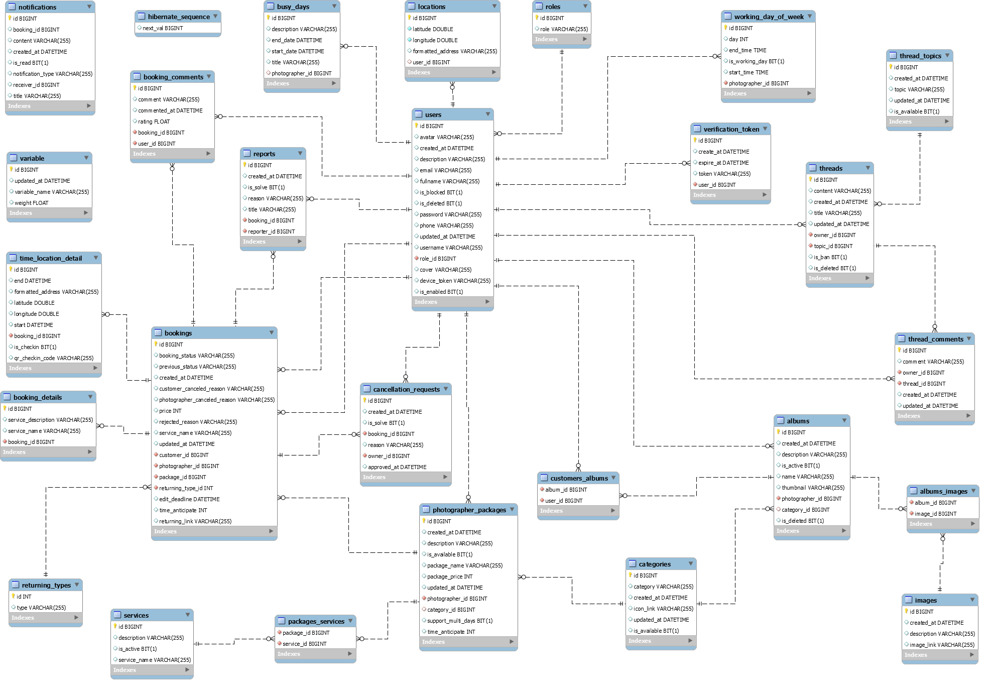

Figure 86 Database Design

#### users

|  |  |  |  |  |  |  |  |
| --- | --- | --- | --- | --- | --- | --- | --- |
| **#** | **Field name** | **Type** | **Size** | **Unique** | **Not Null** | **PK/FK** | **Notes** |
| 1 | id | bigint |  | X | X | X |  |
| 2 | username | varchar | 255 | X | X |  |  |
| 3 | password | varchar | 255 |  | X |  |  |
| 4 | fullname | varchar | 255 |  | X |  |  |
| 5 | description | varchar | 255 |  |  |  |  |
| 6 | avatar | varchar | 255 |  |  |  | Avatar image link of user |
| 7 | phone | varchar | 255 |  |  |  |  |
| 8 | email | varchar | 255 |  |  |  |  |
| 9 | device_token | varchar | 255 |  |  |  | The firebase token of device, using for firebase messaging. |
| 10 | is_blocked | bit |  |  |  |  | Used when admin blocks a user |
| 11 | is_deleted | bit |  |  |  |  |  |
| 12 | is_enabled | bit |  |  |  |  | Used to check if an account has been activated |
| 13 | created_at | datetime |  |  |  |  |  |
| 14 | updated_at | datetime |  |  |  |  |  |
| 15 | role_id | bigint |  |  | X | X |  |
| 16 | cover | varchar | 255 |  |  |  |  |

Table Database - users

#### roles

|  |  |  |  |  |  |  |  |
| --- | --- | --- | --- | --- | --- | --- | --- |
| **#** | **Field name** | **Type** | **Size** | **Unique** | **Not Null** | **PK/FK** | **Notes** |
| 1 | id | int |  | X | X | X |  |
| 2 | role | varchar | 255 |  | X |  |  |

Table Database - roles

#### photographer_packages

|  |  |  |  |  |  |  |  |
| --- | --- | --- | --- | --- | --- | --- | --- |
| **#** | **Field name** | **Type** | **Size** | **Unique** | **Not Null** | **PK/FK** | **Notes** |
| 1 | id | bigint |  | X | X | X |  |
| 2 | package_name | varchar | 255 |  | X |  |  |
| 3 | package_price | int |  |  | X |  |  |
| 4 | is_available | bit | 1 |  |  |  | Used when photographer deletes a package |
| 5 | description | varchar | 255 |  |  |  |  |
| 6 | photographer _id | bigint |  |  | X | X |  |
| 7 | category_id | bigint |  |  |  | X |  |
| 8 | support_multiple_days | bit | 1 |  |  |  | This field represents whether or not a package is supporting multiple day booking. |
| 9 | time_anticipate | int |  |  |  |  | The shooting time of a package (in seconds). |
| 10 | created_at | datetime |  |  |  |  |  |
| 11 | updated_at | datetime |  |  |  |  |  |

Table Database - photographer_packages

#### packages_services

|  |  |  |  |  |  |  |  |
| --- | --- | --- | --- | --- | --- | --- | --- |
| **#** | **Field name** | **Type** | **Size** | **Unique** | **Not Null** | **PK/FK** | **Notes** |
| 1 | package_id | bigint |  |  | X | X |  |
| 2 | service_id | bigint |  |  | X | X |  |

Table Database - packages_services

#### services

|  |  |  |  |  |  |  |  |
| --- | --- | --- | --- | --- | --- | --- | --- |
| **#** | **Field name** | **Type** | **Size** | **Unique** | **Not Null** | **PK/FK** | **Notes** |
| 1 | id | bigint |  | X | X | X |  |
| 2 | service_name | varchar | 255 |  | X |  |  |
| 3 | description | varchar | 255 |  |  |  |  |
| 4 | is_active | bit | 1 |  |  |  |  |

Table Database - services

#### bookings

|  |  |  |  |  |  |  |  |
| --- | --- | --- | --- | --- | --- | --- | --- |
| **#** | **Field name** | **Type** | **Size** | **Unique** | **Not Null** | **PK/FK** | **Notes** |
| 1 | id | bigint |  | X | X | X |  |
| 2 | booking_status | varchar | 255 |  | X |  | There will be following status:  PENDING, ONGOING, EDITING, DONE. REJECTED, CANCELLED_CUSTOMER, CANCELLED_PHOTOGRAPHER, CANCELLING_CUSTOMER, CANCELLING_PHOTOGRAPHER, CANCELLED_ADMIN |
| 3 | previous_status | varchar | 255 |  |  |  | Used each time booking status changes |
| 4 | service_name | varchar | 255 |  | X |  | Package’s name |
| 5 | price | int |  |  | X |  | Package’s price |
| 6 | customer  _canceled  _reason | varchar | 255 |  |  |  | In case customers cancel and provide their reason |
| 7 | photographer _canceled _reason | varchar | 255 |  |  |  | In case photographers cancel and provide their reason |
| 8 | rejected_reason | varchar | 255 |  |  |  | In case photographers reject the request and provide reason |
| 9 | customer_id | bigint |  |  | X | X |  |
| 10 | photographer _id | bigint |  |  | X | X |  |
| 11 | returning_type_id | int |  |  | X | X |  |
| 12 | package_id | bigint |  |  | X | X |  |
| 13 | edit_deadline | datetime |  |  |  |  | The datetime customer wants to have their pictures done. |
| 14 | time_anticipate | int |  |  |  |  | Package’s shooting time (in seconds) |
| 15 | created_at | datetime |  |  |  |  |  |
| 16 | updated_at | datetime |  |  |  |  |  |
| 17 | returning_link | varchar | 255 |  |  |  | Used to save photographer image links after editing phase |

Table Database - bookings

#### albums

|  |  |  |  |  |  |  |  |
| --- | --- | --- | --- | --- | --- | --- | --- |
| **#** | **Field name** | **Type** | **Size** | **Unique** | **Not Null** | **PK/FK** | **Notes** |
| 1 | id | bigint |  | X | X | X |  |
| 2 | name | varchar | 255 |  | X |  |  |
| 3 | description | varchar | 255 |  |  |  |  |
| 4 | created_at | datetime |  |  |  |  |  |
| 5 | thumbnail | varchar | 255 |  |  |  | The thumbnail link of the album. |
| 6 | is_deleted | bit | 1 |  |  |  |  |
| 7 | photographer _id | bigint |  |  | X | X |  |
| 8 | category_id | bigint |  |  |  | X |  |

Table Database - albums

#### locations

|  |  |  |  |  |  |  |  |
| --- | --- | --- | --- | --- | --- | --- | --- |
| **#** | **Field name** | **Type** | **Size** | **Unique** | **Not Null** | **PK/FK** | **Notes** |
| 1 | id | bigint |  | X | X | X |  |
| 2 | formatted_address | varchar | 255 |  |  |  | Location full address. |
| 3 | longitude | double |  |  | X |  |  |
| 4 | latitude | double |  |  | X |  |  |
| 5 | user_id | bigint |  |  | X | X |  |

Table Database - locations

#### categories

|  |  |  |  |  |  |  |  |
| --- | --- | --- | --- | --- | --- | --- | --- |
| **#** | **Field name** | **Type** | **Size** | **Unique** | **Not Null** | **PK/FK** | **Notes** |
| 1 | id | bigint |  | X | X | X |  |
| 2 | category | varchar | 255 |  | X |  |  |
| 3 | icon_link | varchar | 255 |  | X |  | Link for the icon of category |
| 4 | created_at | datetime |  |  |  |  |  |
| 5 | updated_at | datetime |  |  |  |  |  |
| 6 | is_available | bit | 1 |  |  |  | Used when admin deletes a category |

Table Database - categories

#### album_images

|  |  |  |  |  |  |  |  |
| --- | --- | --- | --- | --- | --- | --- | --- |
| **#** | **Field name** | **Type** | **Size** | **Unique** | **Not Null** | **PK/FK** | **Notes** |
| 1 | album_id | bigint |  |  | X | X |  |
| 2 | image_id | bigint |  |  | X | X |  |

Table Database - album_images

#### images

|  |  |  |  |  |  |  |  |
| --- | --- | --- | --- | --- | --- | --- | --- |
| **#** | **Field name** | **Type** | **Size** | **Unique** | **Not Null** | **PK/FK** | **Notes** |
| 1 | id | bigint |  | X | X | X |  |
| 2 | image_link | varchar | 255 |  | X |  | Link of the image. |
| 3 | description | varchar | 255 |  |  |  |  |
| 4 | created_at | datetime |  |  |  |  |  |

Table Database - images

#### customers_albums

This table used to track album likes from customers.

|  |  |  |  |  |  |  |  |
| --- | --- | --- | --- | --- | --- | --- | --- |
| **#** | **Field name** | **Type** | **Size** | **Unique** | **Not Null** | **PK/FK** | **Notes** |
| 1 | album_id | bigint |  |  | X | X |  |
| 2 | customer_id | bigint |  |  | X | X |  |

Table Database - customer_albums

#### working_day_of_week

|  |  |  |  |  |  |  |  |
| --- | --- | --- | --- | --- | --- | --- | --- |
| **#** | **Field name** | **Type** | **Size** | **Unique** | **Not Null** | **PK/FK** | **Notes** |
| 1 | id | bigint |  | X | X | X |  |
| 2 | day | int |  |  |  |  | Day represents week day from Monday to Sunday.  1 is Sunday and 7 is Saturday. |
| 3 | start_time | time |  |  |  |  |  |
| 4 | end_time | time |  |  |  |  |  |
| 5 | is_working_day | bit | 1 |  |  |  |  |
| 6 | photographer _id | bigint |  |  | X | X |  |

Table Database - working_day_of_week

#### busy_days

|  |  |  |  |  |  |  |  |
| --- | --- | --- | --- | --- | --- | --- | --- |
| **#** | **Field name** | **Type** | **Size** | **Unique** | **Not Null** | **PK/FK** | **Notes** |
| 1 | id | bigint |  | X | X | X |  |
| 2 | description | varchar | 255 |  |  |  |  |
| 3 | start_date | datetime |  |  |  |  |  |
| 4 | end_date | datetime |  |  |  |  |  |
| 5 | title | varchar | 255 |  |  |  |  |
| 6 | photographer _id | bigint |  |  | X | X |  |

Table Database - busy_days

#### returning_types

|  |  |  |  |  |  |  |  |
| --- | --- | --- | --- | --- | --- | --- | --- |
| **#** | **Field name** | **Type** | **Size** | **Unique** | **Not Null** | **PK/FK** | **Notes** |
| 1 | id | int |  | X | X | X |  |
| 2 | type | varchar | 255 |  | X |  |  |

Table Database - returning_types

#### booking_details

|  |  |  |  |  |  |  |  |
| --- | --- | --- | --- | --- | --- | --- | --- |
| **#** | **Field name** | **Type** | **Size** | **Unique** | **Not Null** | **PK/FK** | **Notes** |
| 1 | id | bigint |  | X | X | X |  |
| 2 | service_name | varchar | 255 |  | X |  |  |
| 3 | service_description | varchar | 255 |  | X |  |  |
| 4 | booking_id | bigint |  |  | X | X |  |

Table Database - booking_details

#### time_location_detail

|  |  |  |  |  |  |  |  |
| --- | --- | --- | --- | --- | --- | --- | --- |
| **#** | **Field name** | **Type** | **Size** | **Unique** | **Not Null** | **PK/FK** | **Notes** |
| 1 | id | bigint |  | X | X | X |  |
| 2 | formatted_address | varchar | 255 |  |  |  | Booking location full address. |
| 3 | latitude | double |  |  |  |  |  |
| 4 | longitude | double |  |  |  |  |  |
| 5 | start | datetime |  |  |  |  | Start time of the booking. |
| 6 | end | datetime |  |  |  |  | End time of the booking. |
| 7 | booking_id | bigint |  |  | X | X |  |
| 8 | is_checkin | bit | 1 |  |  |  | used to tracks if photographer has checked that date in |
| 9 | qr_checkin_code | varchar | 255 |  |  |  | qr checkin code of that date |

Table Database - time_location_details

#### booking_comments

|  |  |  |  |  |  |  |  |
| --- | --- | --- | --- | --- | --- | --- | --- |
| **#** | **Field name** | **Type** | **Size** | **Unique** | **Not Null** | **PK/FK** | **Notes** |
| 1 | id | bigint |  | X | X | X |  |
| 2 | comment | varchar | 255 |  |  |  |  |
| 3 | commented_at | datetime |  |  |  |  |  |
| 4 | rating | float |  |  |  |  | Rating from 0 to 5. |
| 5 | user_id | bigint |  |  |  |  |  |
| 6 | booking_id | bigint |  |  |  |  |  |

Table Database - booking_comments

#### threads

|  |  |  |  |  |  |  |  |
| --- | --- | --- | --- | --- | --- | --- | --- |
| **#** | **Field name** | **Type** | **Size** | **Unique** | **Not Null** | **PK/FK** | **Notes** |
| 1 | id | bigint |  | X | X | X |  |
| 2 | title | varchar | 255 |  |  |  |  |
| 3 | content | varchar | 255 |  |  |  |  |
| 4 | updated_at | datetime |  |  |  |  |  |
| 5 | created_at | datetime |  |  |  |  |  |
| 6 | topic_id | bigint |  |  | X | X |  |
| 7 | owner_id | bigint |  |  | X | X |  |
| 8 | is_ban | bit | 1 |  |  |  | used when admin bans a thread |
| 9 | is_deleted | bit | 1 |  |  |  | used when user deletes their thread |

Table Database - threads

#### thread_comments

|  |  |  |  |  |  |  |  |
| --- | --- | --- | --- | --- | --- | --- | --- |
| **#** | **Field name** | **Type** | **Size** | **Unique** | **Not Null** | **PK/FK** | **Notes** |
| 1 | id | bigint |  | X | X | X |  |
| 2 | comment | varchar | 255 |  |  |  |  |
| 3 | updated_at | datetime |  |  |  |  |  |
| 4 | created_at | datetime |  |  |  |  |  |
| 5 | thread_id | bigint |  |  |  | X |  |
| 6 | owner_id | bigint |  |  |  | X |  |

Table Database - thread_comments

#### thread_topics

|  |  |  |  |  |  |  |  |
| --- | --- | --- | --- | --- | --- | --- | --- |
| **#** | **Field name** | **Type** | **Size** | **Unique** | **Not Null** | **PK/FK** | **Notes** |
| 1 | id | bigint |  | X | X | X |  |
| 2 | topic | varchar | 255 |  |  |  |  |
| 3 | update_at | datetime |  |  |  |  |  |
| 4 | created_at | datetime |  |  |  |  |  |
| 5 | is_available | bit | 1 |  |  |  | used when admis remove a topic |

Table Database - thread_topics

#### variable

|  |  |  |  |  |  |  |  |
| --- | --- | --- | --- | --- | --- | --- | --- |
| **#** | **Field name** | **Type** | **Size** | **Unique** | **Not Null** | **PK/FK** | **Notes** |
| 1 | id | int |  | X | X | X |  |
| 2 | variable_name | varchar | 255 |  |  |  |  |
| 3 | weight | float |  |  |  |  | Weight from 0 to 1. |
| 4 | updated_at | datetime |  |  |  |  |  |

Table Database – variables

#### notifications

|  |  |  |  |  |  |  |  |
| --- | --- | --- | --- | --- | --- | --- | --- |
| **#** | **Field name** | **Type** | **Size** | **Unique** | **Not Null** | **PK/FK** | **Notes** |
| 1 | id | bigint |  | X | X | X |  |
| 2 | booking_id | bigint | 255 |  |  |  |  |
| 3 | content | varchar | 255 |  |  |  |  |
| 4 | created_at | datetime |  |  |  |  |  |
| 5 | is_read | bit | 1 |  |  |  |  |
| 6 | notification_type | varchar | 255 |  | X | X | type of a notification |
| 7 | receiver_id | bigint |  |  | X | X |  |
| 8 | title | varchar | 255 |  |  |  |  |

Table Database - notifications

#### verification_token

|  |  |  |  |  |  |  |  |
| --- | --- | --- | --- | --- | --- | --- | --- |
| **#** | **Field name** | **Type** | **Size** | **Unique** | **Not Null** | **PK/FK** | **Notes** |
| 1 | id | bigint |  | X | X | X |  |
| 2 | create_at | datetime |  |  |  |  |  |
| 3 | expire_at | datetime |  |  |  |  |  |
| 4 | token | varchar | 255 |  |  |  |  |
| 5 | user_id | bigint |  |  | X | X |  |

Table Database - verification_token

#### cancellation_requests

|  |  |  |  |  |  |  |  |
| --- | --- | --- | --- | --- | --- | --- | --- |
| **#** | **Field name** | **Type** | **Size** | **Unique** | **Not Null** | **PK/FK** | **Notes** |
| 1 | id | bigint |  | X | X | X |  |
| 2 | created_at | datetime |  |  |  |  |  |
| 3 | is_solve | bit | 1 |  |  |  |  |
| 4 | booking_id | bigint |  |  | X | X |  |
| 5 | reason | varchar | 255 |  |  |  |  |
| 6 | owner_id | bigint |  |  | X | X |  |
| 7 | approved_at | datetime |  |  |  |  |  |

Table Database - cancellation_requests

#### reports

|  |  |  |  |  |  |  |  |
| --- | --- | --- | --- | --- | --- | --- | --- |
| **#** | **Field name** | **Type** | **Size** | **Unique** | **Not Null** | **PK/FK** | **Notes** |
| 1 | id | bigint |  | X | X | X |  |
| 2 | created_at | datetime |  |  |  |  |  |
| 3 | is_solve | bit | 1 |  |  |  |  |
| 4 | reason | varchar | 255 |  |  |  |  |
| 5 | title | varchar | 255 |  |  |  |  |
| 6 | booking_id | bigint |  |  | X | X |  |
| 7 | reporter_id | bigint |  |  | X | X |  |

Table Database - reports

### 5.2 Data File Design

We use Aws S3 to store files and images.

|  |  |  |  |
| --- | --- | --- | --- |
| **#** | **File Name** | **Type** | **Notes** |
| 1 | User avatar | Image | url: “{baseUrl}/api/users/{userId}/{userId}-avatar” |
| 2 | Photographer album thumbnail | Image | url: “{baseUrl}/api/photographers/{ptgId}/{albumid}/{albumId}-thumbnail” |
| 3 | Photographer album image | Image | url: “{baseUrl}/api/photographers /{ptgId}/{albumId}/{imageId}-image” |
| 4 | Photographer cover image | Image | url: “{baseUrl}/api/photographers/{ptgId}/{ptgId}-cover” |
| 5 | Category icon image | Image | url: “{baseUrl}/api/categories/{categoryId}-category” |
| 6 | QR checkin code | Image | url: “{baseUrl}/api/bookings/checkin/{bookingId}-qrcode” |

Table Date File Design

## 6. Algorithm

### 6.1 Multiple-factors weighted sorting

#### 6.1.1 Definition

Multiple-factors weighted ranking is considered to be a simple yet effective algorithm for recommendation purpose.

#### 6.1.2 Define problem

A suggestion method is always needed in every kind of commercial application. Since it gives the customers an objective way to decide whether a photographer is trustable or not.

It also boosts the photographers’ motivation to give the best of them in order to connect to more customers.

#### 6.1.3 Solution

**Step 1: Choose suitable factors**

We will rank the photographers based on the following factors:

* Customers’ ratings.
* Photographer’s average service price.
* Distance (from photographer’s working location to the booked location).

**Step 2: Specify weight for each factor**

(Admin can change the weights)

|  |  |
| --- | --- |
| **Factor** | **Weight** |
| Rating | 0.3 |
| Distance | 0.3 |
| Price | 0.4 |

**Step 3: Set a common scale for factors**

Common scale = from 0 (worst) to 100 (best)

**Step 4: Transform each object’s factors score to the common scale**

* Rating: 1 rating point on scale of 5 will equal 20 points on scale of 100
* Distance:

Calculate total distances of all photographers in the list

Calculate score of a photographer’s distance factor = (1 – distance / sum) * max scale

(photographers with higher distance will get lower score)

* Photographer’s average service price

Calculate total prices of all photographers in the list

Calculate score of a photographer’s price factor = (1 – price / sum) * max scale

(Photographer with higher price will get lower score)

**Step 5: Sum the scores**

Score of a photographer = 0.3 * rating score + 0.3 * distance score + 0.4 * price score

**Step 6: Sort photographers based on the score.**

**Note:**

For newcomers, when new photographers join, their rating would be 0.0, because of that they will have huge disadvantages because their rating will be lower than those who have bad rating (like 1.0 to 2.0).

For that reason, if photographer don’t have any rating yet, they will have the average rating of all photographers at that current time whenever the algorithm is triggered. After they have their booking rated, this will no longer affected.

#### 6.1.4 Complexity

The complexity of this algorithm is O(nlog(n)) for finding n photographers.

#### 6.1.5 Flowchart

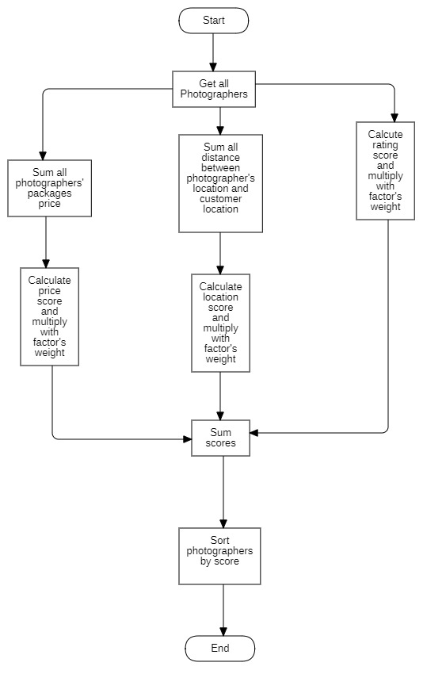

Figure 87 Flowchart - Multiple factors sorting

### 6.2 Naive Bayes Classifier

#### 6.2.1 Definition

Naive bayes classifiers is a simple technique mostly used for building classifiers based on Bayes’ theorem from probability theory and statistics.

It is best suited to solve problems which has categorizable variables Some application of naive bayes includes: Spam email filtering, sentiment prediction, or in our case, weather prediction.

#### 6.2.2 Define problem

Our application domain is photography, which has highly dependence on weather in order to make the most out of a shooting session. So, the problem here is we need a tool which could warn customer or photographer on bad weather days.

#### 6.2.3 Solution

Some definitions:

Bayes’ Theorem: $P\left(A|B\right)=\frac{P\left(B|A\right)P\left(A\right)}{P\left(B\right)}$

P(A|B) - Posterior: The probability of “A” being true given that “B” is already true.

P(B|A) - Likelihood: The probability of “B” being true given that “A” is already true.

P(A) - Prior: The probability of “A” being true.

P(B) - Evidence: The probability of “B” being true.

Input:

* A set of features x = {x1, x2… xn}, in our case x = {Outlook, Temperature, Humidity, Windy}
* A fixed set of classes C = {c1, c2… cn}, in our case C = {Yes, No}

Output

* A predicted class c from C.

For documenting purpose, we use a fictional example dataset below:

|  |  |  |  |  |
| --- | --- | --- | --- | --- |
| **Outlook** | **Temperature** | **Humidity** | **Windy** | **Shooting** |
| Sunny | High | High | Strong | No |
| Overcast | Normal | Normal | Normal | Yes |
| Rainy | High | Normal | Strong | No |
| Sunny | Normal | Normal | Normal | Yes |
| Rainy | High | Normal | Strong | No |
| Overcast | Normal | High | Normal | Yes |
| Rainy | High | High | Strong | No |

We will convert this to Frequency tables:

|  |  |  |  |
| --- | --- | --- | --- |
| **Class** | **Outlook** | | |
| Sunny | Overcast | Rainy |
| Yes | 1 | 2 | 0 |
| No | 1 | 0 | 3 |

|  |  |  |
| --- | --- | --- |
| **Class** | **Temperature** | |
| High | Normal |
| Yes | 0 | 4 |
| No | 4 | 0 |

|  |  |  |
| --- | --- | --- |
| **Class** | **Humidity** | |
| High | Normal |
| Yes | 1 | 2 |
| No | 2 | 1 |

|  |  |  |
| --- | --- | --- |
| **Class** | **Windy** | |
| Strong | Normal |
| Yes | 0 | 4 |
| No | 4 | 0 |

For example, if we want to know if a set of features {Sunny, High Temperature, High Humidity, Strong Windy} is suitable for photographing or not.

According to Bayes theorem we need to calculate posterior probability.

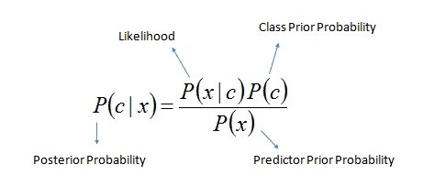

Or we can simply calculate in expanded form:

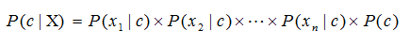

We calculate for each class (Yes and No) and then compare it to find out which gives higher score.

Since we want to classify sunny outlook, high temperature, high humidity and strong wind, we need to calculate following probabilities:

P (Yes) = $\frac{3}{7}$

P (No) = $\frac{4}{7}$

P (Sunny | Yes) = $\frac{1}{3}$

P (Sunny | No) = $\frac{1}{4}$

P (Temperature = High | Yes) = $\frac{0}{3}$

In this case, to avoid the multiplication of probabilities become 0, we will add 1 to the value.

-> P (Temperature = High | Yes) = $\frac{1}{3}$

P (Temperature = High | No) = $\frac{4}{4}$

P (Humidity = High | Yes) = $\frac{1}{3}$

P (Humidity = High | No) = $\frac{2}{4}$

P (Windy = Strong | Yes) = $\frac{0}{3}$

Same as the case above, we will add to 1 to the value.

-> P (Windy = Strong | Yes) = $\frac{1}{3}$

P (Windy = Normal | No) = $\frac{4}{4}$

Final step, we will find two posterior probabilities in expanded form (Without divide it for the evidence):

* P (Yes | X):

$$P\left(Yes\right)×P\left(Yes\right)×P\left(HighHumidity|Yes\right)×P(StrongWindy|Yes)×P(Yes)$$

$=\frac{1}{3}×\frac{1}{3}×\frac{1}{3}×\frac{1}{3}×\frac{3}{7} \sim 0.00529$

* P (No | X):

$$P\left(No\right)×P\left(No\right)×P\left(HighHumidity|No\right)×P(StrongWindy|No)×P(No)$$

$=\frac{1}{4}×\frac{4}{4}×\frac{2}{4}×\frac{4}{4}×\frac{4}{7}\sim 0.0714$

As 0.0714 > 0.00529 so we can predict that the weather is not suitable for shooting.

#### 6.2.4 Complexity

The complexity of Naive Bayes is O(nK), where n is number of features and K is number of classes.

#### 6.2.5 References

* <https://www.geeksforgeeks.org/naive-bayes-classifiers/>
* <https://en.wikipedia.org/wiki/Naive_Bayes_classifier>

# V. Software Testing Documentation

## 1. Overall Description

### 1.1 Test Model

We use a software development process model is V-model because this model is suitable for project conditions. For each stage, there will be a corresponding check it helps us to detect errors from the beginning.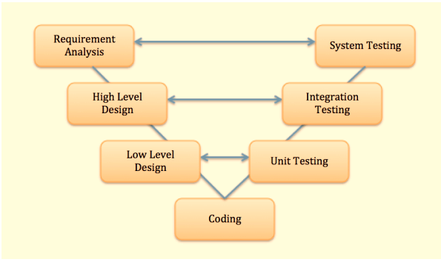

Figure 88 Test Model

References: *https://en.wikipedia.org/wiki/V-Model_(software_development)*

### 1.2 Testing Levels

|  |  |
| --- | --- |
| **Testing Level** | **Description** |
| Unit Testing | Checks if software components are fulfilling functionalities or not. |
| Integration Testing | Checks the data flow from one module to other modules. |
| System Testing | Evaluates both functional and non-functional needs for the testing. |
| Acceptance Testing | Checks the requirements of a specification or contract are met as per its delivery. |

Table Testing Levels

### 1.3 Testing Types

|  |  |
| --- | --- |
| **Testing types** | **Description** |
| Functional Testing | Include:   * Unit Testing * Integration Testing * System Testing * Interface Testing * Regression Testing |
| Non-functional Testing | Include:   * Performance Testing * Load Testing |

Table 129 Testing Types

## 2. Test Plan

### 2.1 Test Stages

|  |  |  |  |  |
| --- | --- | --- | --- | --- |
| **Type of Test** | **Stage of Test** | | | |
| ***Unit*** | ***Integration*** | ***System*** | ***Acceptance*** |
| Interface test | X |  | X |  |
| Performance Testing | X | X |  |  |
| Load Test |  |  | X | X |

Table 130 Test Stages

### 2.2 Resources

#### a. Human Resources

|  |  |  |
| --- | --- | --- |
| **Worker/Doer** | **Role** | **Specific Responsibilities/Comments** |
| Trần Thiên Thảo | Leader | * Functional Testing * Non-functional Testing |
| Bồ Công Đạt | Member | * Functional Testing * Non-functional Testing |
| Đào Sỹ Trung Kiên | Member | * Functional Testing * Non-functional Testing |
| Trương Ngọc Mỹ | Member | * Functional Testing * Non-functional Testing |

Table 131 Human Resources

#### b. Environment

|  |  |  |  |
| --- | --- | --- | --- |
| **Purpose** | **Tool** | **Provider** | **Version** |
| Unit Test | Postman | Postman, Inc. | 7.36.0 |
| Unit Testing  Integration Testing  System Testing  Interface Testing  Regression Testing  Performance Testing  Load Testing | Chrome | Google LLC | 87.0.4280.66 |
| Android phone | Sony Corporation | XZ1 |

Table 132 Environment

### 2.3 Test Milestones sua gio giac

|  |  |  |  |
| --- | --- | --- | --- |
| **Milestone Task** | **Effort (md)** | **Start Date** | **End Date** |
| Unit test case | 25 | 20/11/2020 | 22/01/2021 |
| System test case | 25 | 20/11/2020 | 22/01/2021 |
| Test procedures | 8 | 05/12/2020 | 22/01/2021 |
| Defect reports | 5 | 15/12/2020 | 22/01/2021 |

Table 133 Test Milestones

### 2.4 Deliverables

|  |  |  |
| --- | --- | --- |
| **No** | **Deliverables** | **Due Date** |
| 1 | Unit test case | 22/01/2021 |
| 2 | System Test case | 22/01/2021 |

Table 134 Deliverables

## 3. Test Cases

Test cases are included in these two excel files:

|  |  |
| --- | --- |
| **No** | **Filename** |
| 1 | Unit Test Cases: Report5_Unit_Test_Case.xls |
| 2 | System Test case |

Table 135 Test Cases

## 4. Test Reports

Test reports are included in this file:

|  |  |
| --- | --- |
| **No** | **Filename** |
| 1 | Report5_Test_Case_Document.xlsx |

Table 136 Test Reports

# VI. Release Package & User Guides

## 1. Deliverable Package

### 1.1 Source codes & documents them tên bảng cho ban tieng Nhat

|  |  |  |  |  |
| --- | --- | --- | --- | --- |
| **No.** | **Items** | **Sub-Items** | **Type** | **Version** |
| ***Code Package*** | | | | |
| 1 | Web API | pbs_webapi | New | 1.0.1 |
| 2 | Mobile Apps | photographer_mobile_app | New | 1.0.1 |
| customer_mobile_app | New | 1.0.1 |
| ***Database*** | | | | |
| 1 | Tables | pbs_users.sql | New | 1.0.1 |
| pbs_roles.sql | New | 1.0.1 |
| pbs_photographer_packages.sql | New | 1.0.1 |
| pbs_packages_services.sql | New | 1.0.1 |
| pbs_services.sql | New | 1.0.1 |
| pbs_returning_types.sql | New | 1.0.1 |
| pbs_bookings.sql | New | 1.0.1 |
| pbs_booking_details.sql | New | 1.0.1 |
| pbs_booking_time_location_detail.sql | New | 1.0.1 |
| pbs_booking_comments.sql | New | 1.0.1 |
| pbs_albums.sql | New | 1.0.1 |
| pbs_customers_albums.sql | New | 1.0.1 |
| pbs_album_images.sql | New | 1.0.1 |
| pbs_images.sql | New | 1.0.1 |
| pbs_categories.sql | New | 1.0.1 |
| pbs_threads.sql | New | 1.0.1 |
| pbs_thread_comments.sql | New | 1.0.1 |
| pbs_thread_topics.sql | New | 1.0.1 |
| pbs_locations.sql | New | 1.0.1 |
| pbs_working_day_of_week.sql | New | New |
| pbs_busy_days.sql | New | New |
| pbs_cancellation_requests.sql | New | New |
| pbs_verification_token.sql | New | New |
| pbs_reports.sql | New | New |
| pbs_notifications.sql | New | New |
| pbs_variable.sql | New | New |
| ***Documents*** | | | | |
| 1 | Introduction | Report1_Project-Introduction.docx | New | 1.0.1 |
| 2 | Management Plan | Report2_Project-Management-Plan.docx | New | 1.0.1 |
| 3 | Requirement | Report3_Software Requirement Specification.docx | New | 1.0.1 |
| 4 | Design | Report4_Software Design Document.docx | New | 1.0.1 |
| 5 | Testing | Report5_Test Documentation.docx | New | 1.0.1 |
| Report5_Test Case Document.xlsx | New | 1.0.1 |
| Report5_Unit Test Case.xls | New | 1.0.1 |
| 6 | User guides | Report6_Software User Guides.docx | New | 1.0.1 |
| 7 | Final | Report7_Final Project Report.docx | New | 1.0.1 |

Table Deliverable Package

### 1.2 Known Issues, Limitations & Restrictions

* The application has not supported payment.
* The system does not have a photo verification feature.
* The system has not provided a website version to both customers and photographers. Users may find it uncomfortable to use applications.

## 2. Installation Guides

### 2.1 System Requirements

**2.1.1 Hardware requirements**

**For PC**

|  |  |  |
| --- | --- | --- |
| **PC** | **Minimum Requirements** | **Recommended** |
| Internet Connection | Cable, Wi-Fi (4 Mbps) | Cable, Wi-Fi (8 Mbps) |
| Operating System | Windows 7 | Windows 7 or more. |
| Computer Processor | Intel® Core i3 1.4GHz | Intel® Core i5 2.50GHz |
| Computer Memory | 1GB RAM | 2GB RAM or more |
| Web Browser | Chromes (v42 or higher) | Chrome latest stable version |

Table 138 PC Hardware requirements

**For Android Devices**

|  |  |
| --- | --- |
| **Operating system** | Android 8.0 or higher |
| **Processor** | Intel Atom® Processor Z2520 1.2 GHz, or faster processor |
| **Storage** | Between 850 MB and 1.2 GB, depending on the language version |
| **RAM** | Minimum of 512 MB, 2 GB is recommended |
| **Hard Disk** | * 2 GB of available hard-disk space for installation; extra free space is required during installation. * You cannot install using a removable flash storage device. |
| **Video** | 1920 x 1080 pixels or higher |
| **Browser/Internet** | * This application is designed to work online. * To download and launch Google Play Store apps within the application, a high-speed Internet connection is recommended. |

Table 139 Android Hardware requirements

**2.1.2 Software requirements**

|  |  |  |
| --- | --- | --- |
| **Software** | **Name / Version** | **Description** |
| Operation System | Windows 7, Windows 10 | Operating system and platform for development |
| Web browser | Chrome 69 or above, Mozilla Firefox | For web app |
| Android System | Android 4.0 or higher | For mobile app |

Table 140 Software requirements

### 2.2 Setup Files

* PBS for photographer.apk



Figure 89 Setup files - 1

* PBS for customer.apk



Figure 90 Setup files - 2

### 2.3 Installation Instruction

The installation steps of 2 android apps are the same, so we provide one guideline for both of them.

1. Install PBS by pressing the “Install” button.

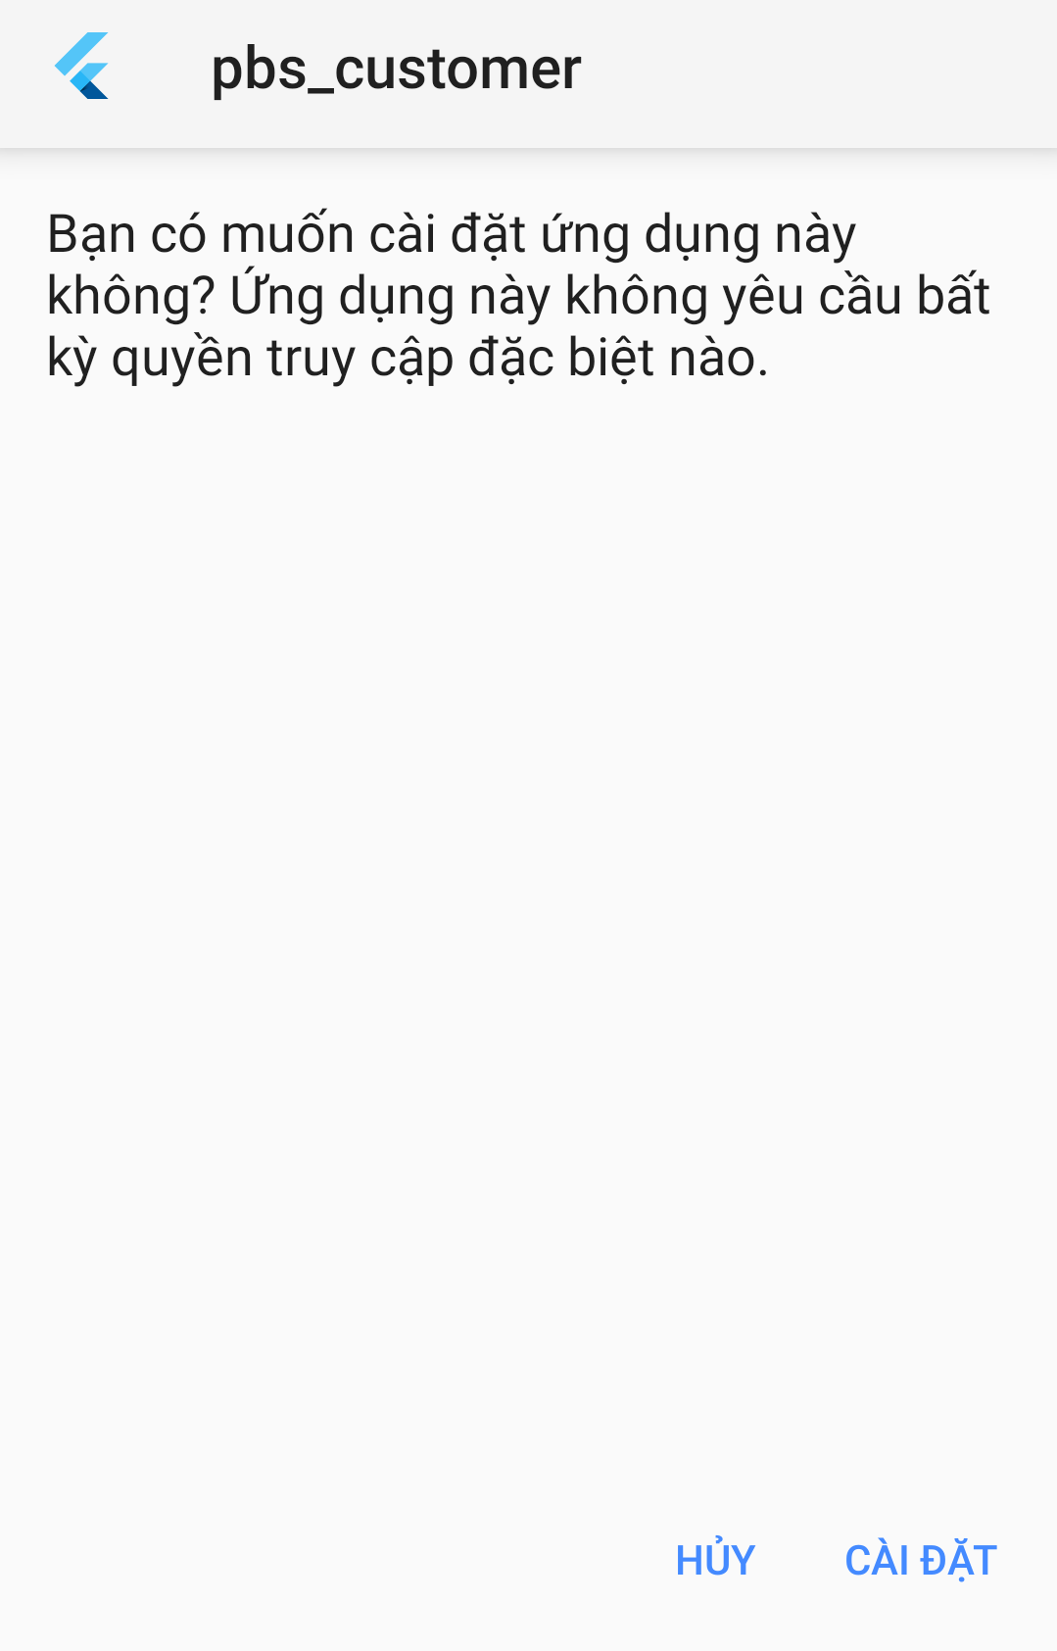

Figure 91 Installation - 1

1. Press “Accept” to accept application permissions.

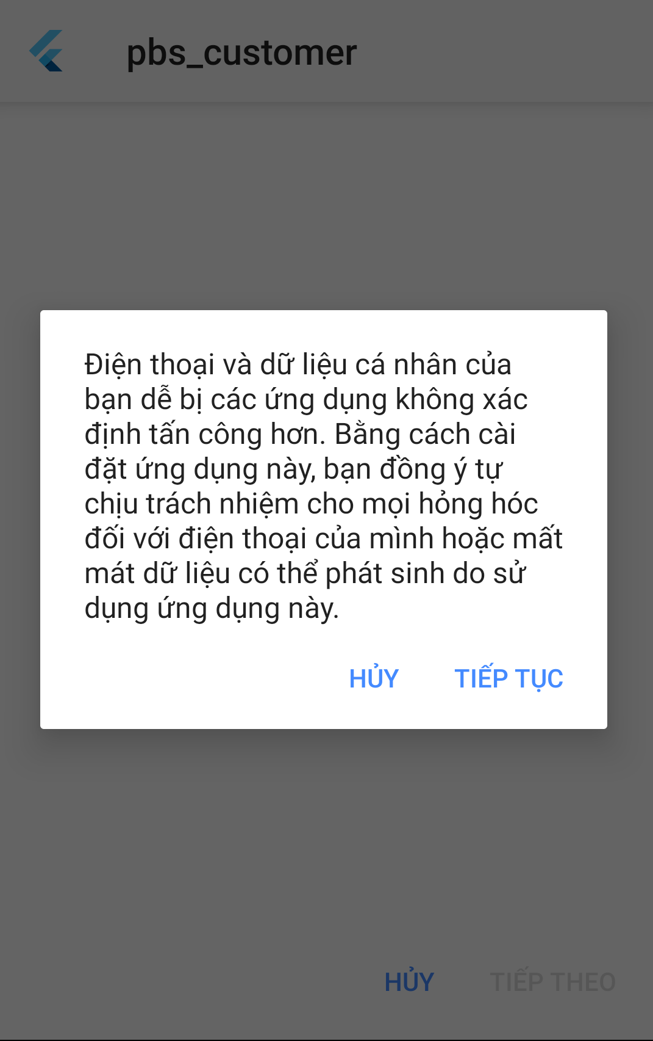

Figure 92 Installation - 2

1. Wait for installation of the PBS App.

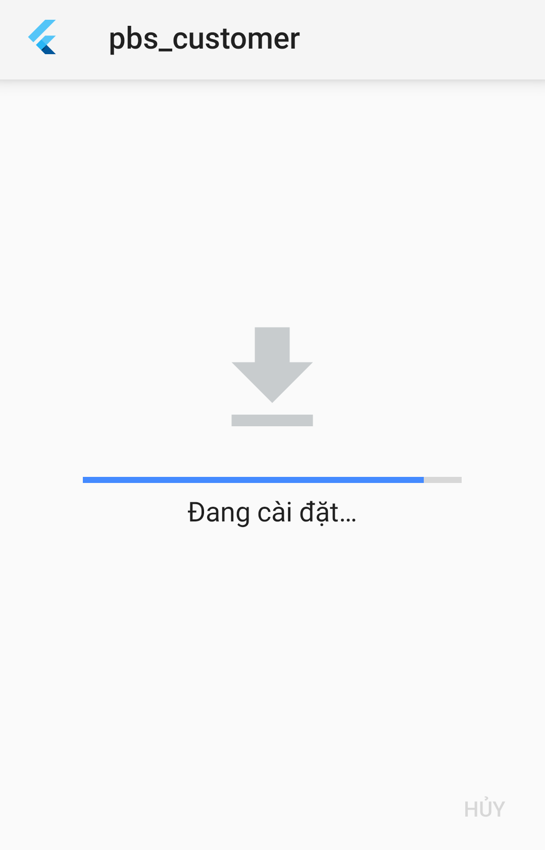

Figure 93 Installation - 3

1. Press “Mở” to start the main App.

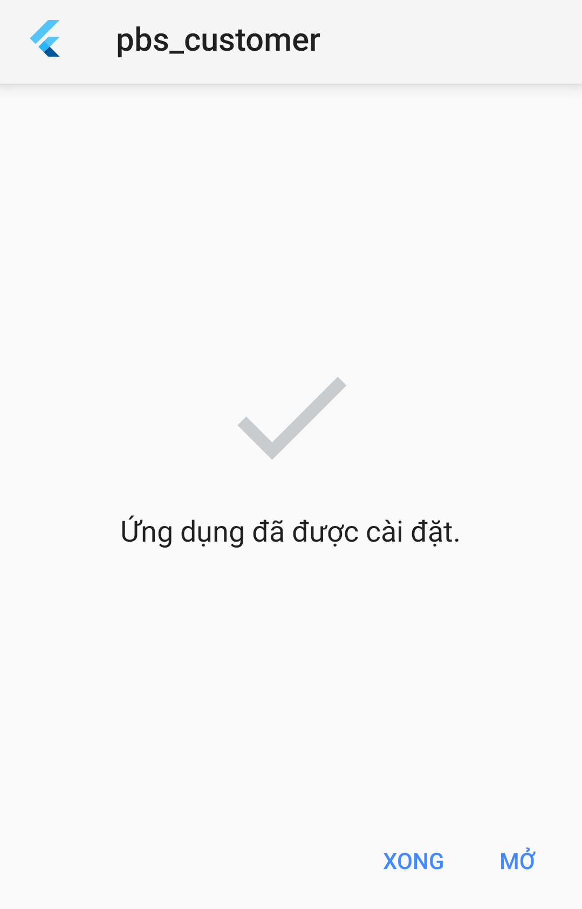

Figure 94 Installation - 4

1. Read the manual for more information.

### 2.4 Server-side deployment

We deploy our webapi to Hostinger’s VPS server. Server’s operating system is Ubuntu 18.04 LTS.

Step 1: Install Tomcat and JDK. Openjdk will be install as dependency with command:

sudo apt-get install tomcat9

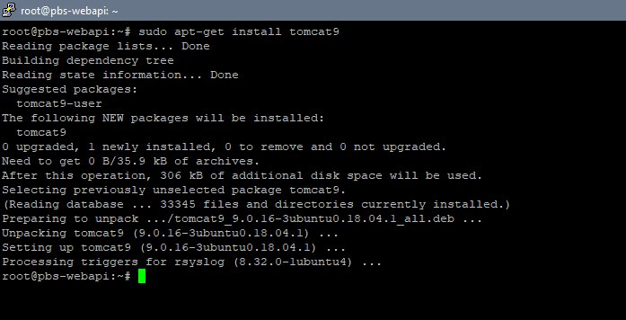

Figure 95 Server-side deployment – 1

Step 2: Start tomcat service with command: sudo systemctl start tomcat9.

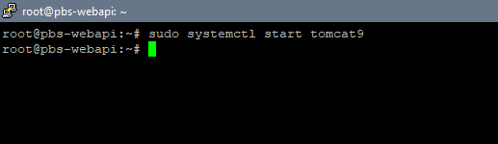

Figure 96 Server-side deployment – 2

Step 3: Configure tomcat admin account at /var/lib/tomcat9/conf/tomcat-users.xml:

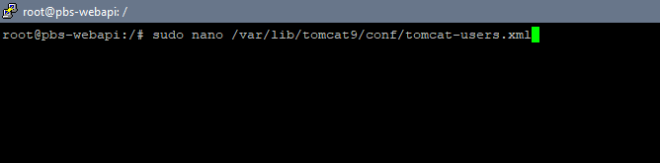

Figure 97 Server-side deployment – 3

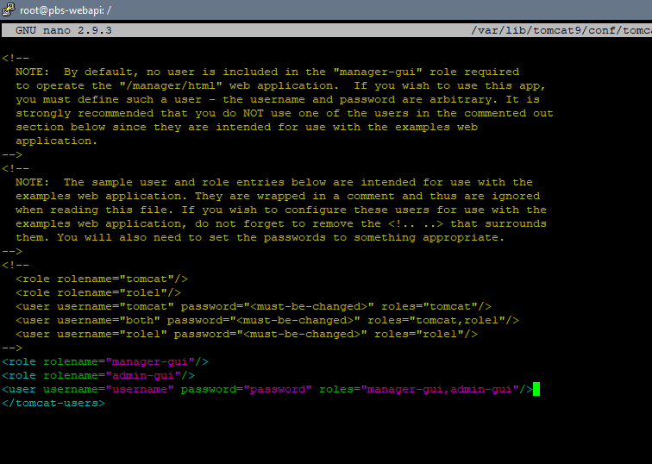

Figure 98 Server-side deployment – 4

Step 4: Export webapi war file using “mvn package clean”:

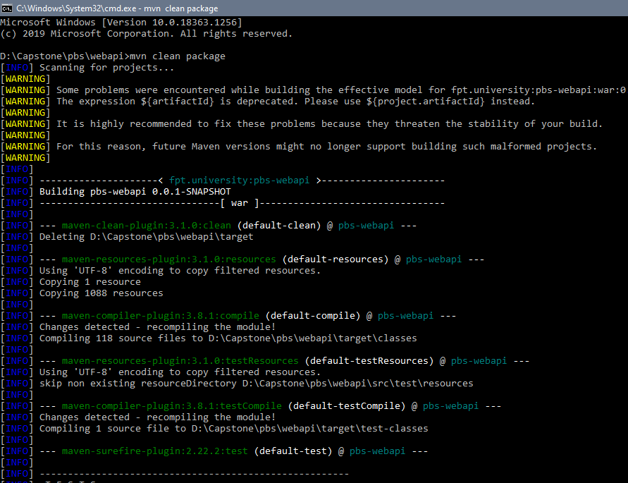

Figure 99 Server-side deployment -5

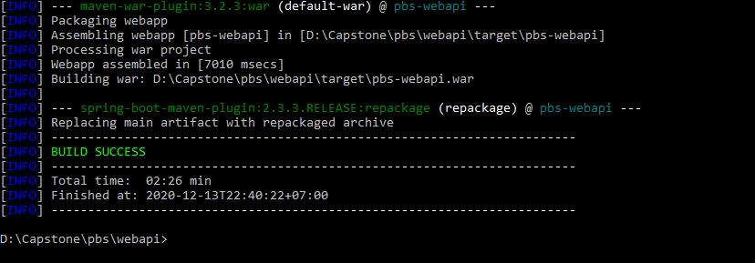

Figure 100 Server-side deployment - 6

Step 5: Last step is to transfer war file to server using pscp via SSH:

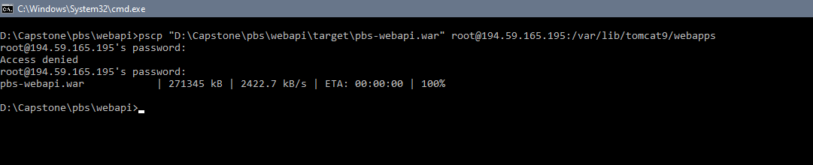

Figure 101 Server-side deployment -7

## 3. User Manual

### 3.1 Terms and definitions

* Accounts are the accounts that you register to sign in as users.
* Photographers’ application is an application provided by PBS for photographers to contact customers.
* Customers’ application is an application provided by PBS for users to contact photographers.
* Mobile devices are your mobile phones, tablets, or other devices that can be used to download and run Photographers’ application and Customers’ application.
* System is the system provided by PBS to support photographers’ and customers’ contact, including the Photographers’ application, Customers’ application, website, and platform.
* Photographers are independent third-party who provide shooting services that customers can book via the system.
* Customers are the ones who have Customers’ application’s accounts.
* Website is the website run by PBS.

### 3.2 System requirements

**3.2.1 Hardware requirements**

**For PC**

|  |  |  |
| --- | --- | --- |
| **PC** | **Minimum Requirements** | **Recommended** |
| Internet Connection | Cable, Wi-Fi (4 Mbps) | Cable, Wi-Fi (8 Mbps) |
| Operating System | Windows 7 | Windows 7 or higher. |
| Computer Processor | Intel® Core i3 1.4GHz | Intel® Core i5 2.50GHz |
| Computer Memory | 1GB RAM | 2GB RAM or more |
| Web Browser | Chromes (v42 or higher) | Chrome latest stable version |

**For Android devices**

|  |  |
| --- | --- |
| **Operating system** | Android 8.0 or higher |
| **Processor** | Intel Atom® Processor Z2520 1.2 GHz, or faster processor |
| **Storage** | Between 850 MB and 1.2 GB, depending on the language version |
| **RAM** | Minimum of 512 MB, 2 GB is recommended |
| **Hard Disk** | * 2 GB of available hard-disk space for installation; extra free space is required during installation. * You cannot install using a removable flash storage device. |
| **Video** | 1920 x 1080 pixels or higher |
| **Browser/Internet** | * This application is designed to work online. * To download and launch Google Play Store apps within the application, a high-speed Internet connection is recommended. |

**3.2.2 Software requirements**

|  |  |  |
| --- | --- | --- |
| **Software** | **Name / Version** | **Description** |
| Operation System | Windows 7, Windows 10 | Operating system and platform for development |
| Web browser | Chrome 69 or above, Mozilla Firefox | For web app |
| Android System | Android 4.0 or higher | For mobile app |

### 3.3 Application Usage

#### 3.3.1. Overview

Customers’ application allows customers to search for and book photographers. Then customers can rate photographers based on their experiences. The rates are displayed as stars and they can also write reviews, which would be shown on photographers’ profiles. To give users more information about photography as well as trendy styles, there is also a forum on the system where they can share information and images.

Photographers’ application helps photographers reach a wide range of potential customers. In addition, they can manage their shooting schedule and receive customers’ bookings. They can also edit their profile, add albums and services that they offer. They can join the forums as well.

The system also provides admins with a website so that they can easily control the system. Admins can manage information related to the system like users, bookings, reports. They can block users who violate community standards.

#### 3.3.2. Android Application

##### 3.3.2.1. Register

* **Purpose**
  + Create users’ accounts
* **Function**
  + Register for PBS account
* **User Interfaces**

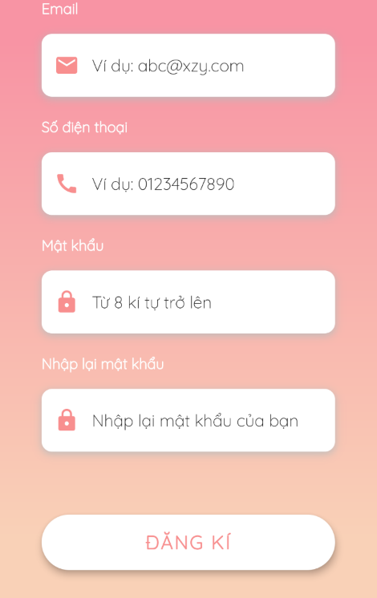

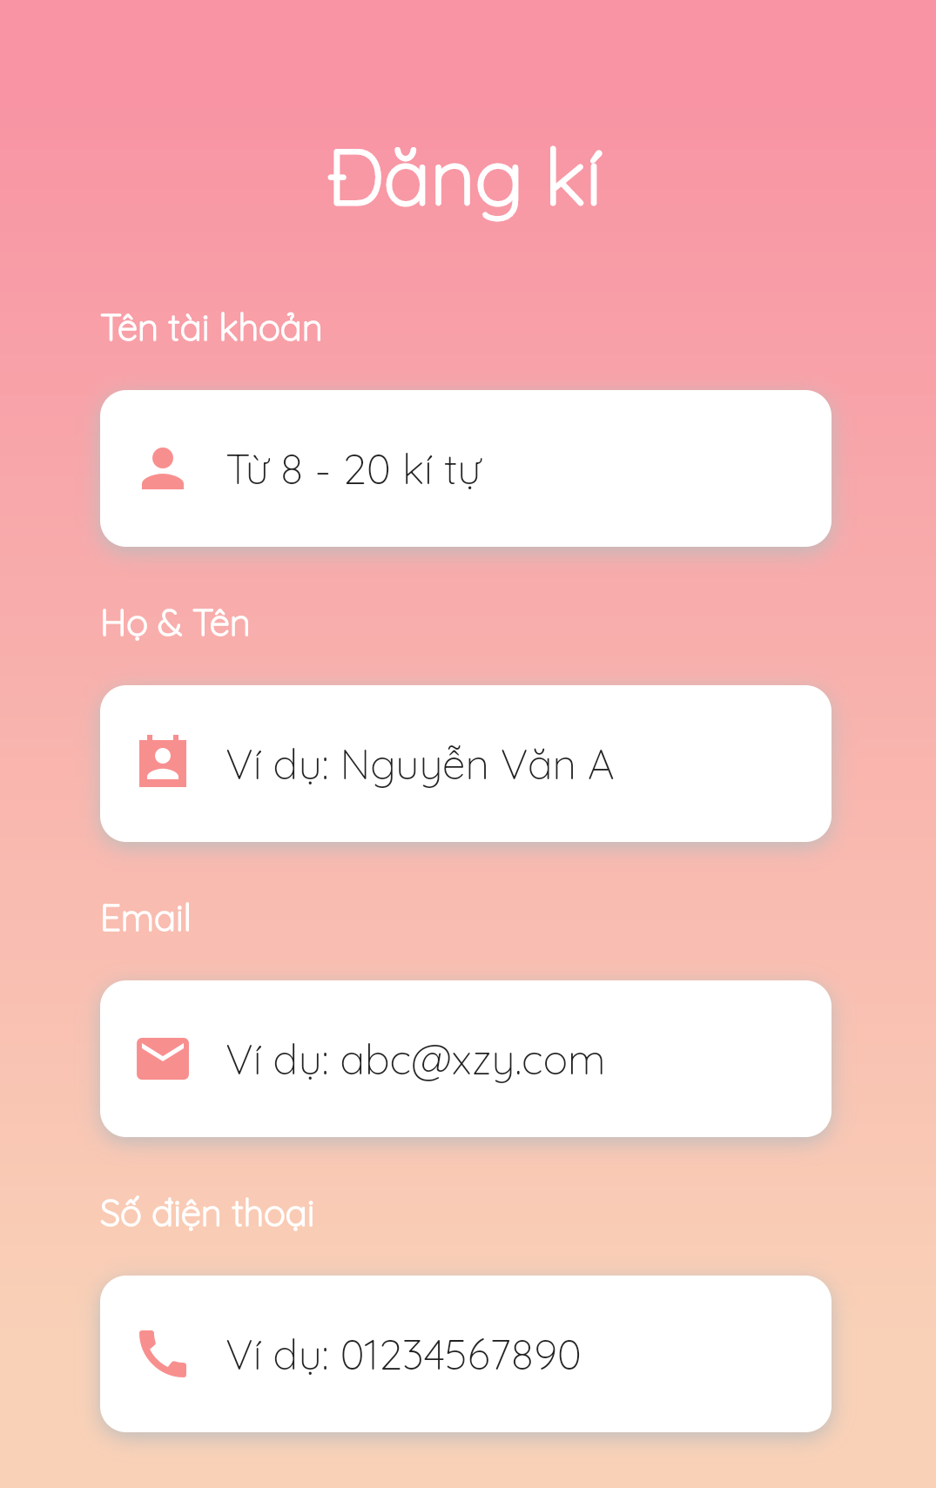

Figure 102 - Register

##### 3.3.2.2. Login

* **Purpose**
  + Allow users to sign in
* **Function**
  + Sign in with PBS account
* **User Interfaces**

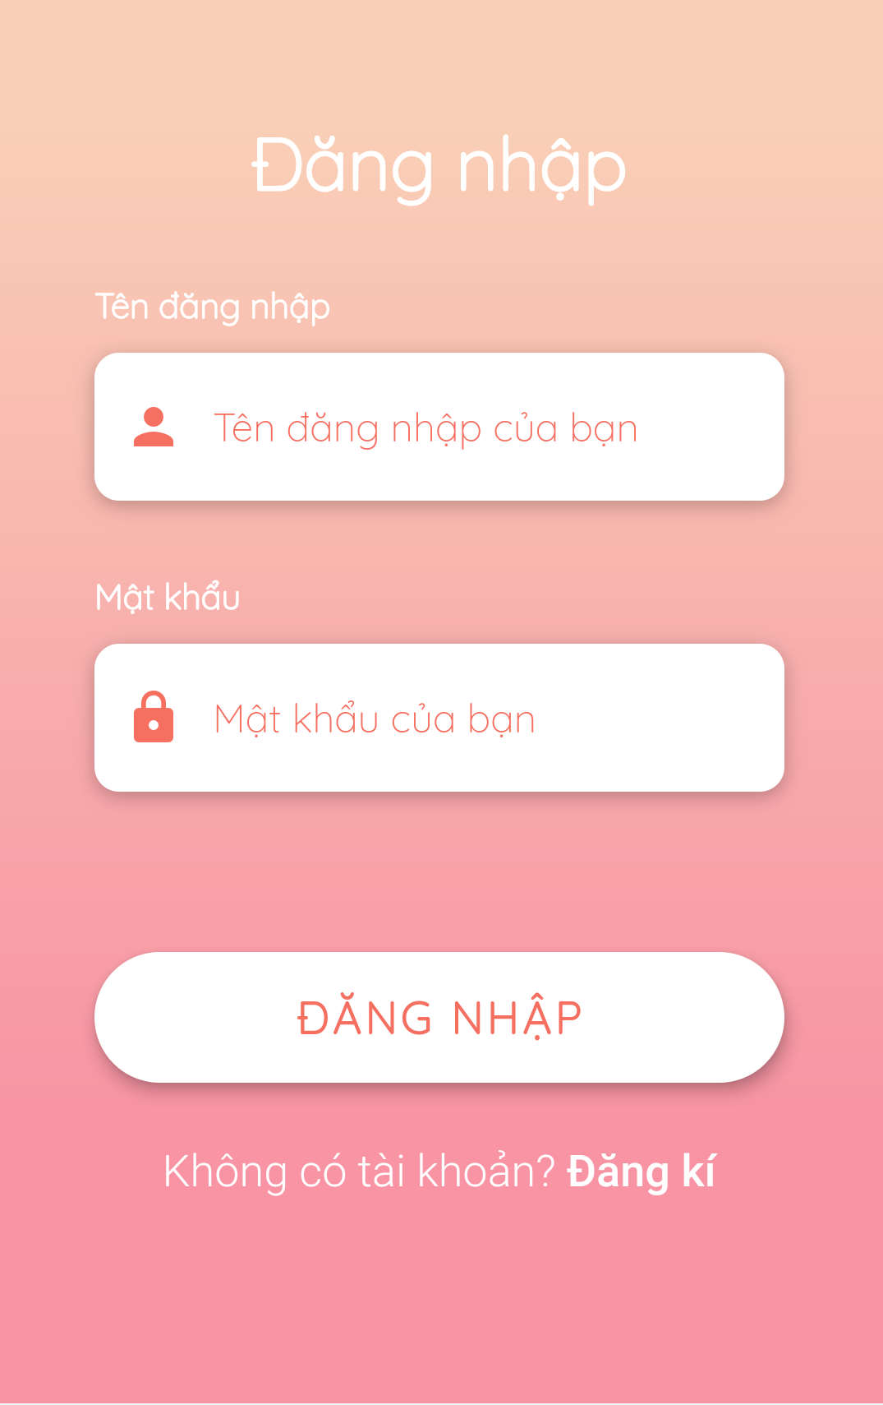

Figure 103 - Login

##### 3.3.2.3 Logout

* **Purpose**
  + Allow users to sign out
* **Function**
  + Sign out
* **User Interfaces**

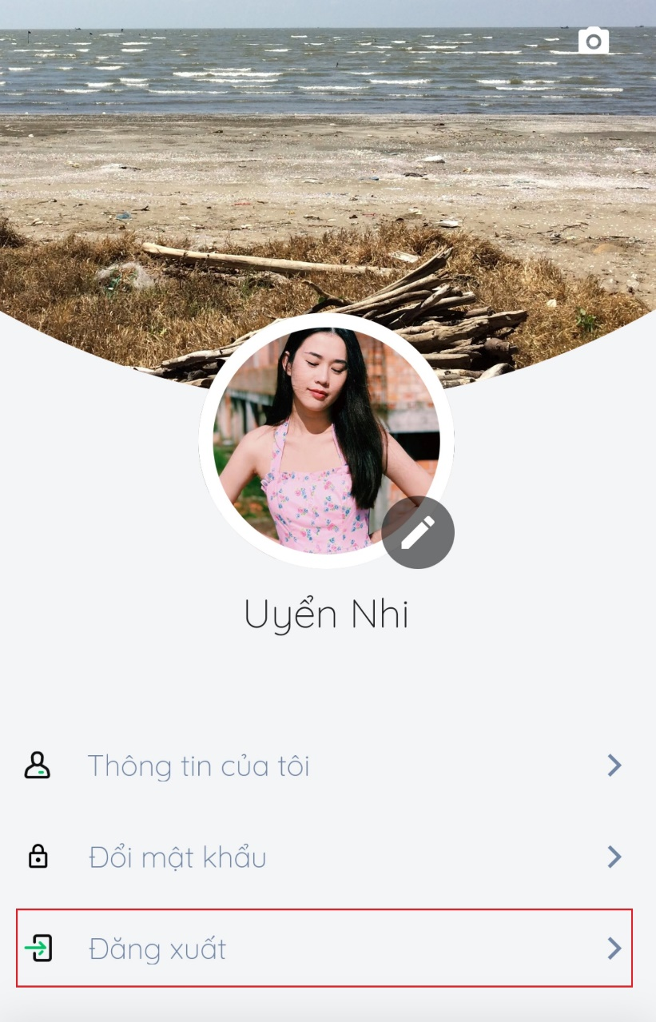

Figure 104 - Logout

##### 3.3.2.4. Search photographer

* **Purpose**
  + Allow customers to find photographers and appropriate services
* **Function**
  + Search for photographers
  + Search for services
* **User Interfaces**

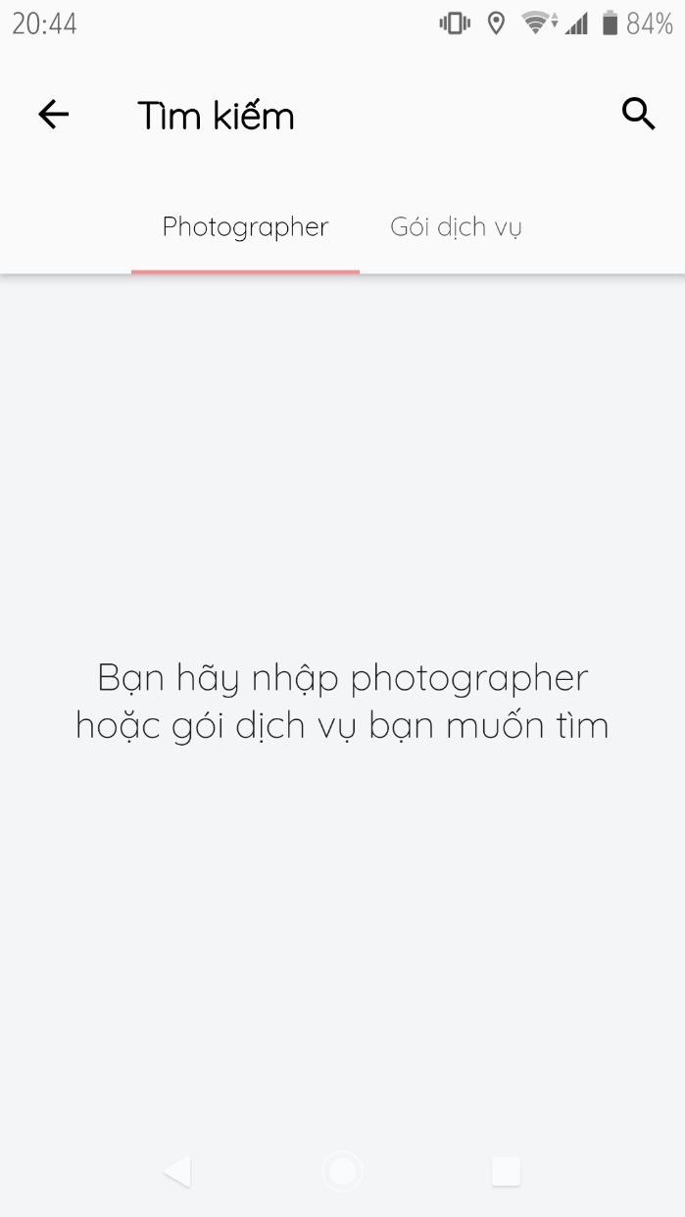

Figure 105 Search photographers

##### 3.3.2.5. Manage request

* **Purpose**
  + Allow customers to manage their bookings
* **Function**
  + Make request for days (customers only)
  + Make request for a day (customers only)
  + Make changes to their bookings (customers only)
  + Cancel their bookings (customers only)
  + Accept bookings (photographers only)
  + Decline bookings (photographers only)
* **User Interfaces**

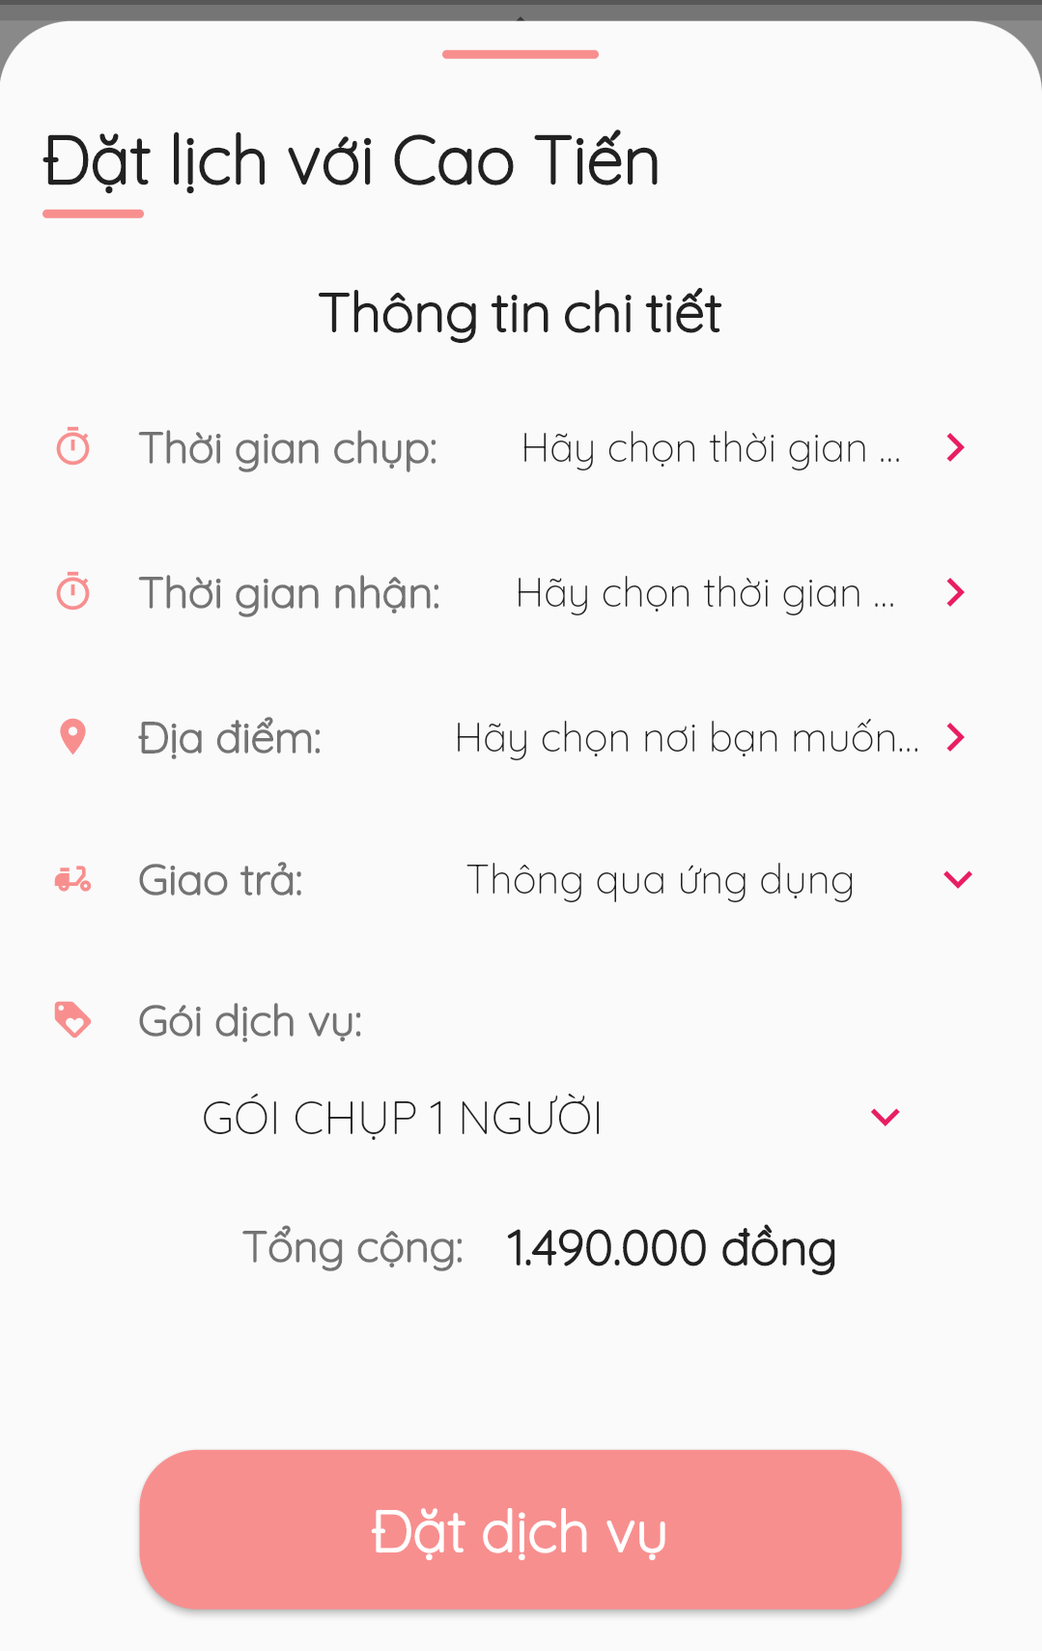

Figure 106 - Make request for a day

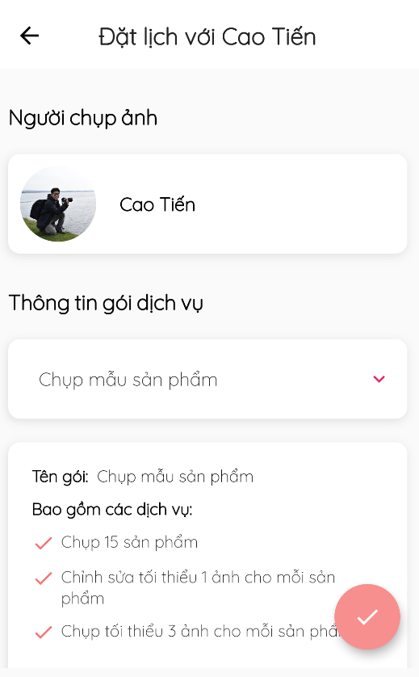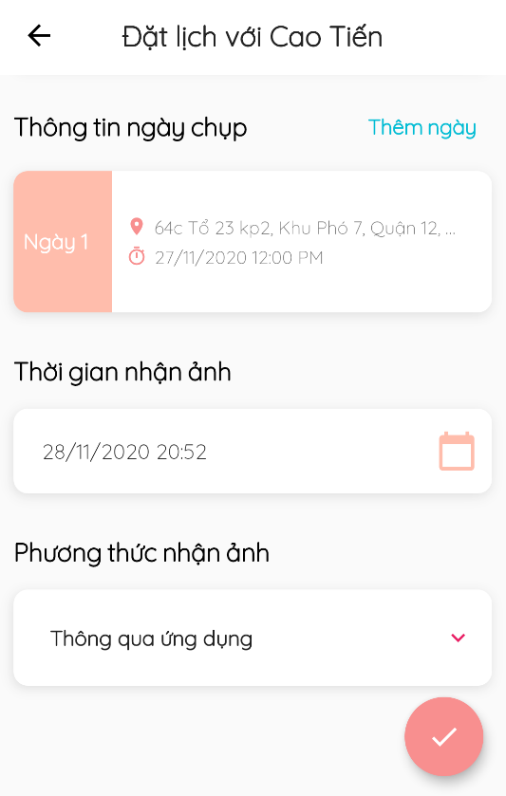

Figure 107 - Make request for days

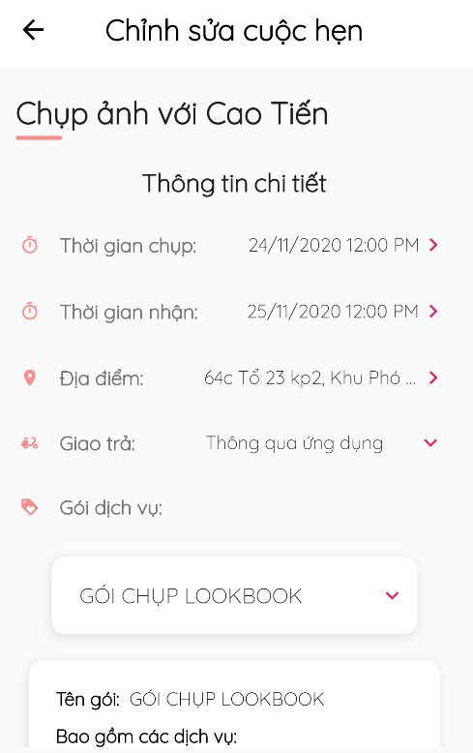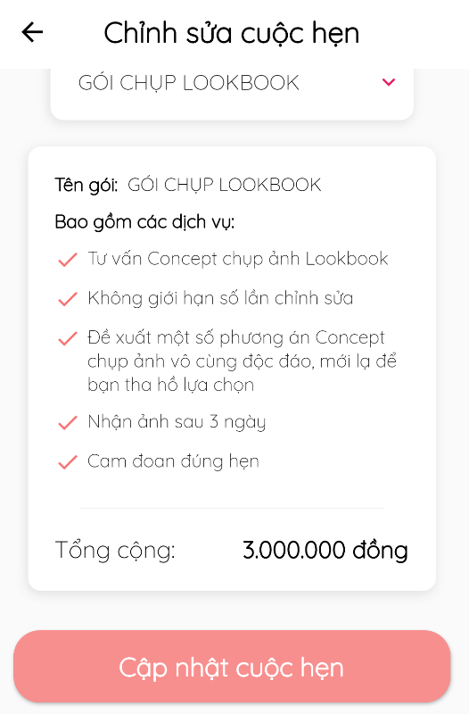

Figure 108 - Update booking for a day

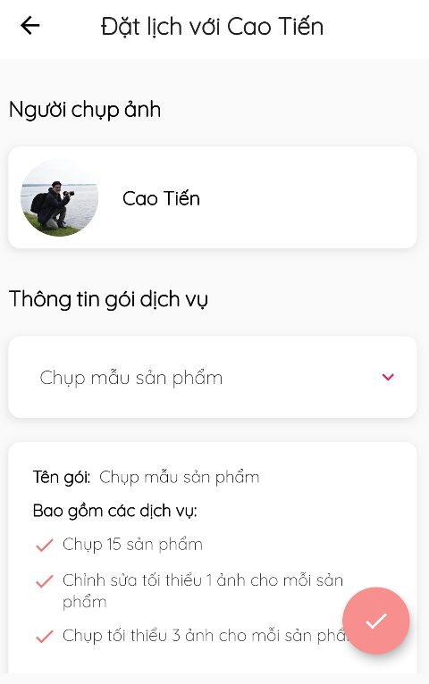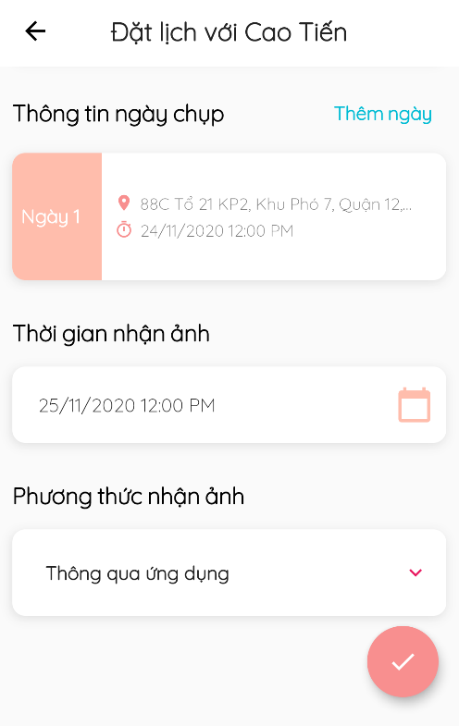

Figure 109 - Update booking for days

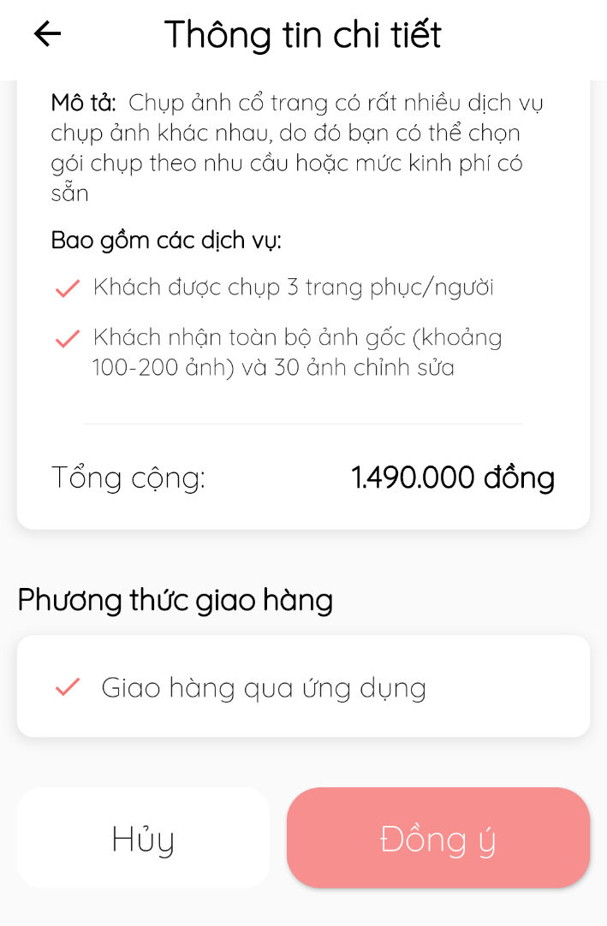

Figure 110 - Decline /Accept /Cancel Booking

##### 3.3.2.6. Manage review

* **Purpose**
  + Allow customers to review shooting services
  + Manage reviews
* **Function**
  + View reviews
  + Write reviews (customers only)
* **User Interfaces**

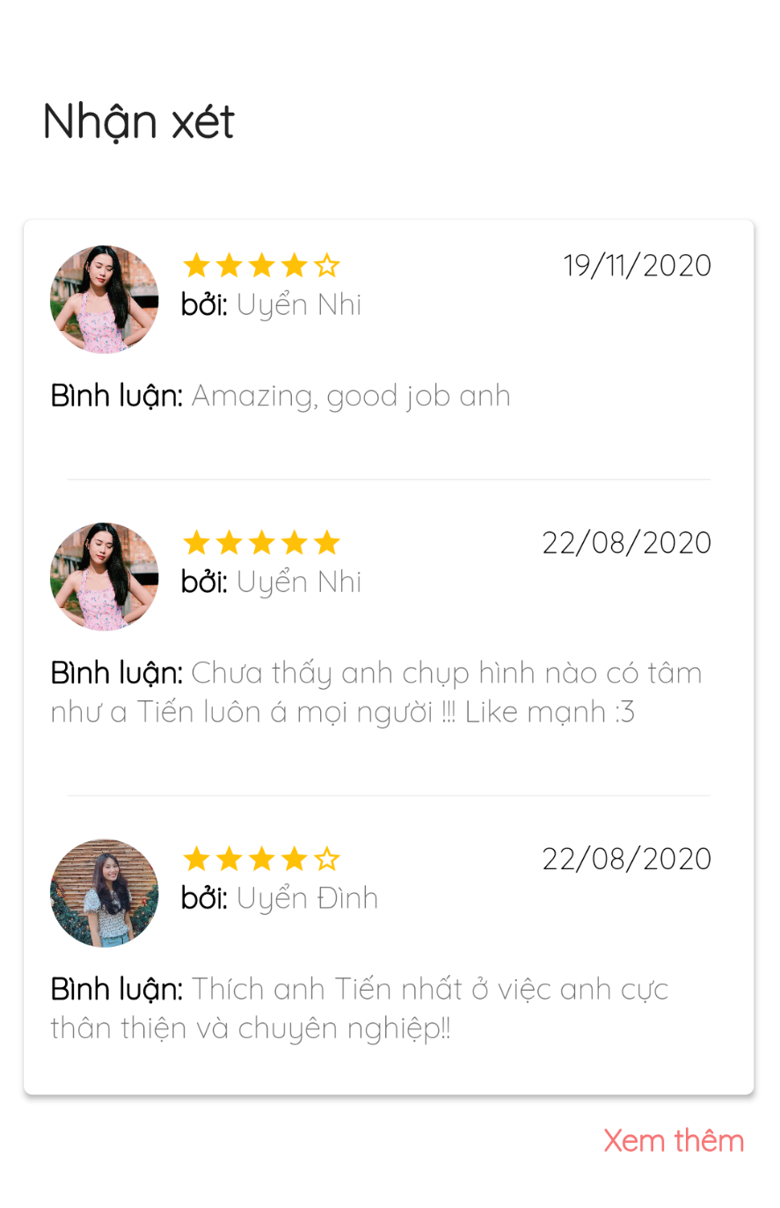

Figure 111 - View Reviews

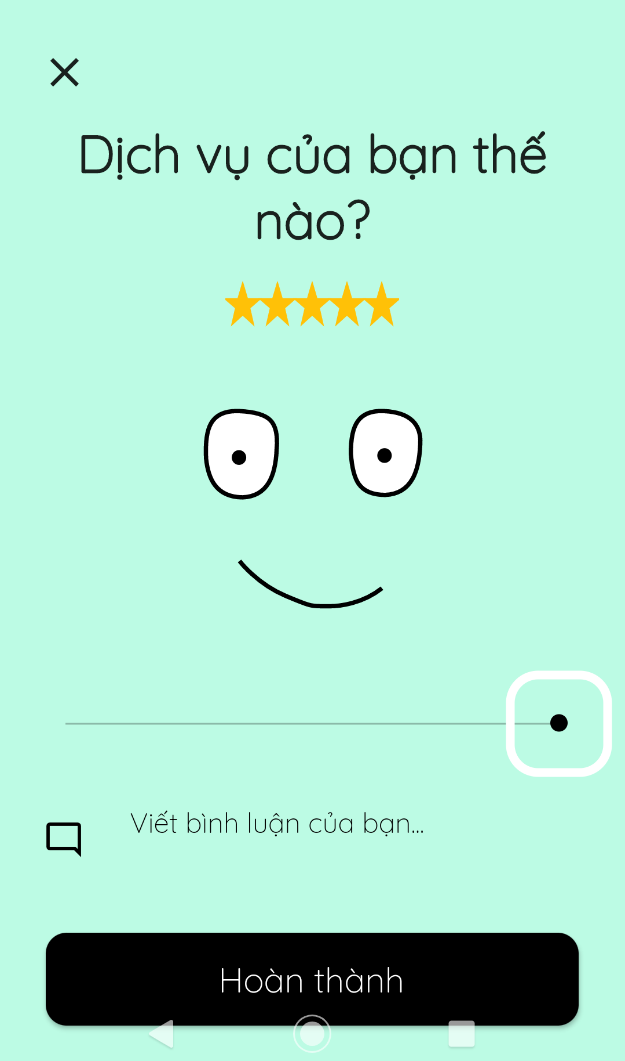

Figure 112 - Write reviews

##### 3.3.2.7. Manage request status

* **Purpose**
  + Allow photographers to update request status
* **Function**
  + Update request status
* **User Interfaces**

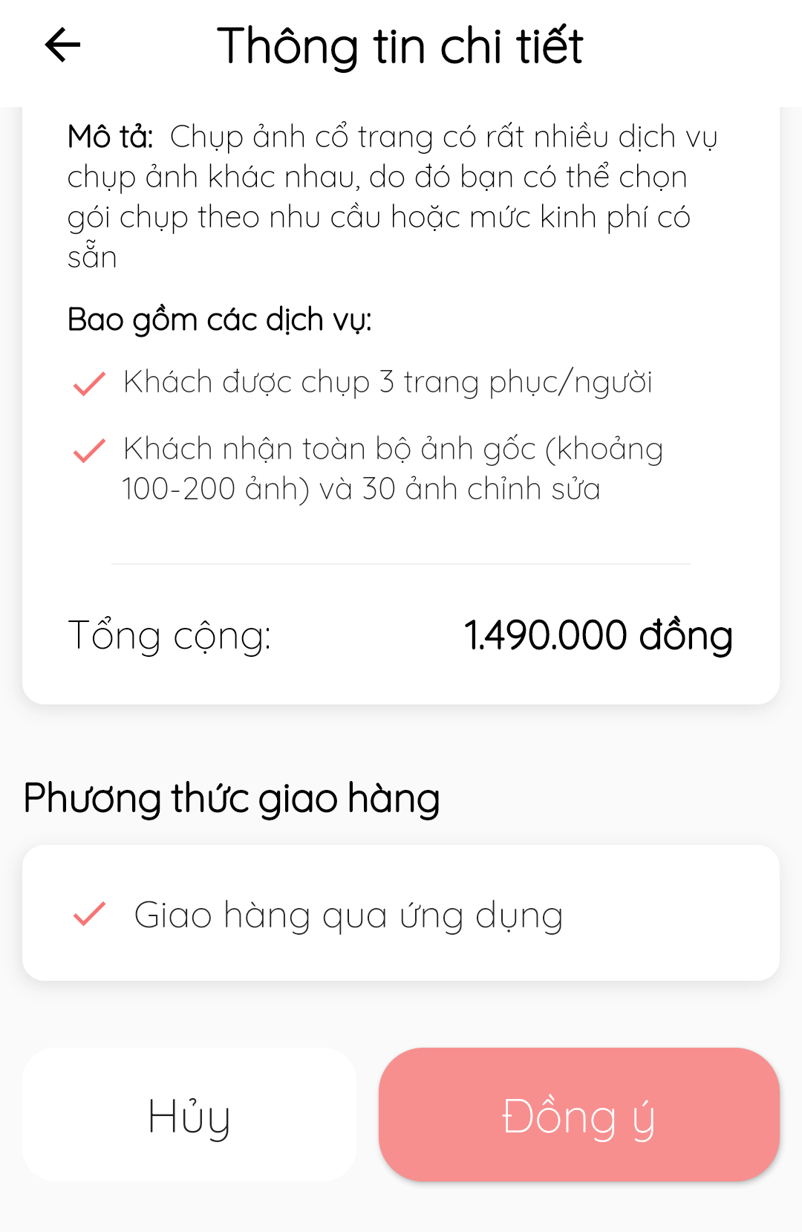

Figure 113 - Change Booking Status

##### 3.3.2.8. Manage calendar

* **Purpose**
  + Allow photographers to make changes to shooting schedule
* **Function**
  + Manage daily shooting schedule
  + Make changes to daily shooting schedule
  + Add unexpected unavailability
* **User Interfaces**

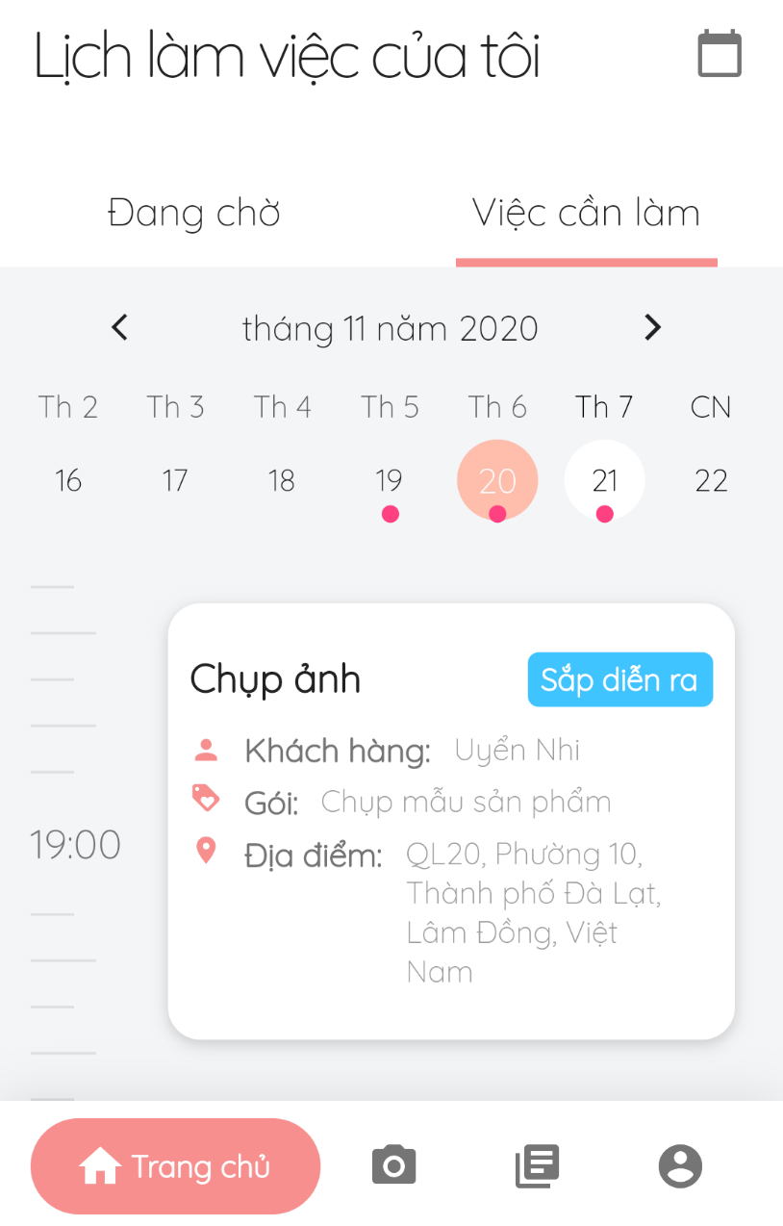

Figure 114 - Shooting schedule

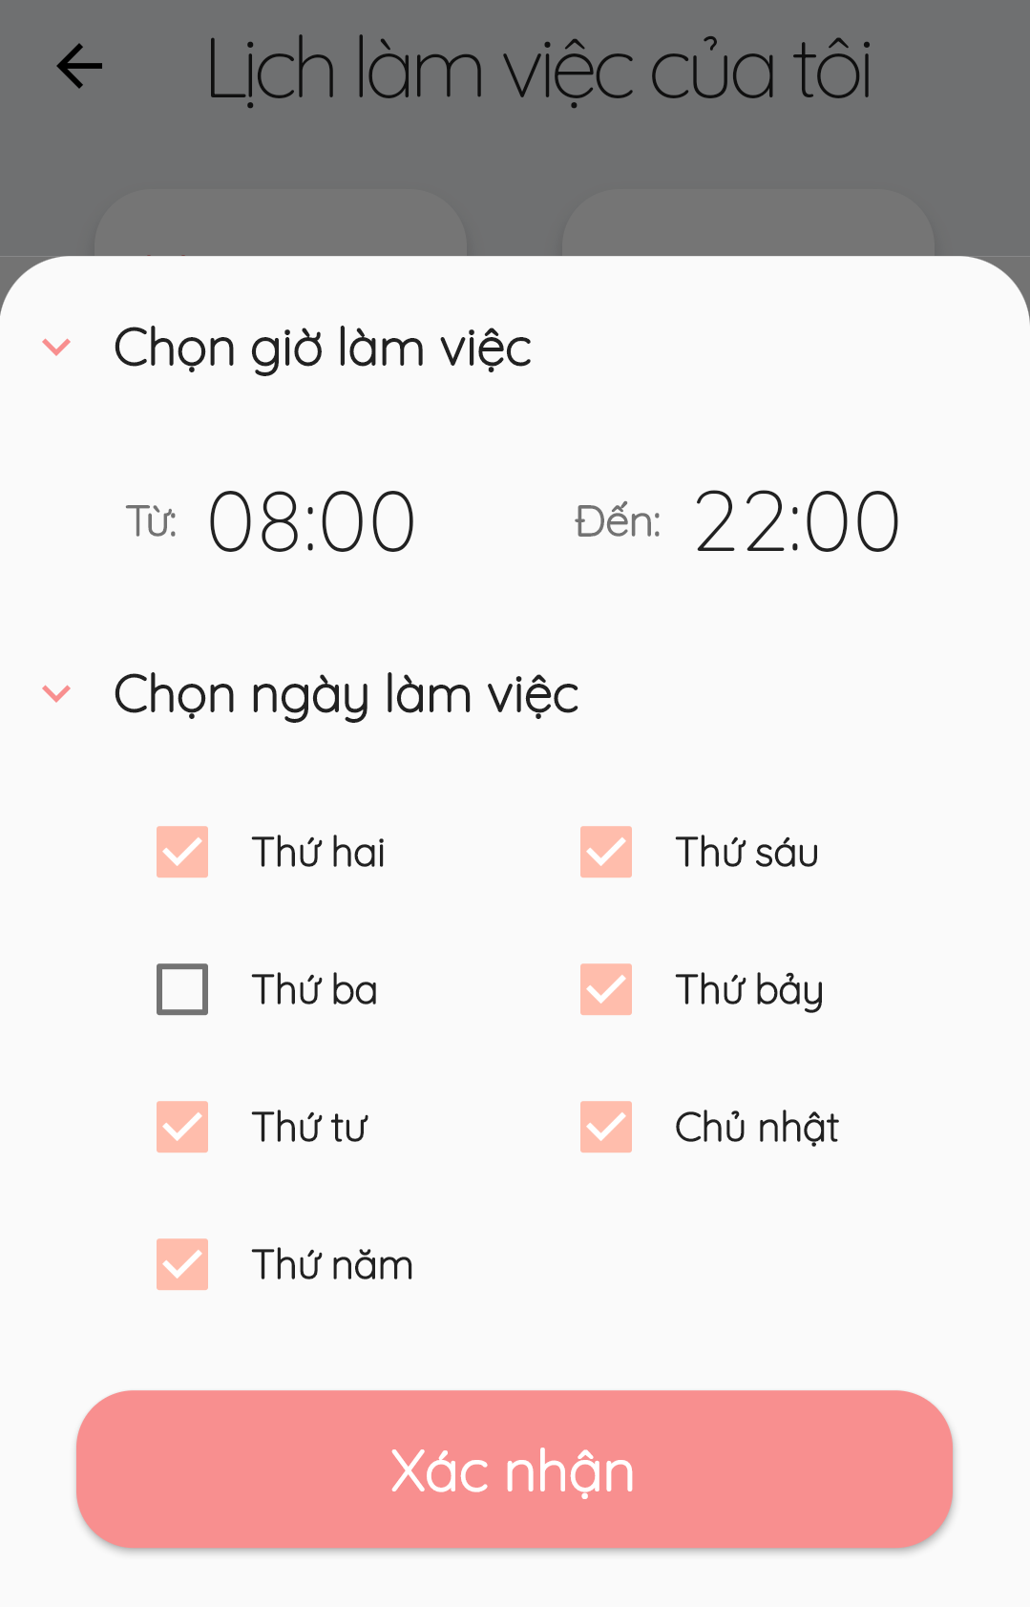

Figure 115 - Make changes to daily shooting schedule

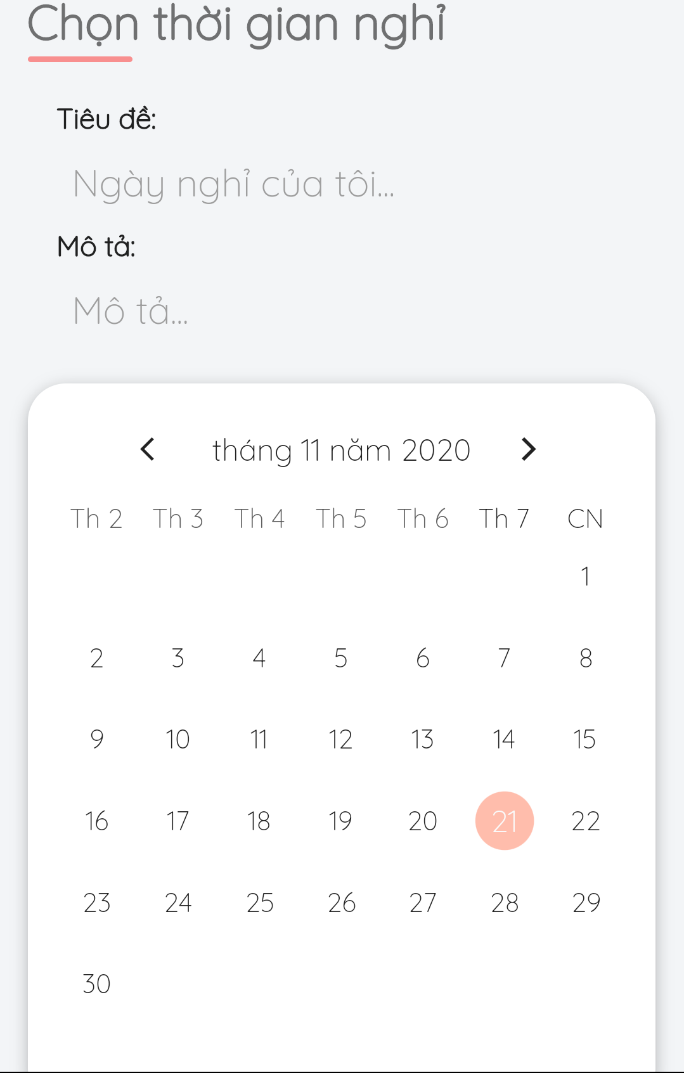

Figure 116 - Add busy days

##### 3.3.2.9. Manage album

* **Purpose**
  + Allow photographers to manage their albums
  + Allow customers to follow their favourite albums
* **Function**
  + Add album (photographers only)
  + Edit album (photographers only)
  + Remove album (photographers only)
  + Follow album (customers only)
* **User Interfaces**

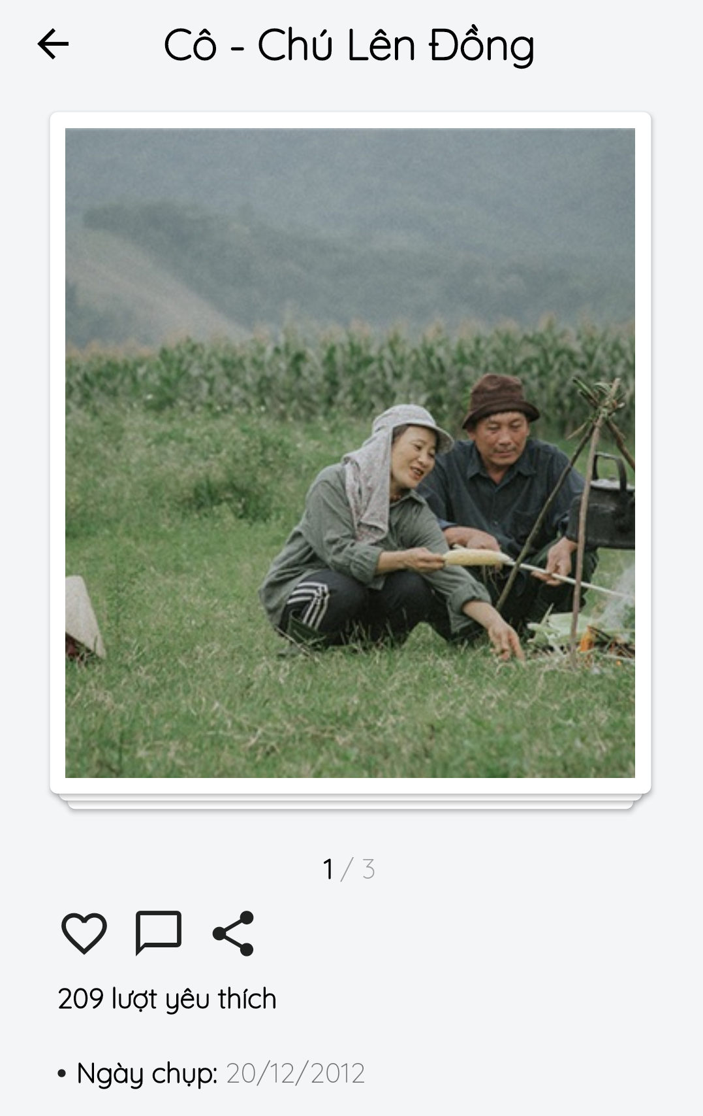

Figure 117 - View Album

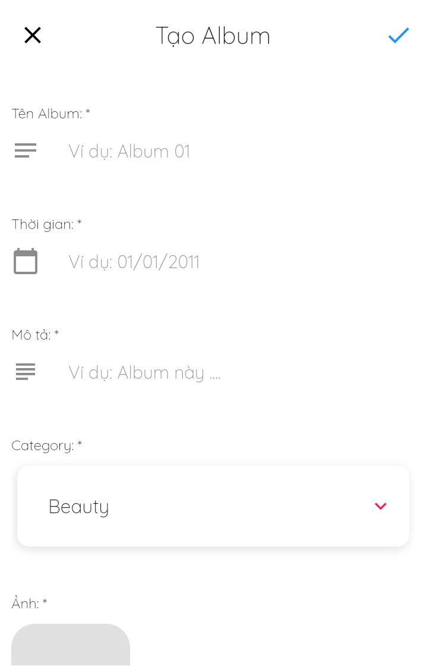

Figure 118 - Add Album

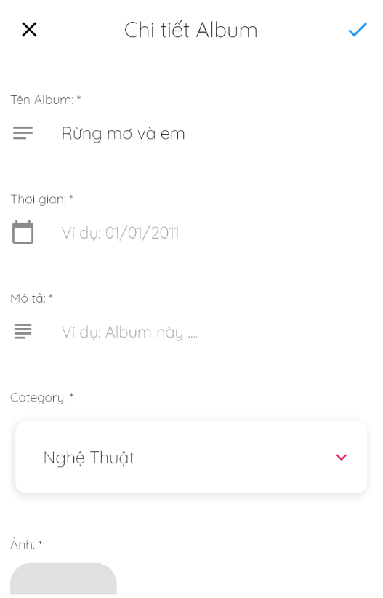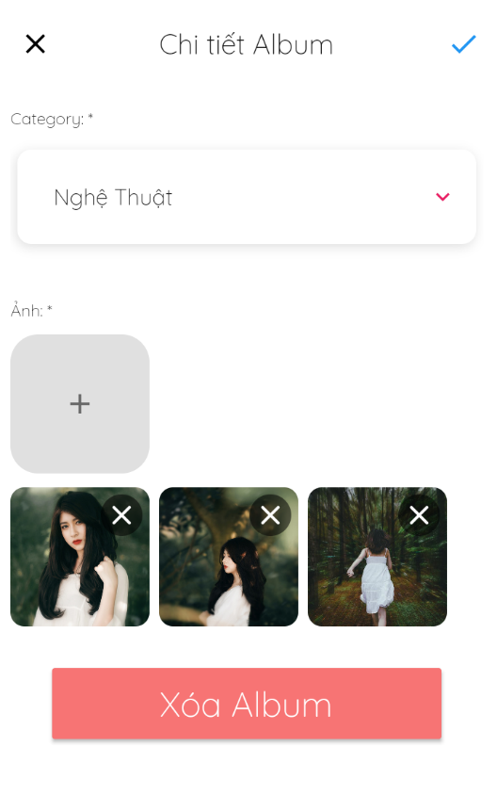

Figure 119 – Edit and Remove Album

##### 3.3.2.10. Manage package

* **Purpose**
  + Allow photographers to manage their packages
  + Allow customers to view photographers’ packages
* **Function**
  + Add package (photographers only)
  + Update package (photographers only)
  + Remove package (photographers only)
  + View packages
* **User Interfaces**

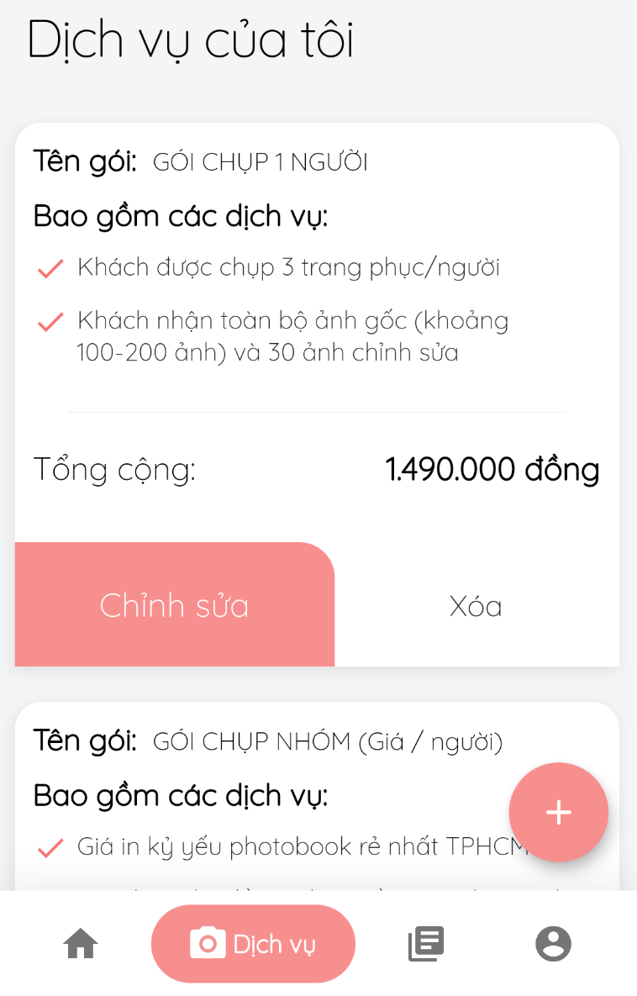

Figure 120 - View Services

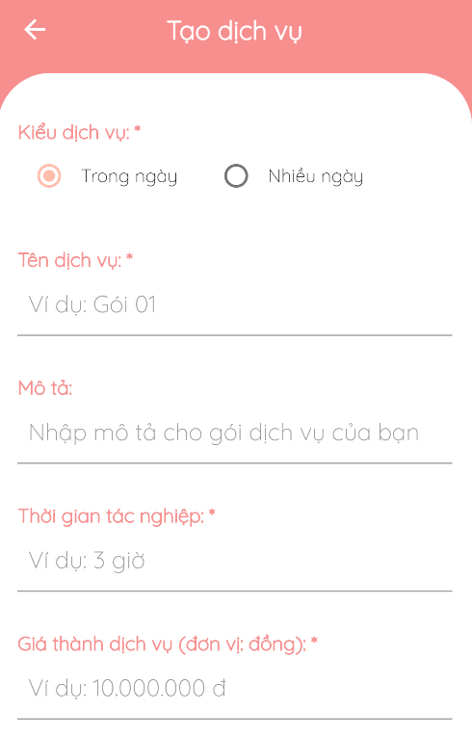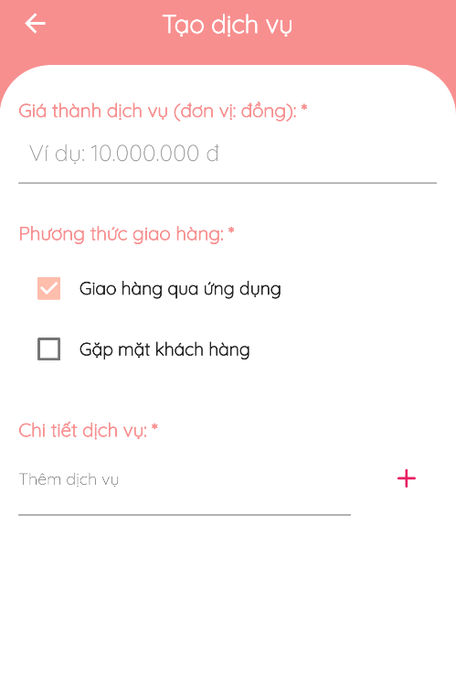

Figure 121 - Add Service

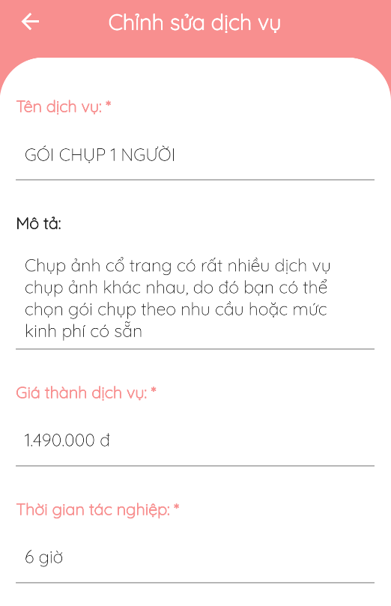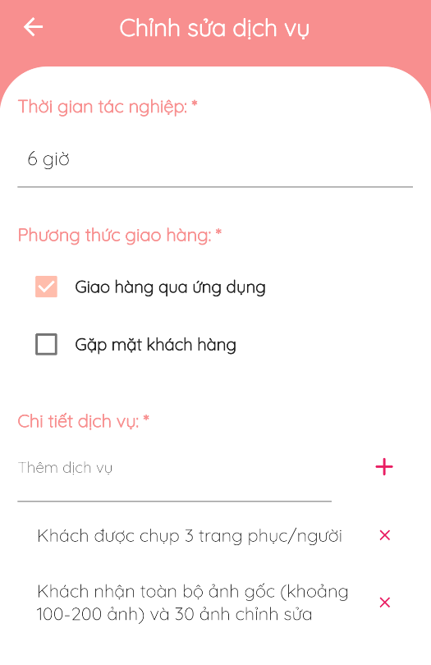

Figure 122 - Update Service

##### 3.3.2.11. Manage categories

* **Purpose**
  + Allow admins to manage shooting categories
  + Allow customers to view and select categories
* **Function**
  + View categories
  + Select categories
* **User Interfaces**

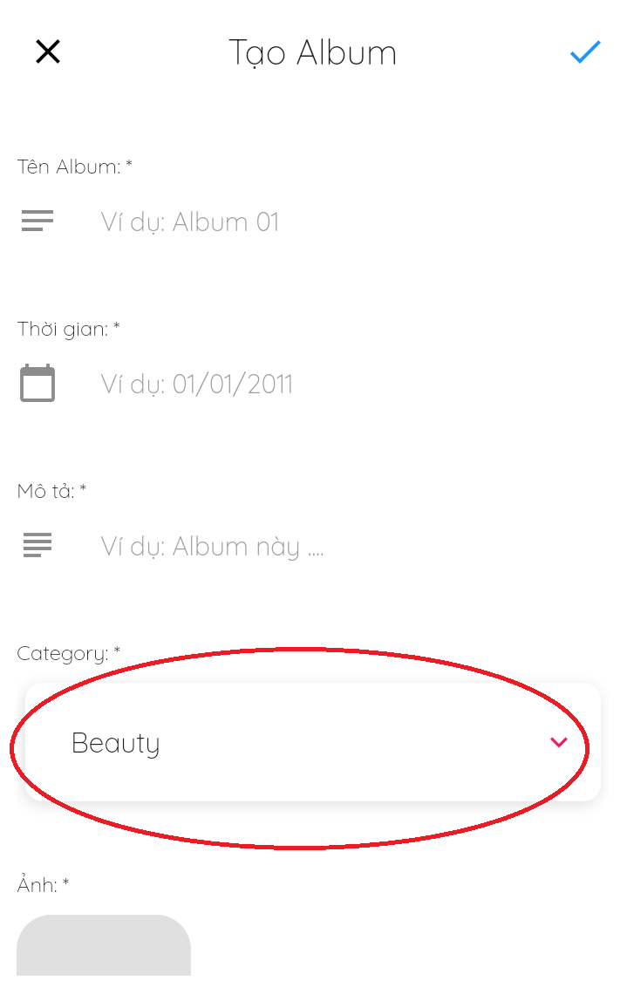

Figure 123 - Select / View Categories

##### 3.3.2.12. Chat

* **Purpose**
  + Allow customers and photographers to easily contact each other
* **Function**
  + Chat
* **User Interfaces**

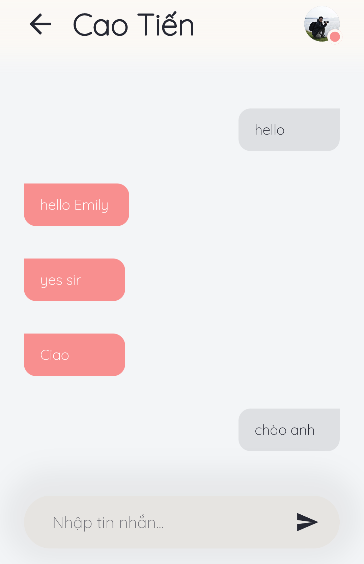

Figure 124 - Chat

##### 3.3.2.13. Forum

* **Purpose**
  + Allow users to view forum’s content
  + Comment in threads
  + Manage threads
  + Manage categories
* **Function**
  + View threads
  + View comments
  + Add threads
  + Edit threads
  + Remove threads
  + Add comments
  + Edit comments
* **User Interfaces**

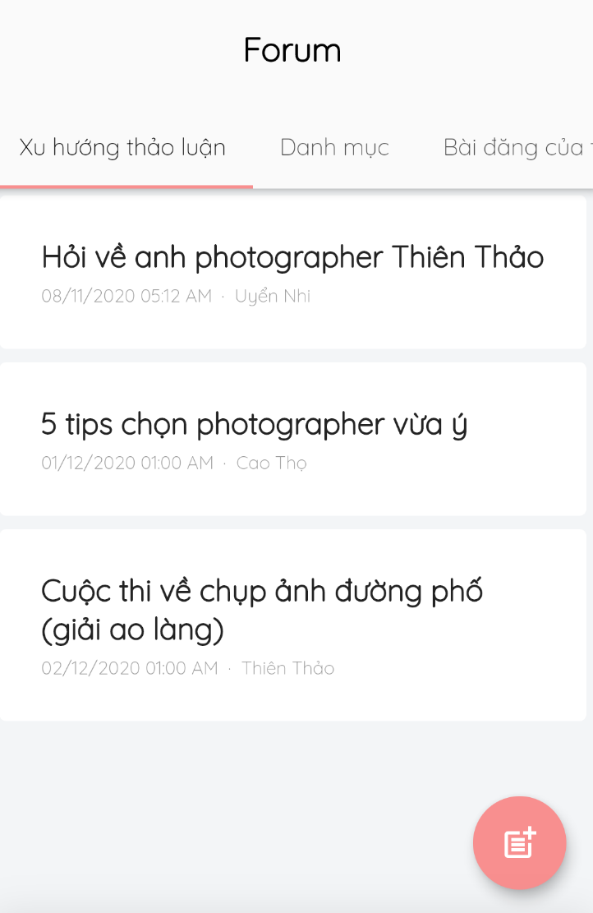

Figure 125 - View Thread

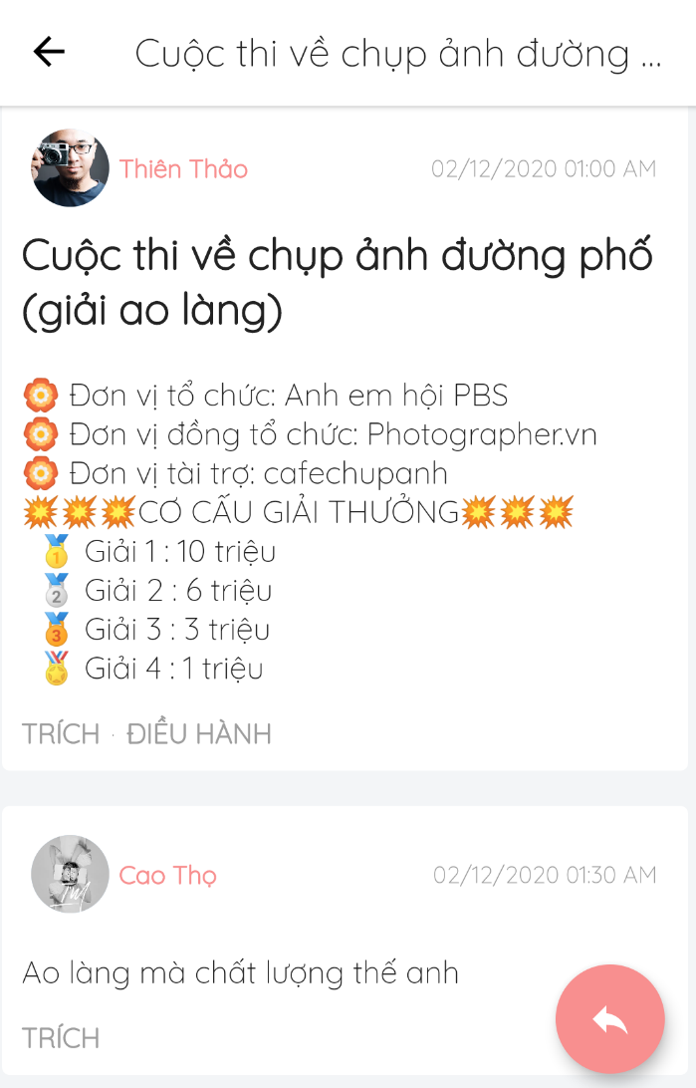

Figure 126 - View Comment

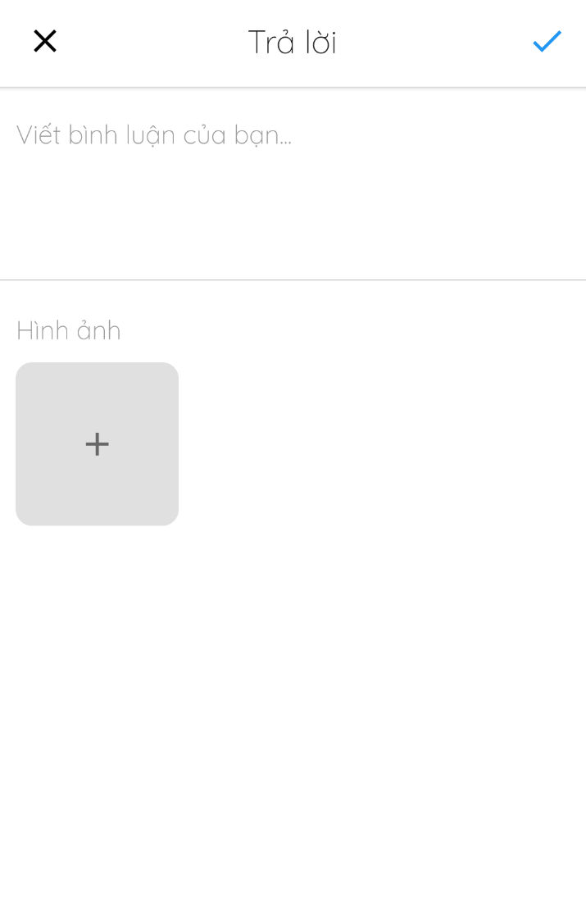

Figure 127 - Add Comment

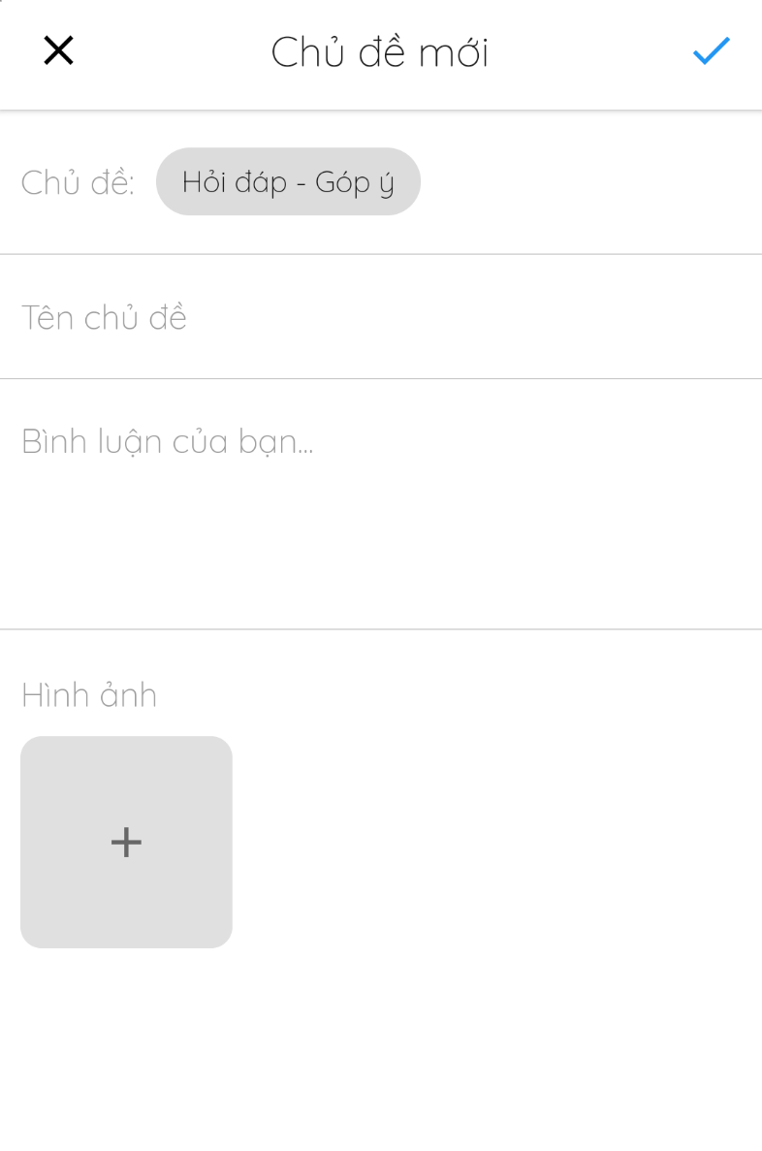

Figure 128 - Create Thread

##### 3.3.2.14. Manage profile

* **Purpose**
  + Allow users to edit their profile
* **Function**
  + Edit profiles
  + Edit avatar and cover photos
* **User Interfaces**

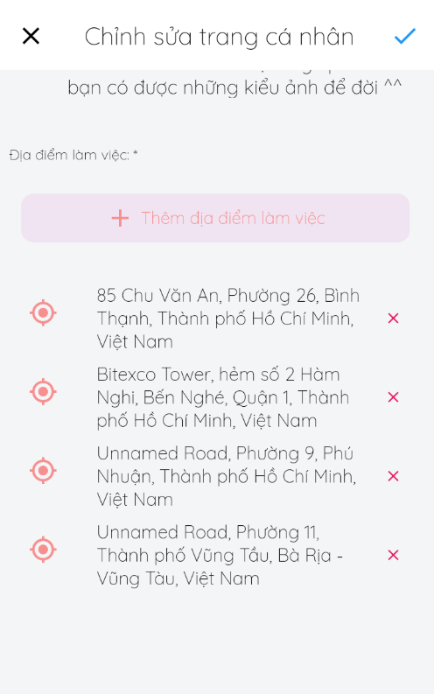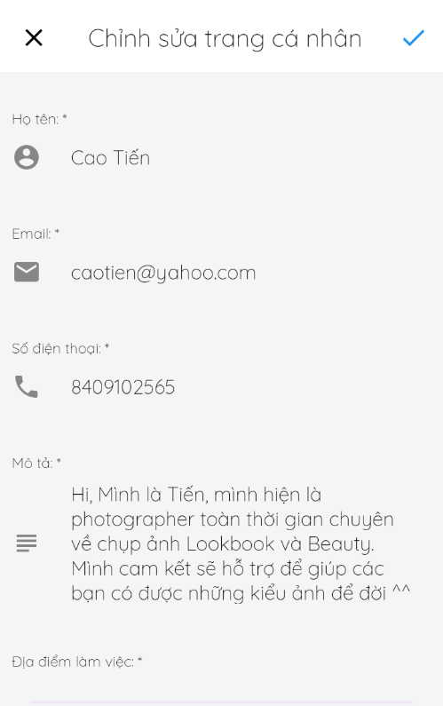

Figure 129 - Update Profile

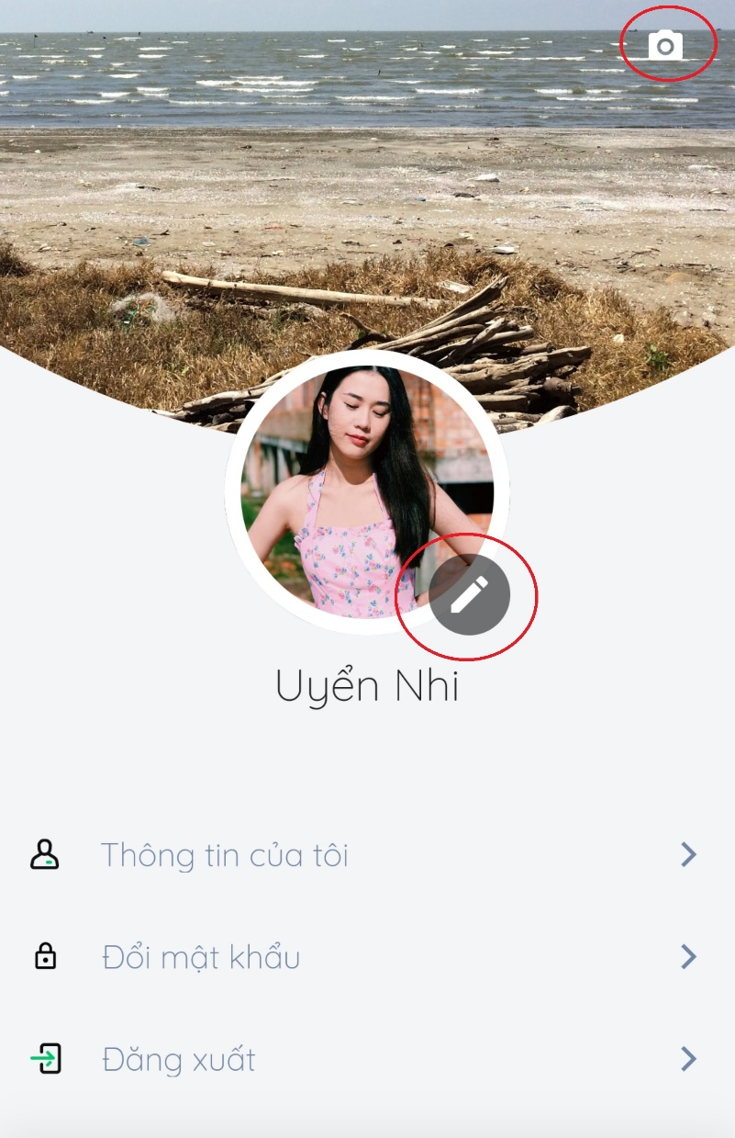

Figure 130 - Update Avatar/ Cover

##### 3.3.2.15. Change Password

* **Purpose**
  + Allow users to edit their password
* **Function** 
  + Edit password
* **User Interfaces**

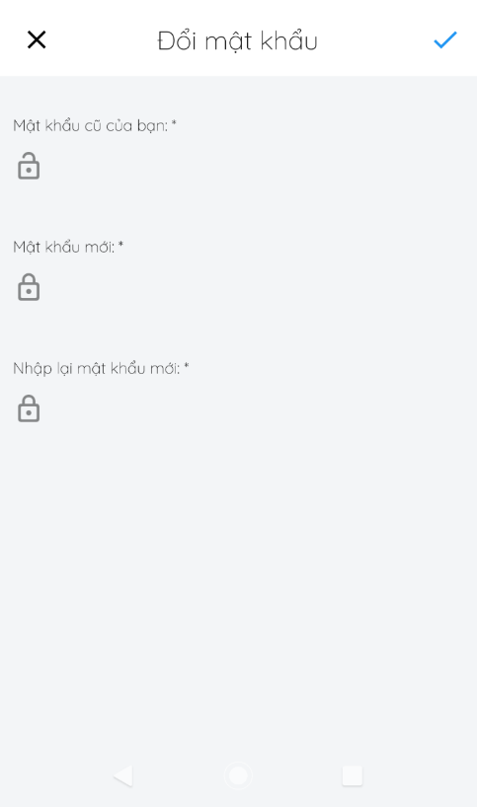

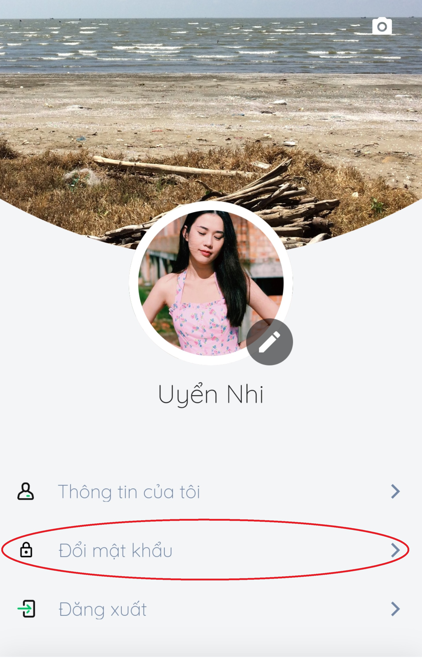

Figure - Change Password

##### 3.3.2.16. Activities

* **Purpose**
  + Allow users to keep track of system notifications
* **Function** 
  + View notifications
  + Remove notification
* **User Interfaces**

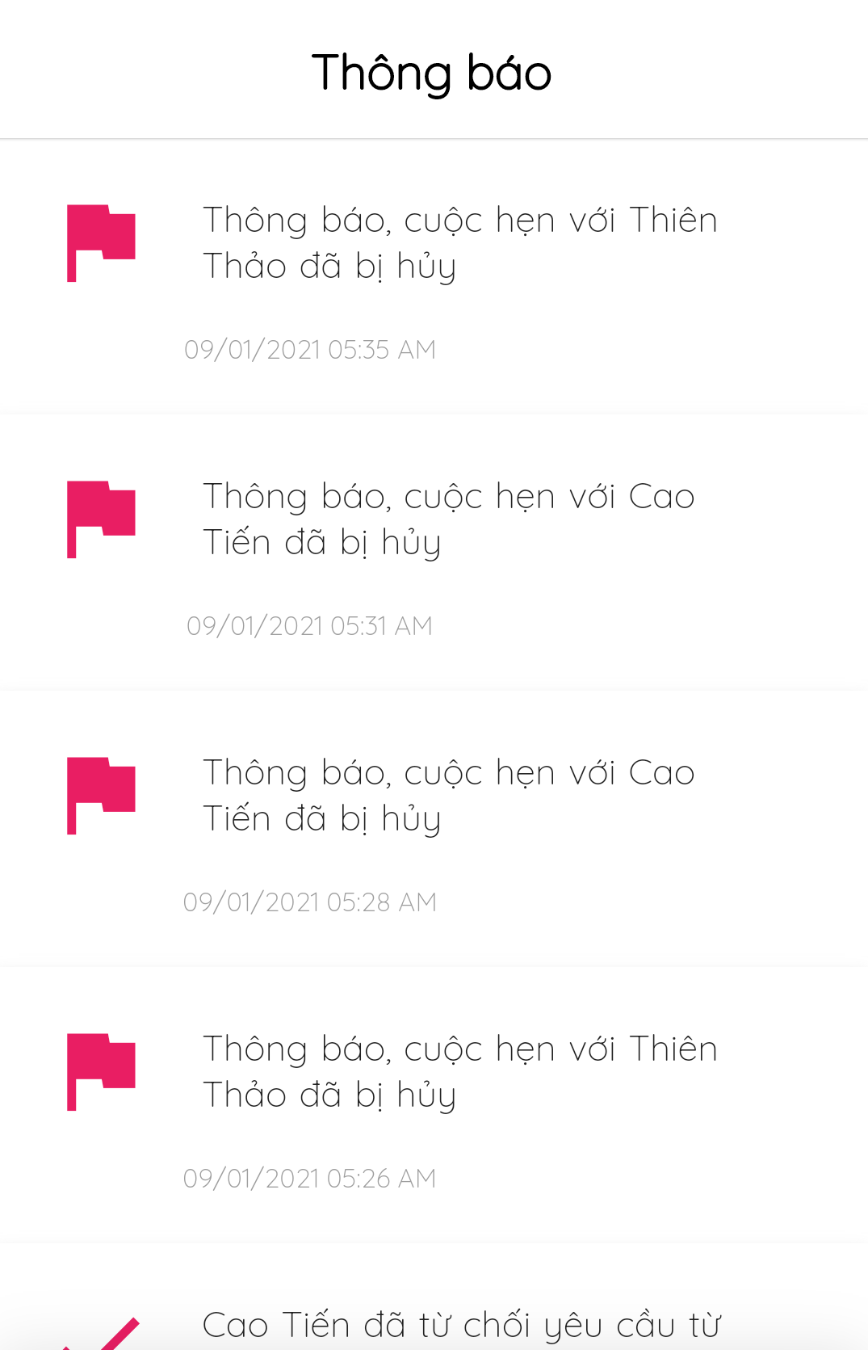

Figure - Activities

##### 3.3.2.17. Forgot Password

* **Purpose**
  + Allow users to get reset password when they have forgotten it.
* **Function** 
  + Insert email to reset password
* **User Interfaces**

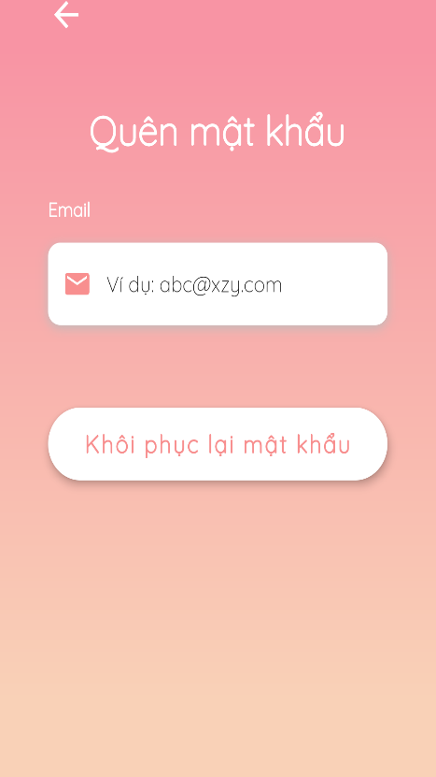

Figure - Forgot Password

#### 3.3.3. Web Admin

##### 3.3.3.1. Dashboard

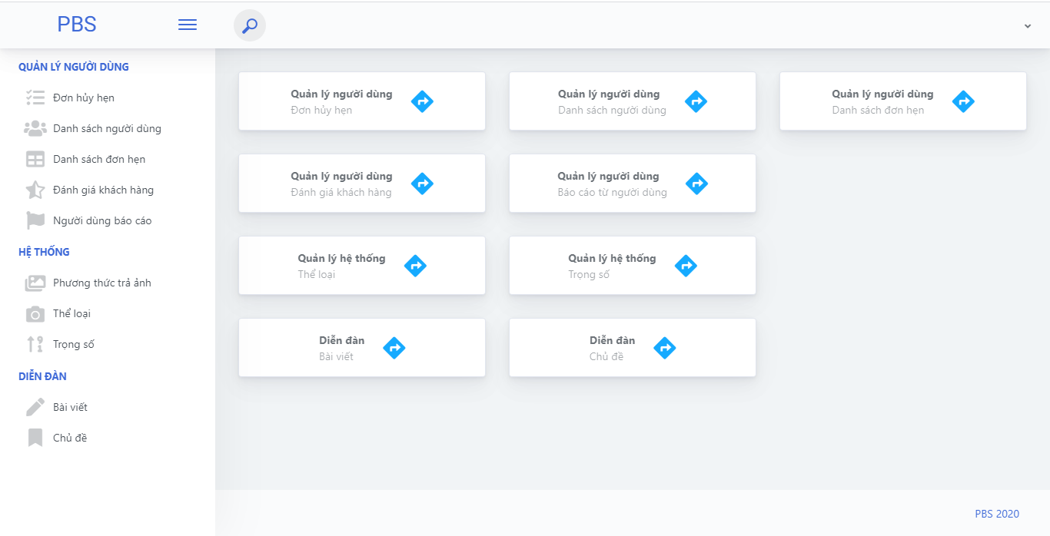

Figure Web admin - dashboard

##### 3.3.3.2. Cancellation management

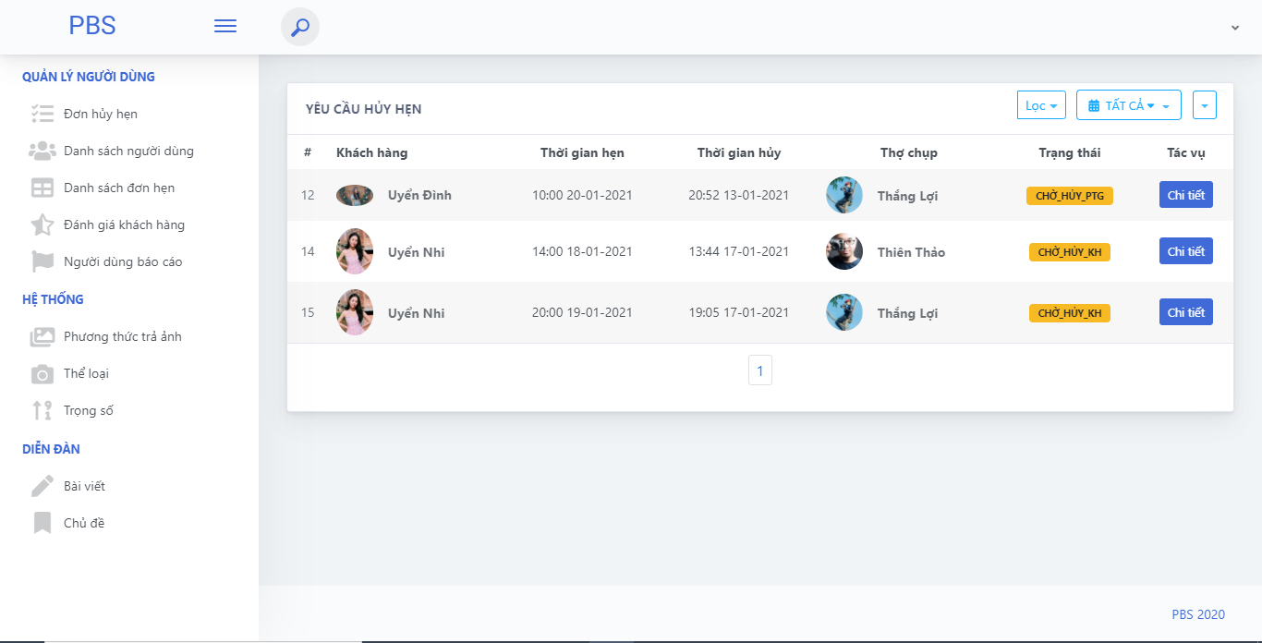

Figure Web admin - cancellation list

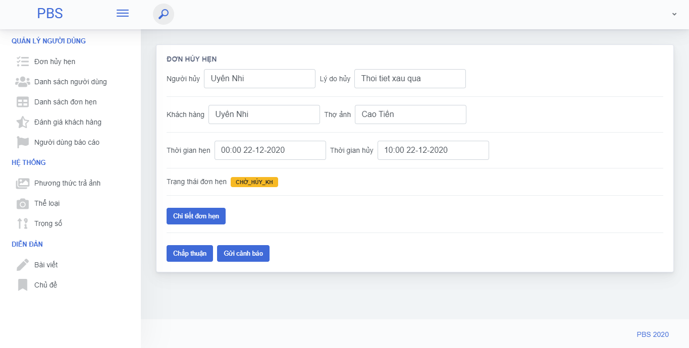

Figure Web admin - approve cancellation

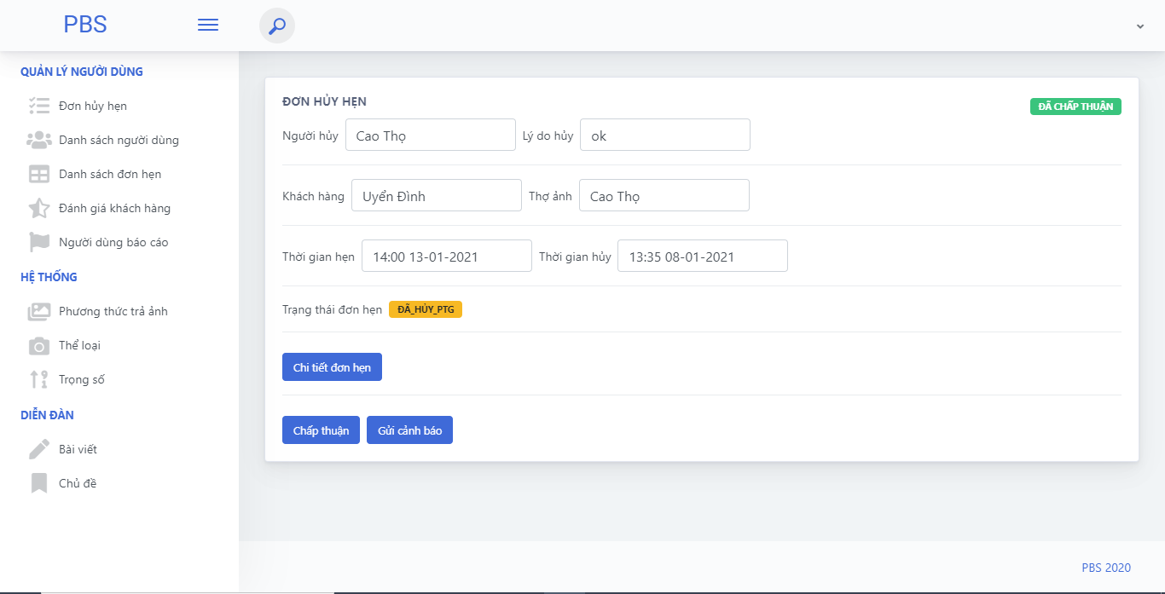

Figure Web admin - cancellation detail

##### 3.3.3.3. User management

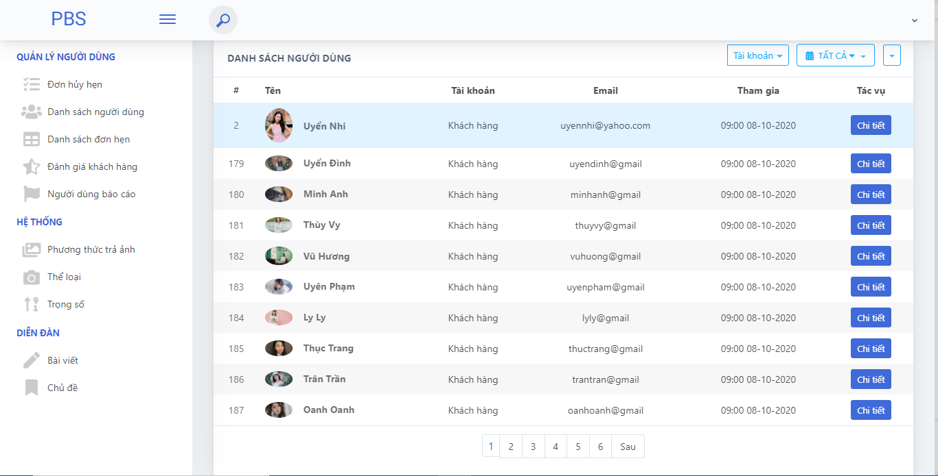

Figure Web admin - user list

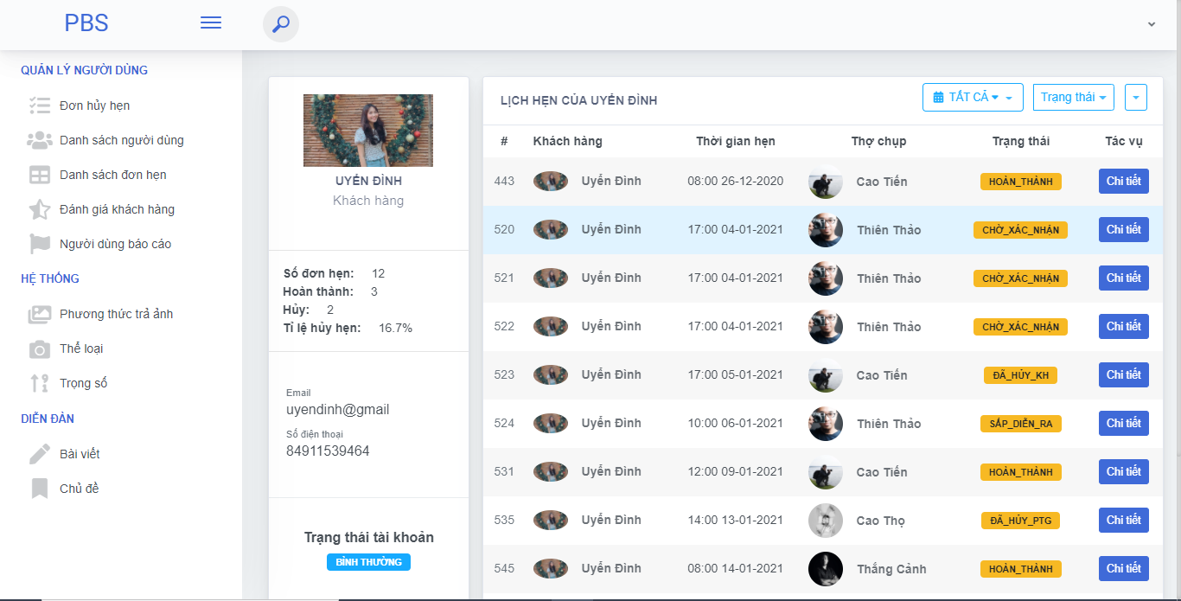

Figure Web admin - user detail

##### 3.3.3.4. Booking management

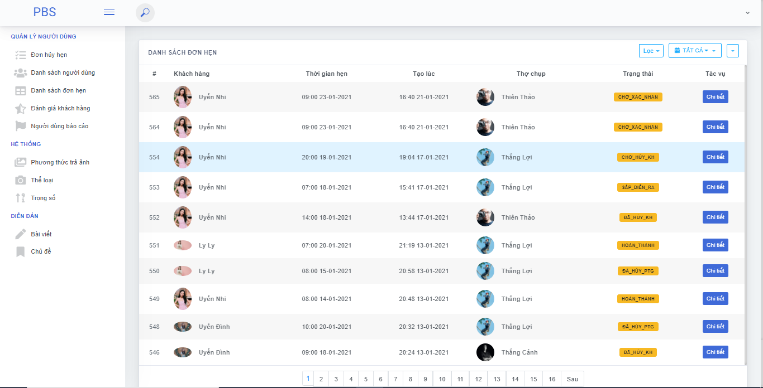

Figure Web admin - booking list

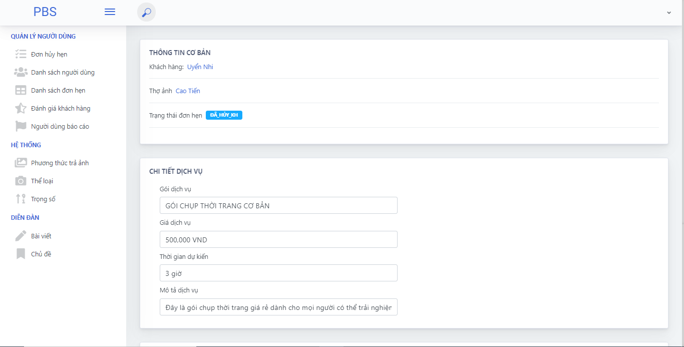

Figure Web admin - booking detail

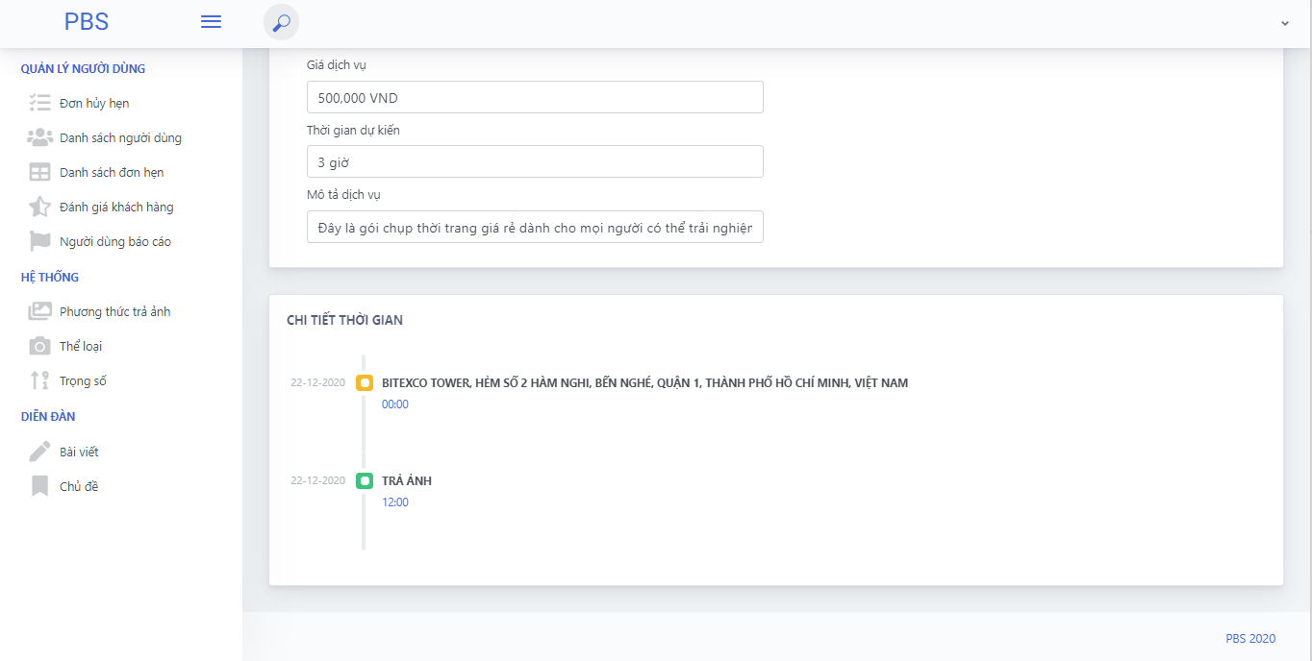

Figure Web admin - booking detail

##### 3.3.3.5. Report management

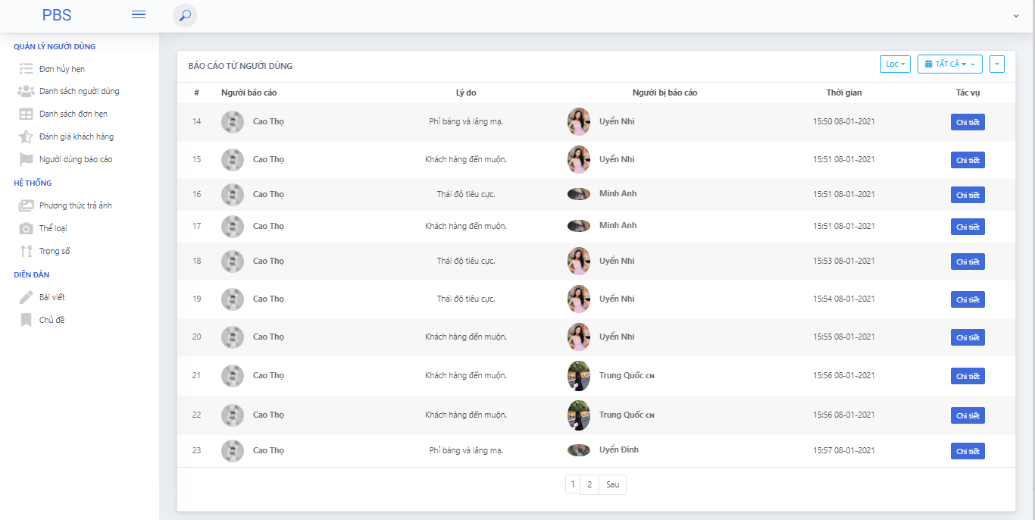

Figure Web admin - report list

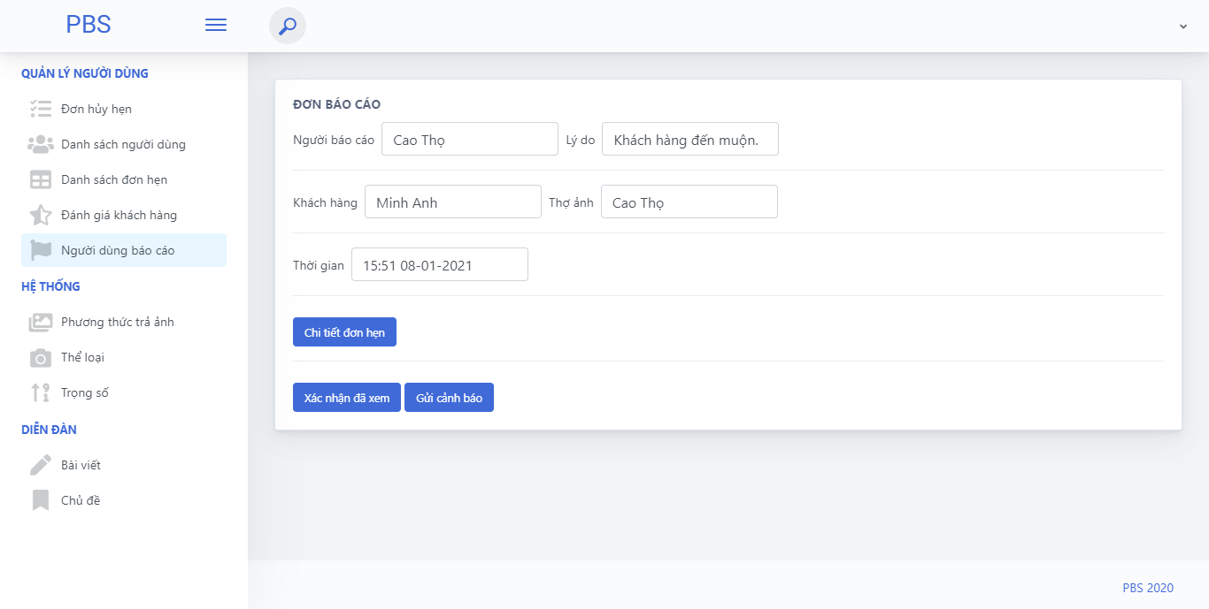

Figure Web admin - report detail

##### 3.3.3.6. System related

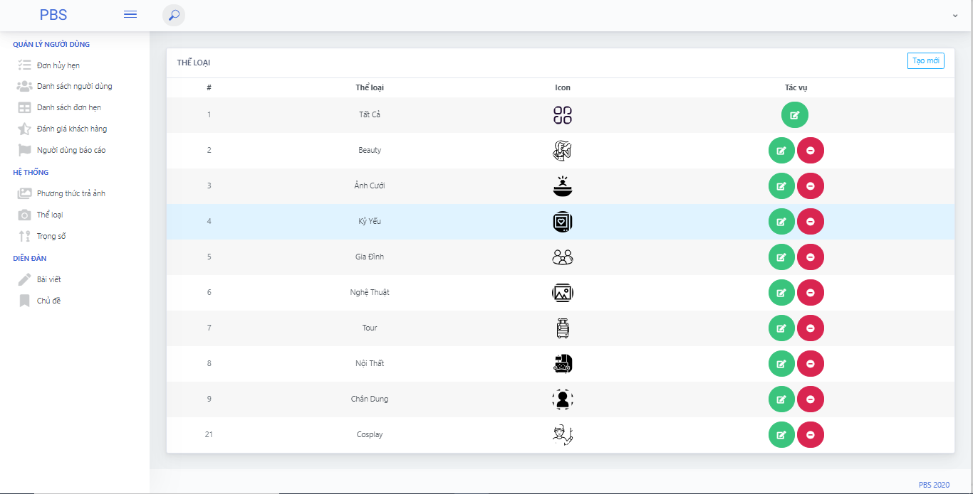

Figure Web admin - category list

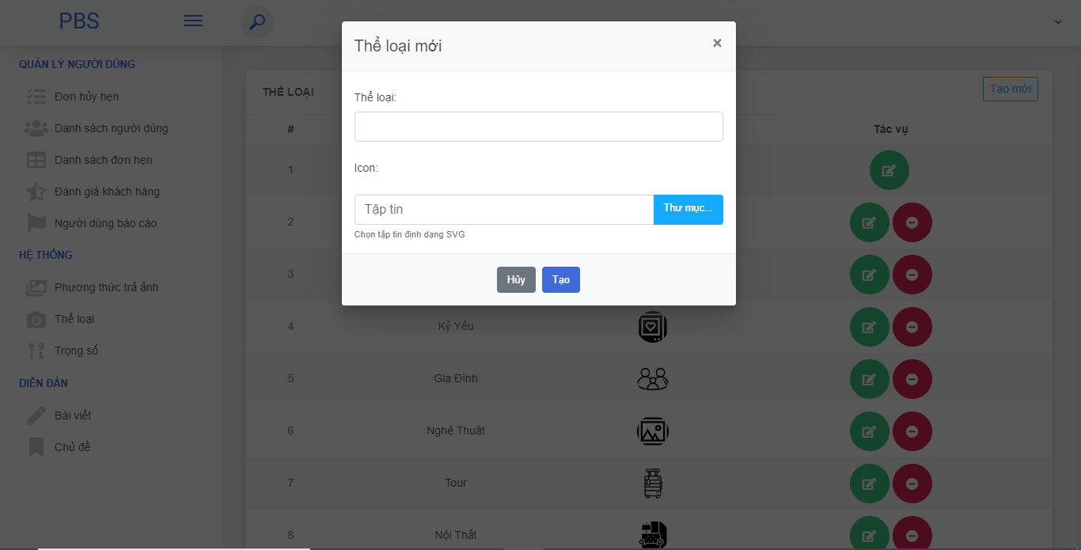

Figure Web admin - add category

##### 3.3.3.7. Forum management

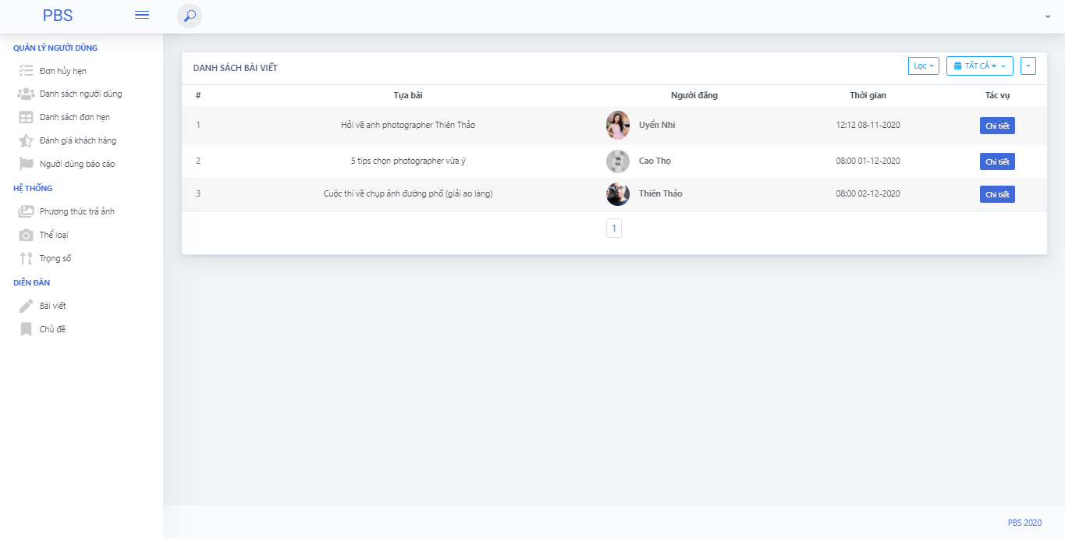

Figure Web admin - thread list

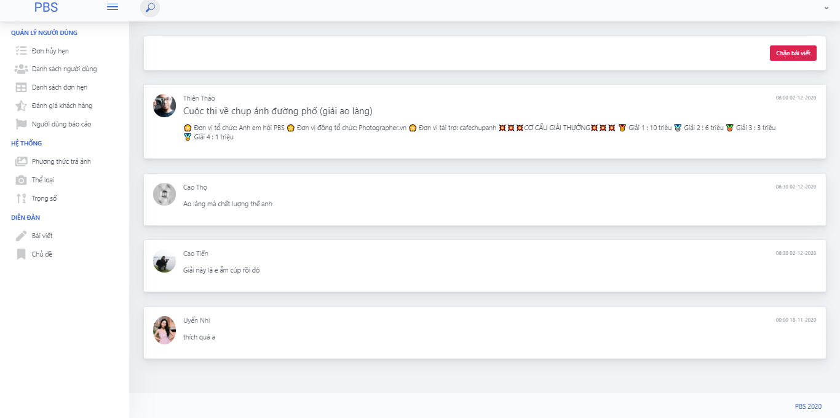

Figure Web admin - thread detail

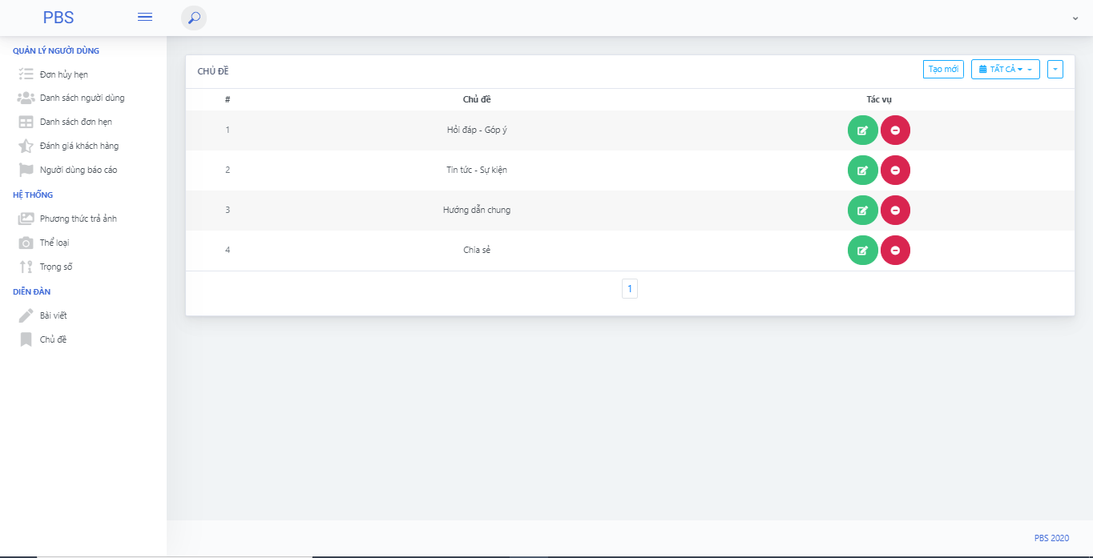

Figure Web admin - topic list

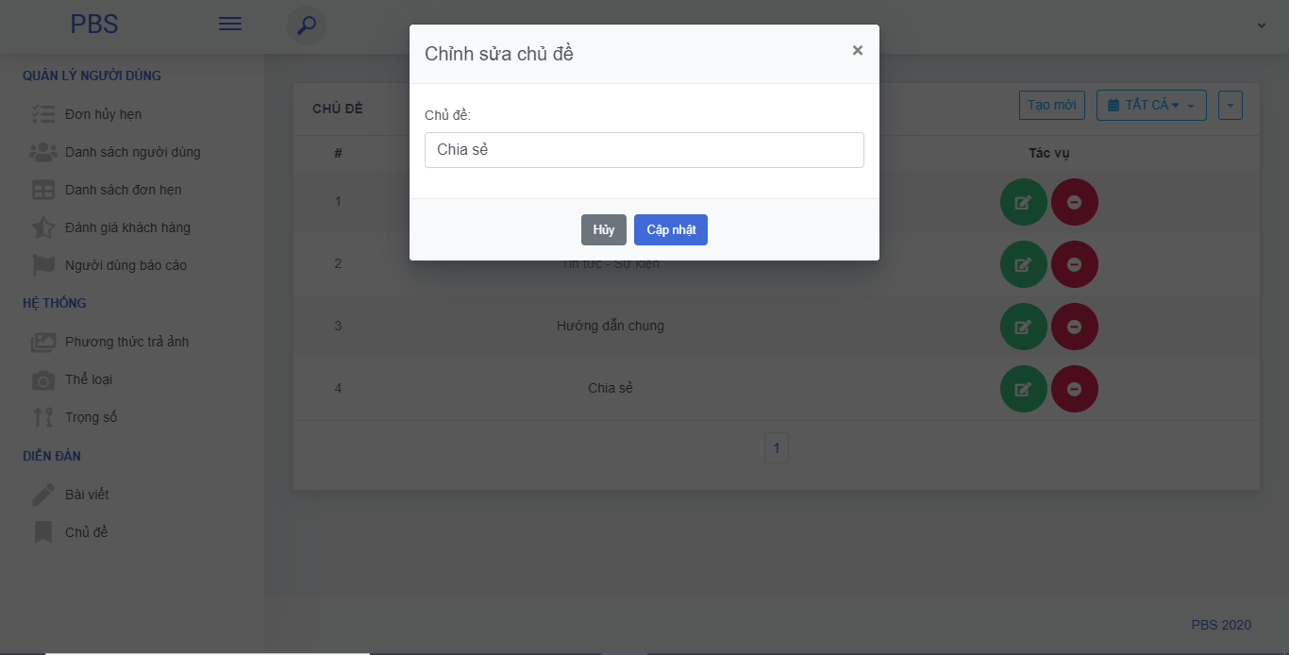

Figure Web admin - edit topic

### 3.4 Troubleshooting

1. **Current location sometimes cannot be determined**

First occurrence

* During testing time

Problem

* Current locations on phone are not allowed

**Workaround**

Do the following steps:

* **Go to Setting** > **Current locations** > **On**

1. **Profile photos are sometimes unsuccessfully updated**

First occurrence

* During testing time

Problem

* Image size exceeds maximum allowable size

**Workaround**

* Choose another photo smaller than … size

## 4. 配達可能なパッケージ

### 4.1 ソースコードと文書

|  |  |  |  |  |
| --- | --- | --- | --- | --- |
| **番号** | **項目** | **サブ項目** | **タイプ** | **バージョン** |
| ***Code Package*** | | | | |
| 1 | Web API | pbs_webapi | 新しい | 1.0.1 |
| 2 | モバイルアプリ | photographer_mobile_app | 新しい | 1.0.1 |
| customer_mobile_app | 新しい | 1.0.1 |
| ***Database*** | | | | |
| 1 | テーブル | pbs_users.sql | 新しい | 1.0.1 |
| pbs_roles.sql | 新しい | 1.0.1 |
| pbs_photographer_packages.sql | 新しい | 1.0.1 |
| pbs_packages_services.sql | 新しい | 1.0.1 |
| pbs_services.sql | 新しい | 1.0.1 |
| pbs_returning_types.sql | 新しい | 1.0.1 |
| pbs_bookings.sql | 新しい | 1.0.1 |
| pbs_booking_details.sql | 新しい | 1.0.1 |
| pbs_booking_time_location_detail.sql | 新しい | 1.0.1 |
| pbs_booking_comments.sql | 新しい | 1.0.1 |
| pbs_albums.sql | 新しい | 1.0.1 |
| pbs_customers_albums.sql | 新しい | 1.0.1 |
| pbs_album_images.sql | 新しい | 1.0.1 |
| pbs_images.sql | 新しい | 1.0.1 |
| pbs_categories.sql | 新しい | 1.0.1 |
| pbs_threads.sql | 新しい | 1.0.1 |
| pbs_thread_comments.sql | 新しい | 1.0.1 |
| pbs_thread_topics.sql | 新しい | 1.0.1 |
| pbs_locations.sql | 新しい | 1.0.1 |
| pbs_working_day_of_week.sql | 新しい | 1.0.1 |
| pbs_busy_days.sql | 新しい | 1.0.1 |
| ***Documents*** | | | | |
| 1 | 概要 | Report1_Project-Introduction.docx | 新しい | 1.0.1 |
| 2 | 経営計画 | Report2_Project-Management-Plan.docx | 新しい | 1.0.1 |
| 3 | 要件 | Report3_Software Requirement Specification.docx | 新しい | 1.0.1 |
| 4 | 設計 | Report4_Software Design Document.docx | 新しい | 1.0.1 |
| 5 | テスト | Report5_Test Documentation.docx | 新しい | 1.0.1 |
| Report5_Test Case Document.xlsx | 新しい | 1.0.1 |
| Report5_Unit Test Case.xls | 新しい | 1.0.1 |
| 6 | ユーザーガイド | Report6_Software User Guides.docx | 新しい | 1.0.1 |
| 7 | 最終 | Report7_Final Project Report.docx | 新しい | 1.0.1 |

表141 配達可能なパッケージ

### 4.2 既知の問題、制限および限定

* お支払いには対応しておりません。
* システムには写真検証機能はありません。
* このシステムは、顧客と写真家の両方にウェブサイト版を提供していません。 ユーザーにとって不快になるアプリケーションの利

## 5. 設置ガイド

### 5.1 システム要件

**5.1.1 ハードウェア要件**

パソコン用

|  |  |  |
| --- | --- | --- |
| **パソコン** | **最小要件** | **お勧め** |
| Internet Connection | Cable, Wi-Fi (4 Mbps) | Cable, Wi-Fi (8 Mbps) |
| Operating System | Windows 7 | Windows 7 or more. |
| Computer Processor | Intel® Core i3 1.4GHz | Intel® Core i5 2.50GHz |
| Computer Memory | 1GB RAM | 2GB RAM or more |
| Web Browser | Chromes (v42 or higher) | Chrome latest stable version |

表142 PCハードウェア要件

Androidデバイス用

|  |  |
| --- | --- |
| **オペレーティン** | Android 8.0 or higher |
| **プロセッサ** | Intel Atom® Processor Z2520 1.2 GHz, or faster processor |
| **ストレージ** | Between 850 MB and 1.2 GB, depending on the language version |
| **RAM** | Minimum of 512 MB, 2 GB is recommended |
| **ハードディスク** | * 2 GB of available hard-disk space for installation; extra free space is required during installation. * You cannot install using a removable flash storage device. |
| **ビデオ** | 1920 x 1080 pixels or higher |
| **ブラウザ/インターネット** | * This application is designed to work online. * To download and launch Google Play Store apps within the application, a high-speed Internet connection is recommended. |

表 ソフトウェア要件

**5.1.2 ソフトウェア要件**

|  |  |  |
| --- | --- | --- |
| **ソフトウェア** | **名前/バージョン** | **説明** |
| Operation System | Windows 7, Windows 10 | Operating system and platform for development |
| Web browser | Chrome 69 or above, Mozilla Firefox | For web app |
| Android System | Android 4.0 or higher | For mobile app |

表 ソフトウェア要件

### 5.2 設定ファイル

* 写真家のアプリのため



図 151 設定ファイル - 1

* お客様のアプリのため



図 152 設定ファイル – 2

### 5.3 インストール手順

2つのandroidアプリのインストール手順は同じですので、私たちはそれらの両方のための一つのガイドライン.

1. "Install"ボタンを押してPBSをインストールします。

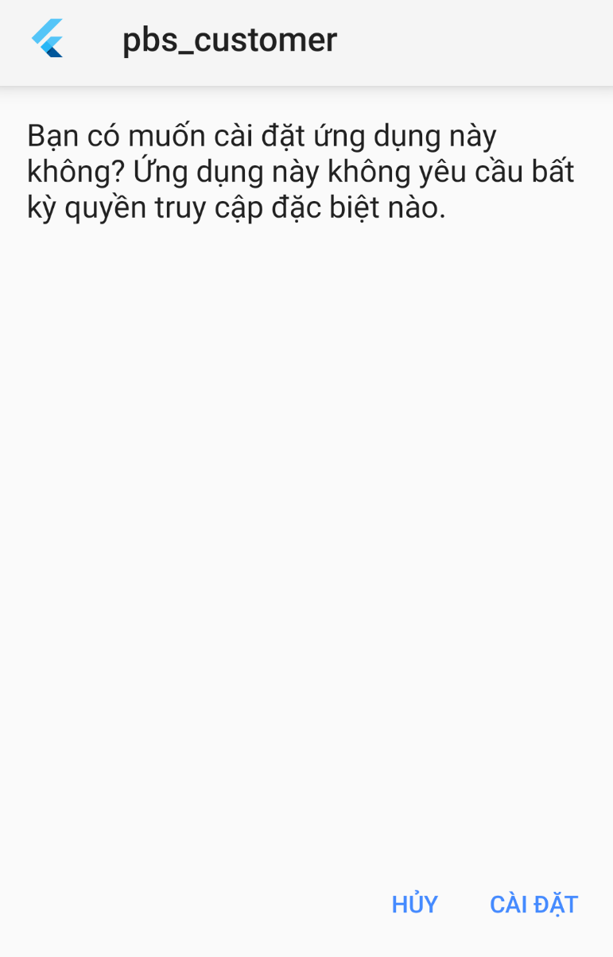

図 153 インストール - 1

1. プレス"Accept"受け入れ申請のアクセス権に優先する。



図 154 インストール - 2

1. PBSアプリのインストールを待ちます。

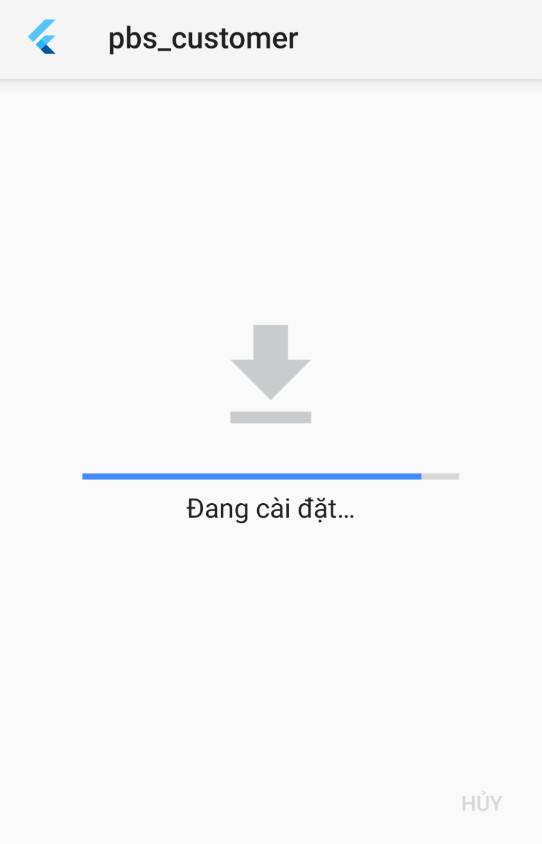

図 155 インストール - 3

1. インアプリを起動するには、"Mở"を押します。

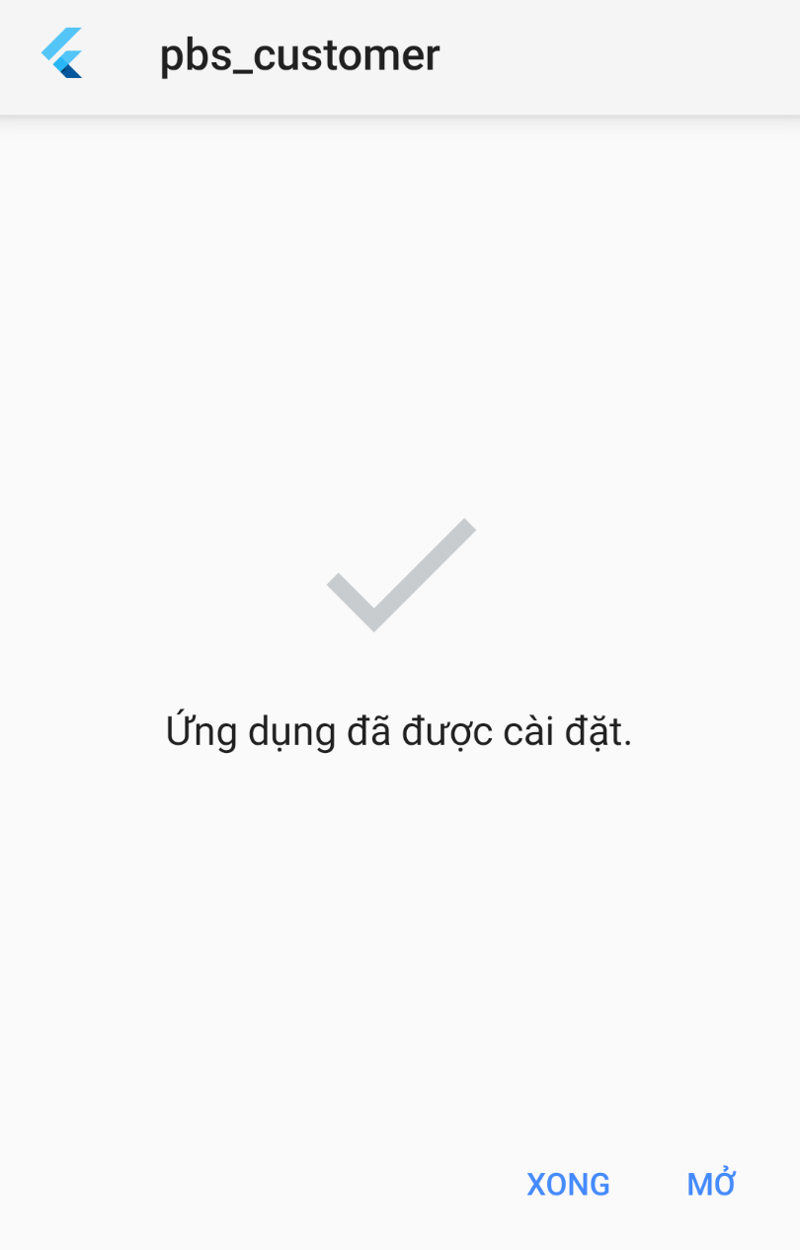

図 156 インストール - 4

1. 詳細はマニュアルをご覧ください。

### 5.4 サーバー側の展開

WebapiをHostingerのVPSサーバーに展開します。 サーバのオペレーティングシステムはUbuntu18.04LTSです。

ステップ1：TomcatとJDKをインストールする。 Openjdkはコマンドの依存関係としてインストールされます: sudo apt-get install tomcat9



図 157 サーバー側の展開 – 1

ステップ2：コマンドでtomcatサービスを開始します：sudo systemctl start tomcat9。



図 158 サーバー側の展開 – 2

ステップ3：/var/lib/tomcat9/conf/tomcat-users.xmlでtomcat管理者アカウントを設定します:



図 159 サーバー側の展開 – 3



図 160 サーバー側の展開 – 4

ステップ4："mvn package clean"を使用してwebapi warファイルを書き出す:



図 161 サーバー側の展開 – 5



図 162 サーバー側の展開 – 6

ステップ5：pscpを使用してssh経由でwarファイルをサーバーに転送します.



図 163 サーバー側の展開 – 7

## 6.ユーザーマニュアル

### 6.1 用語と定義

アカウントはユーザーとしてサインインするために登録するアカウントです。

フォトグラファーのアプリはフォトグラファーが客に連絡するための「ＰＢＳ」によって提供されるアプリです。

客のアプリは客がフォトグラファーに連絡するための「ＰＢＳ」によって提供されるアプリです。

モバイル デバイスはフォトグラファーのアプリや客のアプリをダウンロードして実行するために使えるケイタイ、タブレット、他のデバイスです。

システムとはフォトグラファーのアプリ、客のアプリ、ウェブサイト、プラットフォームなど、フォトグラファーや客の連絡をサポートするために「ＰＢＳ」によって提供するシステムです。

フォトグラファーは客がシステムで予約できる撮るサービスを提供する独立した第三者です。

客は客のアプリのアカウントを持っている人です。

ウェブサイトは「ＰＢＳ」が運営するウェブサイトです。

### 6.2システム要件

**6.2.1ハードウェア**要件

**パソコン**

|  |  |  |
| --- | --- | --- |
| **パソコン** | **最小要**件 | おすすめ |
| インターネット接続 | ケーブル、ワイファイ　（４Ｍｂｐｓ） | ケーブル、ワイファイ　（８Ｍｂｐｓ） |
| オペレーティング システム | ＷＩＮＤＯＷＳ７ | ＷＩＮＤＯＷＳ７以上 |
| コンピュータプロセッサ | インテル®コア i3 1.4GHz | インテル®コア i3 ２．５GHz |
| コンピュータメモリ | 1GB RAM | 2GB RAM以上 |
| ウェブブラウザ | グーグル クローム(v42 以上) | グーグル クロームの最新安定版 |

**アンドロイドデバイス**

|  |  |
| --- | --- |
| **オペレーティング システム** | アンドロイド8.0以上 |
| **プロセッサ** | インテル Atom® プロセッサ Z2520 1.2 GHz 以上のプロセッサ |
| **ストレージ** | 言語バージョンに応じて 850 MB と1.2 GB の間です。 |
| **RAM** | 最小は512 MB です。  2 GB はおすすめです。 |
| **ハードディスク** | インストール用は 2 GB のハード ディスクのスペースが必要です。  フラッシュ ストレージ デバイスを使用してインストールすることはできません。. |
| **ビデオ** | 1920 x 1080 ピクセル以上。 |
| **ブラウザ/インターネット** | このアプリは、オンラインで使うように設計されています。  「GOOGLEPLAY」ストアアプリをダウンロードして起動するには、高速インターネット接続をおすすめします。 |

**6.2.2ソフトウェア要件**

|  |  |  |
| --- | --- | --- |
| **ソフトウェア** | **名前/バージョン** | **説明** |
| オペレーションシステム | ウィンドウズ 7, ウィンドウズ 10 | 開発用のオペレーティング システムとプラットフォーム |
| ウェブブラウザ | クロム 69以上, ファイアーフォックス | ウェブアプリ用 |
| アンドロイドシステム | アンドロイド4.0以上 | モバイルアプリ用 |

### 6.3アプリの使用

#### 6.3.1. 概要

客のアプリでは客がフォトグラファーを検索し、予約することができます。その後、客は自分の体験に基づいてフォトグラファーを評価することができます. 評価は星として表示され、フォトグラファーのプロフィールに表示されるレビューすることができます. ユーザーに写真や流行のスタイルについての情報を提供するために、システムにフォーラムもあります。

フォトグラファーのアプリはフォトグラファーが潜在的な客の広い範囲に達するのに役立ちます. また、撮るスケジュールを管理したり、客の予約を受け取ることができます。そして、プロフィールを編集したり、アルバムや提供するサービスを追加したりすることができます。フォーラムに参加することもできます。

システムには「ＡＤＭＩＮＩＳＴＲＡＴＯＲ」に簡単にシステムを制御できるように、ウェブサイトを提供します。「ＡＤＭＩＮＩＳＴＲＡＴＯＲ」には撮るカテゴリを追加、デリート、編集したり、写真配信方法を管理したりできます。コミュニティ標準に違反しているユーザーをブロックできます。

#### 6.3.2. 登録

* **目標**
  + ユーザーのアカウントを作成します
* **機能**
  + 「ＰＢＳ」アカウントを作成します
  + グーグルでサインアップします
  + フェイスブックでサインアップします
* **ユーザ インターフェイス**

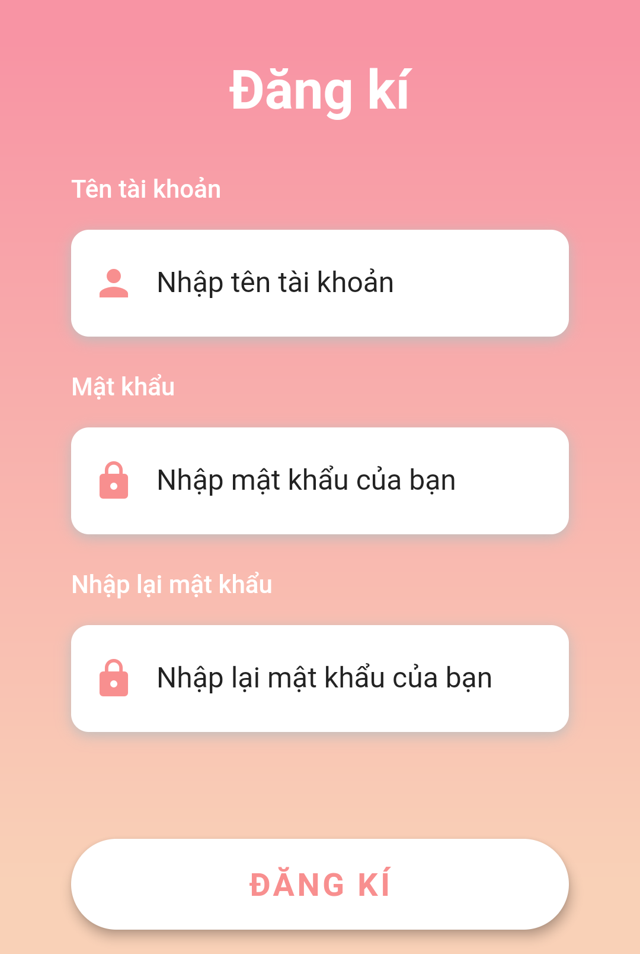

図－「ＰＢＳ」アカウントを作成する

#### 6.3.3. ログイン

* **目標**
  + ユーザーがサインインします
* **機能**
  + 「ＰＢＳ」 アカウントでサインインします
  + グーグルでサインインします
  + フェイスブック アカウントでサインインします
* **ユーザーインターフェース**

#### 6.3.4. ログアウト

* **目標**
  + ユーザーがサインアウトします
* **機能**
  + サインアウトします
* **ユーザーインターフェース**

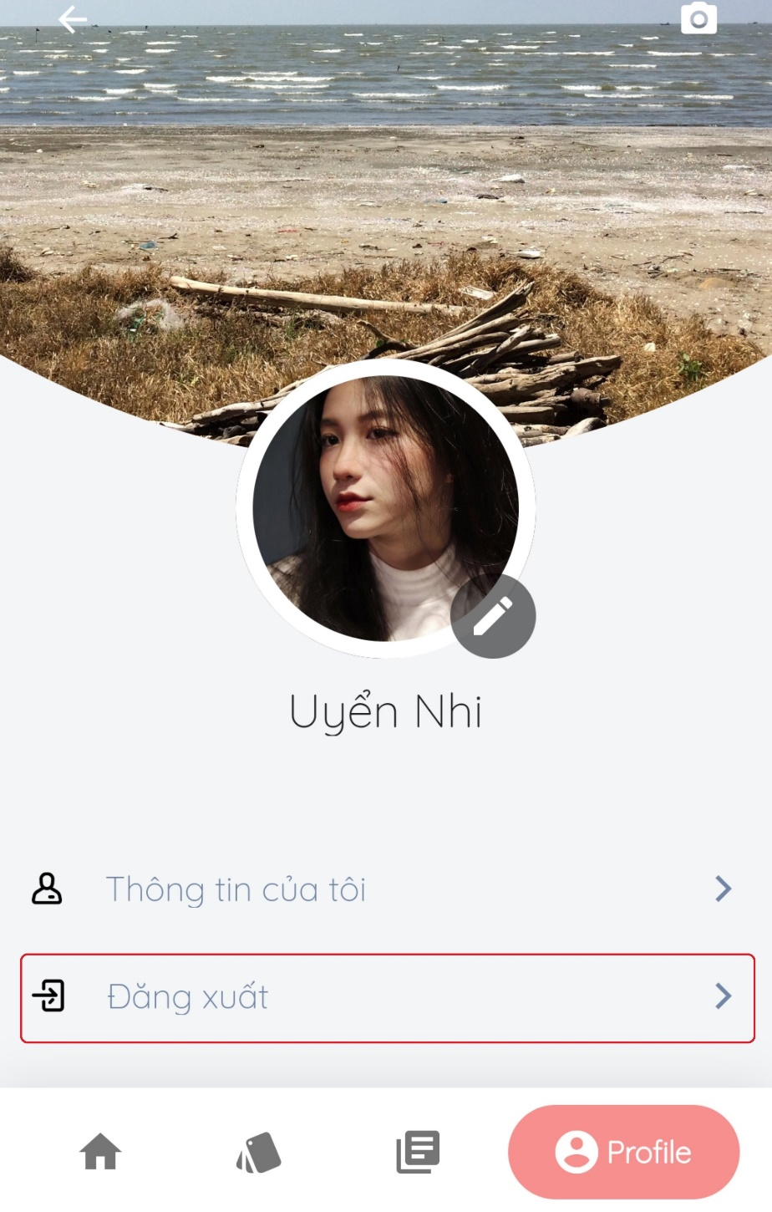

図165 – ログアウト

#### 6.3.5. フォトグラファーを検索

* **目標**
  + 客が適用な***フォトグラファー***やサービスを見つけます
* **機能**
  + フォトグラファーを検索します
  + サービスを検索します
* **ユーザーインターフェース**

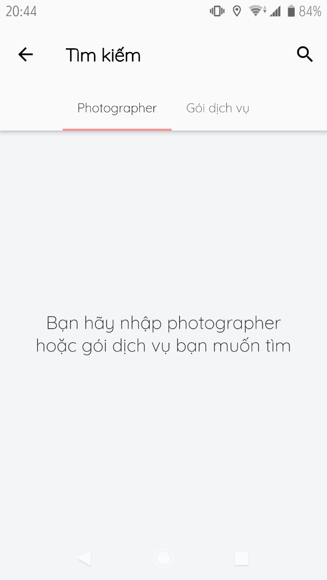

図166-フォトグラファー／サービスの検索

#### 6.3.6. リクエストの管理

* **目標**
  + 客が予約を管理できます
* **機能**
  + 数日を予約します (客のみ)
  + 一日を予約します(客のみ)
  + 予約を変更します(客のみ)
  + 予約をキャンセルします(客のみ)
  + 予約の受け入れます(フォトグラファーのみ)
  + 予約を断ります(フォトグラファーのみ)
* **ユーザーインターフェース**



図167 –一日の予約

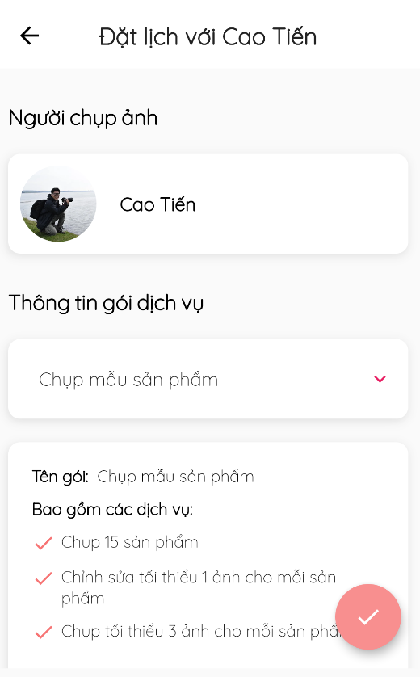

図168 –数日の予約

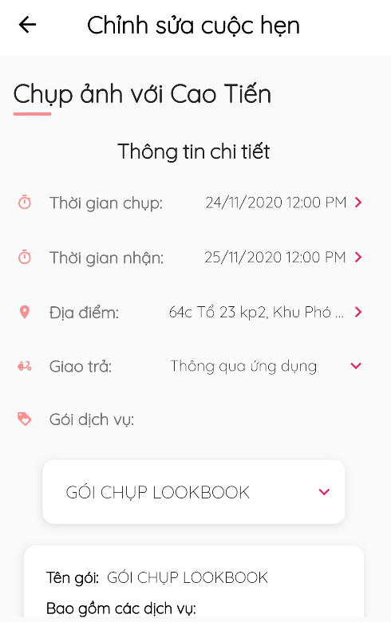

図169 - 一日の予約の変更

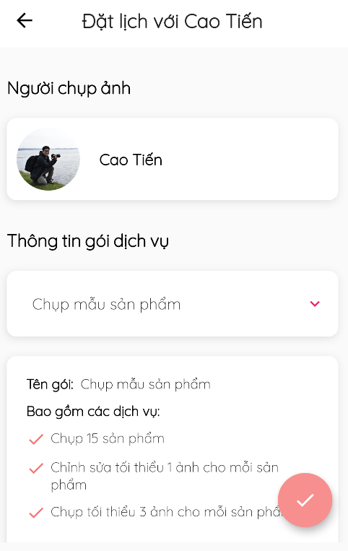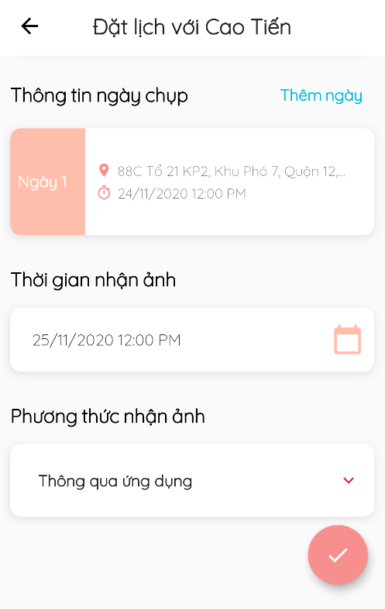

図170 -数日の予約の変更



図171 – 予約の断り/受入 /キャンセル

#### 6.3.7. レビューの管理

* **目標**
  + 客がサービスをレビューします
  + レビューを管理します
* **機能**
  + レビューを観ます
  + レビューを書きます(客のみ)
* **ユーザーインターフェース**

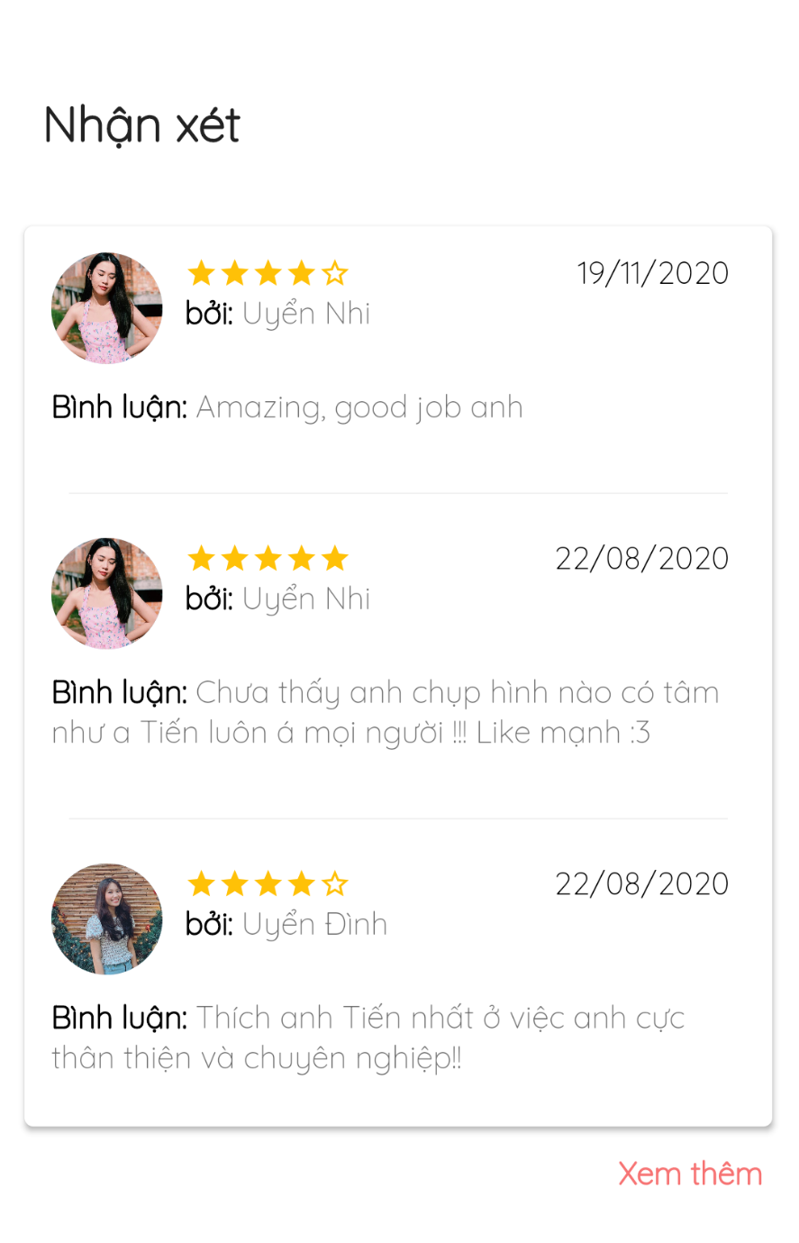

図172 – レビューをを観ます

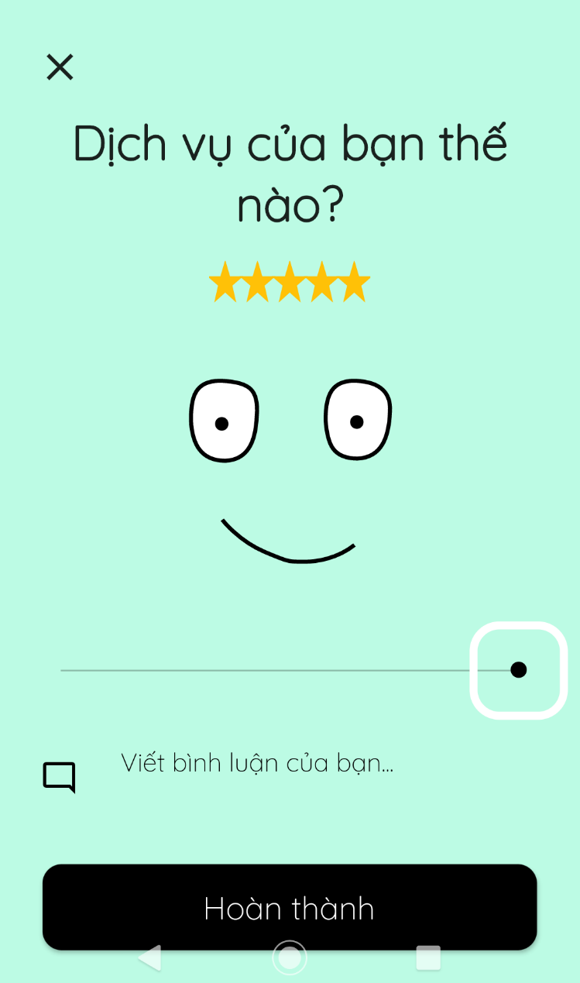

図173 – レビューを書きます

#### 6.3.8. リクエストの状態の管理

* **目標**
  + フォトグラファーがリクエストの状態を変更します
* **機能**
  + リクエストの状態を変更します
* **ユーザーインターフェース**



図174 - 予約の状態を変更します

#### 6.3.9. カレンダーの管理

* **目標**
  + フォトグラファーが撮るスケジュールを変更します
* **機能**
  + 毎日の撮るスケジュールを管理します
  + 毎日の撮るスケジュールを変更します
  + 都合がない日を追加します
* **ユーザーインターフェース**



図175 - 撮るスケジュール

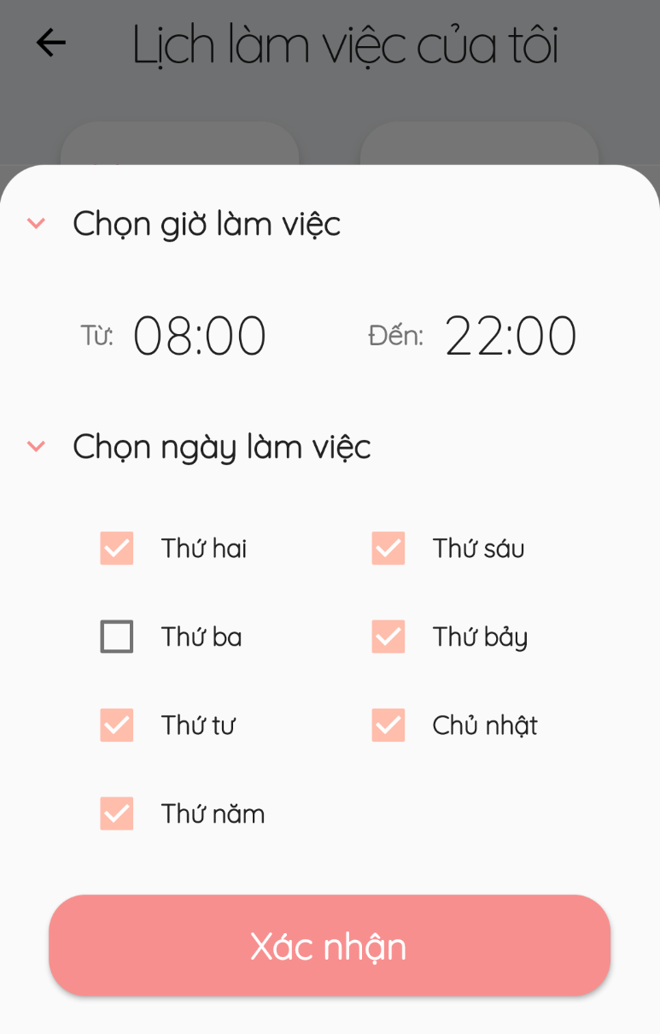

図176 – 毎日の撮るスケジュールを変更します

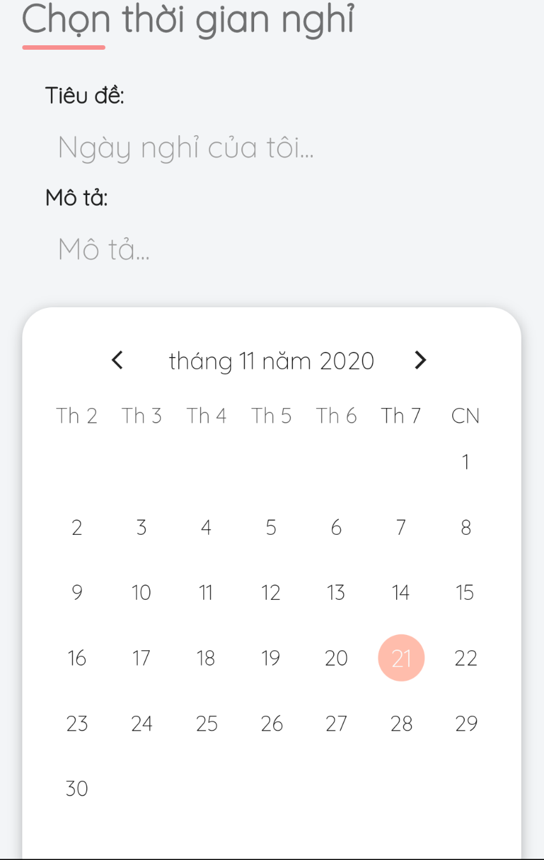

図177 – 都合がない日を追加します

#### 6.3.10. アルバムの管理

* **目標**
  + フォトグラファーがアルバムを管理します
  + 客が好きなアルバムをフォローします
* **機能**
  + アルバムを追加します(フォトグラファーのみ)
  + アルバムを変更します(フォトグラファーのみ)
  + アルバムをデリートします (フォトグラファーのみ)
  + アルバムをフォローします (客のみ)
* **ユーザーインターフェース**



図178 – アルバムをフォローする

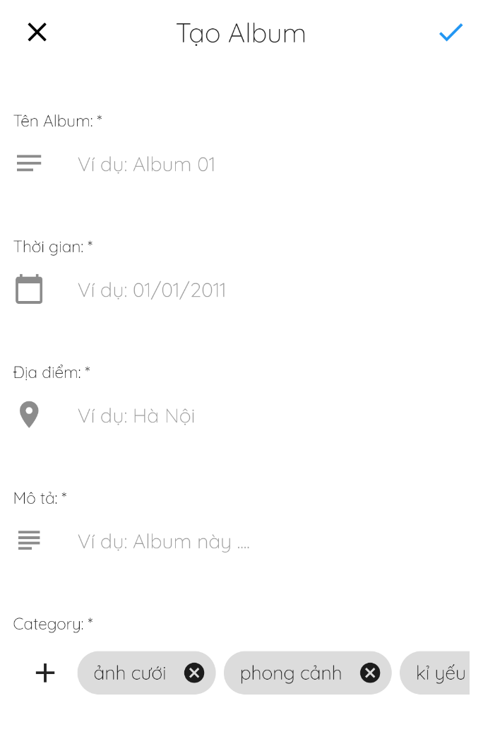

図179 - アルバムを追加します

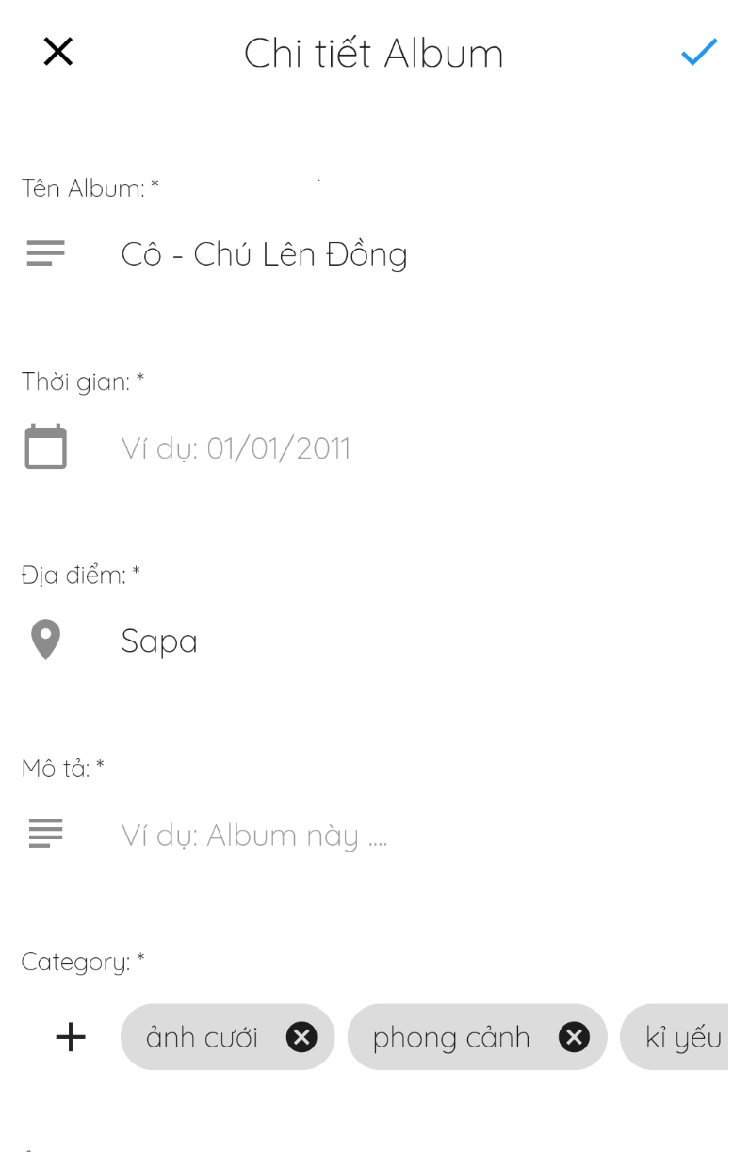

図180 – アルバムを変更します

#### 6.3.11. サービスの管理

* **目標**
  + フォトグラファーがサービスを管理します
  + 客がフォトグラファーのサービスを観ます
* **機能**
  + サービスを追加します(フォトグラファーのみ)
  + サービスを変更します(フォトグラファーのみ)
  + サービスを削除します(フォトグラファーのみ)
  + サービスを観ます
* **ユーザーインターフェース**



図181 – サービスを観ます

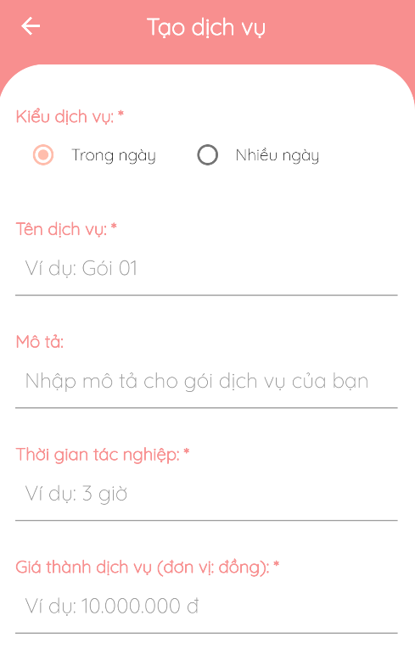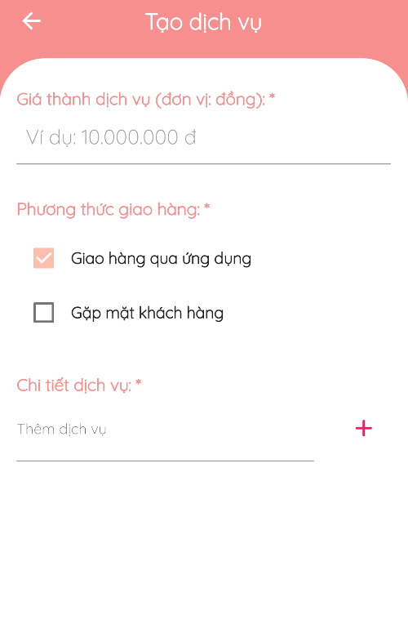

図182 - サービスを追加します

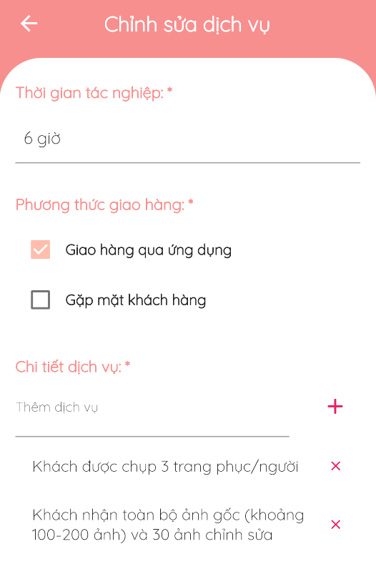

図183 – サービスを変更します

#### 6.3.12. カテゴリーの管理

* **目標**
  + 客がカテゴリーを観たり、選択します
* **機能**
  + カテゴリーを観ます
  + カテゴリーを選択します
* **ユーザーインターフェース**

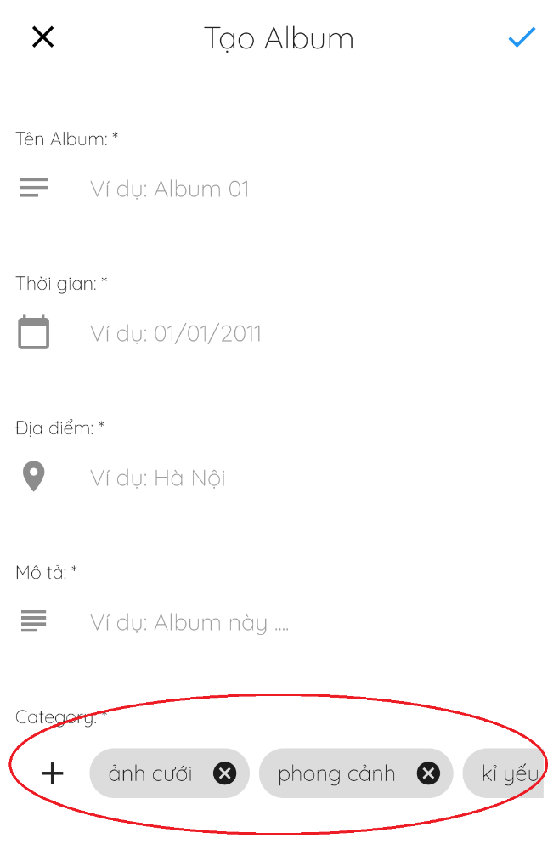

図184 – カテゴリーを観ます／選択します

#### 6.3.13. チャット

* **目標**
  + 客とフォトグラファーが簡単に連絡します
* **機能**
  + チャット
* **ユーザーインターフェース**

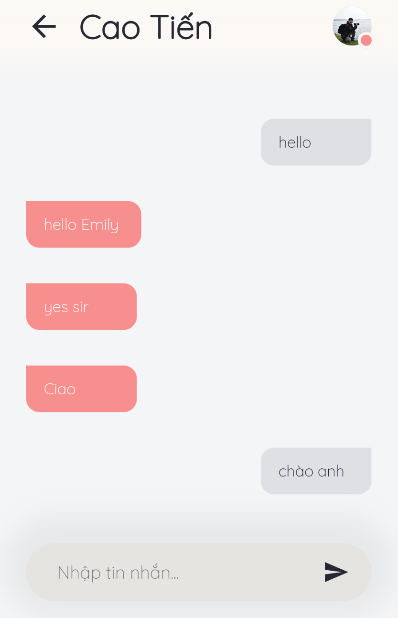

図185 – チャット

#### 6.3.14. フォーラム

* **目標**
  + ユーザーがフォーラムのコンテンツを観ます
  + スレッドにコメントします
  + スレッドを管理します
  + カテゴリーを管理します
* **機能**
  + スレッドを観ます
  + コメントを観ます
  + スレッドを追加します
  + スレッドを編集します
  + スレッドをデリートします
  + コメントを追加します
  + コメントを編集します
  + コメントをデリートします
* **ユーザーインターフェース**



図186 – スレッドを観ます



図187 – コメントを観ます

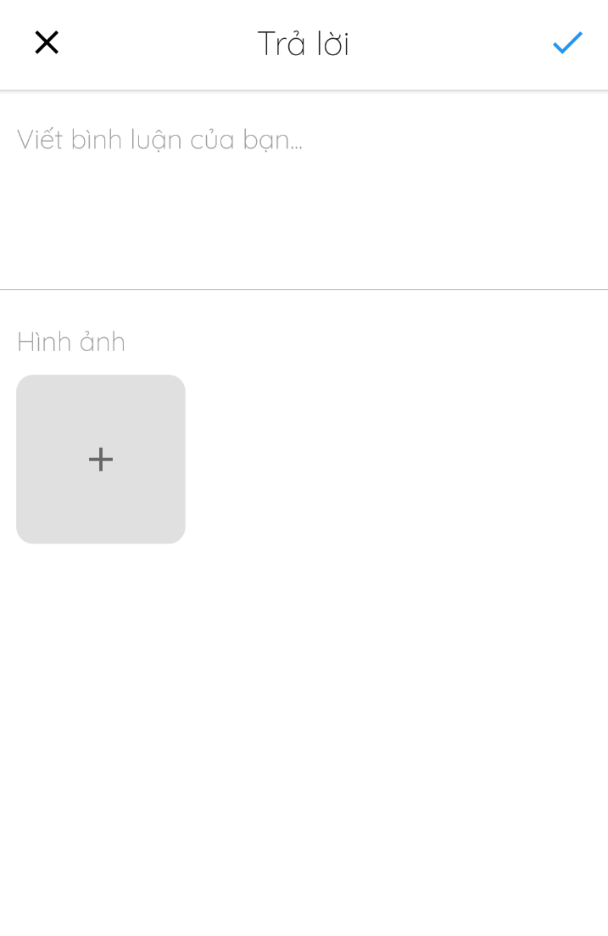

図188 – コメントをを追加します



図189 – スレッドを追加します

#### 6.3.15. 配信方法の管理

* **目標**
  + 管理者が配信方法の管理します
  + 客やフォトグラファーが配信方法を観たり、選択します
* **機能**
  + 配信方法を選択します(客やフォトグラファー)
* **ユーザーインターフェース**

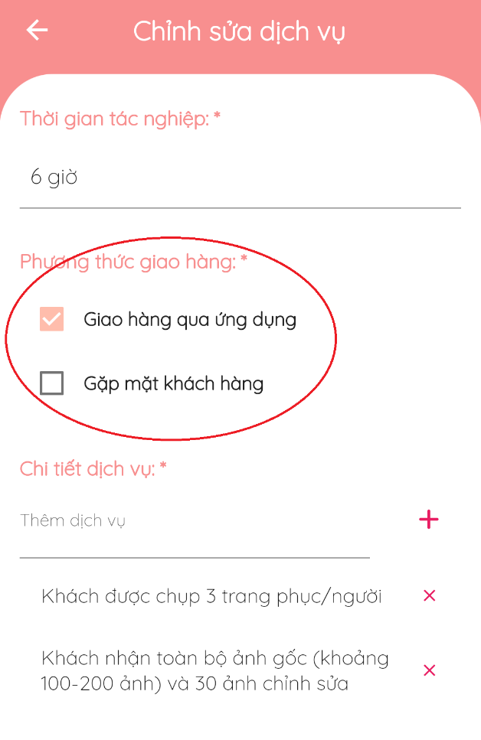

図190 - 配信方法を選びます

#### 6.3.16. プロファイルの管理

* **目標**
  + ユーザーがプロファイルを編集します
* **機能**
  + プロファイルを編集します
  + アバターやカバーを変更します
* **ユーザーインターフェース**

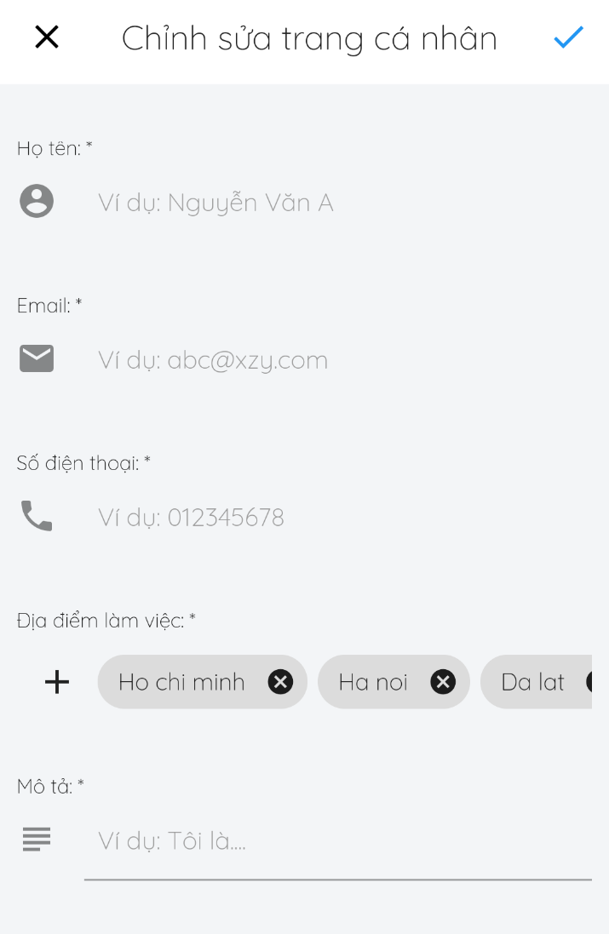

図191 – プロファイルを編集します

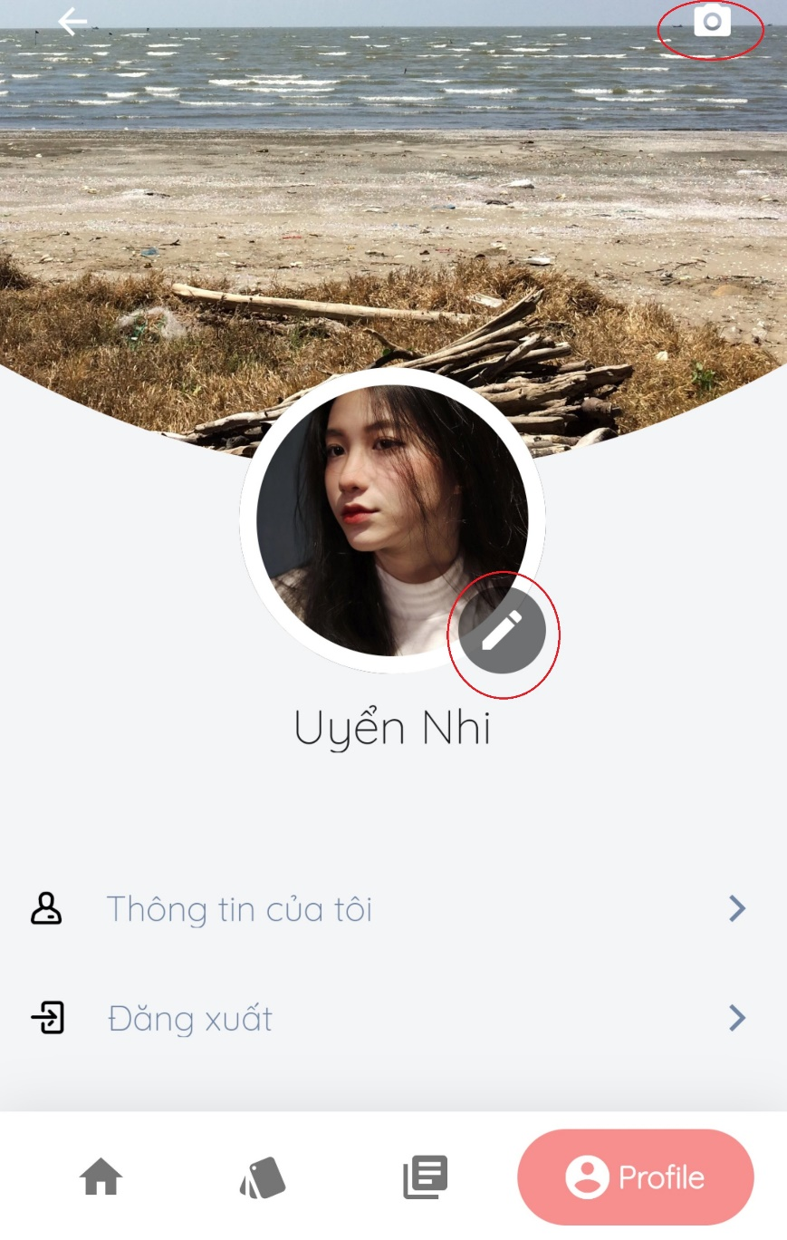

図192 –アバター／コバーを変更します

### 6.4トラブルシューティング

**1.現在の場所を特定できない場合があります**

最初の発生

* テストの間に

問題

* ケイタイの現在の場所は許可されていません

回避策

次のステップを実行します:

* **設定**> **現在の場所** > **オン**

**2. プロファイルのイメージを失敗しに変更する場合があります**

最初の発生

* テストの間に

問題

* イメージのサイズが最大許容サイズを超えています

回避策

* 他の小さなイメージを選択します

# VII. Appendix

## 1. Glossary [Optional]

|  |  |
| --- | --- |
| **Acronym** | **Definition** |
| PBS | Photographer booking system |
| AWS | Amazon Web Services |
| BR | Business Rule |
| ERD | Entity Relationship Diagram |
| SRS | Software Requirement Specification |
| UC | Use Case |
| API | Application Program Interface |

Table Glossary

## 2. References [Optional]

1. Pub.Dev: https://pub.dev/
2. Bloc Library: https://bloclibrary.dev/#/
3. Diagrams.net: https://app.diagrams.net/
4. Lucidchart: www.lucidchart.com
5. StarUML: https://staruml.io/
6. Xmind: https://www.xmind.net/
7. MySQL: https://www.mysql.com/
8. MySQL Workbench: https://www.mysql.com/products/workbench/
9. Android Studio: https://developer.android.com/studio
10. Visual Studio Code: https://code.visualstudio.com/
11. Intellij: https://www.jetbrains.com/idea/
12. Firebase Cloud Messaging: https://firebase.google.com/docs/cloud-messaging
13. Firebase Realtime Database: https://firebase.google.com/docs/database
14. Postman: https://www.postman.com/
15. Amazon Simple Storage Service: https://aws.amazon.com/vi/s3/

## 3. Others [Optional]